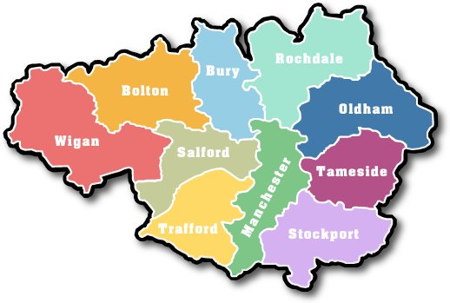

2017 Air Quality Annual Status Report (ASR) for Greater Manchester

In fulfilment of Part IV of the
Environment Act 1995
Local Air Quality Management

Date: 26th September 2018

Matthew O’Neill – Lead Air Quality Officer  Transport for Greater Manchester (TfGM)  2 Piccadilly Place  Manchester  M1 3BG  Tel: 0161 2441141  Matthew.oneill@tfgm.com | Stuart Blackadder  Transport for Greater Manchester (TfGM)  2 Piccadilly Place  Manchester  M1 2BG  0161 244 1710  Stuart.Blackadder@tfgm.com
Katherine King Bolton Metropolitan Borough Council  Ellesmere House, Mayor Street  Bolton, BL3 3DT  Tel: 01204 336526  Caroline.Greenen@bolton.gov.uk | Chris Horth  Bury Metropolitan Borough Council  3 Knowsley Place, Duke Street,  Bury, BL9 0EJ  Tel: 0161 253 5000  c.horth@bury.gov.uk
Rebecca Twigg-Purcell  Manchester City Council  1 Hammerstone Road  Gorton  Manchester M18 8EQ  Tel: 0161 234 5004  R.Twigg@manchester.gov.uk | Joanne Collier  Oldham Council  Chadderton Town Hall  Middleton Road, Chadderton  Oldham, OL9 6PD  Tel: 0161 770 4115  Joanne.Collier@oldham.gov.uk
Laura Elliott  Rochdale MBC  Number One Riverside, Smith Street,  Rochdale, OL16 1XU  Tel: 01706 924136  laura.elliot@rochdale.gov.uk | Ben Rose  Salford City Council  Civic Centre, Chorley Road,  Swinton  Salford, M27 5FJ  Tel: 0161 697 6964  benjamin.rose@salford.gov.uk
Stephen Brown  Stockport MBC  Stopford House  Piccadilly  Stockport  SK1 3XE  Tel: 0161 474 4284  Stephen.brown@stockport.gov.uk | Gary Mongan  Tameside MBC  Environmental Services  Council Offices  Wellington Road, Ashton-Under-Lyne  Lancashire, OL6 6DL  Tel: 0161 342 3941  gary.mongan@tameside.gov.uk
Richard Pollitt  Trafford Borough Council  Trafford Town Hall, Talbot Road, Stretford  Manchester, M32 0YJ  Tel: 0161 912 4026  Richard.pollitt@trafford.gov.uk | Steve Tesson-Fell  Wigan Council  Business Compliance & Improvement  PO Box 100  Wigan, WN1 3DS  comm@wigan.gov.uk

Report Reference number | GMASR2017
Date | 26th September 2018

Executive Summary: Air Quality in Our Area

Air Quality in Greater Manchester
Air pollution is associated with a number of adverse health impacts. It is recognised as a contributing factor in the onset of heart disease and cancer. Additionally, air pollution particularly affects the most vulnerable in society: children and older people, and those with heart and lung conditions. There is also often a strong correlation with equalities issues, because areas with poor air quality are also often the less affluent areas.
The annual health cost to society of the impacts of particulate matter alone in the UK is estimated to be more than £20 billion.
The Greater Manchester Air Quality Working Group led by Transport for Greater Manchester (TfGM) represents the ten authorities that constitute the Greater Manchester Combined Authority (GMCA). These authorities are Bolton, Bury, Manchester, Oldham, Rochdale, Salford, Stockport, Tameside, Trafford, and Wigan. These are also the main members of the Association of Greater Manchester Authorities (AGMA). The Combined Authority, shares the same statutory powers for Local Air Quality Management (LAQM) Sections 82 to 84 of the Environment Act 1995 as the districts.
Greater Manchester has a population of over 2.7 million residents over an area of approximately 500 square miles. Within the conurbation there is a mix of high-density urban areas, suburbs, semi-rural and rural locations, and the area is characterised by the strong regional centre of Manchester, The Quays and Trafford Park.
Long term trends show that there has been an improvement in air quality but areas still remain above the annual mean air quality objective for Nitrogen Dioxide (NO₂).
The assessment of monitoring data shows that real time monitoring data for the NO₂ annual mean objective broadly confirms the Air Quality Management Area (AQMA) boundaries declared in 2016. Exceedances were noted at several roadside monitoring sites. Recent modelling showed that the extent of previous exceedances, and therefore the old AQMAs, reduced in size due to falling NO₂ emissions, but measurements in some areas, particularly those close to the M60, show that concentrations of NO₂ experienced at the roadside have not gone down as expected. This is thought to be largely due to diesel cars having higher emissions ‘in the real world’ than was anticipated and the fact that there are now more of them on the road. The new single AQMA was designated on the 1st May 2016 for the whole of Greater Manchester and reflects the location of the motorways, major roads and urban areas. In terms of the effect on people, this is greatest where high density residential areas coincide with major highways.
5 automatic sites out of the 16 in Greater Manchester exceeded the NO₂ annual mean objective of 40µg/m³ in 2017. These 5 sites were Salford M60, Manchester Oxford Road, Stockport Cheadle A34, Bury Prestwich and Tameside Mottram Moor.
The 2015 Greater Manchester Annual Status Report made reference to exceedances of the hourly NO₂ objective at the Manchester Oxford Road automatic monitoring site. The national objective is for there to be no more than 18 exceedances, and there were a total of 60 exceedances of the hourly objective at this site during that year. A commitment was made in the report to investigate the matter and, in accordance with Technical Guidance TG16, measurements over several years and relevant local factors have been considered, together with Air Quality Action Plan (AQAP) measures.
The investigation concluded that the elevated number of exceedances identified in 2015 were the result of an increase in buses being stationary on Oxford Road adjacent to the monitoring site. This situation was the result of significant roadworks and road closures in the city centre and Mancunian Way during 2015, leading to additional buses being diverted past the monitoring site and queuing back from traffic lights further along Oxford Road towards the city centre. A large proportion of the city centre diversions during 2015/16 were due to the Metrolink works, which have extended the tram network across the city and wider Greater Manchester area. This measure was one of the actions in the GM AQAP predicted to improve air quality in the future.
During 2016 there were 90 exceedances of the hourly objective, which were again due to additional buses queuing close to the monitoring site as a result of diversions due to the ongoing Metrolink works and other road closures.
During early 2017, TfGM implemented a £122m Bus Priority Package, which enables cross-city bus services to run directly through Manchester city centre. Oxford Road has had significant road layout alterations, and general traffic is now prohibited from travelling through new ‘bus gates’ that restrict access between 6am and 9pm, 7 days a-week.
As a result of the road layout changes, traffic flow has improved past the monitoring site and the exceedances of the hourly objective have reduced; only 6 hourly exceedances were recorded in 2017.
Measurements from the Greater Manchester’s diffusion tube network confirms there are locations that continue to be above the annual mean NO₂ air quality objective.
Real time monitoring data for particulate matter (less than 10 microns) shows that annual average objectives are not exceeded and are mostly remaining stable at low concentrations. No sites had more than 35 occurrences of the daily mean particulate objective and therefore this objective is met.
Sulphur dioxide monitoring was carried out at 2 sites, with no exceedances of the air quality objectives. Air quality monitoring and reporting of carbon monoxide and benzene has been discontinued, as previous assessments indicated no exceedances.

The Low Emission Strategy (LES) and AQAP was published on the 16th December 2016 after going out to public consultation and being signed off by the Greater Manchester Combined Authority (GMCA). The LES & AQAP propose a range of measures to improve air quality and reduce ill-health across Greater Manchester, focusing on ‘key priority areas’ in urban centres and near major roads which currently fail to meet UK Government and EU air quality objectives. The LES & AQAP is being led by TfGM on behalf of the GMCA, and includes close working with Highways, England, Public Health England, The Environment Agency, Greater Manchester Police, and charitable organisations to ensure the best outcome can be achieved.

Actions to Improve Air Quality
The AQAP has been produced following a programme of consultation and workshops with key stakeholders, including the Greater Manchester local authorities, Public Health England, TfGM and Highways England, to obtain feedback on the new measures proposed.
Policies and actions were subsequently identified and divided into the following broad subjects, based on the area and type of effects that may be achieved:
- Development management and planning regulation: including standardisation of regulation and policy across the Greater Manchester region.
- Freight and HGVs: there are several opportunities to reduce emissions associated with the movement of freight and goods by road.
- Buses: Buses have a vital role to play in transporting the public and give opportunities to improve air quality. New legislative developments and the creation of the future Greater Manchester bus strategy will assist in growing bus usage and improving vehicle standards.

- Cycling: Existing strategies and initiatives encourage cycling.

- Travel Choices: Encouraging the public and businesses to make sustainable travel choices is essential in realising lasting air quality benefits.

- Cars: Measures to reduce emissions from cars and reduce the number of vehicle trips can deliver real improvements.

- Information and resources: Education and the provision of information to the public, businesses and policy makers is seen as vital in bringing air quality improvements.

Since the Air Quality Action Plan was agreed a National Plan for tackling roadside nitrogen dioxide concentrations (DEFRA, July 2017) has been published. It identified 29 local authorities, including seven in Greater Manchester (GM), with areas likely to exceed the statutory NO₂ annual mean EU Limit Value of 40 µg/m³ (the EU Limit Value) beyond 2020. In March 2018, 33 more local authorities were defined as having “shorter-term NO₂ problems” - including Oldham in GM. The National Plan compels these local authorities to follow a specific process to undertake initial evidence development, detailed feasibility studies and develop plans for the implementation of appropriate measures to deliver compliance with the EU Limit Value in the ‘shortest possible time’. UK Government guidance identifies charging Clean Air Zones (CAZ) as the benchmark measure for achieving compliance in the shortest possible time.

The feasibility study includes the following stages:
• Strategic Outline Case (SOC)
• Initial Evidence and Target Determination
• Outline Business Case (OBC)
• Full Business Case (FBC)

The FBC of the feasibility study will ultimately act as the final GM Clean Air Plan and will include measures to achieve compliance as well as mitigation measures. The package of measures identified in the GM Clean Air Plan will then be implemented to deliver compliance with the EU Limit Value. TfGM has been coordinating the GM feasibility study on behalf of the GMCA and the ten GM local authorities, working closely with Districts, who remain legally responsible for compliance. The OBC must be approved by all ten GM local Authorities by early December 2018 to meet the government’s deadlines.

Local Priorities and Challenges
Given the need to meet EU limits for NO₂ as soon as possible, the short-term focus will need to be on NO₂. Many of the measures that will help achieve this will also be of some benefit in reducing greenhouse gases and particulates, which will be the focus over the longer-term. Key challenges will be obtaining funding to enable the Local Authorities to carry out some of the actions in the plan.

How to Get Involved
https://cleanairgm.com/ has information and links to air quality and how to play a part. The main considerations would be to think about how you travel, reducing single occupancy car use, use carpooling, changing to cleaner alternative fuels, and using public transport, cycling and walking. Other considerations could include avoiding excessive idling of your vehicle, or even considering where the products you buy are coming from.
The GMCA have carried out Clean Air Days/Weeks, which raised awareness and help people understand what they can do to improve their impact. These days were also carried out with events at schools, hospitals and workplaces.

Air Quality Initiatives
Clean Air Day
2017 saw the first National Clean Air Day campaign. In Greater Manchester a number of events took place across the city-region including a city-centre event, an air quality conference, a joined-up effort to collect air quality-related pledges from GM residents, a schools competition and much more. Increasing the public’s awareness of air quality and what behaviour can decrease our contribution is an important part of Greater Manchester’s approach to tackling air quality.

Cycling

Cycling is a quick and easy way to get around, and six new cycleways have been opened in Greater Manchester.
The new routes give cyclists more space as some are separated from traffic and others are completely traffic-free, making it easier to get around Greater Manchester.
A new Dutch style cycle lane has opened on Oxford/ Wilmslow Road, which offers safer segregated (largely by kerb) cycle routes along one of the busiest corridors in Greater Manchester. The Wilmslow Road Cycleway links Didsbury, Withington, Fallowfield and Rusholme, and will also connect directly with Manchester city centre once further cycle lane improvements are completed on Oxford Road. The route is mainly along the highway but special new kerbs have been built to give cyclists dedicated space away from other traffic for the majority of the cycleway. It also has new bus stop and car parking bypasses, allowing cyclists to enjoy their ride. Greater Manchester now has 6 ‘Cycleways’ – where cyclists are separated from traffic for the majority of the route:
• Airport City Cycleway
4 mile, mostly traffic-free, route from Timperley to the airport.
• Ashton Canal Cycleway
6 mile traffic-free route from Manchester city centre to Ashton.
• Bridgewater Canal Cycleway
11 mile traffic-free route from Manchester city centre to Altrincham or the Trafford centre.
• Broughton Cycleway
1 mile route separated from traffic, from Manchester city centre to Broughton.
• Mersey Valley and Stockport Cycleway
3 mile, mostly traffic-free route from Stockport town centre to Parrs Wood and Cheadle.
• Wilmslow Road Cycleway
4.3 mile route, mostly separated from traffic, from Didsbury village to Manchester City Centre.
Greater Manchester Mayor Andy Burnham appointed Chris Boardman as the region’s first ‘Cycling and Walking Commissioner’ in 2017. Subsequently, in the ‘Made to Move’ report the Commissioner set out 15 steps to transform Greater Manchester through cycling and walking initiatives.
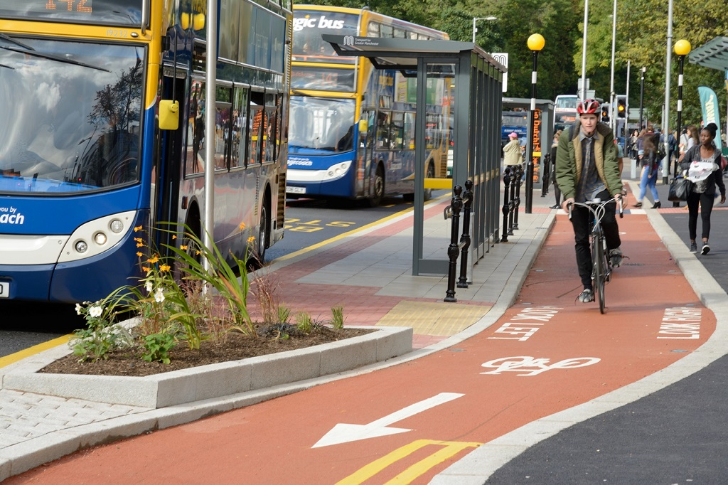

Yellow School Buses
Transport for Greater Manchester (TfGM) launched its ‘Clean Air for Schools’ programme in 2013, targeting the tailpipe emissions of its diesel Yellow School Buses. Of the 93-strong fleet, 52 Yellow School Buses are already low-emission vehicles. Funded through the Department for Transport’s (DfT’s) Clean Bus Technology Fund, the programme involved retro-fitting innovative air pollution control equipment to the remaining 41 diesel vehicles. Emission tests were carried out before the pollution control systems were fitted and again after they had been on the road one year. The results showed a 99% reduction in the level of nitrogen oxides – far higher than the 50% minimum target set by the DfT – with a 93% reduction in particulates, 99% in hydrocarbons and more than 97% in carbon monoxide. The final seven diesel buses were retrofitted with the same equipment in 2016 marking the completion of the project.
Transport for Greater Manchester (TfGM) won the Local Authority and Public Sector Air Quality Initiative of the Year title for this project.

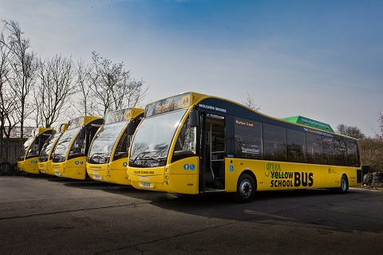

Metrolink
Developing Greater Manchester’s rapid transit network has been essential to improving air quality in the region. The Metrolink has expanded to become the largest light rail network in the UK, with services now running on seven lines to 93 stops covering nearly 60 miles. Construction of the Trafford Park Line is currently ongoing, due for completion in 2020. This service will run through the busy Trafford Park Industrial Estate, serving a large employment centre of Greater Manchester and having the potential to bring a large number of private vehicle journeys off the roads.
The fleet of 120 modern M5000 trams now carries more than 41 million passenger journeys a year. Options to buy more trams are currently being explored.
‘Tram-train’ options are also being explored, which would mean ‘metro-style- services in more areas. This would help to improve access to the city centre at the busiest times, while also offering more capacity on the heavy rail network.

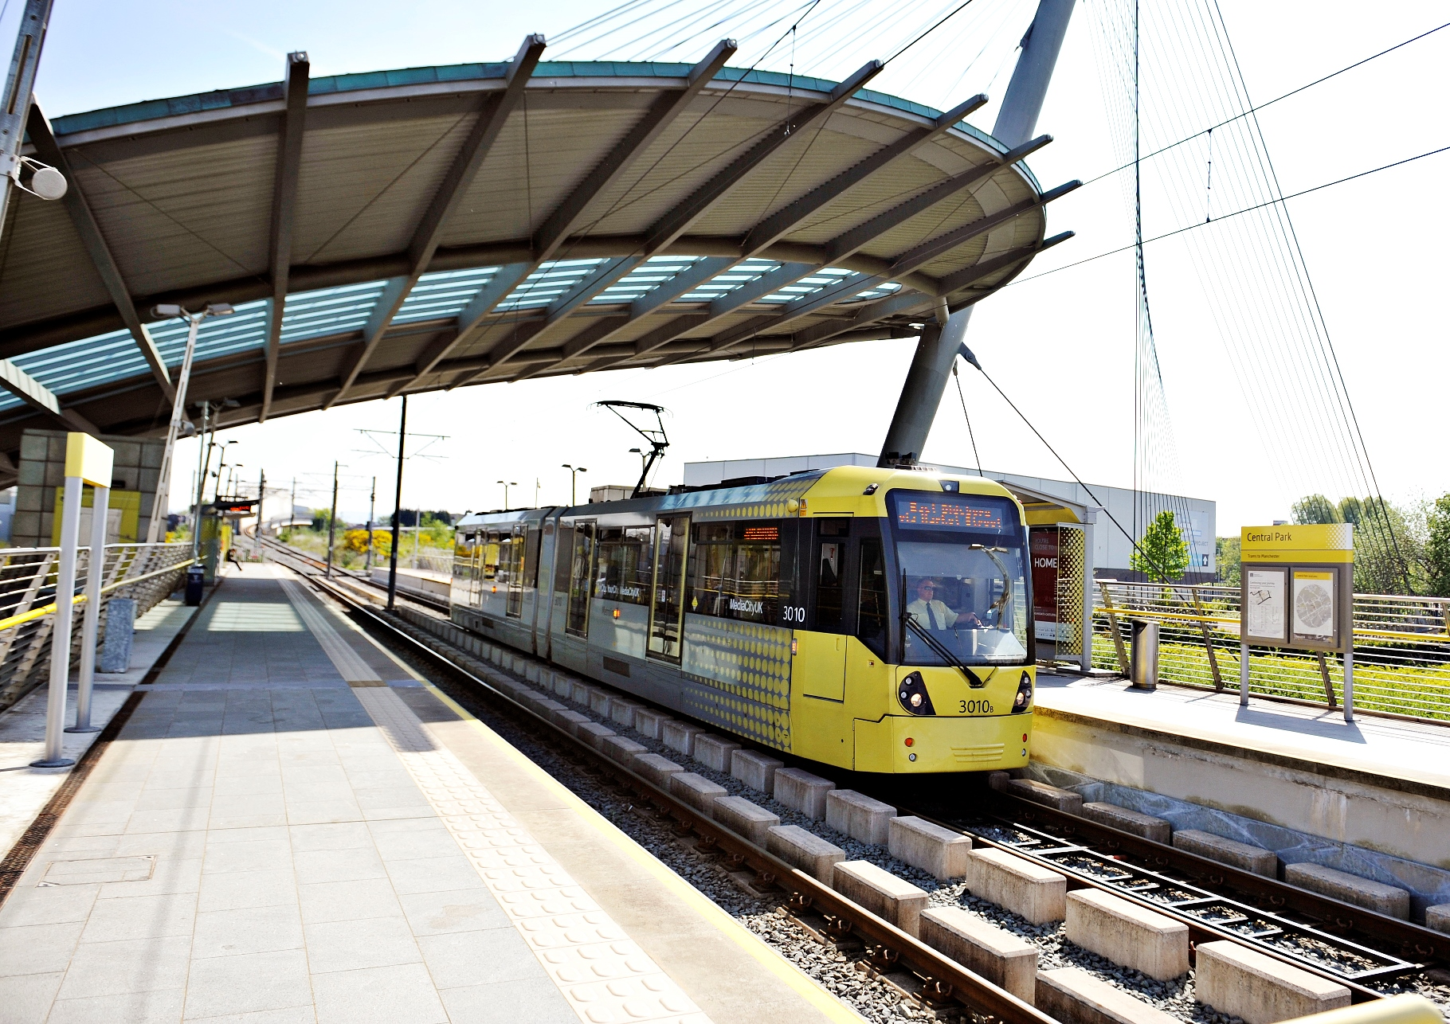

Table of Contents
Executive Summary: Air Quality in Our Area i
Air Quality in Greater Manchester i
Actions to Improve Air Quality iii
Local Priorities and Challenges v
How to Get Involved v
Air Quality Initiatives vi
1 Local Air Quality Management 1
2 Actions to Improve Air Quality 2
2.1 Air Quality Management Areas 2
2.2 Progress and Impact of Measures to address Air Quality in Greater Manchester 3
2.3 PM_{2.5} – Local Authority Approach to Reducing Emissions and or Concentrations 12
3 Air Quality Monitoring Data and Comparison with Air Quality Objectives and National Compliance 16
3.1 Summary of Monitoring Undertaken 16
3.1.1 Automatic Monitoring Sites 16
3.1.2 Non-Automatic Monitoring Sites 17
3.2 Individual Pollutants 17
3.2.1 Nitrogen Dioxide (NO₂) 17
Annual Mean Concentrations 17
Automatic monitoring site results: 17
Diffusion tube results: 18
Hourly Concentrations 21
3.2.2 Particulate Matter (PM₁₀) 25
Annual Mean Concentrations 25
Hourly Concentrations 25
3.2.3 Particulate Matter (PM_{2.5}) 28
3.2.4 Sulphur Dioxide (SO₂) 29
Appendix A: Monitoring Results 30
Appendix B: Full Monthly Diffusion Tube Results for 2017 43
Appendix C: Supporting Technical Information / Air Quality Monitoring Data QA/QC 44
Appendix D: Map(s) of Monitoring Locations 49
Appendix E: Summary of Air Quality Objectives in England 50
Glossary of Terms 51
References 52

List of Tables

Table 2.1 - Declared Air Quality Management Areas 2
Table 2.2 - Progress on Measures to Improve Air Quality 11
Table 2.3 - An estimate of the attributable deaths and years of life lost in Greater Manchester based on 2016 data 14
Table 3.1 – Number of NO₂ Diffusion Tube Sites over 40 μg/m³ 24
Table A.1 - Details of Automatic Monitoring Sites 30
Table A.2 - Details of Non-Automatic Monitoring Sites 32
Table A.3 - Automatic Monitoring Sites Annual Mean NO₂ Monitoring Results 33
Table A.4 – Automatic Monitoring Sites 1-Hour Mean NO₂ Monitoring Results 35
Table A.5 - Annual Mean PM₁₀ Monitoring Results 37
Table A.6 - 24-Hour Mean PM₁₀ Monitoring Results 39
Table A.7 - PM_{2.5} Monitoring Results 41
Table A 8 - SO₂ Monitoring Results 42
Table B.1 - NO₂ Monthly Diffusion Tube Results – 2017 43
Table E.1 - Air Quality Objectives in England 50

List of Figures
Figure 2.1 Maps showing Air Quality Assessment cumulative database. 4
Figure 3.1: GM Automatic Monitoring Stations 16
Figure 3.1 - Trends in Annual Mean NO₂ Concentrations Measured at Automatic Monitoring Sites Bury – Oldham. 22
Figure 3.2 -Trends in Annual Mean NO2 Concentrations Measured at Automatic Monitoring Sites Salford - Wigan 23
Figure 3.3 - Trends in Annual Mean NO2 Concentrations Measured at Diffusion Tube Monitoring Sites 24
Figure 3.4- Trends in Annual Mean PM₁₀ Concentrations Measured at Automatic Monitoring Sites – Bury - Salford 26
Figure 3.5 - Trends in Annual Mean PM₁₀ Concentrations Measured at Automatic Monitoring Sites – Salford – Wigan 27
Figure 3.6 - Trends in Annual Mean PM_{2.5} Concentrations Measured at Automatic Monitoring Sites 28
Figure C1. Annualisation Calculations 44
Figure C2. Bias Adjustment Calculation 45
Figure C3. Examples of Distance Correction Calculations 46

Local Air Quality Management
This report provides an overview of air quality in Greater Manchester during 2017. Transport for Greater Manchester (TfGM) represents the ten authorities that constitute the Greater Manchester Combined Authority (GMCA). The ten authorities are:
- Bolton Metropolitan Borough Council (BoMBC)
- Bury Metropolitan Borough Council (BMBC)
- Manchester City Council(MCC)
- Oldham Council (OC)
- Rochdale Metropolitan Borough Council (RMBC)
- Salford City Council (SCC)
- Stockport Metropolitan Borough Council (SMBC)
- Tameside Metropolitan Borough Council (TMBC)
- Trafford Borough Council (TBC)
- Wigan Council (WC)
The report fulfils the requirements of Local Air Quality Management (LAQM) as set out in Part IV of the Environment Act (1995) and the relevant Policy and Technical Guidance documents.
The LAQM process places an obligation on all local authorities to regularly review and assess air quality in their areas, and to determine whether or not the air quality objectives are likely to be achieved. Where an exceedance is considered likely the local authority must declare an Air Quality Management Area (AQMA) and prepare an Air Quality Action Plan (AQAP) setting out the measures it intends to put in place in pursuit of the objectives. This Annual Status Report (ASR) is an annual requirement showing the strategies employed by the 10 Greater Manchester Local Authorities to improve air quality and any progress that has been made.
The statutory air quality objectives applicable to LAQM in England can be found in Appendix E.

Actions to Improve Air Quality

Air Quality Management Areas
AQMAs are declared when there is an exceedance or likely exceedance of an air quality objective. After declaration, the authority must prepare an Air Quality Action Plan (AQAP) within 12-18 months setting out measures it intends to put in place in pursuit of the objectives.
A summary of the AQMA declared by the (GMCA) can be found in Table 2.1. Further information related to declared or revoked AQMAs, including maps of AQMA boundaries are available online at https://uk-air.defra.gov.uk/aqma/maps.The current AQMA was declared on the 1st May 2016 following the 2014 detailed assessment.

Table 2.1 - Declared Air Quality Management Areas
AQMA Name | Pollutants and Air Quality Objectives | City / Town | One Line Description | Action Plan
AQMA Greater Manchester | - NO₂ annual mean | Greater Manchester | An area covering the 10 districts of Greater Manchester, including arterial routes, district centres and airport. | Greater Manchester Air Quality Action Plan 2016-21

Progress and Impact of Measures to address Air Quality in Greater Manchester
Greater Manchester has taken forward a number of measures during the current reporting year of 2017 in pursuit of improving local air quality. These include:
- Preparing a comprehensive regional ‘Clean Air Plan’, which collates various measures to address poor air quality, in line with the national plan.
- Expanding the GM cycling network and boosting facilities to promote active travel, as well as appointing the first Cycling and Walking commissioner dedicated to improving this even further.
- Continuing our business travel advice operations, which supports businesses across GM change their employees’ commuting habits to low-emission modes.
- Organising the first (2017) and second (2018) annual region-wide ‘Clean Air Day’ event, which shares important information about air quality and how to improve it with the general public.
- Trialling the Volvo 7900e pantograph-charged electric bus for 8 weeks, demonstrating our commitment to considering alternative low-polluting options to public transport.
- Working with the GM Taxi Licensing Group to develop a set of minimum standards. The standards aim to harmonise Taxi and Private Hire Licensing Policy across GM’s 10 constituent authorities. The standards have a particular focus on safety and the emissions impact of vehicles, in particular, they set out maximum age limits for both new and licensed vehicles and minimum Euro class requirements in line with Defra’s clean air class framework.
- Successfully bidding for £3 million of ‘Early Measures’ Funding which will be used to improve Greater Manchester’s electric vehicle charging network and take up.
- Engaging with public and private sector organisations to promote reduced and re-timed deliveries through our Delivery and Servicing Plan (DSP) toolkit, removing HGV journeys from our roads. Initial actions arising from recommendations to SCC include: delivery times adjusted to avoid peak times at Swinton Hall Road depot, and any non-urgent, peak time deliveries are being considered for re-scheduling so that they occur outside of peak times at the Turnpike depot.
- Encouraging behaviour change through our ‘Anti-idling’ campaign, which aims to highlight the dangers of keeping a vehicle’s engine running while parked.
- Sharing information on sustainable freight transport with the Greater Manchester in the biannual Logistics Forum.
- Promoting the use of approved national air quality management standards in GM-wide planning decisions.
- Collating data from GM planning authorities on developments which have necessitated Air Quality Assessments (in accordance with IAQM Guidelines), apprehending cumulative air quality impacts, whereby air quality is affected by multiple development sites. This information can be accessed by emailing airquality@tfgm.com, and is illustrated at Figure 2.1.

Figure 2.1 Maps showing Air Quality Assessment cumulative database.
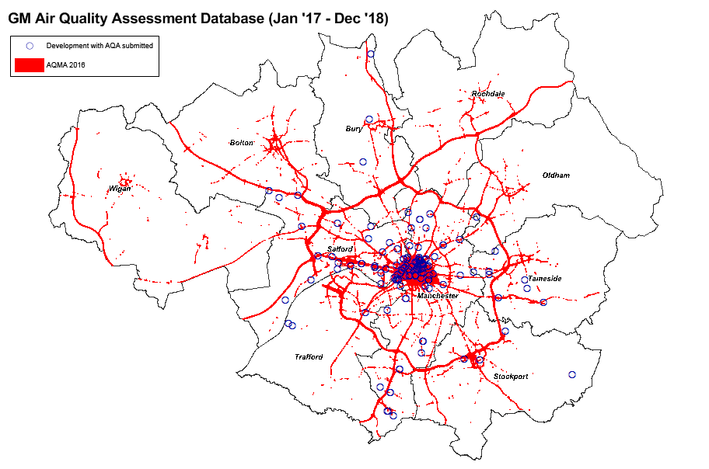
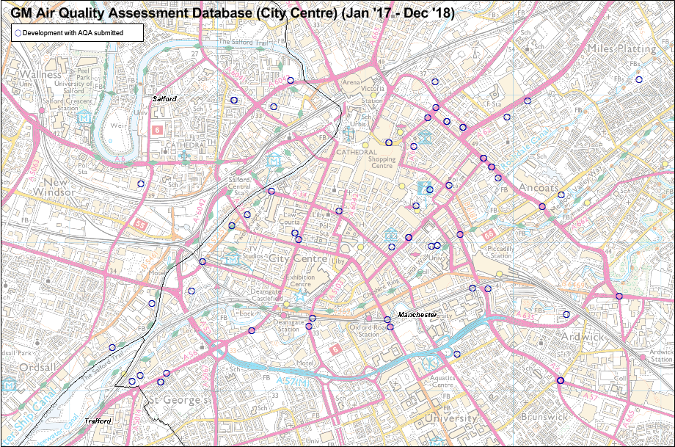

- Developing a website for the public to access local air quality information.
At local authority level, additional measures have been in place to reduce air quality emissions. These include, but are not limited to:

Bury Metropolitan Borough Council (BMBC)
- BMBC has been working to encourage participation in active travel through different measures, including: Breeze champions, who lead regular bike rides for women; a new Bike to Work Scheme within BMBC; securing funding for improved cycling facilities at council venues; and local health walks led by trained volunteers.
Manchester City Council (MCC)
- MCC has been working to implement its Green Infrastructure strategy and action plan (further details at: https://www.manchester.gov.uk/info/500002/council_policies_and_strategies/7061/green_and_blue_infrastructure) including projects such as the Nature of Hulme, Grow Green Project. 100 trees were planted, with a total of 500m2 green infrastructure land improvement.
- MCC Public Health have been highlighting the health effects of air pollution to various sectors, and recommended actions in their Annual Report including active travel, promotion of AQ message/campaigns, use of public transport for appointments, COPD patient alerts, healthy schools programme.
- A Task & Finish Group has been put together by MCC Highways / Education to work with Members on school issues including Healthy Schools, anti-idling, safety and walking.
Salford City Council (SCC)
- Co-Wheels car club to reduce business mileage and encourage use of low emission vehicles: The Salford car club has expanded and now covers 13 sites across the city with a total of 39 low emission vehicles (including 8 fully electric Nissan Leafs, 20% of the total fleet). Salford continues to have the highest usage of electric vehicles in Greater Manchester. Implementation of the Co-Wheels car club has resulted in a reduction in claimed business mileage of 95%. Further development of the SCC Green wheels Travel Plan is ongoing, which will provide additional measures to encourage mode shift.
- A staff car parking permit scheme is operating at principal SCC office/ depot locations. A monthly charging scheme is in place to obtain a parking permit, which is currently charged at 1% of employee annual salary. Specific parking spaces are allocated for pool vehicles, electric vehicles and car share vehicles at Salford Civic Centre to encourage their use. Car parks are regularly patrolled by Parking Wardens – a £70 fixed penalty fee is in place for not displaying a permit.
Stockport Metropolitan Borough Council (SMBC)

- SMBC has been working to encourage staff and the public to change the way they travel as part of the work being done in the Town Centre to improve accessibility.

- Stockport has implemented in 2017 and expanded in 2018 its Enterprise Car Club offer in the town centre. This is used to both encourage traveling to work by alternate modes to the car and to provide the residents and visitors of the town centre with an alternative to car ownership. Two of the vehicles are hybrids.

- SMBC has worked with a local taxi company to identify the opportunity for electric taxis and potential locations for chargers to support local drivers.
Tameside Metropolitan Borough Council (TMBC)
- TMBC’s Director of Public Health Annual Report “Facing Up To Air Quality” was issued, aiming to raise awareness of the risks of traffic-related air pollution and identify what individuals and organisations in Tameside can do to limit their contribution and exposure
- TMBC have continued to improve their own Council fleet with £7.5million invested over the last 3 years. Two thirds of their fleet are now of euro 6 standard with the remaining vehicles to be replaced over the course of 2019/2020. 9 fully electric vehicles will be added to the fleet next year.
- A number of elected member training sessions have been run on the subject of air quality and the challenges facing us in driving forward improvements.
- The first Tameside Green Summit was held, bringing together businesses, public services and voluntary and community groups. Delegates heard presentations on a range of environmental issues including air quality.
Trafford Borough Council (TBC)
- TBC have successfully obtained funding for 6 on street EV charge points and are liaising with residents to decide upon best locations. Additional electric vehicles charging points in Council premises (available to public).
- TBC are undertaking a project with the local taxi and private hire fleet to focus on benefits of switching to electric vehicles and understanding the charging infrastructure required.
- The Council have engaged with the TfGM sustainable journeys team and propose and are to undertake a survey on staff travel to guide changes in staff travel.
- The Council have trialled electric ‘pool bikes’ for work journeys and continue to operate the 'cycle to work scheme'.
- There has been engagement with the Energy Saving Trust to understand the impact of private cars being used for Council business use.
Wigan Council (WC)
- Fuel efficiency devices installed on all 37 RCVs and trial underway with devices on 3 ITU vehicles at WC; fuel economical driving courses for fleet drivers exhibiting uneconomical driving behaviour; 14 car share bays with 30 registered users
Further details of all measures completed, in progress or planned are set out in Table 2.2.
More detail on these measures can be found in their respective Action Plans (Greater Manchester Air Quality Action Plan 2016-21).
Greater Manchester expects the following measures to be initiated over the course of the next reporting year:
- TfGM along with the stated LAs will be addressing the requirements of the national plan, and investigating a number of mitigation options to bring Greater Manchester into compliance with the legal levels of NO₂ as soon as possible.
- Plugged-in Places EV Charging Network: Continue to increase the number of EV charging points. £3 million of funding from central government ‘Early Measures Fund’ is being invested into expanding, upgrading and promoting the Greater Manchester Electric Vehicle (GMEV) charging network. 48 rapid charging points are now set to be installed in 2018/19. This adds to the 324 charging points that already exist in the GMEV network.
- Further improvements on Bus Priority Programme
- Engine Idling: promotion of anti-idling policies with freight transport companies.
- TfGM Delivery and Servicing Plan (DSP) Toolkit: Air quality considerations will be incorporated into the DSP toolkit to reduce HGV movements, and hence emissions, in the Key Priority Areas.
- Encouraging Travel Planning: TfGM will work with the local authorities to encourage travel planning measures in businesses and individuals to affect a significant modal shift.
- Green Infrastructure: Investigate the potential of green infrastructure in improving air quality.
- Cycle Programmes: Improve the cycle infrastructure and provide practical support to reduce vehicle movements in the Key Priority Areas.
- Public Cycle Hire: Explore the feasibility of expanding public cycle hire facilities beyond Manchester city centre.
- Cycle Logistics: Encourage and promote a logistics programme to use cycle or electrically-assisted cycles for short distance deliveries and distribution in urban centres.
- 2040: Undertake further work to better understand the more innovative options available to further promote cycling and walking, and to set out a clear delivery plan in line with the 2040 transport strategy.
- Local Authority Parking Charges: Work with local authorities to review the introduction of parking charges at local authority offices to discourage private car use.
- School Travel: TfGM will appraise opportunities to reduce air quality impacts from school car travel.
- Awareness Raising: Air quality awareness programmes to encourage people to take action against air pollution.
- Greater Manchester delivered phase 1 of the Cycle City Ambition Grant (CCAG) programme in March 2016 to encourage a step change in cycling, and work towards the GM cycling strategy target of a 10% cycling mode share by 2025. Within Salford the highlight of this programme was a 2.0km light segregation cycleway, the longest scheme of this type in the country. Early results show that cycling in the peak commuting periods has doubled on the corridor, since the introduction of light segregation. Several other high profile cycling projects in Salford were completed that will encourage more cycle trips, and reduce poor air quality. Including the final section of the Roe Green loopline, with this, the 7.5km traffic free route from Bolton to Monton Green is now open, providing an excellent commuter route and direct traffic free access to 7 schools along the route to encourage cycling to school and a reduction on car trips during the ‘school run’.
- A study into Alternative Fuels for heavy vehicles
- A trial of electric buses on standard routes
- A trial of GTL fuel
- Developing applicability of the Cumulative Air Quality Assessment Database to mitigate air quality impacts in areas with large numbers of developments.
- Bus retrofitting - £3 million has been awarded to TFGM through the central government ‘Clean Bus Technology Fund’ to retrofit older diesel buses with new abatement technology to reduce nitrogen dioxide tailpipe emissions.
- Air Quality Grant funding will be sought for actions aimed at reducing PM_{2.5} from wood-burning sources.

Table 2.2 - Progress on Measures to Improve Air Quality

Details of progress on measures is located in the attached “GM Monitoring Results 2017” file

PM_{2.5} – Local Authority Approach to Reducing Emissions and or Concentrations
As detailed in Policy Guidance LAQM.PG16 (Chapter 7), local authorities are expected to work towards reducing emissions and/or concentrations of PM_{2.5} (particulate matter with an aerodynamic diameter of 2.5µm or less). There is clear evidence that PM_{2.5} has a significant impact on human health, including premature mortality, allergic reactions, and cardiovascular diseases.
The EU has also set a target of a 20% reduction in urban background concentrations of PM_{2.5} between 2010 and 2020. Greater Manchester currently has 5 sites that monitor PM_{2.5}: Manchester Piccadilly; Manchester Sharston; Salford Eccles; Salford M60; and Wigan Centre. All of these sites have showed an overall significant downward trend over recent years.
Given the need to meet EU limits for NO₂ as soon as possible, and the downward trend of particulate matter, the short-term focus will need to be on NO₂. Many of the measures that will help achieve this will also be of some benefit in reducing greenhouse gases and particulates, which will be the focus over the longer-term.
Air quality impacts will need to be assessed for all major development schemes where an impact is likely, and mitigation measures implemented where necessary. IAQM’s Guidance on the Assessment of Dust from Demolition and Construction has been adopted by GM local planning authorities in order to properly assess potential impacts from construction activity and implement appropriate mitigation controls consistently.
In line with the 1993 Clean Air Act, each GM council has a Smoke Control Area in place, where only smokeless or ‘authorised fuels’ can be burnt unless they are being used in an ‘exempt appliance’. Additionally, particulate concentrations will also see reductions through many of the actions which are featured in the Clean Air Plan and the Air Quality Action Plan.
Public Health Outcomes Framework Indicator 3.01 - Fraction of mortality attributable to particulate air pollution

In 2010 the Department of Health included an air quality indicator based on annual average background concentrations of fine particulate matter (known as PM_{2.5}) in the Public Health Outcomes Framework (PHOF). Population exposure to anthropogenic (man-made) PM_{2.5} is used as the basis of PHOF indicator 3.01. This indicator measures the percentage of all deaths in people aged 25 and over in a single year that is attributable to long-term exposure to current levels of PM_{2.5}. Concentrations of man-made (rather than total) PM_{2.5} are used as the basis of this indicator because estimates based on total PM_{2.5} could give a misleading impression of the extent to which potential policy interventions could have an impact on this measure. The data is presented as ‘Fraction of mortality attributable to particulate air pollution’ and is updated annually. The latest available dataset is for 2016.

Background annual average PM_{2.5} concentrations for the year of interest are calculated using a computer dispersion model, based on a 1km x 1km grid. The dispersion model is calibrated using measured concentrations taken from background sites in Defra’s Automatic Urban and Rural Network (http://uk-air.defra.gov.uk/interactive-map).

Expressing the mortality effect associated with long-term exposure to current levels of air pollution in this way allows comparisons to be made between different areas. In 2016, it is estimated that approximately 5% of deaths each year in Greater Manchester are attributable to exposure to man-made PM_{2.5} particulate air pollution. The average figure for Greater Manchester is similar to the England average (5.3%).

It is important to note that these deaths are not individually attributed to air pollution, but instead it is an estimated measure of how many deaths air pollution contributes to. Individuals will have other contributory causes such as respiratory or cardiovascular disease.

By using the PHOF indicator for the percentage of deaths attributable to PM_{2.5}, it is possible to estimate the number of deaths attributable to air pollution in Greater Manchester, and in turn the number of life years lost to the local population (by estimating the average years these people would have lived if they had not died prematurely due to long term exposure to particulate air pollution). However, it is recognised that there is a high degree of uncertainty in making these estimates.

The percentage and number of attributable deaths due to exposure to man made PM_{2.5} for each Greater Manchester district in 2016 is shown in the following table, provided by Public Health England Northwest.

Table 2.3 - An estimate of the attributable deaths and years of life lost in Greater Manchester based on 2016 data
Greater Manchester District | Number of deaths (age 25+) | Percentage of attributable deaths due to exposure to man made PM_{2.5} (PHOF indicator 3.01) | Estimated number of attributable deaths due to exposure to man made PM_{2.5} | Estimated associated life-years lost
Bolton | 2559 | 5.0 | 129 | 1545
Bury | 1798 | 4.9 | 88 | 1057
Manchester | 3480 | 5.2 | 181 | 2166
Oldham | 2085 | 5.0 | 104 | 1245
Rochdale | 2027 | 4.8 | 98 | 1173
Salford | 2157 | 5.1 | 110 | 1319
Stockport | 2666 | 4.9 | 131 | 1571
Tameside | 2177 | 5.1 | 110 | 1323
Trafford | 1959 | 4.9 | 97 | 1162
Wigan | 3165 | 4.7 | 150 | 1798
Greater Manchester | 24073 | 5.0 | 1196 | 14347

The table above shows that Manchester, Salford and Tameside had the highest percentage fraction of mortality attributable to particulate air pollution in 2016. It is estimated that there were approximately 1,200 attributable deaths due to exposure to man made PM_{2.5}, which in turn is estimated to have resulted in approximately 14,000 years of life lost to the Greater Manchester population.

Further information on the PHOF indicator is available from the Public Health England website:
https://fingertips.phe.org.uk/profile/public-health-outcomes-framework/data#page/3/gid/1000043/pat/6/par/E12000002/ati/102/are/E08000006/iid/30101/age/230/sex/4

The Committee on the Medical Effects of Air Pollutants (COMEAP) has concluded that evidence associating NO₂ with health effects has strengthened substantially in recent years. COMEAP is currently considering how to quantify the mortality effects associated with long-term average concentrations of NO₂.

Air Quality Monitoring Data and Comparison with Air Quality Objectives and National Compliance

Summary of Monitoring Undertaken

Automatic Monitoring Sites
This section sets out what monitoring has taken place and how it compares with objectives.
Greater Manchester undertook automatic (continuous) monitoring at 16 sites during 2017. Table A.1 in Appendix A shows the details of the sites. N.B. Local authorities do not have to report annually on the following pollutants: 1, 3 butadiene, benzene, carbon monoxide and lead, unless local circumstances indicate there is a problem.
A map showing the location of automatic monitoring sites are below, and also at this link. Further details on how the monitors are calibrated and how the data has been adjusted are included in Appendix C.

Figure 3.1: GM Automatic Monitoring Stations
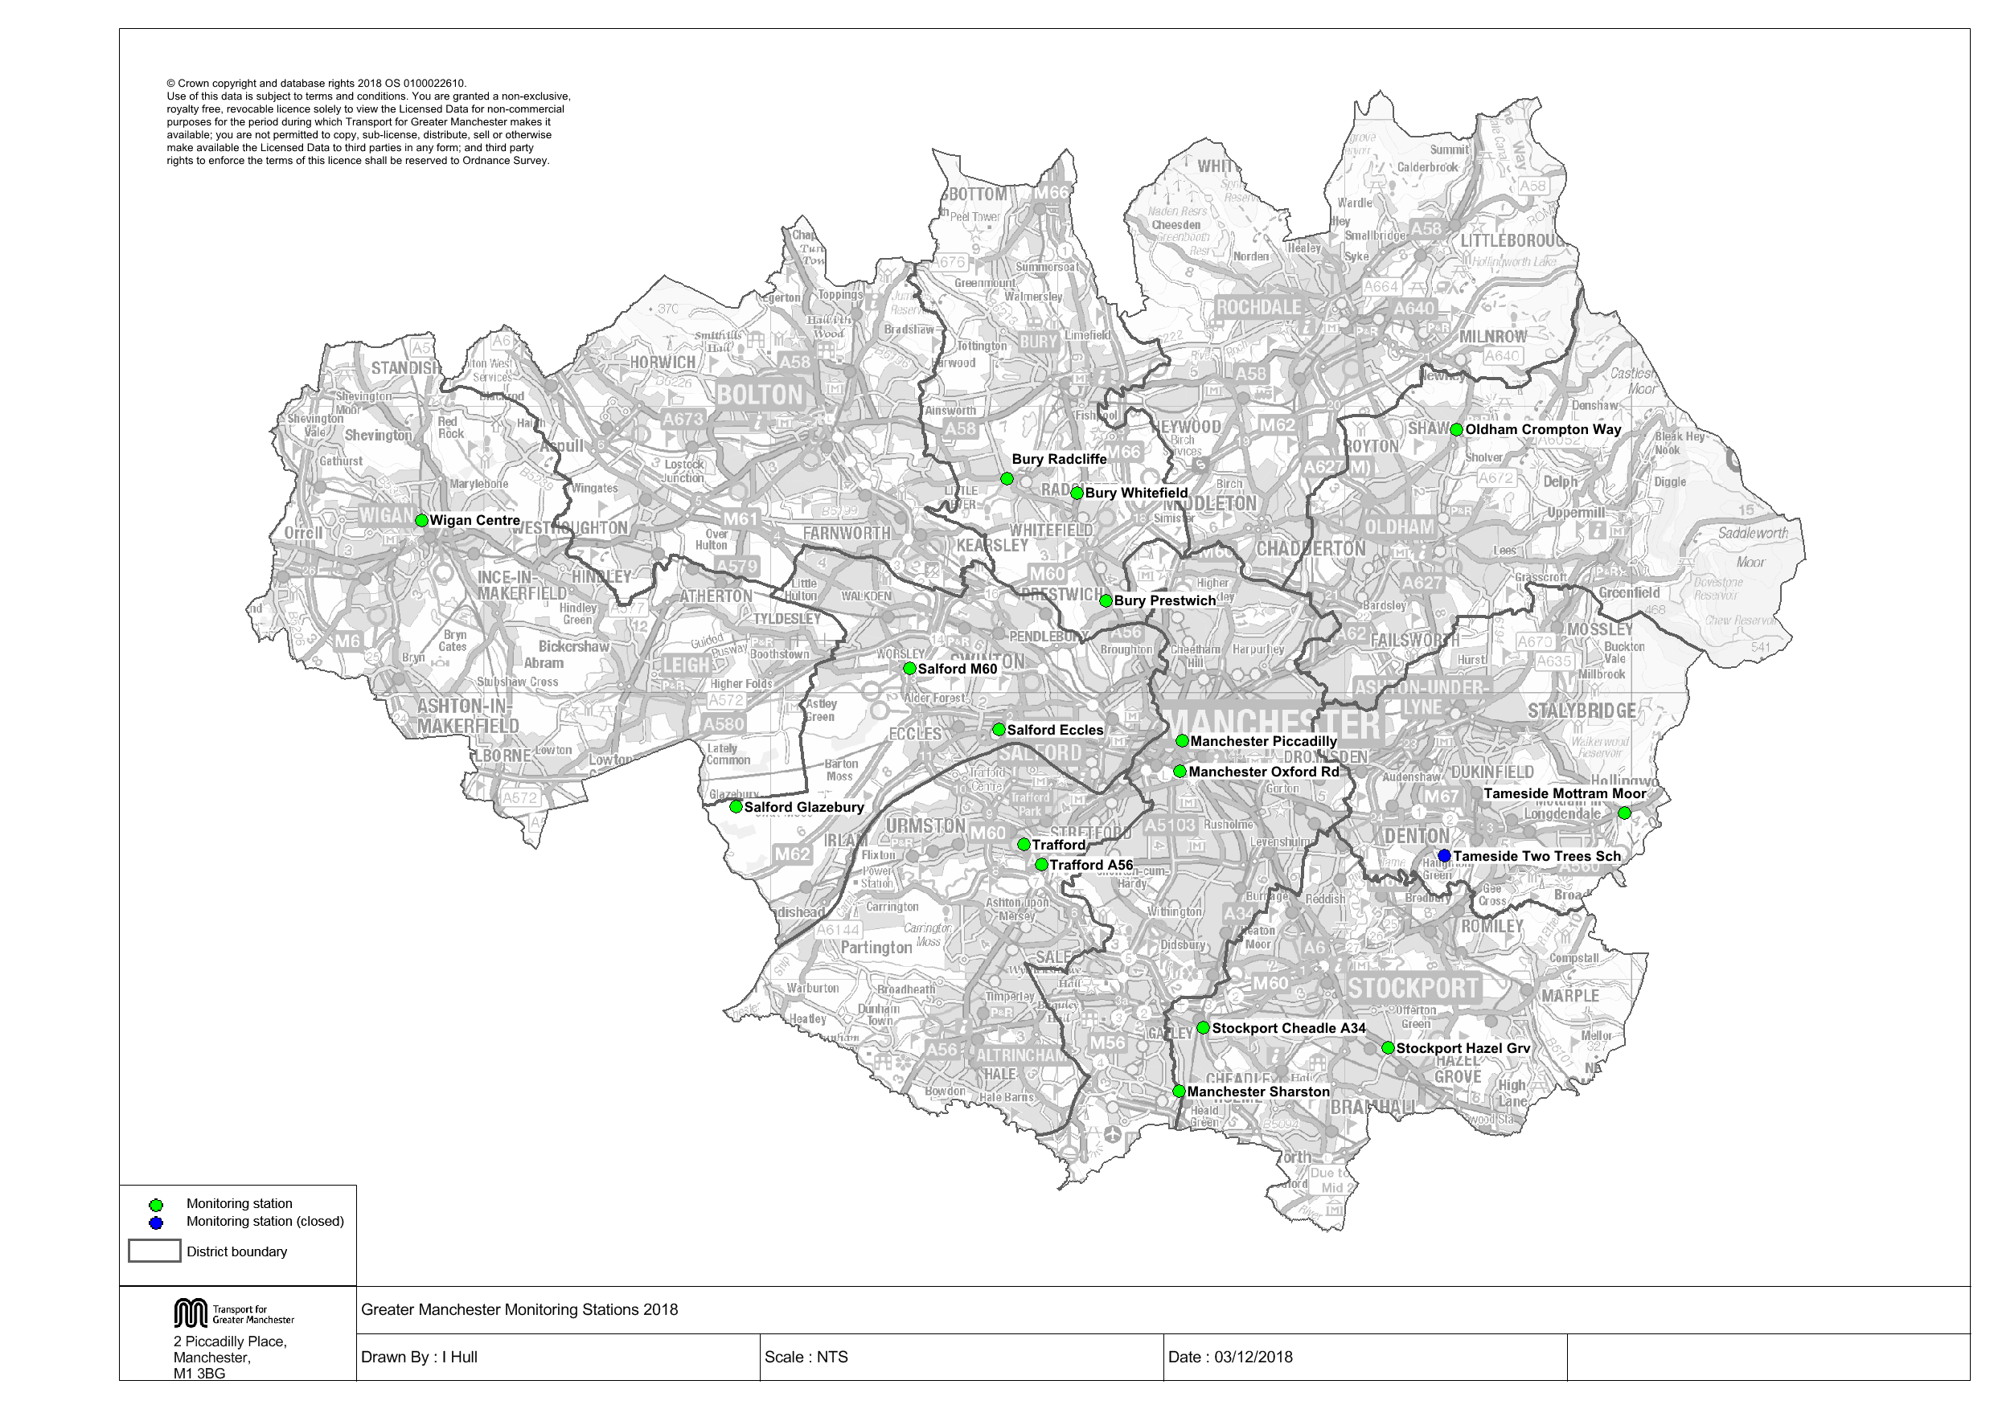

Non-Automatic Monitoring Sites
Greater Manchester undertook non-automatic (passive) monitoring of NO₂ at 272 sites during 2017. Table A.2 in Appendix A shows the details of the sites.
Maps showing the location of the monitoring sites are provided in GM Monitoring Locations. Further details on Quality Assurance/Quality Control (QA/QC) and bias adjustment for the diffusion tubes are included in Appendix C.

Individual Pollutants
The air quality monitoring results presented in this section are, where relevant, adjusted for “annualisation” and bias. Further details on adjustments are provided in Appendix C.

Nitrogen Dioxide (NO₂)

Annual Mean Concentrations

Automatic monitoring site results:
In 2017 the Greater Manchester Air Quality Network (GMAQN) operated 16 automatic NO₂ chemiluminescence monitors. The ratified annual mean NO₂ results from 2013 to 2017 are provided in Table A.3 in Appendix A. Figure 3.1 and Figure 3.2 show the trends.

The following stations were decommissioned during 2011/12:
- Bolton College, Oldham West End, Stockport Shaw Heath in 2011
- Wigan Leigh 2, Bury Roadside in 2012

The following sites were relocated in 2016:
- Manchester South was relocated and named as Manchester Sharston

The following site was added in 2016:
- Stockport Cheadle A34

The Bury roadside site was decommissioned by DEFRA as it did not meet EU site criteria, and was relocated in 2014 to the A56. The Tameside Two Trees site was closed in November 2016. Bury Radcliffe and Prestwich were re-commissioned in 2011. Bury Whitefield and Oldham Crompton way were commissioned in 2015 and 2014 respectively.
Figures 3.1 and 3.2 show the annual mean results of all automatic monitoring sites in GM over the last five years. The general trend is either a stabilisation or decline of NO₂ concentrations, with the exception of the new Manchester Sharston site, which shows a small increase in NO₂ concentrations (the new site is closer to a busy road junction). Manchester Oxford Road continued to record the highest concentration at 65µg/m³ (94.30% data capture), down 1µg/m³ from the 2016 annual mean. Oxford Road is one of the main corridors from south Manchester into the city centre, with two major Universities, student accommodation and a teaching hospital, making it one of the busiest commuter routes in Europe with a high proportion of buses. There have also been a lot of roadworks near the monitoring site to improve the network, which is believed to have caused temorary congestion in the area. Tameside Mottram Moor remains the second highest site with an annual mean of 44µg/m³, down 5µg/m³ from 2016.
In total, during 2017 there were 56 exceedances of NO₂ annual mean (AM) air quality objective (AQO) inside the AQMA. These were recorded in all 10 boroughs. Further to this, there were 22 sites (in BoMBC, BMBC, MCC, SCC, SMBC, TMBC, TBC and WC) that recorded NO₂ AM concentrations within 10% of the AQO. Outside of the AQMA, there were a further 13 exceedances of the NO₂ AM AQO (in OC, SMBC, TMBC and WC), with a maximum concentration of 59.4µg/m³ recorded in TMBC. There were 5 sites outside of the AQMA (in SCC, TMBC, and WC) that recorded NO₂ AM concentrations within 10% of the AQO.

Diffusion tube results:
For diffusion tubes, the full 2017 dataset of monthly mean values is provided in the attached “GM Monitoring Results 2017” spreadsheet file.
Of the 117 DT sites operating inside the AQMA in 2011, 100 of them recorded lower concentrations in 2017. Of the 74 DT sites operating outside of the AQMA across the same period, 60 have shown gradual improvement; however the yearly gains are relatively minor (with the exception of a triplicate site in Bury that has shown significant reductions by 36µg/m³ since 2011). From 2016 to 2017, of the 141 DTs inside the AQMA, 112 recorded lower NO₂ AM concentrations (with an average decrease of 3.3µg/m³, one of the strongest years on record). Over the same period, 29 DTs saw elevated concentration, with an average increase of 1.9µg/m³. Many of these sites have shown good reductions over the last 7 years, however, there are some sites where air quality has deteriorated significantly over the last 7 years. From 2016 to 2017, outside of the AQMA, of the 103 DT sites, 74 showed good improvement, with an average reduction of 2.4µg/m³. 25 sites outside of the AQMA saw NO₂ AM concentrations rise over the last year. Again, many are fairly small increases but some are for sites where concentrations have risen for a number of years. Sites of particular concern include those located in BoMBC, OC, SMBC, and TMBC (there are 8 sites in OC where concentrations rose by 15.8µg/m³ since 2016, 3 sites saw increases between 23.2-29.7 µg/m³.
With regards to NO₂ AM concentrations per region, on top of the information presented above the following observations are made:
- BoMBC has seen good improvement over the last 7 years. Of the 21 DTs operating in 2011, 18 have recorded an average reduction of 4.6µg/m³. Between 2016 and 2017, 21 of 24 sites showed good improvement, with an average reduction of 3.7µg/m³. Two sites (46 and 48) close to or at relevant exposure (one inside and one outside the AQMA), have shown large increases, 8.2 µg/m³ on average. There are still sites with exceedances far above objective limits.
- In BMBC there have been good improvements on all fronts. There was a single exceedance in 2017, however concentrations have shown a downward trend over the last 7 years and are now at their lowest. All 10 DT sites showed improvement.
- In MCC, there have been minor to good improvements at 25 of 26 sites since 2011 and 29 of 38 sites showed lower concentrations in 2017 relative to 2016. Between 2016 and 2017, 8 sites had an average increase of 1.2µg/m³. 23 of 29 sites within the AQMA have improved from 2016 levels. However all DT sites still record concentrations greater than 34µg/m³; the average AM concentration inside this part of the AQMA is 43µg/m³. In 2017 there were 6 DT sites inside the AQMA that are of particular concern; these have shown increases year on year and 4 of them are just below objective limits.
- In OC, the monitoring programme was expanded to include 7 additional DT sites (net) from 2015 to 2017. From 2016 to 2017, only 4 DT sites saw lower concentrations (and these were fairly significant). However there were 10 sites across the same period where levels rose significantly, as discussed above. Inside the AQMA there are only 3 DT sites which report mixed results, one increase (one of the exceedances), one reduction, and one new site (the second exceedance in this area). The area outside of the AQMA has more exceedances (6 in total of 11 sites, 52.6µg/m³ maximum), all of which have seen higher concentrations in 2017, many of which are alarmingly high. Over the past 7 years air NO₂ concentrations have significantly deteriorated.
- In RMBC NO₂ concentrations are generally trending downwards, with all 16 sites recording lower levels in 2017 than in 2011. There were minor increases at 4 sites, all within the AQMA, with only one of these being a site of exceedance.
- In SCC, of the 25 DT sites operating in 2011, lower levels were recorded in 2017 at 21 of these. Of the 32 DT sites in 2017, lower levels were recorded at 28 of these compared to 2016. Two increases were outside the AQMA and two were inside. However, there are still many exceedances close to relevant exposure.
- In SMBC, of the 29 DT sites in 2011, higher concentrations were recorded at 7 sites in 2017. The same is true, and for many of the same sites, between 2016 and 2017. Most are minor increases, however there are two sites outside the AQMA (SK2 and SK14) where concentrations have nearly doubled over the last 7 years, and continue to increase (both are exceeding the NO₂ AM objective).
- In TMBC, reductions were recorded at 23 of the 28 sites operational between 2011-2017. 35 of 44 DT sites in 2017 showed lower levels compared to 2016. 15 of 19 sites inside the AQMA showed improvement in 2017; however there were still 8 exceedances. Outside the AQMA there were 4 exceedances, 2 of these were extremely high, and 3 of 4 fairly close to relevant exposure.
- In TBC, 6 of the 9 DT sites operational in 2011showed higher concentrations in 2017, 3 of which were outside the AQMA. Only 3 of 18 sites showed increases between 2016 and 2017, all within the AQMA. Two new sites added inside the AQMA in 2017 both reported exceedances.
- In WC there have been good improvements since 2011, with all 21 sites recording lower levels in 2017. Between 2016 and 2017, there were 4 sites that showed elevated levels from 2016, 3 were inside the AQMA and all were sites of exceedance.
Diffusion Tubes which continuously show low concentrations are analysed by air quality officers to determine whether increased utility could be achieved through relocation.

Hourly Concentrations
Table A.4 shows the number of automatic monitoring site hourly exceedences above 200μg/m³ with 99.8 percentile in brackets for some years. There were no exceedences of the hourly air quality objective in 2017.
The 99.8 percentile is a useful indicator to compare against the 200μg/m³ for sites with low data capture. If the 99.8 percentile is above 200μg/m³, then the hourly standard is likely to be exceeded. No sites have a 99.8 percentile above 200μg/m³ in 2017 .
The investigation into the elevated number of exceedences at the Oxford Road monitoring site in 2015 and 2016 concluded that this was the result of an increase in buses being stationary on Oxford Road adjacent to the monitoring site. This situation was the result of significant roadworks and road closures in the city centre and Mancunian Way during 2015/16, leading to additional buses being diverted past the monitoring site and queuing back from traffic lights further along Oxford Road towards the city centre. A large proportion of the city centre diversions during 2015/16 were due to the Metrolink works, which have extended the tram network across the city and wider Greater Manchester area. This measure was one of the actions in the GM AQAP predicted to improve air quality in the future.
During early 2017, TfGM implemented a £122m Bus Priority Package, which enables cross-city bus services to run directly through Manchester city centre. Oxford Road has had significant road layout alterations, and general traffic is now prohibited from travelling through new ‘bus gates’ that restrict access between 6am and 9pm, 7 days a-week.
As a result of the road layout changes, traffic flow has improved past the monitoring site and the exceedances of the hourly objective have reduced; there were 4 occurrences in January 2017 (prior to the Bus Priority works), and 6 in total for 2017. Monitoring continues at this location, and it has been determined that the existing AQMA should not be amended to include exceedances of the hourly NO₂ objective.

Figure 3.1 - Trends in Annual Mean NO₂ Concentrations Measured at Automatic Monitoring Sites Bury – Oldham.
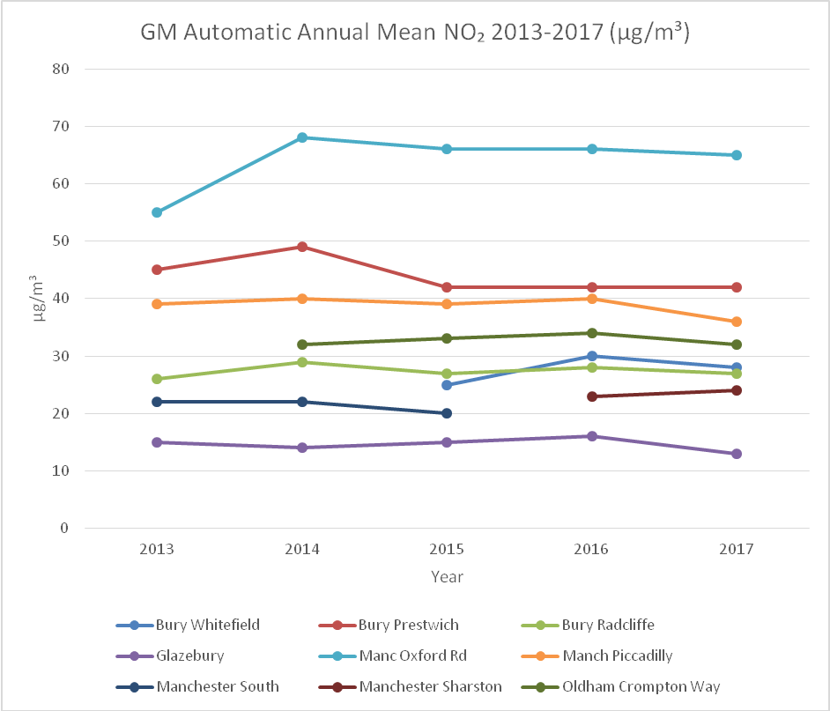

Figure 3.2 -Trends in Annual Mean NO2 Concentrations Measured at Automatic Monitoring Sites Salford - Wigan

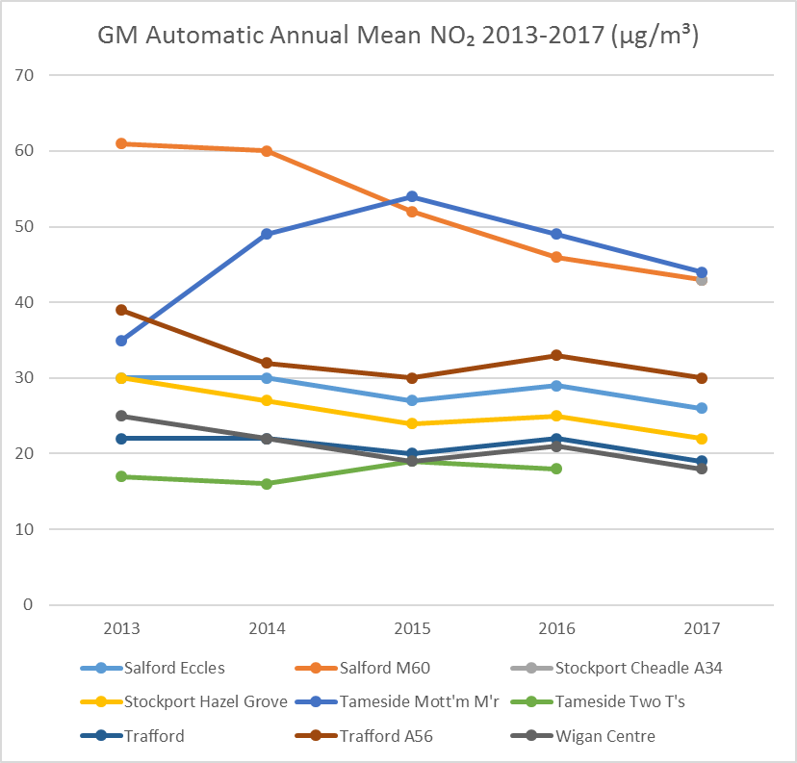

The results of NO2 2017 Diffusion Tubes and annual mean concentration adjusted for bias are reported in the “GM Monitoring Results 2017” spreadsheet file due to the large number of tubes in the data set. Table 3.1 shows that 46 locations exceeded the air quality standard. All districts except Bury recorded a location where the annual mean objective is exceeded.

Figure 3.3 - Trends in Annual Mean NO2 Concentrations Measured at Diffusion Tube Monitoring Sites

Table 3.1 – Number of NO₂ Diffusion Tube Sites over 40 μg/m³

Local Authority | 2017
Bolton | 4
Bury | 0
Manchester | 9
Oldham | 2
Rochdale | 5
Salford | 5
Stockport | 7
Tameside | 8
Trafford | 1
Wigan | 5
Total | 46

Particulate Matter (PM₁₀)

Annual Mean Concentrations
Table A.5 in Appendix A compares the ratified and adjusted monitored PM₁₀ annual mean concentrations for the past 5 years with the air quality objective of 40µg/m³.
This shows that the annual mean PM₁₀ concentration for sites in Greater Manchester is well below the objective level. Figures 3.4 and 3.5 present the results graphically. Reductions in concentrations have stabilised compared with last year’s sharper reductions, and in some cases a small increase is evident. There are no sites that exceed the annual mean air quality objective.
As expected concentrations at Urban Traffic sites remain higher than other sites in the network. The highest annual mean concentration recorded was 27μg/m³ at an Urban Traffic location, compared with 13μg/m³ at the site with the lowest annual mean concentration.

Hourly Concentrations
Table A.6 in Appendix A compares the ratified continuous monitored PM₁₀ daily mean concentrations for the past 5 years with the air quality objective of 50µg/m³, not to be exceeded more than 35 times per year. No site exceeded this objective.

Figure 3.4- Trends in Annual Mean PM₁₀ Concentrations Measured at Automatic Monitoring Sites – Bury - Salford
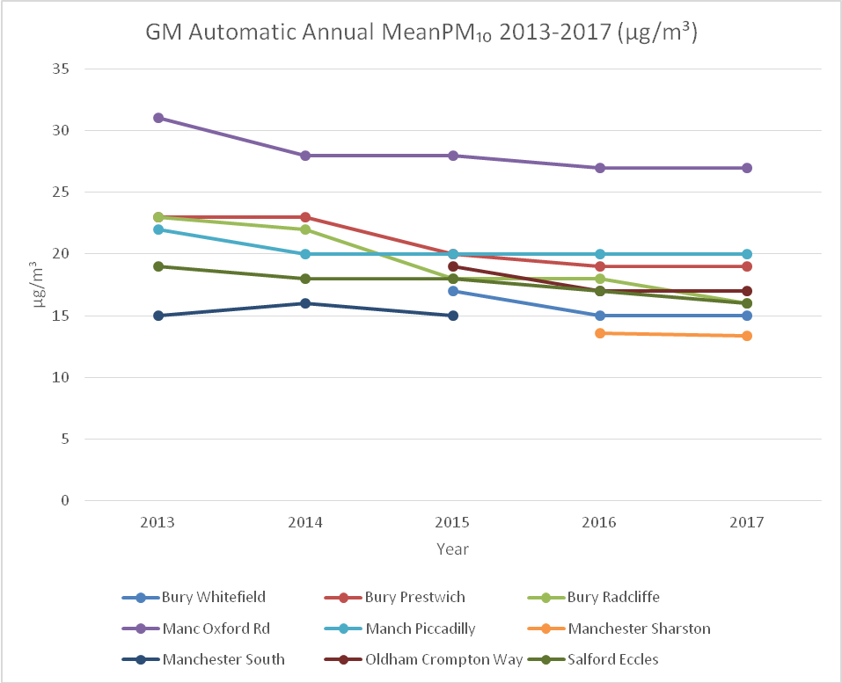

Figure 3.5 - Trends in Annual Mean PM₁₀ Concentrations Measured at Automatic Monitoring Sites – Salford – Wigan

Particulate Matter (PM_{2.5})
Table A.7 in Appendix A presents the ratified and adjusted monitored PM_{2.5} annual mean concentrations for the past 5 years.
PM_{2.5} is monitored at 5 sites in Greater Manchester. All these sites had been seeing a signficant downward trend since 2014, aside from Salford Eccles, which saw a small increase in 2017.(Figure 3.6)

Figure 3.6 - Trends in Annual Mean PM_{2.5} Concentrations Measured at Automatic Monitoring Sites
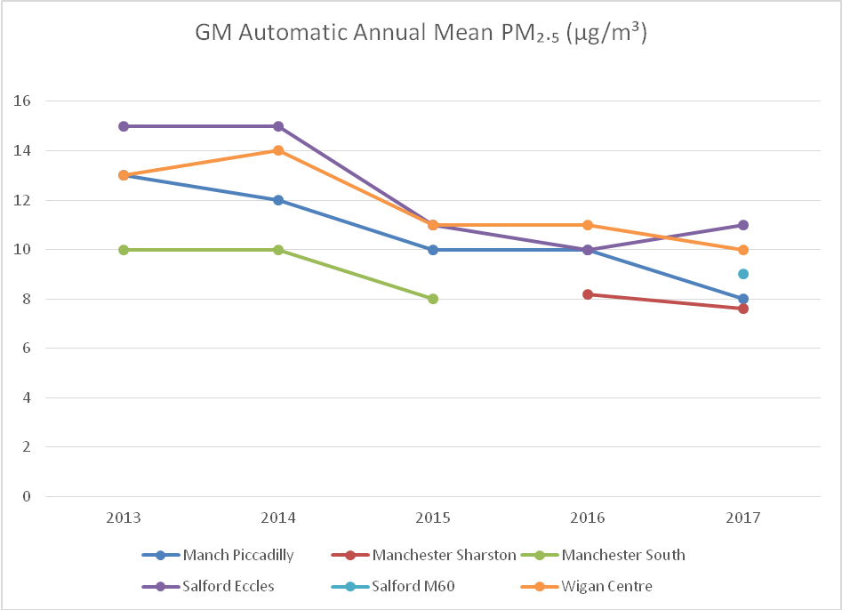

Sulphur Dioxide (SO₂)
Table A.8 in Appendix A compares the ratified continuous monitored SO₂ concentrations for year 2017 with the air quality objectives for SO₂.
SO₂ is monitored at 2 sites in Greater Manchester (Manchester Piccadilly and Manchester Sharston). Neither of these sites exceeded any of the SO₂ objectives.

Appendix A: Monitoring Results

Table A.1 - Details of Automatic Monitoring Sites
Site ID | Site Name | Site Type | X OS Grid Ref | Y OS Grid Ref | Pollutants Monitored | In AQMA? | Monitoring Technique | Distance to Relevant Exposure (m) ⁽¹⁾ | Distance to kerb of nearest road (m) ⁽²⁾ | Inlet Height (m)
BURY | Bury Whitefield | Urban Traffic | 380637 | 406974 | NO₂ PM₁₀ | Y | Chemiluminescent & FDMS | 24 | 7 | 3.5
BUR2 | Bury Prestwich | Urban Traffic | 381650 | 403222 | NO₂ PM₁₀ | Y | Chemiluminescent & TEOM | 15 | 2.5 | 1.5
BUR1 | Bury Radcliffe | Urban Traffic | 378190 | 407480 | NO₂ PM₁₀ | Y | Chemiluminescent & TEOM | 10 | 2.5 | 1.5
GLAZ | Glazebury | Rural Background | 368758 | 396031 | NO₂ O₃ | N | Chemiluminescent & UV absorption | 127 | 1377 | 3
MAN1 | Manchester Oxford Rd | Urban Traffic | 384233 | 397287 | NO₂ PM₁₀ | Y | Chemiluminescent & BAM | 1 | 1 | 2
MAN3 | Manchester Piccadilly | Urban Background | 384310 | 398337 | NO₂ O₃ PM₁₀ PM_{2.5} SO₂ | Y | Chemiluminescent & UV absorption & BAM & FDMS & UV fluorescence | 2 | 30 | 4
MAHG | Manchester Sharston | Suburban Background | 384179 | 386086 | NO₂ O₃ SO₂ PM₁₀ PM_{2.5} | N | Chemiluminescent & UV absorption & UV fluorescence & Partisol | 35 | 6 | 2.7
CW | Oldham Crompton Way | Urban Traffic | 393887 | 409191 | NO₂ PM₁₀ | Y | Chemiluminescent & TEOM | 10 | 1 | 1.5
ECCL | Salford Eccles | Urban Industrial | 377924 | 398728 | NO₂ PM₁₀ PM_{2.5} | Y | Chemiluminescent & FDMS | 7 | 5 | 3.5
M60 | Salford M60 | Urban Traffic | 374807 | 400858 | NO₂ O₃ PM₁₀ PM_{2.5} | Y | Chemiluminescent & UV absorption & BAM | 85 | 20 | 3
STK5 | Stockport Hazel Grv | Urban Traffic | 391481 | 387637 | NO₂ PM₁₀ | Y | Chemiluminescent & TEOM | 33 | 4 | 2
STK7 | Stockport Cheadle A34 | Urban Traffic | 385047 | 388339 | NO₂ PM₁₀ | Y | Chemiluminescent & TEOM | 18 | 2 | 2
TAM1 | Tameside Mottram M’r | Urban Traffic | 399719 | 395804 | NO₂ PM₁₀ | Y | Chemiluminescent & TEOM | 4 | 5 | 4
TRAF | Trafford Moss Park | Urban Background | 378783 | 394726 | NO₂ PM₁₀ SO₂ | N | Chemiluminescent & TEOM | 60 | 98 | 2.5
TRF2 | Trafford A56 | Urban Traffic | 379413 | 394014 | NO₂ PM₁₀ | Y | Chemiluminescent & TEOM | 40 | 2 | 2.5
WIG5 | Wigan Centre | Urban Background | 357816 | 406024 | NO₂ O₃ PM₁₀, PM_{2.5} | N | Chemiluminescent & UV absorption & TEOM & FDMS | 0 | 175 | 2.5

- 0m if the monitoring site is at a location of exposure (e.g. installed on the façade of a residential property).
- N/A if not applicable.

Table A.2 - Details of Non-Automatic Monitoring Sites
The full list of the 272 non-automatic monitoring sites is detailed in the attached “GM Monitoring Results 2017” file.

Table A.3 - Automatic Monitoring Sites Annual Mean NO₂ Monitoring Results
Site ID | Local Authority | Site Type | Monitoring Type | Valid Data Capture for Monitoring Period (%) ⁽¹⁾ | Valid Data Capture 2017 (%) ⁽²⁾ | NO₂ Annual Mean Concentration (µg/m³) ⁽³⁾
 |  |  |  |  |  | 2013 | 2014 | 2015 | 2016 | 2017
Bury Whitefield | Bury | Urban Traffic | Automatic | N/A | 99.29% | - | - | 25 | 30 | 28
Bury Prestwich | Bury | Urban Traffic | Automatic | N/A | 78.39% | 45 | 49 | 42 | 42 | 42
Bury Radcliffe | Bury | Urban Traffic | Automatic | N/A | 97.35% | 26 | 29 | 27 | 28 | 27
Glazebury | Salford | Rural Background | Automatic | N/A | 88.93% | 15 | 14 | 15 | 16 | 13
Manchester Oxford Rd | Manchester | Urban Traffic | Automatic | N/A | 94.30% | 55 | 68 | 66 | 66 | 65
Manchester Piccadilly | Manchester | Urban Background | Automatic | N/A | 96.05% | 39 | 40 | 39 | 40 | 36
Manchester South | Manchester | Suburban Background | Automatic | N/A | N/A | 22 | 22 | 20 | N/A | N/A
Manchester Sharston | Manchester | Suburban Background | Automatic | N/A | 98.70% | - | - | - | 23 | 24
Oldham Crompton Way | Oldham | Urban Traffic | Automatic | N/A | 98.90% | - | 32 | 33 | 34 | 32
Salford Eccles | Salford | Urban Industrial | Automatic | N/A | 96.11% | 30 | 30 | 27 | 29 | 26
Salford M60 | Salford | Urban Traffic | Automatic | N/A | 99.16% | 62 | 60 | 52 | 46 | 43
Stockport Hazel Grove | Stockport | Urban Traffic | Automatic | N/A | 98.87% | 30 | 27 | 24 | 25 | 22
Stockport Cheadle A34 | Stockport | Urban Traffic | Automatic | N/A | 76.61% | - | - | - | - | 43
Tameside Mott’m M’r | Tameside | Urban Traffic | Automatic | N/A | 95.94% | 35 | 49 | 54 | 49 | 44
Tameside Two T’s | Tameside | Urban Background | Automatic | N/A | N/A | 17 | 16 | 19 | 18 | N/A
Trafford Moss Park | Trafford | Urban Background | Automatic | N/A | 86.48% | 22 | 22 | 20 | 22 | 19
Trafford A56 | Trafford | Urban Traffic | Automatic | N/A | 94.24% | 39 | 32 | 30 | 33 | 30
Wigan Centre | Wigan | Urban Background | Automatic | N/A | 99.19% | 25 | 22 | 19 | 21 | 18

Notes: The full list of the 236 non-automatic monitoring sites in detailed in the attached “GM Tube Results” file.
Exceedances of the NO₂ annual mean objective of 40µg/m³ are shown in bold.
NO₂ annual means exceeding 60µg/m³, indicating a potential exceedance of the NO₂ 1-hour mean objective are shown in bold and underlined.
(1) Data capture for the monitoring period, in cases where monitoring was only carried out for part of the year.
(2) Data capture for the full calendar year (e.g. if monitoring was carried out for 6 months, the maximum data capture for the full calendar year is 50%).
(3) Means for diffusion tubes have been corrected for bias. All means have been “annualised” as per Technical Guidance LAQM.TG16 if valid data capture for the full calendar year is less than 75%. See Appendix C for details.

Table A.4 – Automatic Monitoring Sites 1-Hour Mean NO₂ Monitoring Results
Site ID | Local Authority | Site Type | Monitoring Type | Valid Data Capture for Monitoring Period (%) ⁽¹⁾ | Valid Data Capture 2017 (%) ⁽²⁾ | NO₂ 1-Hour Means > 200µg/m³ ⁽³⁾
 |  |  |  |  |  | 2013 | 2014 | 2015 | 2016 | 2017
Bury Whitefield | Bury | Urban Traffic | Automatic | N/A | 99.29% | - | - | 0 | 0 | 0
Bury Prestwich | Bury | Urban Traffic | Automatic | N/A | 78.39% | 0(126) | 0 | 0 | 0 | 0
Bury Radcliffe | Bury | Urban Traffic | Automatic | N/A | 97.35% | 0(114) | 0 | 0 | 0 | 5
Glazebury | Salford | Rural Background | Automatic | N/A | 88.93% | 0 | 0 | 0 | 0 | 0
Manchester Oxford Rd | Manchester | Urban Traffic | Automatic | N/A | 94.30% | 0(138) | 14 | 60 | 90 | 6
Manchester Piccadilly | Manchester | Urban Background | Automatic | N/A | 96.05% | 0(97) | 2 | 1 | 0 | 1
Manchester South | Manchester | Suburban Background | Automatic | N/A | N/A | 0(95) | 0 | 0 | - | -
Manchester Sharston | Manchester | Suburban | Automatic | N/A | 98.70% | - | - | - | 0 | 0
Oldham Crompton Way | Oldham | Urban Traffic | Automatic | N/A | 98.90% | - | 0(301) | 0(109) | 0 | 0
Salford Eccles | Salford | Urban Industrial | Automatic | N/A | 96.11% | 0(123) | 0 | 0 | 0 | 0
Salford M60 | Salford | Urban Traffic | Automatic | N/A | 99.16% | 4(187) | 0 | 3 | 0 | 0
Stockport Hazel Grove | Stockport | Urban Traffic | Automatic | N/A | 98.87% | 0(109) | 0 | 0 | 0 | 0
Tameside Mott’m M’r | Tameside | Urban Traffic | Automatic | N/A | 95.94% | 0(141) | 13(199) | 8(189) | 0 | 0
Tameside Two T’s | Tameside | Urban Background | Automatic | N/A | N/A | 0(80) | 0 | 0 | 0 | -
Trafford Moss Park | Trafford | Urban Background | Automatic | N/A | 86.48% | 0(86) | 0 | 0 | 0 | 0
Trafford A56 | Trafford | Urban Traffic | Automatic | N/A | 94.24% | 7 | 0 | 0(107) | 0 | 0
Wigan Centre | Wigan | Urban Background | Automatic | N/A | 99.19% | 0(86) | 0 | 0 | 0 | 0

Notes: Exceedances of the NO₂ 1-hour mean objective (200µg/m³ not to be exceeded more than 18 times/year) are shown in bold.
(1) Data capture for the monitoring period, in cases where monitoring was only carried out for part of the year.
(2) Data capture for the full calendar year (e.g. if monitoring was carried out for 6 months, the maximum data capture for the full calendar year is 50%).
(3) If the period of valid data is less than 90%, the 99.8th percentile of 1-hour means is provided in brackets.

Table A.5 - Annual Mean PM₁₀ Monitoring Results
Site ID | Local Authority | Site Type | Monitoring Type | Valid Data Capture for Monitoring Period (%) ⁽¹⁾ | Valid Data Capture 2017 (%) ⁽²⁾ | PM₁₀ Annual Mean Concentration (µg/m³) ⁽³⁾
 |  |  |  |  |  | 2013 | 2014 | 2015 | 2016 | 2017
Bury Whitefield | Bury | Urban Traffic | Automatic | N/A | 90.61% | - | - | 17 | 15 | 15
Bury Prestwich | Bury | Urban Traffic | Automatic | N/A | 76.60% | 23 | 23 | 20 | 19 | 19
Bury Radcliffe | Bury | Urban Traffic | Automatic | N/A | 89.28% | 23 | 22 | 18 | 18 | 16
Manchester Oxford Rd | Manchester | Urban Traffic | Automatic | N/A | 86.68% | 31 | 28 | 28 | 27 | 27
Manchester Piccadilly | Manchester | Urban Background | Automatic | N/A | 95.92% | 22 | 20 | 20 | 20 | 20
Manchester South | Manchester | Suburban Background | Automatic | N/A | N/A | 15 | 16 | 15 | - | -
Manchester Sharston | Manchester | Suburban Background | Automatic | N/A | 99.50% | - | - | - | 13.6 | 13.4
Oldham Crompton Way | Oldham | Urban Traffic | Automatic | N/A | 94.99% | - | - | 19 | 17 | 17
Salford Eccles | Salford | Urban Industrial | Automatic | N/A | 95.75% | 19 | 18 | 18 | 17 | 16
Salford M60 | Salford | Urban Traffic | Automatic | N/A | 86.07% | 26 | 21 | 20 | 20 | 20
Stockport Hazel Grove | Stockport | Urban Traffic | Automatic | N/A | 98.85% | 23 | 22 | 18 | 19 | 16
Stockport Cheadle A34 | Stockport | Urban Traffic | Automatic | N/A | 99.51% | - | - | - | - | 18
Tameside Mott’m M’r | Tameside | Urban Traffic | Automatic | N/A | 92.45% | 23 | 23 | 18 | 18 | 17
Tameside Two T’s | Tameside | Urban Background | Automatic | N/A | N/A | 18 | 17 | 14 | 13 | -
Trafford Moss Park | Trafford | Urban Background | Automatic | N/A | 96.75% | 15 | 17 | 15 | 15 | 13
Trafford A56 | Trafford | Urban Traffic | Automatic | N/A | 99.52% | 20 | 20 | 18 | 17 | 15
Wigan Centre | Wigan | Urban Background | Automatic | N/A | 96.79% | 19 | 18 | 18 | 16 | 15

Notes: Exceedances of the PM₁₀ annual mean objective of 40µg/m³ are shown in bold.
(1) Data capture for the monitoring period, in cases where monitoring was only carried out for part of the year.
(2) Data capture for the full calendar year (e.g. if monitoring was carried out for 6 months, the maximum data capture for the full calendar year is 50%).
(3) All means have been “annualised” as per Technical Guidance LAQM.TG16, if valid data capture for the full calendar year is less than 75%. See Appendix C for details.

Table A.6 - 24-Hour Mean PM₁₀ Monitoring Results
Site ID | Local Authority | Site Type | Monitoring Type | Valid Data Capture for Monitoring Period (%) ⁽¹⁾ | Valid Data Capture 2017(%) ⁽²⁾ | PM₁₀ 24-Hour Means > 50µg/m³ ⁽³⁾
 |  |  |  |  |  | 2013 | 2014 | 2015 | 2016 | 2017
Bury Whitefield | Bury | Urban Traffic | Automatic | N/A | 90.61% | - | - | 6 | 1 | 1
Bury Prestwich | Bury | Urban Traffic | Automatic | N/A | 76.60% | 8 | 4 | 6 | 1 | 4(29)
Bury Radcliffe | Bury | Urban Traffic | Automatic | N/A | 89.28% | 9 | 4 | 5 | 2 | 1
Manchester Oxford Rd | Manchester | Urban Traffic | Automatic | N/A | 86.68% | 21 | 18 | 25 | 16 | 15
Manchester Piccadilly | Manchester | Urban Background | Automatic | N/A | 95.92% | 7 | 5 | 3 | 3 | 3
Manchester South | Manchester | Suburban Background | Automatic | N/A | N/A | 6 | 8 | 4 | - | -
Manchester Sharston | Manchester | Suburban Background | Automatic | N/A | 99.50% | - | - | - | 0 | 0
Oldham Crompton Way | Oldham | Urban Traffic | Automatic | N/A | 94.99% | - | 5(28) | 11 | 1 | 2
Salford Eccles | Salford | Urban Industrial | Automatic | N/A | 95.75% | 6 | 6 | 5 | 2 | 5
Salford M60 | Salford | Urban Traffic | Automatic | N/A | 86.07% | 19 | 3(34) | 5 | 5(34) | 8
Stockport Hazel Grove | Stockport | Urban Traffic | Automatic | N/A | 98.85% | 12 | 11 | 6 | 5 | 1
Stockport Cheadle A34 | Stockport | Urban Traffic | Automatic | N/A | 99.51% | - | - | - | - | 0
Tameside Mott’m M’r | Tameside | Urban Traffic | Automatic | N/A | 92.45% | 0 | 3 | 3 | 0 | 2
Tameside Two T’s | Tameside | Urban Background | Automatic | N/A | N/A | 3 | 0 | 1 | 0 | -
Trafford Moss Park | Trafford | Urban Background | Automatic | N/A | 96.75% | 0 | 1 | 2 | 0 | 0
Trafford A56 | Trafford | Urban Traffic | Automatic | N/A | 99.52% | 1 | 3 | 5 | 0 | 0
Wigan Centre | Wigan | Urban Background | Automatic | N/A | 96.79% | 1 | 1(26) | 1 | 0 | 3

Notes: Exceedances of the PM₁₀ 24-hour mean objective (50µg/m³ not to be exceeded more than 35 times/year) are shown in bold.
(1) Data capture for the monitoring period, in cases where monitoring was only carried out for part of the year.
(2) Data capture for the full calendar year (e.g. if monitoring was carried out for 6 months, the maximum data capture for the full calendar year is 50%).
(3) If the period of valid data is less than 90%, the 90.4th percentile of 24-hour means is provided in brackets.

Table A.7 - PM_{2.5} Monitoring Results

Site ID | Site Type | Monitoring Type | Valid Data Capture for Monitoring Period (%) ⁽¹⁾ | Valid Data Capture 2017 (%) ⁽²⁾ | PM_{2.5} Annual Mean Concentration (µg/m³) ⁽³⁾
 |  |  |  |  | 2013 | 2014 | 2015 | 2016 | 2017
Manchester Piccadilly | Urban Background | Automatic | N/A | 94.09% | 13 | 12 | 10 | 10 | 8
Manchester South | Suburban Background | Automatic | N/A | N/A | 10 | 10 | 8 | N/A | N/A
Manchester Sharston | Suburban Background | Automatic | N/A | 88.50% | - | - | - | 8.2 | 7.6
Salford Eccles | Urban Industrial | Automatic | N/A | 95.16% | 15 | 15 | 11 | 10 | 11
Salford M60 | Roadside | Automatic | N/A | 78.25% | - | - | - | - | 9
Wigan Centre | Urban Background | Automatic | N/A | 90.38% | 13 | 14 | 11 | 11 | 10

(1) Data capture for the monitoring period, in cases where monitoring was only carried out for part of the year.
(2) Data capture for the full calendar year (e.g. if monitoring was carried out for 6 months, the maximum data capture for the full calendar year is 50%).
(3) All means have been “annualised” as per Technical Guidance LAQM.TG16, valid data capture for the full calendar year is less than 75%. See Appendix C for details.

Table A 8 - SO₂ Monitoring Results
Site ID | Site Type | Monitoring Type | Valid Data Capture for Monitoring Period (%) ⁽¹⁾ | Valid Data Capture 2017 (%) ⁽²⁾ | Number of Exceedances  (percentile in bracket) ⁽³⁾
 |  |  |  |  | 15-minute Objective (266 µg/m³) | 1-hour Objective (350 µg/m³) | 24-hour Objective (125 µg/m³)
Manchester Sharston | Suburban Background | Automatic | N/A | 99.14% | 0 | 0 | 0
Manchester Piccadilly | Urban Background | Automatic | N/A | 98.98% | 0 | 0 | 0

Notes: Exceedances of the SO₂ objectives are shown in bold (15-min mean = 35 allowed a year, 1-hour mean = 24 allowed a year, 24-hour mean = 3 allowed a year)
(1) Data capture for the monitoring period, in cases where monitoring was only carried out for part of the year.
(2) Data capture for the full calendar year (e.g. if monitoring was carried out for 6 months, the maximum data capture for the full calendar year is 50%)
(3) If the period of valid data is less than 90%, the relevant percentiles are provided in brackets.

Appendix B: Full Monthly Diffusion Tube Results for 2017

Table B.1 - NO₂ Monthly Diffusion Tube Results – 2017

The full list of the 272 non-automatic monitoring sites is detailed in the attached “GM Monitoring Results 2017” file, due to the large number of tubes in the data set.

(1) See Appendix C for details on bias adjustment

Appendix C: Supporting Technical Information / Air Quality Monitoring Data QA/QC
Diffusion Tube Annualisation
Annualisation is applied where monitoring has been completed for less than 75% of the year, and are used to estimate an annual average from a part year average. The example in Figure C1 below shows calculations used to annualise 11 DTs, as recommended by DEFRAs TG16 guidance.

Figure C1. Annualisation Calculations
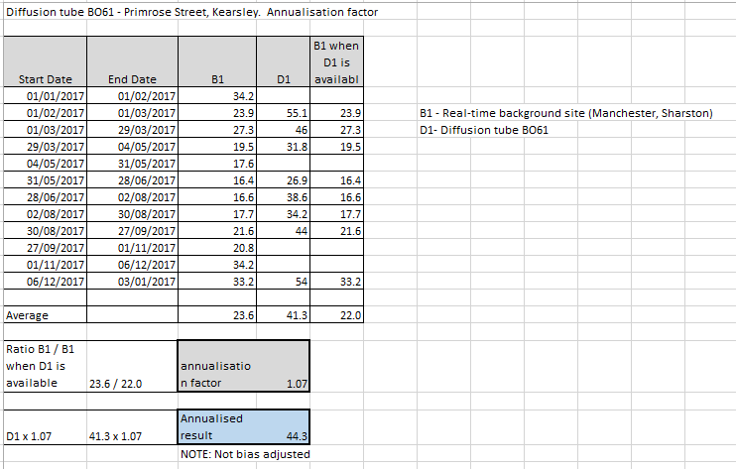
Diffusion Tube Bias Adjustment Factors
The tubes are prepared and analysed by Staffordshire Scientific Services using the 20% triethanolamine (TEA) in water method. The laboratory method is UKAS accredited. Results from the quality control schemes published on the LAQM website give the laboratory a good precision rating for 2017.
NO₂ diffusion tubes are affected by several factors, which may cause them to have bias (over-read), or negative bias (under-read) relative to the reference technique. To compare with the AQS objectives it’s important that tubes are corrected (adjusted) by comparing with a chemiluminescent analyser reference method for NO₂.
A bias factor is calculated using a spread sheet provided by the National Physical Laboratory. Bias factors are collated in a national database enabling a large number of factors at a range of different site locations using the same laboratory and analysis method. There is a choice of using a locally derived bias factor based on local data or using the national dataset.
The bias adjustment factor used for 2017 is 0.88. This is the average bias adjustment factor for all colocation studies for Staffordshire Scientific Services, from the Defra National Bias Adjustment Factors Spreadsheet, July 2018 (version 06/18), available from the DEFRA website:
https://laqm.defra.gov.uk/bias-adjustment-factors/national-bias.html

Figure C2. Bias Adjustment Calculation
As can be seen in Figure C2, the bias adjustment is applied to the annual average NO₂ concentration.
Distance Correction
Distance Correction is also required to represent the relevant exposure as it is not always possible to measure concentrations at precisely the desired location. For this, the DEFRA’s NO₂ Fall-off with distance calculator (v4.2) has been applied to the bias adjusted concentrations. The methodology consists of comparing the monitored annual mean NO₂ concentrations at a given point against known relationships between NO₂ concentrations and the distance from a road source. Results should be treated with caution as a number of limitations of this methodology are acknowledged and can be downloaded from the DEFRA website: https://laqm.defra.gov.uk/tools-monitoring-data/no2-falloff.html
Figure C3 shows an example of the calculator being used to determine distance correction values. This calculation was only applied to DTs with concentrations within 10% of the NO₂ AM objective.

Figure C3. Examples of Distance Correction Calculations

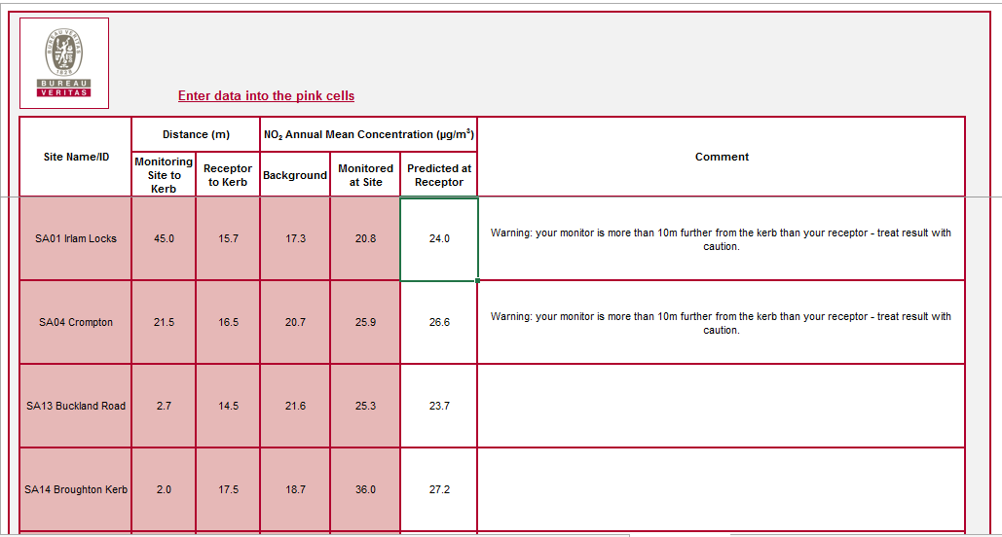
Automatic Analysers
Automatic air quality analysers in Greater Manchester area are subject to a high level of quality assurance/ quality control. All analysers are either operated as part of the national Automatic Urban and Rural Network (AURN) or are part of the 'Calibration Club' scheme run by Ricardo-AEA.
The procedures are equivalent to the UK Automatic Urban and Rural Network (AURN) the main features of the services being:-
Calibration Club
• Data screened daily for errors and final data ratified and published to same standard as AURN sites.
• Data checked daily for errors and faults reported to Local Site operators.
• Independent audits twice per year.
• Final data set scaled and ratified to same standard as AURN.

Greater Manchester Air Quality Network (GMAQN)
Ricardo-AEA manages QA/QC and audit of the air quality stations to the same standard as the AURN. The GMAQN officially started on 1 September 2013. Table A1 lists the Greater Manchester sites that are currently operational.

Particulate Monitoring
A number of different instruments are used in Greater Manchester for the measurement of particles. Historically TEOM have been used, but DEFRA replaced a number of instruments with TEOM FDMS and some sites use the BAM or Partisol.
The reference method for the UK PM₁₀ Objectives (and EU limit values) is based upon measurements from a gravimetric sampler. This samples over a 24 hour period and the particulate proportion less than 10 microns (PM₁₀) is measured by the mass difference before and after exposure. It is labour intensive and the UK, and European Counties have invested heavily in the TEOM (Tapered Element Oscillating Microbalance). The TEOM measurements have been historically adjusted by a factor of 1.3 to make them gravimetric equivalent. However to further improve the technique; the measurement was modified by lowering the sampling temperature from 50 C to 30 C and adding a dryer to remove water vapour. This system is referred to a Filter Dynamics Measurement System (FDMS) and is equivalent to the EU reference method.
Due to widespread use of the TEOM, and its reliability and the need to report to the EU using an ‘equivalent method’, The Volatile Correction Model (VCM) was developed by Kings College London, to adjust the TEOM data. Studies have shown that FDMS sites within 200 kilometres can be used to correct the TEOM data as it assumes that the sample lost by the heating is the same over this geographical area. Sufficient FDMS sites have only been available since 2008/9 for the correction to be applied. VCM corrections have been applied to TEOM analyser results automatically since 2014 and historic records within the ASR have been altered to reflect VCM corrected results.

Appendix D: Map(s) of Monitoring Locations

All monitoring locations are detailed at:

http://www.airqualityengland.co.uk/local-authority/?la_id=219

https://www.google.com/maps/d/viewer?mid=16qq4gYdQtrL3Ct8h6Xp-5lyZUpM&hl=en&ll=53.49920953066335%2C-2.3458778164999785&z=10
GM Monitoring Locations.

Appendix E: Summary of Air Quality Objectives in England

Table E.1 - Air Quality Objectives in England
Pollutant | Air Quality Objective
 | Concentration | Measured as
Nitrogen Dioxide (NO₂) | 200 µg/m³ not to be exceeded more than 18 times a year | 1-hour mean
 | 40 µg/m³ | Annual mean
Particulate Matter (PM₁₀) | 50 µg/m³, not to be exceeded more than 35 times a year | 24-hour mean
 | 40 µg/m³ | Annual mean
Sulphur Dioxide (SO₂) | 350 µg/m³, not to be exceeded more than 24 times a year | 1-hour mean
 | 125 µg/m³, not to be exceeded more than 3 times a year | 24-hour mean
 | 266 µg/m³, not to be exceeded more than 35 times a year | 15-minute mean
Carbon Monoxide (CO) | 10 mg/m³ | Maximum daily running 8 hour mean
Lead (Pb) | 0.25 µg/m³ | Annual mean
Benzene | 5 µg/m³ | Annual mean
1,3 - butadiene | 2.25 µg/m³ | Running annual mean

National air quality policy guidance states that concentrations of carbon monoxide, lead, benzene and 1,3-butadiene have been well below objective levels for several years and national monitoring is currently providing a sufficient basis for the review and assessment of these pollutants.

Local Authorities are also expected to work towards reducing emissions and concentrations of very fine particles (PM_{2.5}) in their local area as practicable.

Glossary of Terms

Abbreviation | Description
AQAP | Air Quality Action Plan - A detailed description of measures, outcomes, achievement dates and implementation methods, showing how the local authority intends to achieve air quality limit values’
AQMA | Air Quality Management Area – An area where air pollutant concentrations exceed / are likely to exceed the relevant air quality objectives. AQMAs are declared for specific pollutants and objectives
ASR | Air quality Annual Status Report
Defra | Department for Environment, Food and Rural Affairs
DMRB | Design Manual for Roads and Bridges – Air quality screening tool produced by Highways England
EU | European Union
FDMS | Filter Dynamics Measurement System
LAQM | Local Air Quality Management
NO₂ | Nitrogen Dioxide
NO_{x} | Nitrogen Oxides
PM₁₀ | Airborne particulate matter with an aerodynamic diameter of 10µm (micrometres or microns) or less
PM_{2.5} | Airborne particulate matter with an aerodynamic diameter of 2.5µm or less
QA/QC | Quality Assurance and Quality Control
SO₂ | Sulphur Dioxide
GM | Greater Manchester
GMCA | Greater Manchester Combined Authority

References
Abbot, J. 2008. Technical Guidance: Screening assessment for biomass boilers [online], AEA Energy & Environment. Avalable Internet:
http://uk-air.defra.gov.uk/reports/cat18/0806261519_methods.pdf

Association of Greater Manchester Authorities
http://www.agma.gov.uk/

Association of Greater Manchester Authorities (AGMA). 1997. Greater Manchester Air Quality Management Strategy - 'Clearing the Air', AGMA.

Association of Greater Manchester Authorities (AGMA). 2004. The Greater Manchester Air Quality Action Plan (online), AGMA. Avalable Internet:
http://www.manchester.gov.uk/download/downloads/id/14851/greater_manchester_air_quality_action_plan_-_2004

Department for Environment, Food and Rural Affairs (Defra). 2016. Technical Guidance LAQM.TG (16), Defra publications.
http://laqm.defra.gov.uk/technical-guidance/

Department for Environment, Food and Rural Affairs (Defra). 2010. FAQ - How can I identify areas in my district where burning of solid fuels such as coal, smokeless fuel or wood (i.e. biomass) might be leading to exceedances of the 2004 daily mean PM₁₀ air quality objective (and the 2010 annual mean objective in Scotland)? [Online], DEFRA. Available Internet: http://laqm.defra.gov.uk/laqm-faqs/faq36.html

Department for Environment, Food and Rural Affairs (Defra). 2011. QA QC Framework (online), Defra. Available Internet:
http://laqm.defra.gov.uk/diffusion-tubes/qa-qc-framework.html

Department for Environment, Food and Rural Affairs (Defra). 2012. National bias adjustment factors (online), Defra. Available Internet:
http://laqm.defra.gov.uk/bias-adjustment-factors/national-bias.html

Department for Environment, Food and Rural Affairs (Defra). 2012. Defra National Statistics Release: Air quality statistics in the UK, 1987 to 2011 – Final (online), Defra. Available Internet: http://www.defra.gov.uk/statistics/files/Air-Qual-Statistics-final-release-2011.pdf

Emissions Inventory for Greater Manchester (EMIGMA) Reports page hosted by Transport for Greater Manchester (TfGM) formerly Greater Manchester Transportation Unit
http://www.gmtu.gov.uk/reports/emigma.htm

2007 Update published Feb 12
http://www.gmtu.gov.uk/reports/emigma/HFASReport1679v1.0.pdf

2008 Update published March 2013
http://www.gmtu.gov.uk/reports/emigma/HFASReport1692v1.0.pdf
2010 Update published May 2014
http://www.gmtu.gov.uk/reports/emigma/HFASReport1750v1.0.pdf

Greater Manchester Air Quality Action Plan (2004)
http://www.manchester.gov.uk/download/downloads/id/14851/greater_manchester_air_quality_action_plan_-_2004

Greater Manchester Combined Authority and Transport for Greater Manchester. 2011. Greater Manchester’s third Local Transport Plan 2011/12 – 2015/16 (online), Transport for Greater Manchester. Available Internet:
http://www.tfgm.com/ltp3/

Local Transport Plan (LTP)
http://www.tfgm.com/ltp3/Pages/Local-Transport-Plan.aspx

Local_ transport_Plan_Core_Strategy.pdf
http://www.tfgm.com/ltp3/documents/Greater_Manchester_Local_ Local transport_Plan_Core_Strategy.pdf

Local Transport Plan (Ltp3) Air Quality Strategy http://www.tfgm.com/journey_planning/LTP3/Documents/Air-Quality-Strategy-and-Action-Plan.pdf

Manchester Strategy 2013-2020 Stronger Together
http://www.agma.gov.uk/gmca/gms_2013/index.html

Low Carbon Benefits to the Economy
http://europeanclimate.org/wp-content/uploads/2014/06/EY_ECF_Macro-economic-impacts-of-the-low-carbon-transition_Report_2014-06-05.pdf

http://laqm.defra.gov.uk/laqm-faqs/faq36.html
http://laqm.defra.gov.uk/diffusion-tubes/qa-qc-framework.html
http://laqm.defra.gov.uk/bias-adjustment-factors/national-bias.html
The Air Quality Strategy for England, Scotland, Wales and Northern Ireland, Defra.

The Air Quality (England) (Amendment) Regulations, 2002, Statutory Instrument 3043 (2002), HMSO. Defra (2007)

The Air Quality Regulations, 2000, Statutory Instrument 928 (2000), HMSO, London

Royal College of Physicians ‘Every Breathe We Take’
Sites with three Tubes are listed as one site, i.e. TA45-46-47 & MAN82-83-84. Those with two are listed as one. i.e. SA21-22, MA88A-88B, TR26-26A.
The units are in micrograms of pollutant per cubic metre of air (µg/m³).

