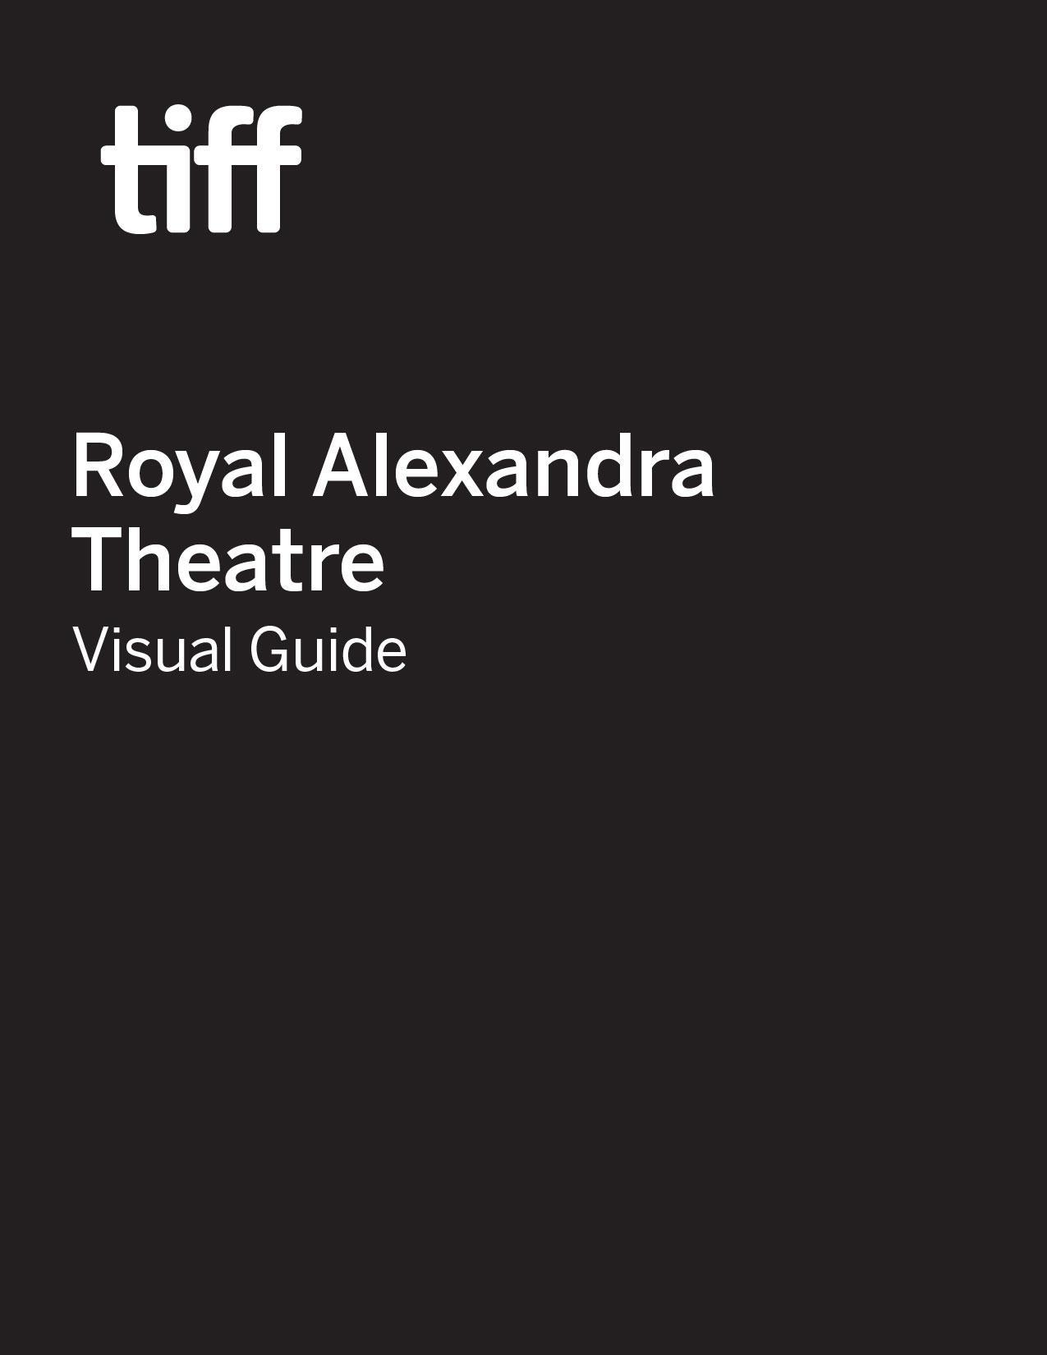

Royal Alexandra Theatre Visual Guide

Location
260 King Street West, Toronto, ON M5V 1J2
Closest intersection
King St. W. & Simcoe St.
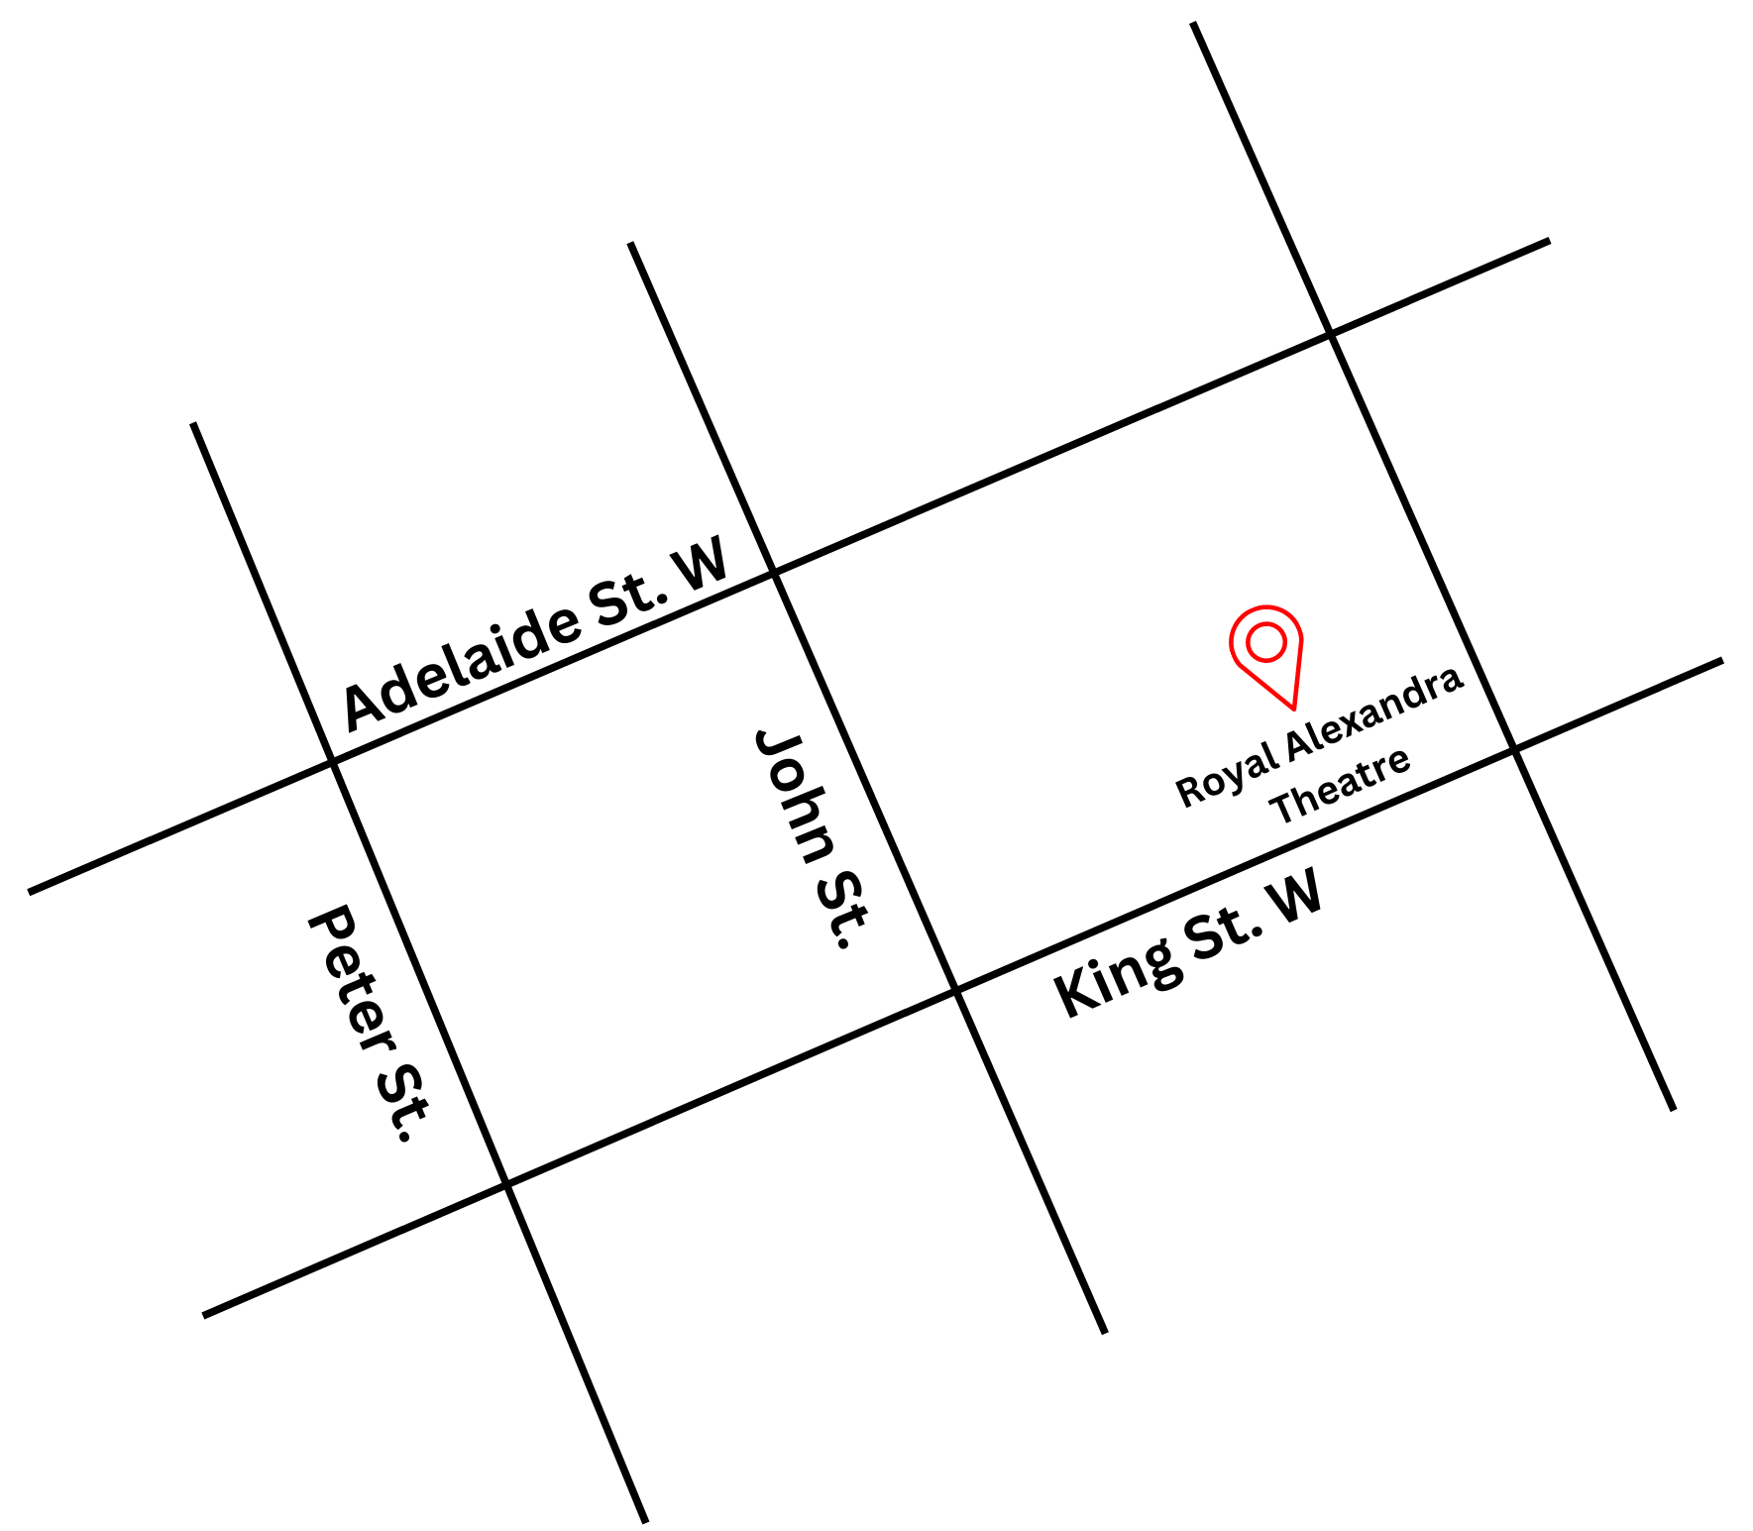
Figure 1: A Map of downtown Toronto with Royal Alexandra at King St. W. and John St., and Adelaide St. W. to the north.

General information
- This venue has reserved seating

Routes of arrival
*Please see Festival Street closures

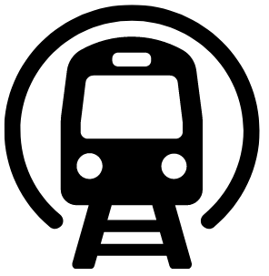
Subway
Royal Alexandra Theatre is located just next to St. Andrew subway station on Line 1. It is a 3-minute or 250 m walk.


Streetcar or bus

The King streetcar (Route 504) stops at the corner of King Street & University Street. It is a 4-minute or 300 m walk from the streetcar.
GO Transit or VIA Rail
Royal Alexandra is a 17-minute walk or 1.4 km from Union station. The subway can be taken from Union Station one stop northbound to St. Andrew Subway Station.

Driving
There are four levels of parking located beneath the theatre, with an entrance ramp off John Street. If arriving from the parking garage located beneath the Princess of Wales Theatre, elevators are available on levels P1 and P4, which can take patrons to street level. The theatre is then a 2-minute walk away.

The entrance and lobby

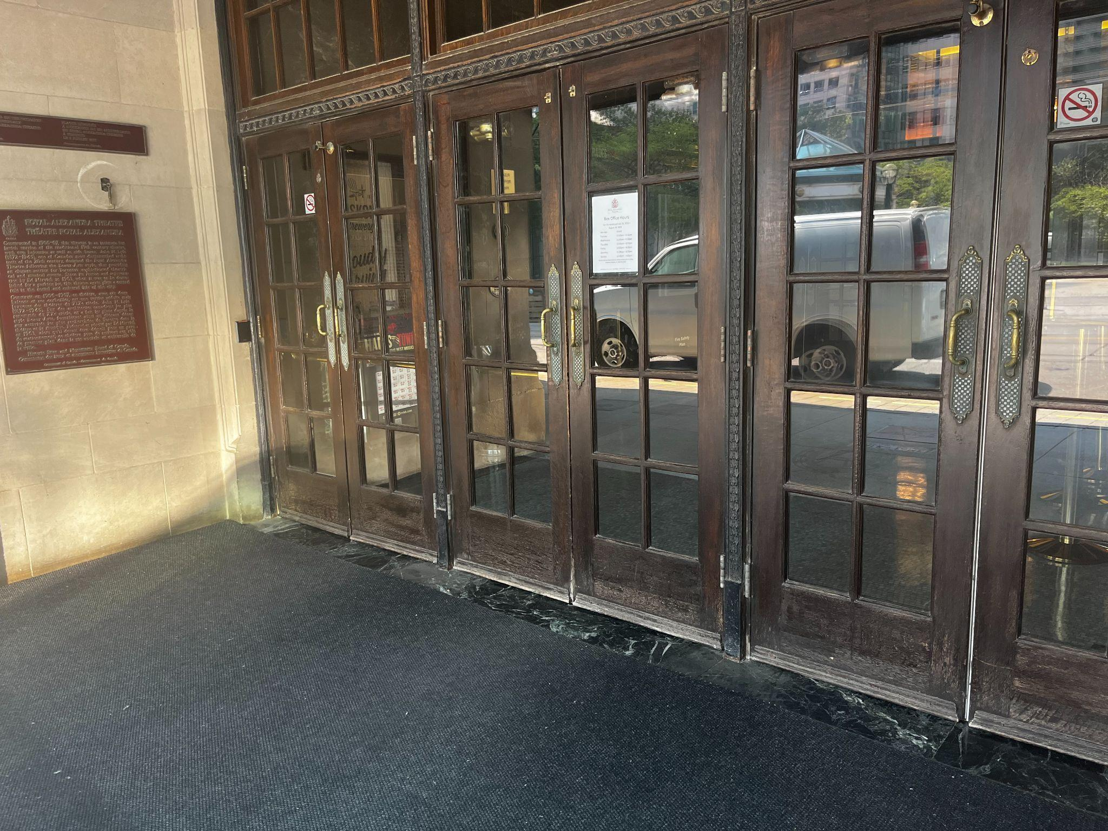
Figure 2: Photograph of the entrance and door at Royal Alexandra Theatre. There are three sets of double doors.
- Those with accessibility needs can use the main front entrance; there is step-free access to the Main Lobby, Box Office, and Orchestra through large glass double doors
- Due to the age of the building, there are no elevator facilities.
- There are currently no tactile colour-contrast cane detection tiles or truncated domes at the entrance or drop-off areas
- A pushed button can be used to open the door
- There are no curb cuts or ramps directly in front of the building. The closest sidewalk accessibility is at Duncan St. & King St. W
- There is an overhang at the front of the building to protect attendees from the elements

Rush lines
- Rush line is located on the north east corner of Duncan and Pearl, extending eastward on Pearl St.
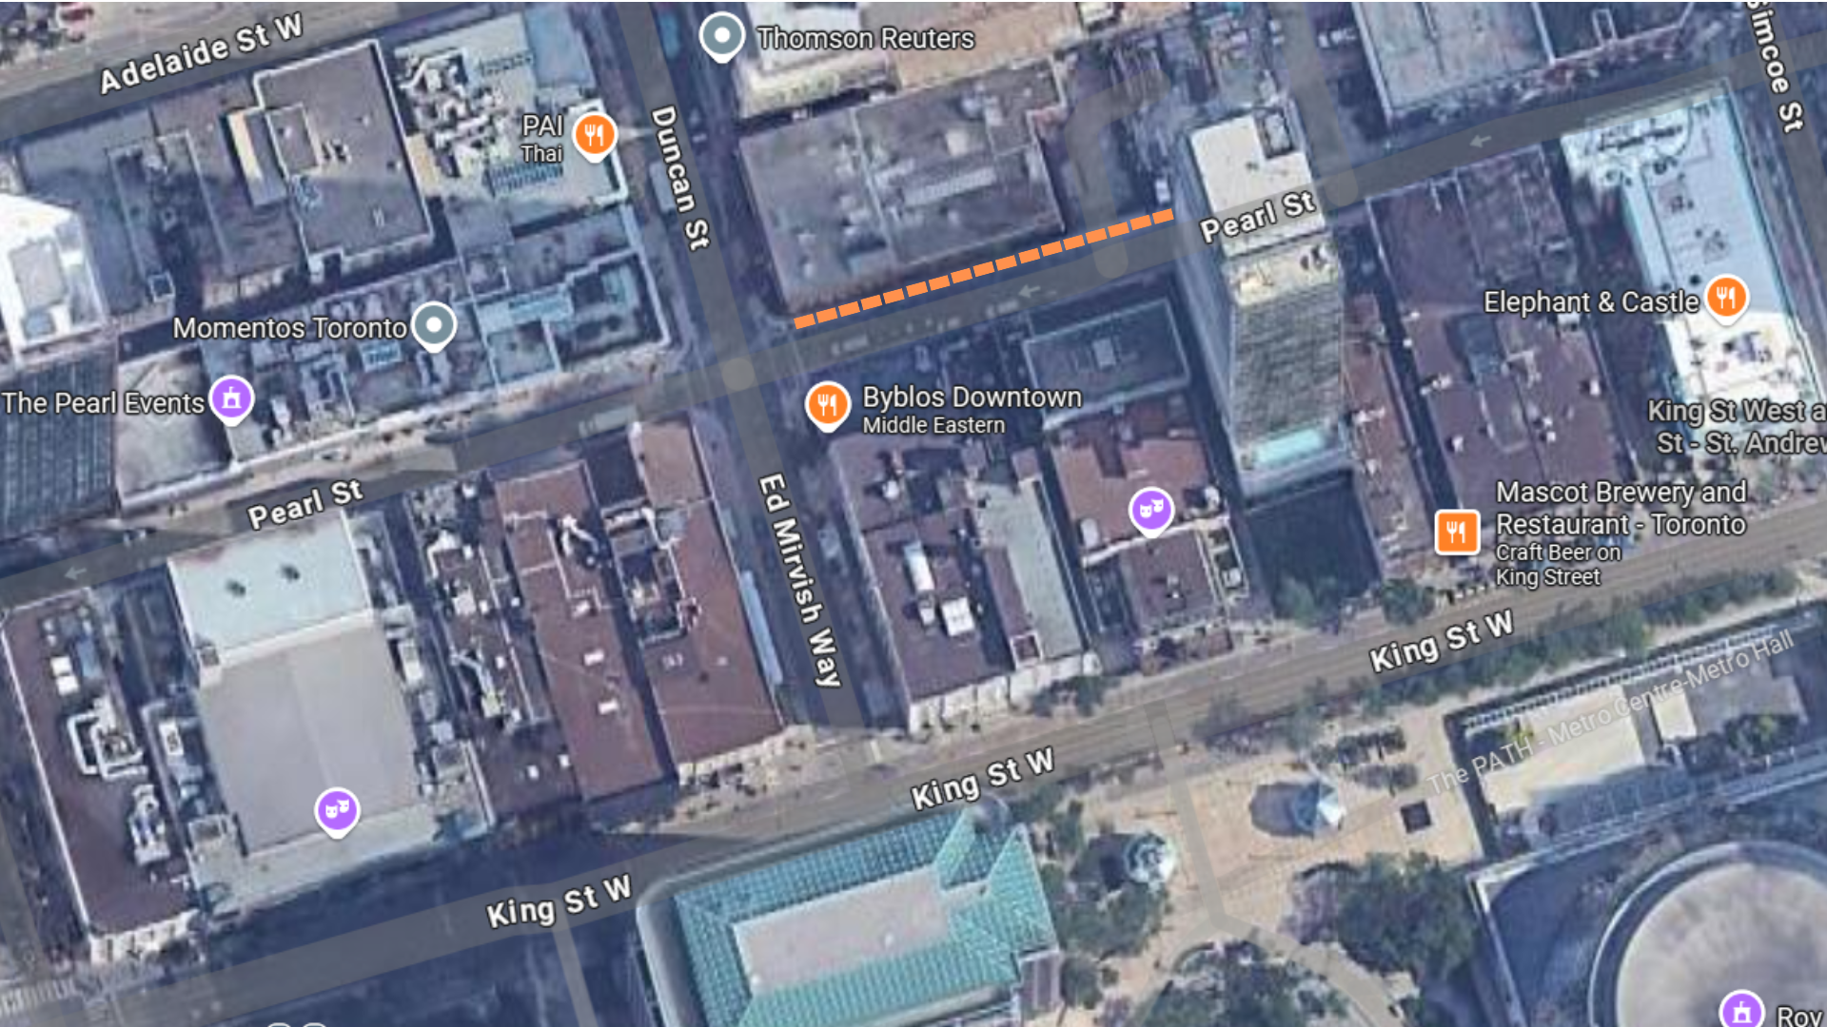
Figure 3: An aerial view of the Royal Alexandra Theatre Rush line.

Access to theatres
- There are no stairs required to access the Main Entrance, Box Office Lobby, Main Lobby, Louis XIV Lounge, Orchestra Auditorium

Orchestra
- The Orchestra Level is located at street level.
- There are no stairs in sections G–S
- There are no handrails and there is a gradual slope to the floor
Extra legroom
- Extra legroom can be found in Row B, seats 7–10 and 27–30, and in aisle seats and movable Box seats

Venue measurements
Door/Area | W x H | Notes
Front Doors | 56" | per door (3-4 inches less when door is open = 52")
Curb Height (front doors) | 3.5"
Box Office counter (Height) | 45" | Reach to Box office Agent window is 4 feet
Doors leading from Box Office to Main Lobby | 55"
Doors into Theatre | 4 feet
Accessible Washroom Door | 30" | 28" when door is open

Accessible seating
There are a total of 9 wheelchair accessible seats, including:
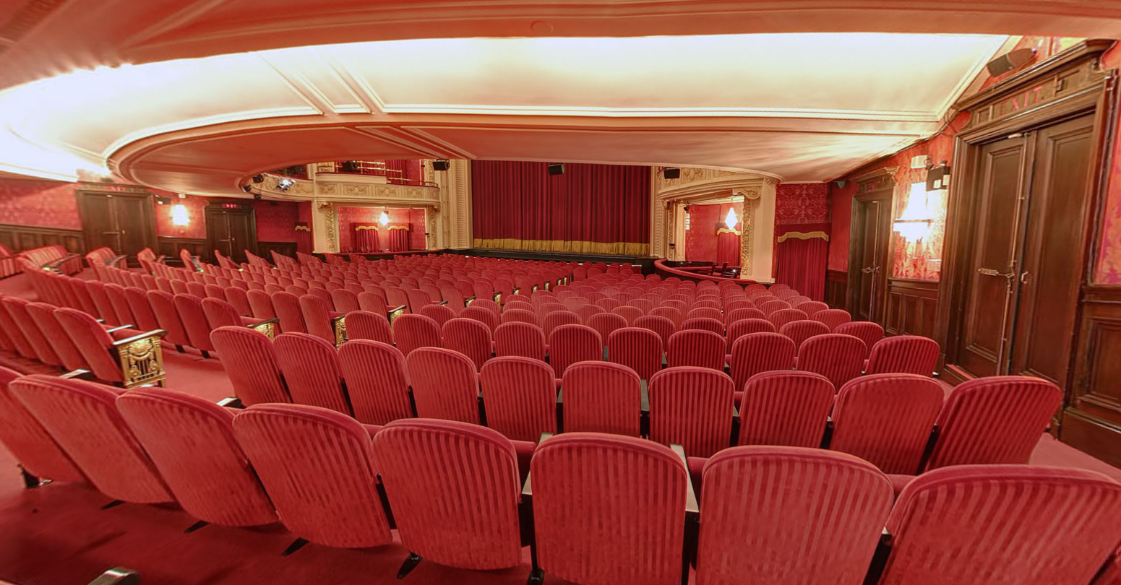
Figure 4: Photograph of approximate view from Orchestra House Right.
- Boxes A and C: Wheelchair accessible seating for up to 2 guests or special access seating for up to 4 guests. Some restrictions may apply.
- Boxes B and D: Wheelchair accessible or special access seating for up to 4 guests. Some restrictions may apply.
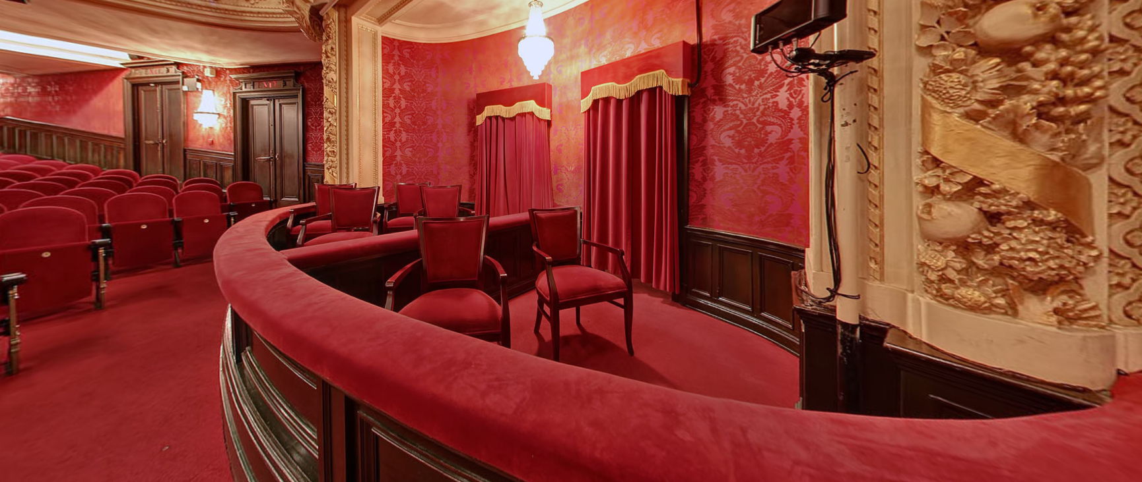
Figure 5: Photograph of Box A & Box D seating sections
- Rows DD: Wheelchair accessible or special access seating for up to 4 guests and 2 companions in total (2 guests + 1 companion seat on the left side of the aisle, and 2 guests + 1 companion seat on the right side of the aisle)

Dress circle
- Staircases located on the west and east side of the Orchestra Main Lobby provide access to the upper levels. Stair access is required for all seats on this level
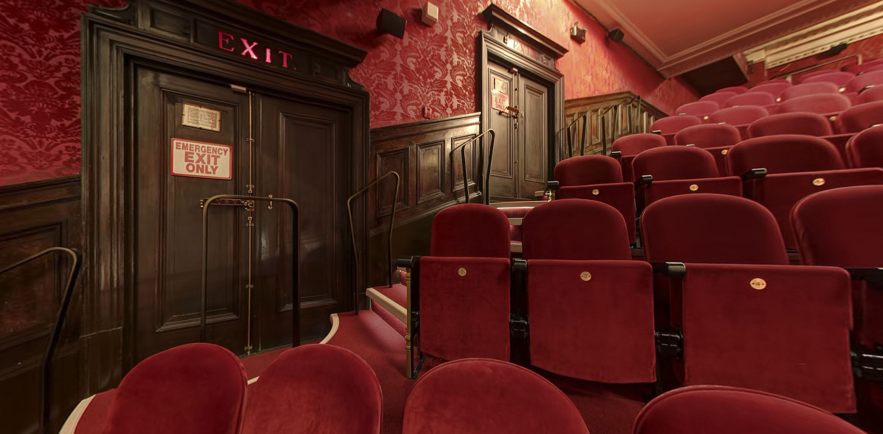
Figure 6: Photograph of Dress Circle stairs, handrails, and seating.
  - Orchestra up to Dress Circle: 30 stairs with handrails
  - This zone contains stairs with handrails on the outer-left and right-side aisles, and stairs with no handrails on the inner-centre aisles
  - Additional legroom can be found in the movable Box seats, or in aisle seats
Balcony
- Orchestra up to Dress Circle up to Balcony: 69 stairs with handrails
- This zone contains stairs with handrails on the outer-left and right-side aisles, and on the inner-centre aisles
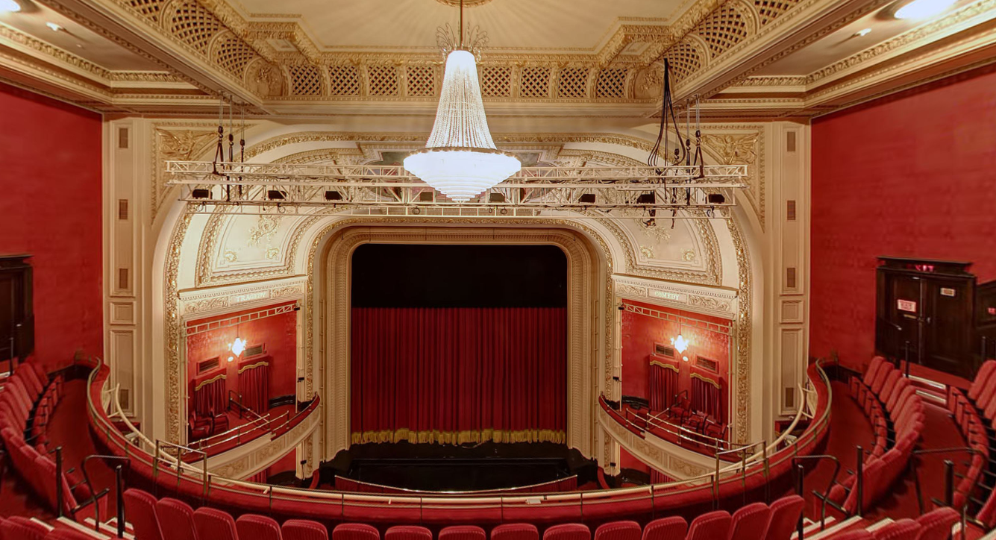
Figure 7: Photograph of view from balcony centre

Accessibility services and devices available
Closed Captions | Yes | Dolby Accessibility Solution
Assisted Listening | Yes | Stethoset, limited neck loops available
Audio Description | Yes* | Receivers with disposable earbuds
*Audio Description is subject to content including an Audio Description option

Concession stand
- No outside food and drink is permitted inside
- All payments are accepted at sales locations (major credit cards and cash)
- No water fountains, but bar staff can pour glasses of water upon request

Washrooms
- A barrier-free single stall restroom is available on the east side of the main floor
Dress circle and balcony washrooms
Gender neutral | No
Sensored flushing | Partial | Automatic urinal in men’s washroom only
Sensored faucets | Yes
Automatic soap dispensers | Partial | Men’s washroom is manual
Sensored hand dryer or paper towel | Unknown
Change tables | No

Basement washrooms
Gender neutral | No
Sensored flushing | No
Sensored faucets | No
Automatic soap dispensers | Yes
Sensored hand dryers | Unknown
Change tables | No

