

The Visa Screening Room at the Princess of Wales

Venue Access Guide

Visa Screening Room at the Princess of Wales Venue Access Guide
Overview
This guide provides accessibility information to support visitors in planning their experience. If you have specific access needs, we recommend contacting the venue in advance.

Location
300 King Street West, Toronto, ON M5V 1J2
Closest intersection
King St. and John St.

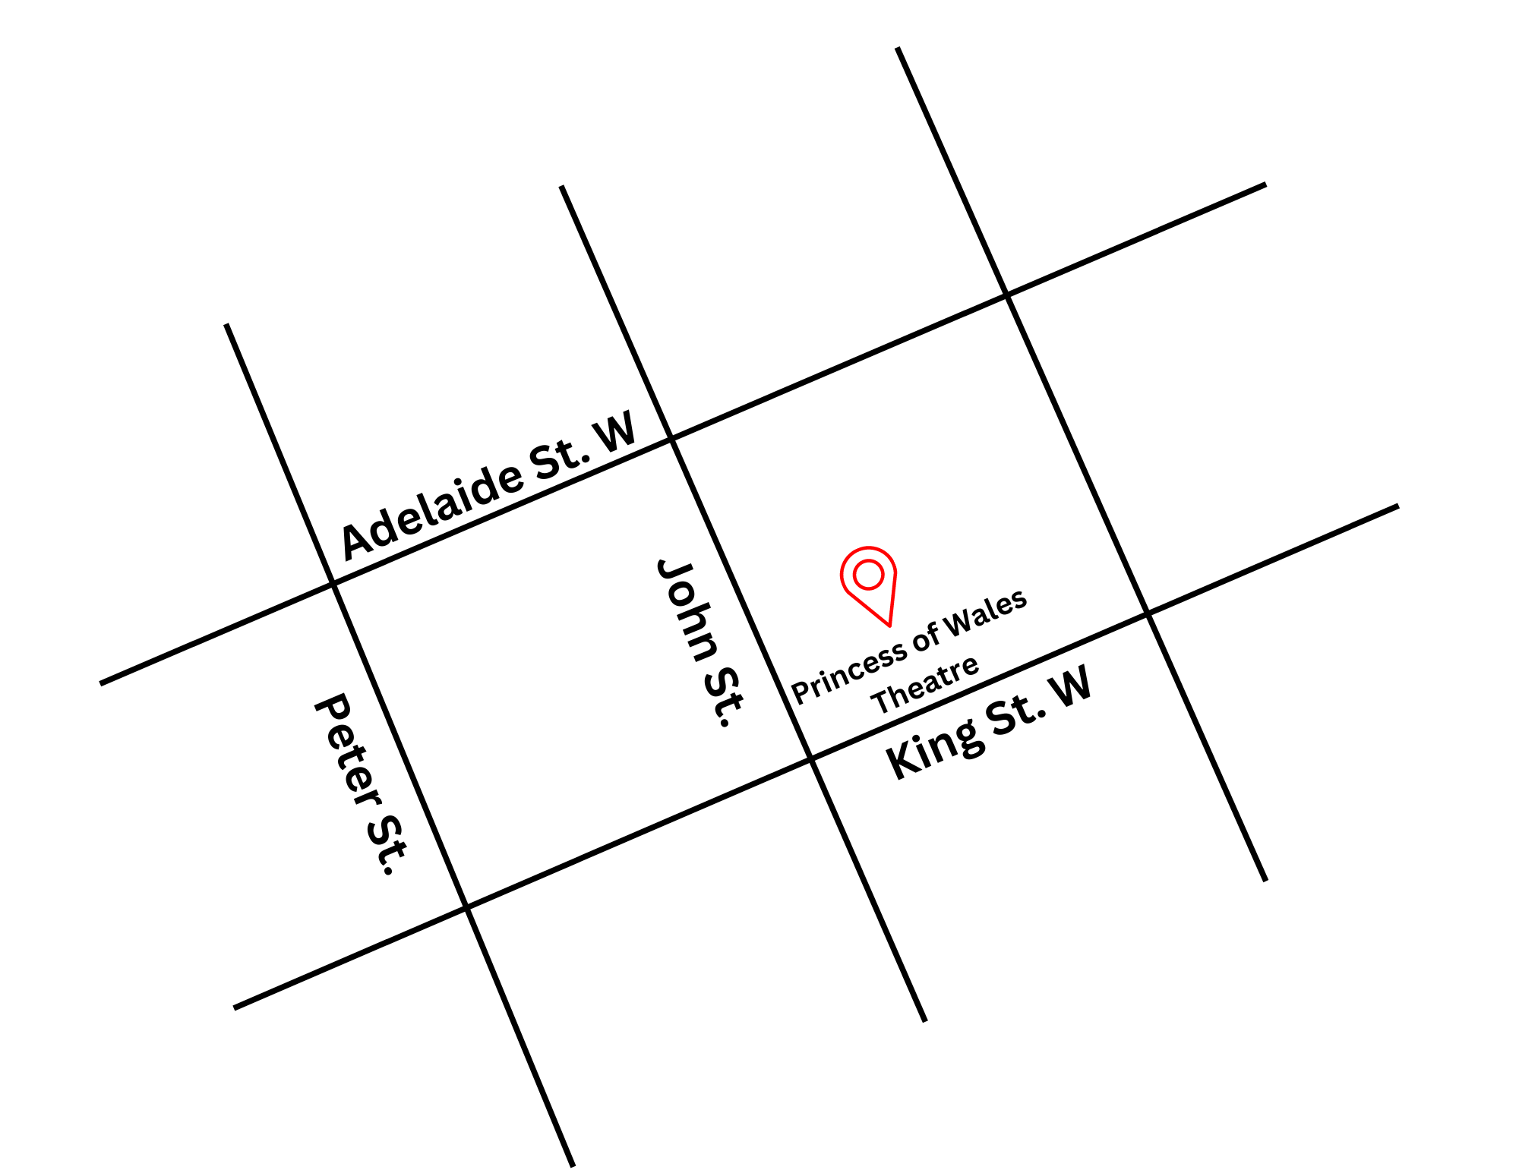
Figure 1: A Map of downtown Toronto with Princess of Wales at King St. W. and John St., and Adelaide St. W. and King St. W. to the north and south.
General information
- This venue has reserved seating

Getting There
*Please see Festival Street closures
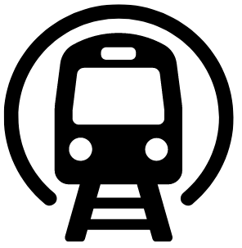
Subway
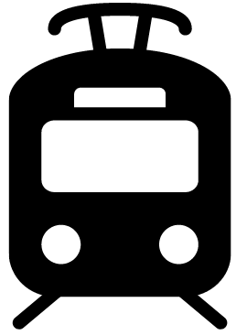
The Visa Screening Room at the Princess of Wales theatre is located near St. Andrew subway station on Line 1. It is a 350 m (about a 4-minute walk at an average pace; travel time may vary) from the subway
Streetcar or bus
The King streetcar (Route 504) stops at the corner of King Street & University Ave. It is 450 m (about a 6-minute walk at an average pace; travel time may vary) from the streetcar stop

GO Transit or VIA Rail
It is 800 m (about a 15-minute walk at an average pace; travel time may vary) from Union Station. The subway can be taken from Union Station (on the University line) one stop North to the St. Andrew Subway Station.

Driving
There are four levels of parking located beneath the theatre, with an entrance ramp off John Street. If arriving from the parking garage located beneath the Princess of Wales Theatre, elevators are available on levels P1 and P4, which can take patrons to street level.

Arrival and Entrance
- The front entrance includes automatic doors with push-button activation on the right side.
- The entrance doors may be heavy to open manually; staff and volunteers are available to assist.
- The entrance is step-free and leads into the Main Lobby
- There are no tactile walking surface indicators at the entrance
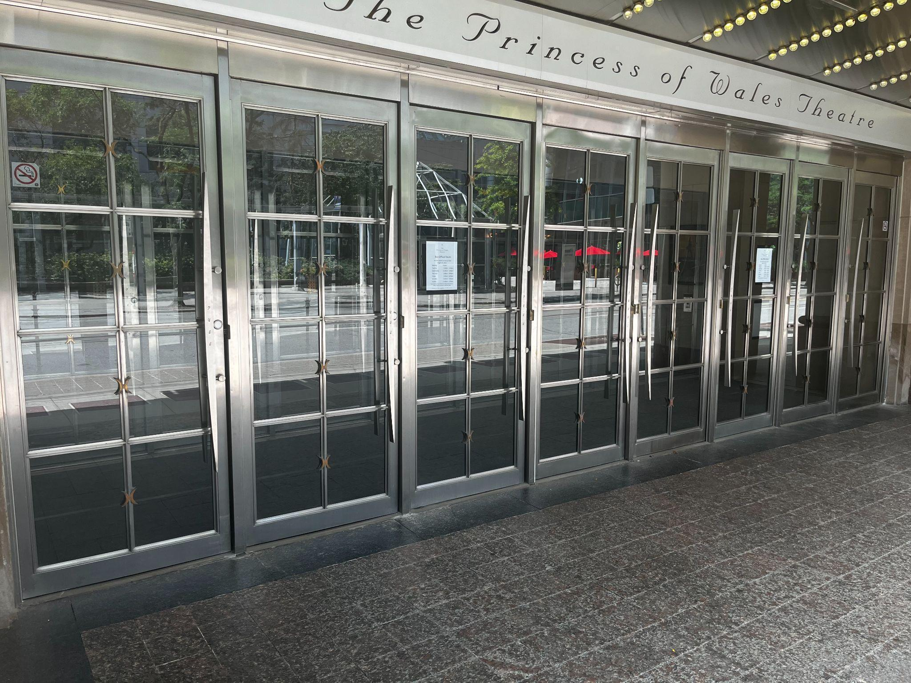
Figure 2: A photograph of the Front Doors to the Princess of Wales Theatre. There are Ushers who can assist
in opening these doors.

Main Lobby and Stairs
Lobby Circulation
- The Main Lobby connects to multiple levels via stairs, ramps, and elevators.
- Elevators provide step-free access to all levels of the theatre.

Stair access from the Main Lobby includes:
- 9 stairs to the Lower Lobby handrails
- 11 stairs to the Lower Orchestra
- 23 stairs to the Orchestra
- 53 stairs to the Dress Circle
- 84 stairs to the Balcony
- A ramp is available between the Main Lobby and Lower Lobby (with handrails)

Rush lines
- The rush line starts at the northeast corner of King St. W. and John St. and extends north along John St. towards Pearl St.

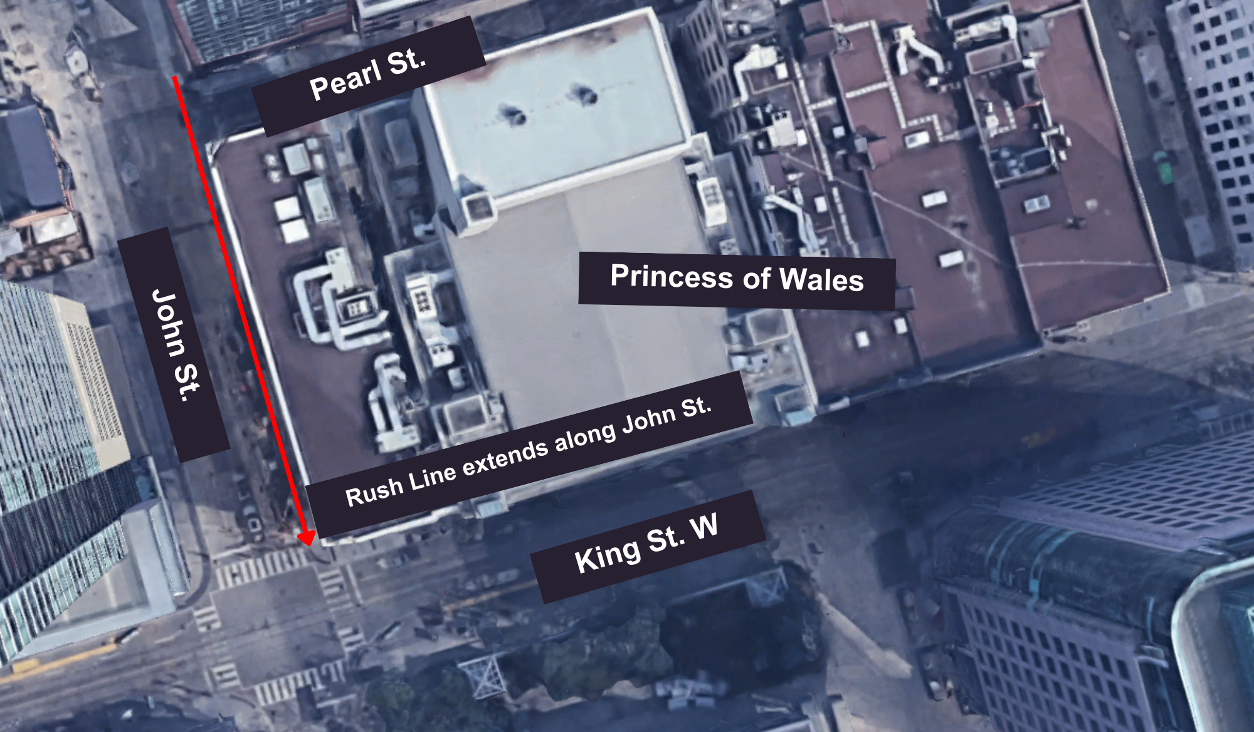
Figure 3: Aerial image of Rush line for Princess of Wales

Access to theatres and seating
- All levels of the theatre are accessible via lobby elevators, which provide step-free access to seating areas in the Orchestra, Dress Circle, and Balcony.
- The Orchestra level is step-free from the street and Main Lobby, and can also be accessed via elevators from the parking garage below the theatre
- The Dress Circle and Balcony levels can be accessed step-free via elevators.
- Within the auditorium, some seating areas require stairs:
- In the Orchestra, rows H-W are accessed by steps with handrails
- A gradual ramp is available between rows AA-G

Orchestra
- Rows AA–HH and A–G are step-free
- Row H–U include14 shallow steps (one per row), with handrails along the outer-left and right-side wall
Accessible seating spaces (wheelchair users)
- Row GG (left section): Seats 40 to 41
- Row GG (right section): Seats 10 to 11

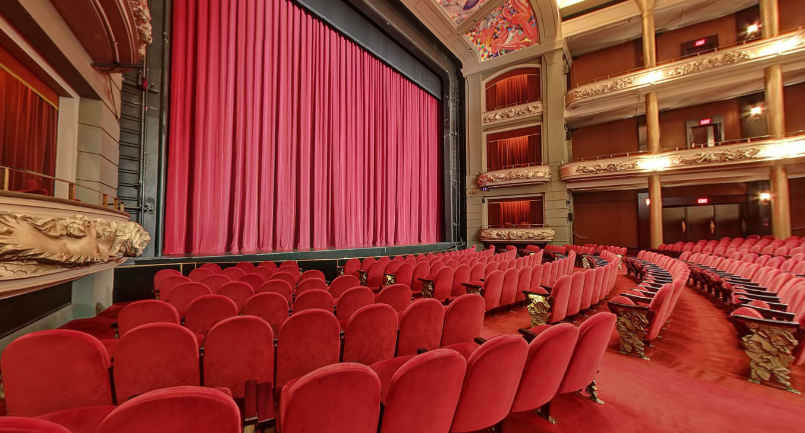
Figure 4: A photograph of the approximate view from Row GG 40–42

Dress circle
- Row K is step-free
- Rows A–J include stairs:
- Outer aisles: 18 steps total (2 per row) with handrails
- Centre aisle: 12 steps total (2 per row) without handrails
Accessible seating spaces (wheelchair users)
- Row K (centre section): Seats 23 to 37
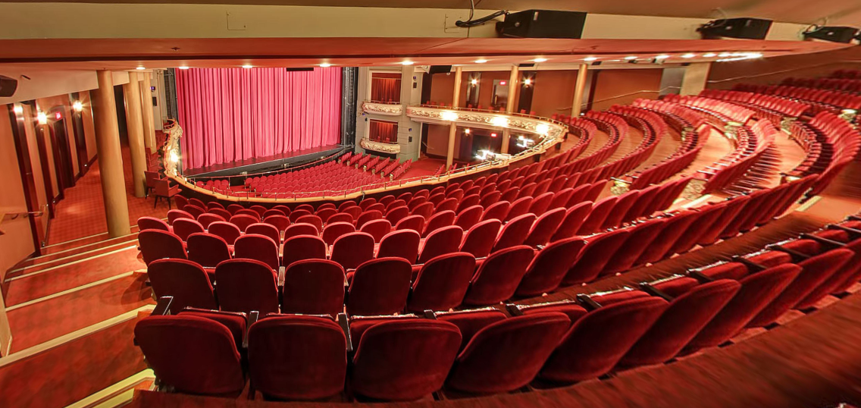
Figure 5: A photograph of the approximate view from dress circle Row K

Balcony
- The Balcony Lobby is step-free
- Row J is step-free
- Other seating areas in the Balcony may require stairs
Accessible seating spaces (wheelchair users)
  - Row J (right section): Seats 6–9
  - Row K (left section): Seats 52–55
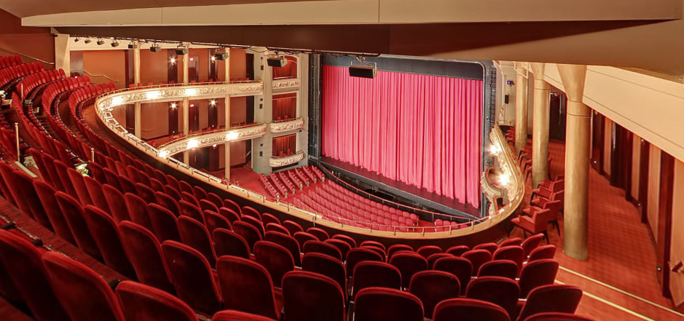
Figure 6: A photograph of the approximate view from Balcony row J

Venue measurements
Door/Area | W x H | Notes
Front Doors | 3 feet | 3-4 inches less when open: total of 8 single doors
Curb Height (front doors) | 4.8 inches
Parking Access doors | 40 inches | 40" each (one door-divider-one door)
Elevator Access to all parkings | 42 inches
Elevator (all floors) | 42 inches
Accessible Washroom | 3 feet | Downstairs by Lounge
Theatre Entrance (orchestra Level) | 58 inches | First Doors
Theatre Entrance (orchestra Level) | 32 inches | Second doors (3 single doors)
Orchestra Doors (By Bar) | 32 inches

Accessibility services and devices available
Feature | Availability | Device | Notes
Closed Captions | Yes | Dolby Accessibility Solution
Assisted Listening | Yes | Stethoset, limited neck loops
Audio Description | Yes | Receivers with disposable earbuds | Audio Description is subject to content including an Audio description option

Concession stand
- No outside food and drink permitted inside
- All payments accepted at sales locations (major credit cards and cash)
- No water fountains, but the bar staff can pour glasses of water upon request
Washrooms
Feature | Availability | Notes
Accessible stall | Yes | There are barrier-free washrooms on the ground floor, dress circle, and balcony, with single stalls
Gender neutral | No
Sensored flushing | Partial | Lower lounge Accessible Washrooms only
Sensored faucets | Yes
Automatic soap dispensers | Yes
Sensored paper towel | No
Change tables | No

