# **Next-gen Displays: Overview**



**Next-gen displays: Illuminating new possibilities**

Display devices or screens have come a long way since the days of bulky televisions and oversized computer monitors with their tiny, low-resolution screens and grainy picture quality. Technological development over the past few decades, including advances in material science, semiconductors, and nanotechnology, has led to thinner, wider, brighter, and more energy-efficient displays of all shapes and sizes.

With advances in the internet of things (IoT) and miniaturization, displays have also become much smaller and more portable, leading to them being embedded in everyday objects. Displays are now commonplace in our lives and can be found across various sectors from retail store displays, vehicle infotainment systems, and wearable watches to smart home devices.

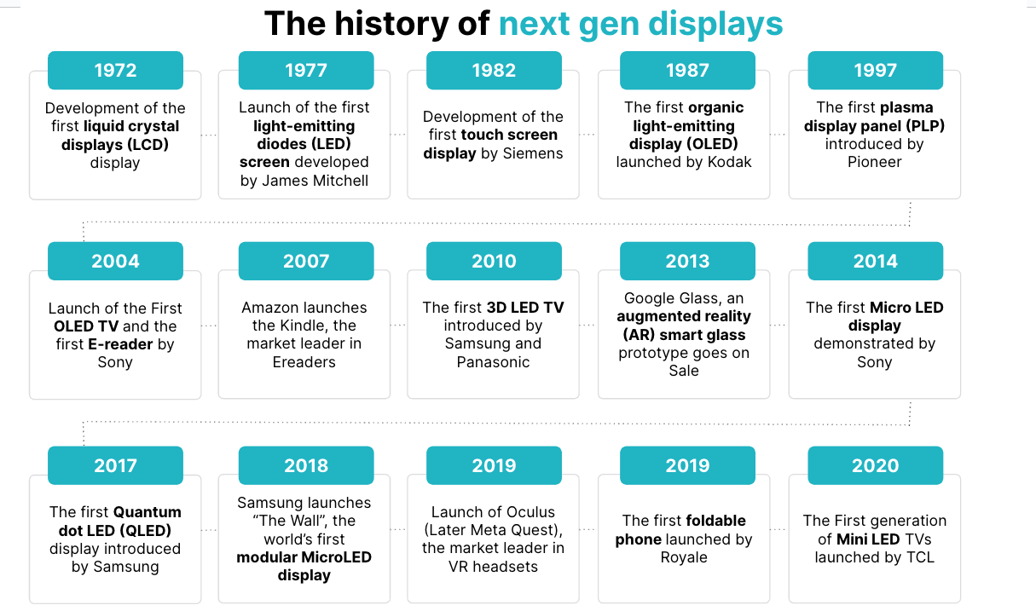

### *Source: SPEEDA Edge based on news articles and company press releases*

**What are next-gen displays?**

Next-gen displays are visual display devices that come in a range of shapes and forms. They are built on a variety of new and emerging display technologies that use different materials and innovative designs that seek to enhance the viewer experience in terms of image quality, flexibility, and energy efficiency.

Next-gen displays cover a wide range of applications across many industries including retail, automotive, healthcare, and entertainment. This includes traditional use cases such as televisions, mobile phones, and computer monitors as well as emerging devices such as smart watches, AR/VR glasses, and smart home devices. We have categorized the key types of displays and the companies offering them into the following segments:

**Key types of next-gen displays**

|  |  |  |  |  |
| --- | --- | --- | --- | --- |
| **Segments** | **Product image** | **Description** | **Enabling technologies** | **Use cases** |
| Advanced visual displays |  | Includes display manufacturers that provide R&D and manufacturing facilities for alternatives to more traditional LED/LCD technology, which are used in many of the other display segments. This covers a range of light-emitting technologies including OLED, QLED, and MicroLED, with a focus on improving picture quality, size, and energy efficiency. | -Advanced microchips and semiconductors  -Nanotechnologies (nanocrystals, nanoparticles)  -Advanced chemicals and molecules  -Light-emitting technologies (OLED, QLED, MicroLED, MiniLED) | -Consumer electronics (televisions, smartphones, tablets, laptops)  -Marketing and advertising (digital signage)  -Media and entertainment (live events) |
| Flexible and foldable displays |  | Displays that are bendable/foldable, allowing for innovative and versatile form factors. | -Thin-film transistors (TFTs)  -Flexible substrate materials  -Light-emitting technologies (OLED) | -Consumer electronics (smartphones, tablets,  wearables)  -Automotives (HUD)  -Health and wellness (patient monitoring and imaging tech) |
| Holographic and volumetric displays |  | Displays that can project 3D images in mid-air, without requiring any special glasses or viewing devices. Holographic displays use light diffraction to create 3D images, while volumetric displays use a combination of multiple 2D images or rotating surfaces to create a 3D illusion. | -Laser technology  -Holographic optical elements (HOEs)  -Light scattering and light diffraction technologies  -Spatial light modulators (SLMs)  -Movement tracking technology (accelerometers, gyroscopes, and magnetometers) | -Media and entertainment (museums, music concerts)  -Retail (digital signage) |
| E-paper and E-Ink displays |  | Displays that are designed to mimic the appearance of ink on paper. These displays are energy-efficient, sunlight-readable, and have a wide viewing angle. | -Electrophoretic display (EPD) and electrochromic display (ECD) technologies  -Microcapsules and pigment particles  -IoT | -Consumer electronics (e-readers)  -Retail (digital signage)  -Wearable devices (fitness trackers)  -Packaging and logistics (labeling)  -Education (e-schoolbooks) |
| Immersive displays |  | These displays are primarily found in AR/VR displays that can be integrated into headsets or smart glasses used for creating immersive experiences. This also includes transparent displays that can display information while maintaining transparency, allowing them to be integrated into transparent surfaces. | -Transparent conductive layers  -Optic lenses  -Movement tracking technology (accelerometers, gyroscopes, and magnetometers)  -Light-emitting technologies (OLED, QLED, MicroLED)  -Graphics processing units  -IoT  -Advances in AR/VR/MR technologies | -Retail (digital checkouts, interactive shopping)  -Marketing and advertising (digital signage)  -Transportation and logistics (in-flight entertainment, digital signboards)  -Education and training services (AR-enhanced classrooms)  -Defense and public services (HUDs in military helmets)  -Manufacturing (control panels, R&D)  -Media and entertainment (AR/VR glasses, museum/art installations)  -Automotive (HUDs)  -Health and wellness (patient monitoring)  -Construction (smart windows) |
| Tactile and haptic feedback displays |  | Displays that can provide tactile or haptic feedback to users, simulating the sensation of touch. This technology can be used in touchscreens, wearables, and other interactive devices to enhance user experiences. | -Motion detection and touch sensing technology (actuators)  -Shape memory alloys  -IoT  -Light-emitting technologies (OLED) | -Education (interactive whiteboards)  -Retail (digital signage)  -Entertainment (video gaming)  -Manufacturing (R&D)  -Automotive (infotainment systems) |
| Projection displays |  | Displays that are ideal for ultra short throw (UST) projectors, which require limited space and wide viewing angles. These displays can be both portable or fixed frame screens, which are large in size, and capable of high-quality resolutions. | -Projection technology (LCD, DLP. LCoS)  -Screen materials  -Ambient light rejecting (ALR)/ceiling light rejecting (CLR) material | -Media and entertainment (home theatre, live events)  -Education (classroom/lecture halls)  -Retail and restaurants (digital signage)  -Workplace (boardrooms, conference rooms) |

### *Source: SPEEDA Edge*

In addition to the above, there are a number of other display types that are mostly at an experimental stage. *See the future outlook section for some of these newer types of displays.*

We also exclude the following areas when selecting companies for this industry:

1. Companies that develop content and software solutions to run on next-gen displays (covered under [Extended Reality](https://sp-edge.com/industry/65), [Content Creation Tools](https://sp-edge.com/industry/113), [and Metaverse Experience Platforms](https://sp-edge.com/industry/132))
2. Companies that offer purely manufacturing services for displays (covered under [Additive Manufacturing](https://sp-edge.com/industry/71))
3. Companies that manufacture hardware components or equipment used for the production of next-gen displays (covered under [Next-gen Semiconductors](https://sp-edge.com/industry/161), [Bio-based Materials](https://sp-edge.com/industry/45), and [Smart Factory](https://sp-edge.com/industry/6))

### **Use case map**

|  |  |  |  |  |  |  |
| --- | --- | --- | --- | --- | --- | --- |
|  | **Flexible and foldable displays** | **Holographic and volumetric displays** | **E-paper and E Ink displays** | **Immersive displays** | **Tactile and haptic feedback displays** | **Projection displays** |
| Media and entertainment | Smart home devices | Music concerts and films | E-readers | AR/VR gaming experiences | Art installations and mixed reality experiences | Home entertainment systems |
| Education and training |  | Exhibits at planetariums museums, and art installations | E-schoolbooks | Immersive VR classroom teaching | Interactive displays for museums and art galleries | Multimedia learning |
| Transport and logistics | In-vehicle infotainment systems |  | Digital road signage | Smart digital window displays | In-vehicle gesture controls |  |
| Retail and trade |  | Holographic product displays | Dynamic price tags and package labeling | Virtual fit-ons and interactive shopping experiences | Touchless menus and self-checkout POS terminals | Showroom displays |
| Manufacturing |  |  |  | R&D and prototyping | Touchless control panels |  |
| Healthcare and wellness | Wearable patient monitoring devices | Holograms and volumetric displays of human anatomy | Fitness and health trackers | AR glasses for diagnostic assistance | Tactile feedback on devices for visually impaired users |  |
| Defense and public services |  | Holographic sonar displays for submarine warfare |  | Heads-up displays (HUD) in helmets |  |  |

*Source: Compiled by SPEEDA Edge*

### **Examples of use cases of next-gen displays**

|  |  |  |  |  |
| --- | --- | --- | --- | --- |
| **Case study** | **Industry** | **Firm** | **Segment** | **Use case description** |
| [Jackson Public School](https://arpost.co/2023/03/06/jackson-public-schools-virtual-reality-in-the-classroom/)s | Education and training | [Lobaki](https://sp-edge.com/companies/778465) | Transparent and AR/VR displays | To introduce hands-on immersive VR experiences for classroom teaching in a variety of subjects. |
| [Evexio](https://www.ynvisible.com/news-inspiration/digital-road-signs) | Transport and logistics | [Ynvisible](https://sp-edge.com/companies/160311) | E-paper displays | To develop a digital e-paper road sign placed at significant locations to inform the availability of EV charging stations. |
| [Digety](https://www.ynvisible.com/news-inspiration/ynvisible-supports-sustainable-fashion-with-paper-like-digital-price-labels) | Retail and trade | [Ynvisible](https://sp-edge.com/companies/160311) | E-paper displays | In 2022, developed a reusable digital price label for clothing to improve the sustainability of the fashion industry. |
| [Spotsee](https://www.ynvisible.com/news-inspiration/ynvisible-spotsee-announce-launch-of-new-temperature-indication-solution-tempsafe-electrocard) | Transport and logistics | [Ynvisible](https://sp-edge.com/companies/160311) | E-paper displays | In 2021, delivered the first temperature indication solution to the market. The low-power, calibrated temperature indication label is used for cold-chain and temperature-controlled shipment and storage of goods such as blood bags, premium foods, biomaterials, and medicines. |
| [Innoscentia](https://www.ynvisible.com/news-inspiration/smart-expiry-date-label) | Retail and trade | [Ynvisible](https://sp-edge.com/companies/160311) | E-paper displays | Developed dynamic expiry date labels on food packages for real-time quality monitoring for foods. |
| [Design Centre Furniture](https://elitescreens.com/2021/07/aeon-clr-3-at-design-center-furniture-testimonial-alr-clr-fixed-frame-screen/) | Retail and trade | Elite Screens | Projector displays | Its fixed frame screens are suitable for ultra-short throw (UST) projectors that provide a large-screen performance in the close quarters of retail stores. |
| [Decades Bar and Grill](https://elitescreens.com/2020/03/the-manual-tab-tension-2-series-at-decades-bar-and-grill-in-anaheim-ca/) | Media and entertainment | Elite Screens | Projector displays | Its manual Tab_tension 2 retractable projection displays provide a better viewing experience for customers from all corners of the restaurant, which also includes a safety return feature. |
| [Compton High School](https://elitescreens.com/2019/04/yard-master-2-wraithveil-dual-portable-front-rear-projection-screen-at-compton-high-school/) | Education and training | Elite Screens | Projector displays | Installed the WraithVeil™ Dual Portable Front-Rear Projection Screen in 2019 used for K12 classes for projecting large YouTube videos, student presentations, 3-D virtual college tours, and movie nights. |
| [HumanWare](https://www.businesswire.com/news/home/20140923005312/en/Novasentis-HumanWare-Join-Forces-Bring-Radically-Sensory#.VCFzeytdV5k) | Retail and trade | [Novasentis](https://sp-edge.com/companies/18428) | Tactile and haptic feedback displays | Developed miniaturized sensory feedback actuators to be integrated into computers and mobile devices to provide richer tactile feedback for the visually impaired. |
| [Red Bull](https://www.ultraleap.com/company/news/press-release/red-bull-ultraleap/) | Media and entertainment | [Ultraleap](https://sp-edge.com/companies/260128) | Tactile and haptic feedback displays | In 2023, it developed a new mixed reality cliff diving experience powered by the Varjo XR-3 mixed reality headset and Ultraleap’s hand tracking technology. |
| [UST](https://www.ultraleap.com/company/news/press-release/ust-checkout-experience/) | Retail and trade | [Ultraleap](https://sp-edge.com/companies/260128) | Tactile and haptic feedback displays | In 2022, UST introduced Ultraleap’s TouchFree hand-tracking solution to provide touchless interactions for its self-checkout POS that uses computer vision to identify SKUs. The firm claims this led to 3x faster checkout experience. |
| [Lufthansa Airlines](https://www.ultraleap.com/company/news/case-study/lufthansa-vr-training/) | Education and training | [Ultraleap](https://sp-edge.com/companies/260128) | Tactile and haptic feedback displays | In partnership with NMY Mixed Reality Studio, it developed a VR cabin crew program that includes hand tracking and provides an immersive learning program. The training program was the first VR training program approved by the German Aviation Authority. |
| [PepsiCo](https://www.ultraleap.com/company/news/case-study/pepsico-touchless-ordering/) | Retail and trade | [Ultraleap](https://sp-edge.com/companies/260128) | Tactile and haptic feedback displays | Developed a touchless menu for food and drink ordering powered by Ultraleap hand tracking technology. The firm claims that 85% of customers stated that they would be extremely likely to use the touchless kiosk again. |
| [Aquarium of the Pacific](https://www.ultraleap.com/company/news/press-release/touchfree-aquarium-pacific-exhibit/) | Education and training | [Ultraleap](https://sp-edge.com/companies/260128) | Tactile and haptic feedback displays | Cortina productions retrofitted a popular exhibit on whales at the Aquarium of the Pacific to a touchless experience powered by Ultraleap’s hand-tracking technology to enable visitors to continue to engage with the interactive exhibit and learn more about our oceans without having to touch the screen. |
| [Enklu](https://www.ultraleap.com/company/news/case-study/unreal-garden/) | Media and entertainment | [Ultraleap](https://sp-edge.com/companies/260128) | Tactile and haptic feedback displays | Developed Unreal Garden, a mixed reality multiplayer experience at E3 2019, which integrated Ultraleap’s haptics technology to provide unique interactions. |
| [Lego](https://www.ultraleap.com/company/news/case-study/lego-interactive-experience/) | Media and entertainment | [Ultraleap](https://sp-edge.com/companies/260128) | Tactile and haptic feedback displays | As part of Lego’s “Rebuild the World” campaign, developed a play experience, where using Ultraleap’s haptic technology, Lego fans could interact with Lego bricks in a contactless manner to build models on a screen. |
| [Springbok Entertainment](https://techcrunch.com/2022/06/07/looking-glass-factory-large-holographic-display/) | Media and entertainment | [Looking Glass Factory](https://sp-edge.com/companies/315382) | Holographic and volumetric displays | In 2022, Looking Glass Factory launched a 65-inch 8k holographic display, which it claimed to be the world's largest. Springbok Entertainment was amongst the first firms to use it for a new film screened at the Tribeca Film Festival. |
| [Children’s Medical Center, Israel](https://realviewimaging.com/medical/) | Health and wellness | [Realview](https://sp-edge.com/companies/223797) | Holographic and volumetric displays | Adopted Realview’s medical holography system that provides fully volumetric 3D holograms to provide a more intuitive understanding of human anatomy. |
| [Canadian Department of National Defense](https://www.avalonholographics.com/news/canadian-technology-companies-create-holographic-sonar-display-for-hunting-submarines) | Defense and public service | [Avalon Holographics](https://sp-edge.com/companies/480967) | Holographic and volumetric displays | In partnership with Kongsberg Geospatial, Avalon Holographics developed a holographic sonar display for submarine warfare, which would enable suface vessels to visualize and process data. |
| [Adidas](https://hypervsn.com/use-cases#gallery-9) | Retail and trade | [HYPERVSN](https://sp-edge.com/companies/345373) | Holographic and volumetric displays | In partnership with DDS Turkey, Addidas installed a HYPERVSN solo billboard on a heavy footfall traffic street in Turkey to increase brand awareness for Adidas sneakers. |
| [Sahara Movements](https://hypervsn.com/use-cases#gallery-4) | Retail and trade | [HYPERVSN](https://sp-edge.com/companies/345373) | Holographic and volumetric displays | In partnership with HYBRID XPERIENCE in the UAE, installed HYPERVSN solo L devices to launch the Holo Lumina art project, developed by three top artists, in the Sahara desert. |
| [General Dynamics Land Systems](https://www.kopin.com/kopin-receives-4-4-million-follow-on-order-for-armored-vehicle-display-systems-enabling-100-million-in-potential-lifetime-program-revenue/) | Defense and public service | [Kopin](https://sp-edge.com/companies/53114) | Transparent and AR/VR displays | In 2023, Kopin received a USD 4.4 million production award to develop display systems for a major armored vehicle upgrade program. The upgrade is expected to enable crews to identify enemy targets from farther away through the introduction of higher-performance sensors and displays. |
| [Accedo](https://www.nreal.ai/nrealWithAccedo/) | Media and entertainment | [Nreal](https://sp-edge.com/companies/534005) | Transparent and AR/VR displays | In 2021, entered into a partnership to become the first in the world to enable content providers to stream digital rights media (DRM) video content via Nreal’s AR glasses in a compliant manner. |
| [BMW](https://www.gauzy.com/articles/bmw-reveals-i-vision-dee-at-ces-2023-keynote-featuring-collaboration-with-gauzy-world-leader-in-smart-glass-technology/) | Transport and logistics | [Gauzy](https://sp-edge.com/companies/144511) | Transparent and AR/VR displays | BMW debuted the BMW iVISION Dee, a first-of-its-kind concept vehicle at CES 2023. The concept car featured Gauzy’s LCG smart glass technologies providing passengers an option to morph into an encapsulated vessel, where windows can be turned into digital displays and shift back to transparent displays in seconds. |
| [Deutsche Bahn](https://www.gauzy.com/articles/smart-train-fitted-with-spd-smart-glass-windows-in-cabins/) (DB) | Transport and logistics | [Gauzy](https://sp-edge.com/companies/144511) | Transparent and AR/VR displays | DB showcased a concept of a reimagined train cabin, which featured Gauzy SPD smart glass technology that let passengers control light levels through a sliding touch panel instead of traditional roller shutters or curtains. |
| [SIA Lightspace Technologies](https://www.delfi.lv/bizness/tehnologijas/augsto-tehnologiju-un-paplasinatas-realitates-ieroci-ukrainai-no-latvijas.d?id=54247456) | Defense and public service | [Lightspace Labs](https://sp-edge.com/companies/283906) | Transparent and AR/VR displays | To supply Ukraine with 50 high-tech remote weapon stations equipped with Lightspace Labs augmented reality glasses. |
| [Real Response](https://varjo.com/case-studies/reimagining-aeromedical-training-how-real-response-is-transforming-the-way-we-learn-with-mixed-reality/) | Education and training | [Varjo](https://sp-edge.com/companies/466855) | Transparent and AR/VR displays | Enhanced Real Response’s BlueRoom™ simulation-based training for medical, trauma, and safety training for both defense and civilian sectors. The platform will feature Varjo’s XR-3 Focal Edition headset, which would allow trainees to interact with real-world objects and develop their fine motor skills. |
| LG Display/BOS | Transport and logistics | [Gauzy](https://sp-edge.com/companies/144511) | Transparent and AR/VR displays | At Glasstec in 2022, in partnership with LG Display and BOS, Gauzy showcased the first-ever mixed material PDLC laminated fabric sun visor, which aims to replace traditional solid view blocking sun visors with a semi-transparent material. The firm claims the solution provides a wider field of vision while blocking glare from traffic lights. |

### *Source: Compiled by SPEEDA Edge based on company websites*

**Technological advances pushing the boundaries of visual experiences**

Advances in material sciences, semiconductors, nanotechnology, and advanced production techniques have led to a series of technological breakthroughs in light-emitting technologies, which form the centerpiece of most next-gen displays.

Sophisticated substrates, such as graphene and silicon nanowires that offer high electrical conductivity and infuse nanotechnology as well as advanced chemical and semiconductor particles such as nanocrystals, are used for creating displays that are thinner, lighter, and more flexible. This is coupled with advanced manufacturing techniques that are able to scale display manufacturing to an accepted yield. For instance, Xdisplay uses micro-transfer printing technology, which allows scaling to micro-sized LEDs for large display arrays, and claims to be able to deliver over 100 million units per hour. Meanwhile, [Kateeva](https://sp-edge.com/companies/116314) uses precision inkjet printing technology, which it claims has lower production costs and causes fewer defects. Some R&D firms, such as [OTI Lumionics](https://sp-edge.com/companies/301563), use quantum simulations and machine learning (ML) to accelerate their new material discovery for displays by 1,000x.

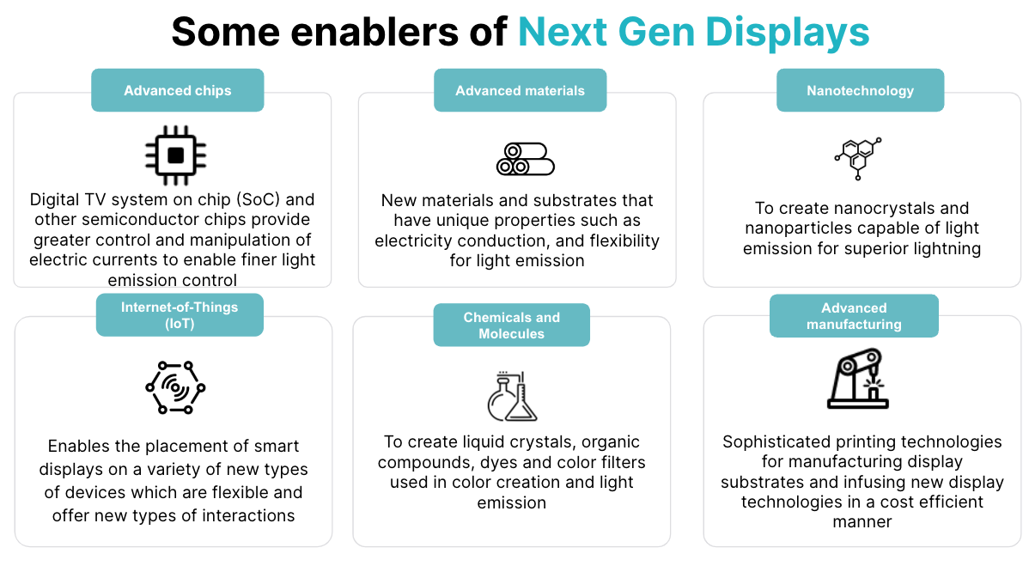

### *Source: SPEEDA Edge*

The combination of these technologies has given rise to an alphabet soup of competing light-emitting technologies, including organic light-emitting diodes (OLED), quantum dot light-emitting diodes (QLED), MicroLED, and MiniLED. Currently, OLED (uses organic materials that emit light when an electric current is applied) and QLED (uses a layer of quantum dots that emit light when exposed to a blue LED backlight) are the most common backlighting options in the display space, offering slim profiles, enhanced color quality, and improved energy efficiency. Lately, MicroLED and MiniLED technologies have been gaining traction and are expected to be more energy efficient.

### 

### 

### 

### 

### 

### 

### 

### **Comparison of light-emitting technologies**

|  |  |  |  |  |  |
| --- | --- | --- | --- | --- | --- |
| Light-emitting technology | LCD | OLED | QD/QLED | MiniLED | MicroLED |
| Cross section |  |  |  |  |  |
| Description | Liquid crystal display (LCD) uses liquid crystals and a backlight to produce images. It works by controlling the amount of light passing through each pixel, creating different colors and shades. | Organic light-emitting diode (OLED) uses organic materials that emit light when an electric current is applied. It creates images without a backlight, enabling thinner and more flexible displays. | Quantum dot light–emitting diode (QLED) uses a layer of quantum dots that emit light when exposed to a blue LED backlight. This improves color accuracy and brightness compared to traditional LCDs. | MinLED uses LEDs, which are smaller than traditional LEDs, to create the backlighting for LCD displays. MiniLEDs offer more precise control over backlighting, which leads to higher contrast ratios and better performance. | MicroLED uses microscopic LEDs to create individual pixels, providing higher contrast ratios, better energy efficiency, and longer lifespans than other display technologies. |
| Cost* | Low  (USD 800– 900) | Medium–high  (USD 1,900–2,500) | Medium–high  (USD 2,000–3,000) | High  (USD 5,000–6,000) | Very high  (USD 8,000+) |
| Quality | Medium | Higher than conventional LCDs | Higher than OLED | Higher brightness than OLED | Highest brightness of any display type |
| Energy efficiency/power consumption | Medium–high  (28 W–130 W) | Medium–high,  possibility of burn-in after prolonged use  (50 W–170 W) | High  (110 W–260 W) | Very high  (2 W–6 W) | Very high  (below 5 W) |
| Refresh rate | Medium | High | Medium | Medium | High |

*Source: SPEEDA Edge*

*\*Based on average cost of latest television displays by leading display manufacturers*

In addition, advances in laser-based technologies, haptic technologies, Electrophoretic display (EPD), and electrochromic display (ECD) have led to further advances in projection displays, tactile and haptic feedback displays, and E-paper displays.

**What’s driving demand?**

**1. Greater digitalization of consumer experiences and new use cases driving demand for better quality screen time**

The growth of digitalization across a range of industries has led to the adoption of digital equivalents of everyday objects such as newspapers and magazines (e-papers and e-magazines), books (e-books), billboards, and signage (digital signboards). This has led to the development of a range of devices such as tablets, e-readers, and large-size digital screens, where advances in display technology are a critical factor for adoption.

A case in point is the growth in e-books. The advent of e-book readers, such as Amazon Kindle in 2007, has driven strong growth in the e-books market—reaching a peak in 2014 and accounting for 27% of the global market share for books. According to a [survey](https://www.pwc.com/kz/en/publications/new_publication_assets/ebooks-trends-developments.pdf) by PWC, alongside the availability of content, the quality of the device (factors such as long battery life and ease of use) and access to a wide range of e-books are key determinants driving further adoption. Hence, device manufacturers pay attention to improving the quality of their devices to differentiate themselves by making them longer-lasting and lighter while improving picture quality. For example, with further advances in its E Ink Carta screen (EPD display) and miniaturization of its hardware, the 2022 edition of Amazon’s Kindle and Kindle paperwhite e-book readers are more portable, featuring a glare-free 300 pixels-per-inch display with adjustable light and a battery life of 6–10 weeks.

### 

### 

### 

### 

### 

### 

### 

### **Device quality is a key factor driving the adoption of display-based devices**

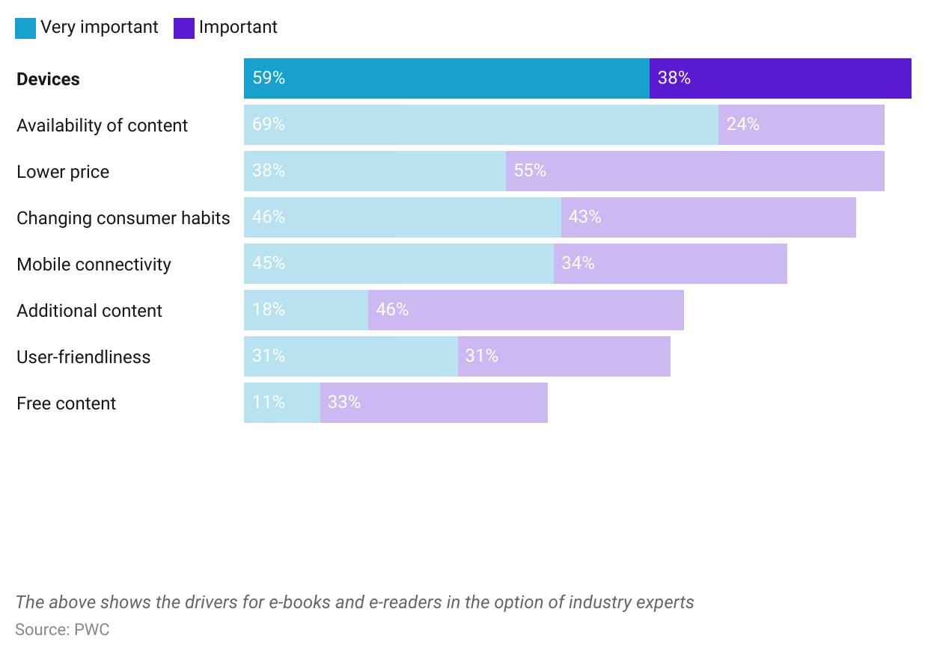

As displays become more ubiquitous in day-to-day living, where individuals are faced with screens at work, home, and everywhere in between, it is no surprise that the time consumers spend on these devices has also steadily increased. The average US adult now spends more than [seven hours](https://www.comparitech.com/tv-streaming/screen-time-statistics/) looking at a screen each day (nearly one hour more than the time spent a decade ago), of which ~53% is spent consuming social media and video games.

**Consumers spending more time in front of screens (hours in 2022)**

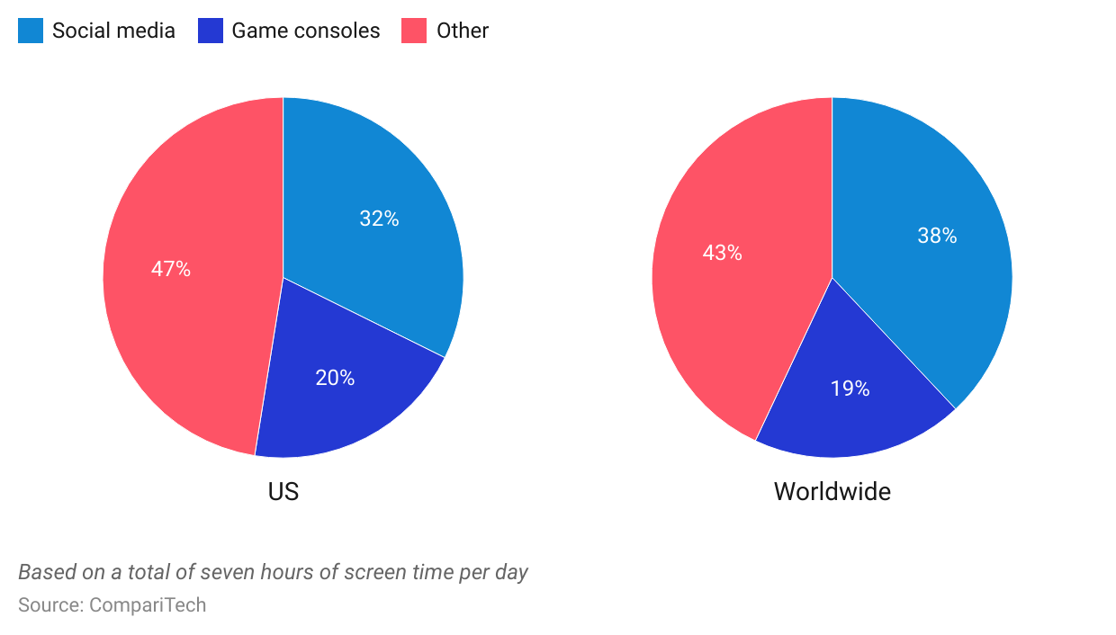

This increased exposure to displays and the growing popularity of consumer experiences, such as video gaming and streaming, have led consumers to become more demanding in terms of their visual experiences. Consumers now expect to see cinema-quality visuals from their televisions at home, while advances in video gaming technology have prompted improvements in screen technology to keep up with the higher quality and realistic graphics capabilities, faster loading speeds and refresh rates, and low-latency streaming capabilities.

### **Evolution of picture quality in video games over time**

|  |  |  |
| --- | --- | --- |
| **Console name** | **Playstation 1** | **Playstation 5** |
|  |  |  |
| Manufacturer | Sony | Sony |
| Release date | December, 1994 | November, 2020 |
| Refresh rate | 50 hz | 120 hz |
| Frame rate | 25 fps | 120 fps |
| Resolutions/color depth | 256x224 to 640x240 pixels  16.7 million colors  (24-bit true color) | 1080p full HD (1920x1080)  4K UHD (3840 x 2160)  8k UHD (7680x4320) |

### Source: Sony, Core Design, Square-Enix

These developments have led to improvements in light-emitting technologies in displays that are able to deliver better picture quality and color brightness, faster response rates, and higher refresh rates while creating new experiences such as immersive displays and holographic displays.

**2. Environmentally and cost-conscious consumers demand more energy-efficient displays**

While modern displays are able to create superior visual experiences with displays of higher resolution and superior picture quality, it comes at the cost of higher energy consumption. For instance, an OLED TV can consume between 50 W and 130 W of energy depending on the screen size. While modern displays are significantly more efficient than displays based on older technologies, such as cathode ray tubes (CRT) and plasma display panels (PDP), with the increased digitalization and growing popularity of smart devices found in households, displays are expected to account for an increasing share of a household's electricity usage. Based on a 2015 survey by the Energy Information Administration (EIA), displays such as TVs, mobile phones, and other related devices accounted for 6.9% of an average US household's total electricity usage. By 2020, this had grown to account for ~[12% of a household’s energy consumption](https://www.cta.tech/Resources/Articles/2021/Energy-Consumption-of-Consumer-Electronics-in-U-S), while the [International Energy Agency (IEA)](https://www.iea.org/news/iea-expects-energy-use-by-new-electronic-devices-to-triple-by-2030-but-sees-considerable-room-for-more-efficiency) expects this to triple by 2030. While consumers may not be willing to give up on their display devices, consumers are more conscious of their environmental impact and are looking for ways to have better visual experiences while reducing their energy burden.

### **Electricity consumption of average US household by end usage (% of total)**

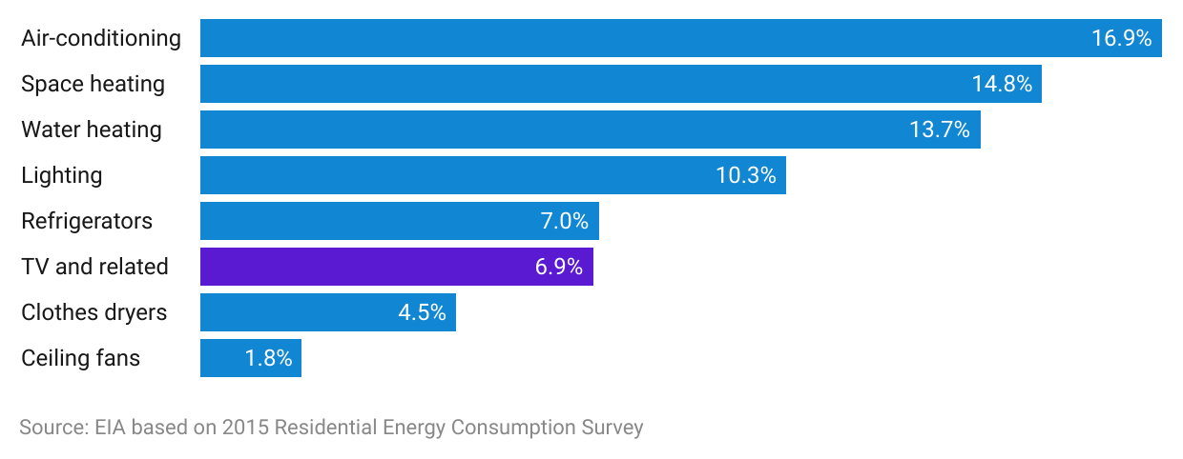

Hence, a key driving factor for display manufacturers for developing new light-emitting technologies is to create more energy-efficient and sustainable displays. Currently, popular light-emitting technologies such as OLED and QLED are developed with more sustainable materials and are embedded with energy-saving features. A case in point is Samsung’s 2021 series of QLED televisions, which include MiniLED backlighting, which is said to [reduce energy consumption by 25%](https://www.techradar.com/news/tired-of-your-tvs-energy-bill-samsung-mini-led-tvs-are-11-more-efficient) through a combination of improved backlights and optimized power supply boards. Emerging lighting technologies such as MiniLEDs and MicroLED, which are longer lasting are expected to be significantly more energy efficient than conventional LED/LCD displays. [Studies](https://www.ledinside.com/news/2017/12/what_industry_professionals_say_about_micro_led#:~:text=The%20average%20power%20consumption%20of,display%20can%20be%20below%205W.) have also shown that MicroLEDs, which do not require backlights and color filters, could have an average power consumption of below 5 W for a 55-inch TV (compared to 55 W and 98 W of a similar-sized LED and OLED TV, respectively).

In addition, technological advances in E Ink and e-paper displays, which have low power consumption, could see broader use cases that go beyond e-readers. A case in point is [Papercast](https://www.papercast.com/), which has developed battery and solar-powered e-paper displays to be used in indoor and outdoor spaces as digital signage.

### **Examples of new displays providing more energy-efficient options**

|  |  |  |
| --- | --- | --- |
| **Company** | **Technology/type of display** | **Benefits claimed** |
| [Helio display materials](https://sp-edge.com/companies/1484586) | Perovskite Quantum dot color technology used for OLED and MicroLED displays | Its patented technology uses an in-pixel color conversion technique, which it claims results in [70% more power efficiency](https://www.heliodisplaymaterials.com/applications) than conventional LCD displays. |
| [Nanosys](https://sp-edge.com/companies/43196) | Combines Quantum dot technology with MicroLED displays | Claims to have created the very first [100% heavy-metal-free](https://nanosys.com/) TVs and monitors and plans to continue to innovate to reduce the use of heavy metals in displays. |
| [Nanolumi](https://sp-edge.com/companies/918990) | Perovskite quantum dot technology for edge-lit displays | Claims to achieve [90% color efficiency](https://nanolumi.com/2020/news/green-perovskite-for-professional-monitors/), which results in lower emissions compared to traditional LCD displays due to its ability to absorb a broad spectrum of light, resulting in a high amount of light recycling. |
| [Saphlux](https://sp-edge.com/companies/310475) | “Quantum dot-in-chip” MicroLED displays | Developed the [world's first 4K QLED display](https://www.saphlux.com/blog-3/unveiling-the-worlds-first-4k-direct-emitting-qled-display). It claims its NPQD LED chip is 3x–8x more efficient than standard quantum dot chips. Claims that this breakthrough paves the way for the development of large-screen displays and addresses the problem of low efficiency of quantum dot technologies. |

### Source: Compiled by SPEEDA Edge based on company websites and news articles

**3. IoT results in screens being played everywhere and anywhere**

In the past, it was possible to count the number of objects on which one would encounter a screen, such as televisions, computer monitors, and mobile phones. However, with advances in IoT, the number of devices that sport display screens has increased significantly. Household appliances like refrigerators, thermostats, smart displays (smart speakers with screens); wearable devices such as smartwatches; and connected vehicles such as in-vehicle infotainment devices now sport display screens of all shapes and sizes, offering convenience and functionality. This provides further use cases for displays.

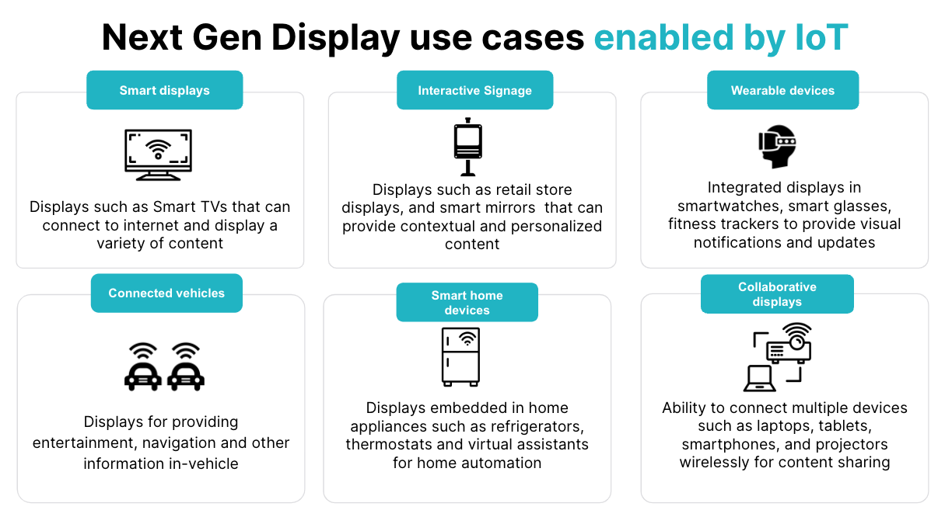

### Source: SPEEDA Edge

For instance, [Omniply](https://sp-edge.com/companies/1082998) develops delamination technology, which is used to manufacture flexible displays that can be embedded into clothing and wearable devices. Meanwhile, [Tanvas](https://sp-edge.com/companies/299798) develops tactile displays for automotive touchscreens to let drivers perceive fine textures when interacting with screens without needing to look at them. As the popularity of IoT is set to grow, with projections indicating an increase from 14.4 billion devices in 2022 to over 27 billion by 2025, it is expected to further spur innovative designs and forms of displays.

**What are the risks to growth?**

1. **Stringent environmental regulations may curtail innovation**

While next-gen displays have been pushing the boundaries in terms of picture quality and accuracy, it comes at the cost of higher energy usage. [Studies](https://www.nrdc.org/bio/noah-horowitz/tvs-may-be-consuming-12-billion-more-energy-expected) published by the Natural Resources Defense Council (NRDC) showed that watching content in high dynamic range (HDR) has been shown to increase energy use by 30% to 50%, while changing the display setting on televisions to high-quality resolutions can double its energy consumption. Other [studies](https://invidis.de/2023/02/realer-als-die-realitaet-die-magie-von-8k-content/) have shown that energy consumption increases exponentially with the quality of resolution (e.g., 8K displays use more than twice the energy as that of 4K ones).

It is in this context that more stringent regulations have been put in place, such as the [European Union’s energy efficiency labels](https://commission.europa.eu/energy-climate-change-environment/standards-tools-and-labels/products-labelling-rules-and-requirements/energy-label-and-ecodesign/energy-efficient-products/electronic-displays-including-televisions_en), which require standardized energy labeling of all electronic displays and adherence to new minimum requirements to promote eco-friendly designs. The regulations, which set a limit on energy consumption, would force manufacturers to apply energy-saving presets that restrict the use of high-consumption resolutions like 8K. Consumer surveys also reveal that these measures are likely to have an impact on consumer choices. A survey in 2019 revealed that many consumers welcome the addition of energy labeling and [79% claimed](https://energy.ec.europa.eu/data-and-analysis/eurobarometers-energy_en#special-eb-492) that it influenced their decision on what product to buy. While at present, the EU regulations exempt professional displays such as digital out-of-home (DOOH) displays, industry insiders worry that these regulations would have an impact on the development of new display technologies.

At the same time, such regulations also open up the scope for the development of emerging display technologies such as sustainability-focused displays. This can include self-powered displays such as solar-powered displays that convert sunlight into electrical energy using photovoltaic cells, reducing their reliance on traditional energy sources. This also includes energy harvesting displays that can convert ambient energy into electrical energy, which can power low-energy devices such as sensors, wearables, and IoT devices without the need for batteries or traditional power sources. A case in point is [OptoGlo](https://sp-edge.com/companies/733201), which has developed solar-powered display panels used for DOOH advertising, which can function during the day and at night.

1. **High upfront investment cost and fickle consumer tastes create adoption uncertainty**

The development of next-gen displays comes with a hefty price tag, as evident in the spending of leading display manufacturers. For example, Samsung subsidiary Samsung Displays, which develops next-gen displays, reportedly spent [USD 11 billion](https://asia.nikkei.com/Business/Technology/Samsung-to-invest-11bn-in-cutting-edge-quantum-dot-displays) for developing quantum dot displays and [USD 3 billion](https://asia.nikkei.com/Business/Technology/Samsung-Display-to-invest-3bn-in-OLED-panels-for-tablets-laptops) for developing OLED panels for tablets and laptops, while LG spend [USD 2.8 billion](https://www.business-standard.com/article/technology/lg-display-to-invest-2-8-bn-to-expand-oled-display-production-capacity-121081700226_1.html) to expand its expand OLED display production capacity.

At the same time, developers face an uncertain future, given fickle consumer tastes, which have seen certain display trends fall by the wayside. A case in point is the rise and fall of 3D television, which was building on the success of James Cameron’s 2009 blockbuster film, Avatar. This saw Samsung and Pansonic release the first generation of 3D LED TVs, which promised to replicate the same cinema experience in a viewer's living room. However, it failed to generate interest, as consumers rejected having to wear bulky 3D glasses as well as screen size limitations, which restricted how 3D can be displayed. In addition, 3D films and TV shows failed to catch on, with media providers such as DirecTV and ESPN canceling their 3D channels a few years after their launch.

Another challenge for developers is the competing display standards and formats, which include high definition (HD), high definition plus (HD+), full high definition (FHD), ultra high definition (UHD), and 2K/4K/8K. Developers face the uncertain prospect of which display standard would win out to become the dominant one. Similar “format wars” have played out in other fields including digital audio recordings (MP3 vs. MPEG), video recordings (VHS vs. Betamax), and optical disc (Blu-Ray vs. DVD) formats where a particular format sets the standard for the industry and the rest fall into obscurity. A case in point is the decline in interest in plasma display panel (PDP) televisions, which were first introduced by Pioneer in 1997 and hailed as the next gold standard in display technology for the new millennium. However, the problems of high energy consumption and burn-in (images left behind on the screen after a bright image is displayed for too long) led to declining interest and its eventual withdrawal from the display market. This creates uncertainty for display manufacturers and content developers, possibly curtailing experimentation and new innovations in display technology.

### **Noteworthy display product flops**

|  |  |  |  |
| --- | --- | --- | --- |
| **Product** | **Product image** | **Segment** | **Description** |
| Samsung Galaxy Fold  (2019–2022) |  | Flexible and foldable displays | A smartphone that was capable of being folded to provide a tablet-sized display.  This resulted in frequent breakages, which forced the firm to re-release an updated model a year later. The phone was subsequently discontinued in 2022. |
| [Samsung Curved TV](https://www.yahoo.com/lifestyle/happened-curved-tvs-why-disappeared-213032022.html#:~:text=In%202017%2C%20Samsung%20began%20to,flatscreen%20model%20instead%20of%20curved.&text=Curved%20TVs%20are%20essentially%20dead,%2D%20and%2065%2Dinch%20models.)  (2013–2016) |  | Advanced visual displays | Interest in curved TVs quickly shifted in favor of flatter, thinner, and bigger TVs. This led many developers, including Samsung, to shift their focus away from curved TVs and toward high-end flatscreen models. |
| [LG Cinema 3D smart TV](https://www.cnet.com/tech/home-entertainment/shambling-corpse-of-3d-tv-finally-falls-down-dead/)  (2012–2016) |  | Advanced visual displays | After failure to gain traction due to high prices and lack of 3D content, leading 3D TV developers including LG and Sony discontinued their respective 3D TVs in 2017. |
| [Panasonic Plasma TV](https://money.cnn.com/2014/10/30/technology/plasma-tv/index.html)  (2006–2013) |  | Advanced visual displays | Panasonic had been a proponent of plasma TVs since the launch of a 103-inch plasma display in 2006. However, its higher electricity consumption compared with LCD screens as well as burn-in led to declining sales. In 2013, Panasonic shut down its plasma screen production. |
| [Google Glass](https://www.cnbc.com/2023/03/15/google-discontinues-google-glass-enterprise-end-to-early-ar-project.html)  (2013–2023) |  | Immersive displays | First unveiled in 2013, Google’s experimental AR glasses failed to catch on in the consumer market. While the firm subsequently launched an improved enterprise successor to its AR glasses (Glass Enterprise) by March 2023, it announced the discontinuation of the product. |

### Source: Compiled by SPEEDA Edge based on news articles

However, it could be that some of these failures were due to the products being at a more experimental stage and not ready for mass markets; therefore, some of these trends may experience a revival. A case in point is the growing popularity of foldable laptops such as Azuz’s Zenbook, which consists of a 17-inch ultra-thin foldable OLED screen, or LG’s [42-inch OLED Flex](https://www.theverge.com/2022/9/1/23333515/lg-oled-flex-transforming-tv-curved-flat-hands-on) in 2022, which can transform from a flat-screen TV to a curved TV. Even in the case of the much-maligned 3D televisions, with the release of the sequel to James Cameron’s Avatar in 2022, industry commentators have renewed hope in its market potential, supported by new developments such as glass-free 3D displays like those developed by [Leia](https://sp-edge.com/companies/297458) (at a nascent stage).

**Is the future for displays crystal clear?**

Some industry commentators worry that display technologies are beginning to plateau, given the limitations of what we can perceive with our naked eye; modern displays are already so sharp they seem lifelike. However, judging by the size of the investments made by established display manufacturers and fundraising done by startups, it is clear that the race for creating the biggest, thinnest, most color-accurate, and energy-efficient screens is far from over. In addition, display technologies, such as holographic and volumetric as well as transparent and AR/VR glasses, are still emerging forms of displays yet to reach widespread adoption.

### 

### **New and emerging display technologies**

|  |  |  |  |  |
| --- | --- | --- | --- | --- |
| **Display type** | **Description** | **Technology** | **Use cases** | **Examples** |
| Stretchable displays | Displays that are capable of 3D freeform shaping including pulling, twisting, and other actions | - Light-emitting technologies (MicroLED)  - Polymer dispersed liquid crystal (PDLC) technology  - Thin-film transistors (TFTs) | - Healthcare and wellness (health monitoring)  - Transport and logistics (in-vehicle displays)  - Media and entertainment (theme park rides) | At a [prototyping stage](https://www.idetic.co.za/blog/next-generation-display-technologies); displays with 130% stretchability, convex bending up to 40°, and resolutions up to 120 PPI have been developed |
| 3D and glass-free 3D displays | Spatial reality displays that can produce 3D visualizations with and without the need for special equipment | - Laser technology  - Lenticular lens and cameras | - Media and entertainment (3D art, communications, movies, gaming) | In [March 2023](https://arstechnica.com/gadgets/2023/03/the-leia-lume-pad-2-is-a-1100-glasses-free-3d-android-tablet/), [Leia](https://sp-edge.com/companies/297458) launched Lume Pad 2, the world’s first 3D tablet that leverages AI face-tracking software and built-in stereoscopic cameras to convert 2D to 3D content without the need for 3D glasses |
| Rollable displays | Displays that can be rolled up like a piece of paper for ease of transportation and storage | - Light-emitting technologies (flexible OLED)  - Thin film transistors (TFTs)  - Flexible substrates (plastic, metal foils) | - Consumer electronics (smartphones, tablets, smartwatches) | In [April 2023](https://timesofindia.indiatimes.com/auto/news/worlds-1st-rollable-display-for-cars-developed-by-hyundai-mobis-in-south-korea/articleshow/99586782.cms), Hyundai Mobis claimed to have developed the world’s first [rollable display](https://www.google.com/search?q=Hyundai+mobis+rollable+display&oq=Hyundai+mobis+rollable+display&aqs=chrome..69i57j69i60.4963j0j7&sourceid=chrome&ie=UTF-8#fpstate=ive&vld=cid:a4aa51d8,vid:puvIS2Gx_8c) for automotive displays. The display can resize for different modes of display, such as navigation and entertainment, and disappears when the engine is turned off |
| Wearable/washable displays | Displays that can be integrated into fabrics and other soft materials and are even washable | - Light field technology  - Laser technology  - Electrically conductive transparent fibers | - Wearable devices (smart clothing, health monitoring, fitness tracking)  - Media and entertainment (artists and performers) | The technology is at an experimental stage; several types of research have experimented with smart fabrics. This includes a flexible waterproof fabric that can convert body movement into electrical energy for powering wearable devices as well as weaving fabric displays into smart clothing |
| Biodegradable displays | A more environmentally friendly alternative developed using sustainable materials that help address the problem of electronic scrap | - Electrically conductive organic and biocompatible material  - Electrophoretic display (EPD) and electrochromic display (ECD) technologies  - Biodegradable and natural substrates (cellulose)  - Light-emitting technologies (OLED) | - Healthcare and wellness (medical diagnostics)  - Retail and trade (food packaging) | The technology is at an experimental stage. In January 2023, scientists in Germany created a display that uses an organic polymer  In [February 2023](https://www.pocket-lint.com/zagg-ultra-eco-and-flex-eco-are-worlds-first-biodegradable-iphone-14-screen-protectors/), Zagg, a maker of phone accessories, claimed to have developed the world’s first biodegradable screen protectors for Apple’s iPhone, made out of plant-based materials |
| Self-powered and energy harvesting displays | Displays with an emphasis on sustainability that are capable of generating their own energy or uses renewable energy sources to power the display | -Transparent conductive layers  - Electrophoretic display (EPD) and electrochromic display (ECD) technologies | - Retail and trade (advertising signage)  - Transport and logistics (information displays) | [OptoGlo](https://sp-edge.com/companies/733201) has developed solar-powered displays used as digital signages and displays that can be used during the day and at night |

### Source: Compiled by SPEEDA Edge based on news articles and company websites

Despite market uncertainties and the fickleness of consumer tastes, the future for next-gen displays looks promising, in which consumers can look forward to a whole range of immersive and engaging visual experiences.

*Last updated: June 2023*

©2024 Uzabase, Inc. All Rights Reserved. The information contained herein: (1) is proprietary to Uzabase Inc. and/or its content providers; (2) may not be copied or distributed; and (3) is not warranted to be accurate, complete or timely. Neither Uzabase Inc. nor its content providers are responsible for any damages or losses arising from any use of this information.