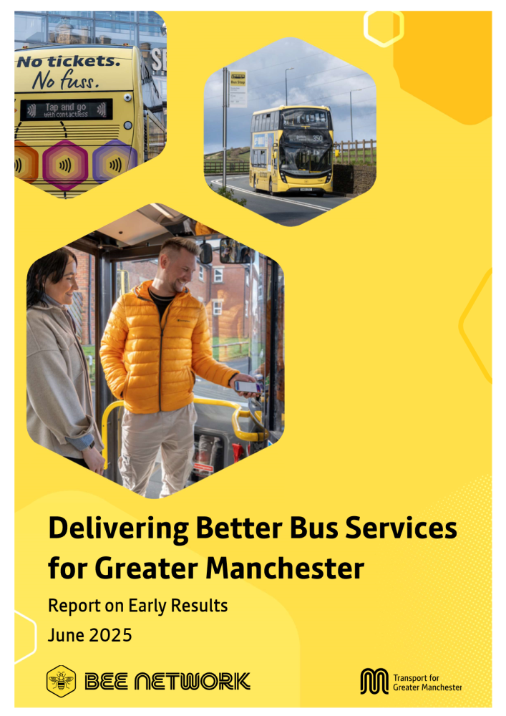

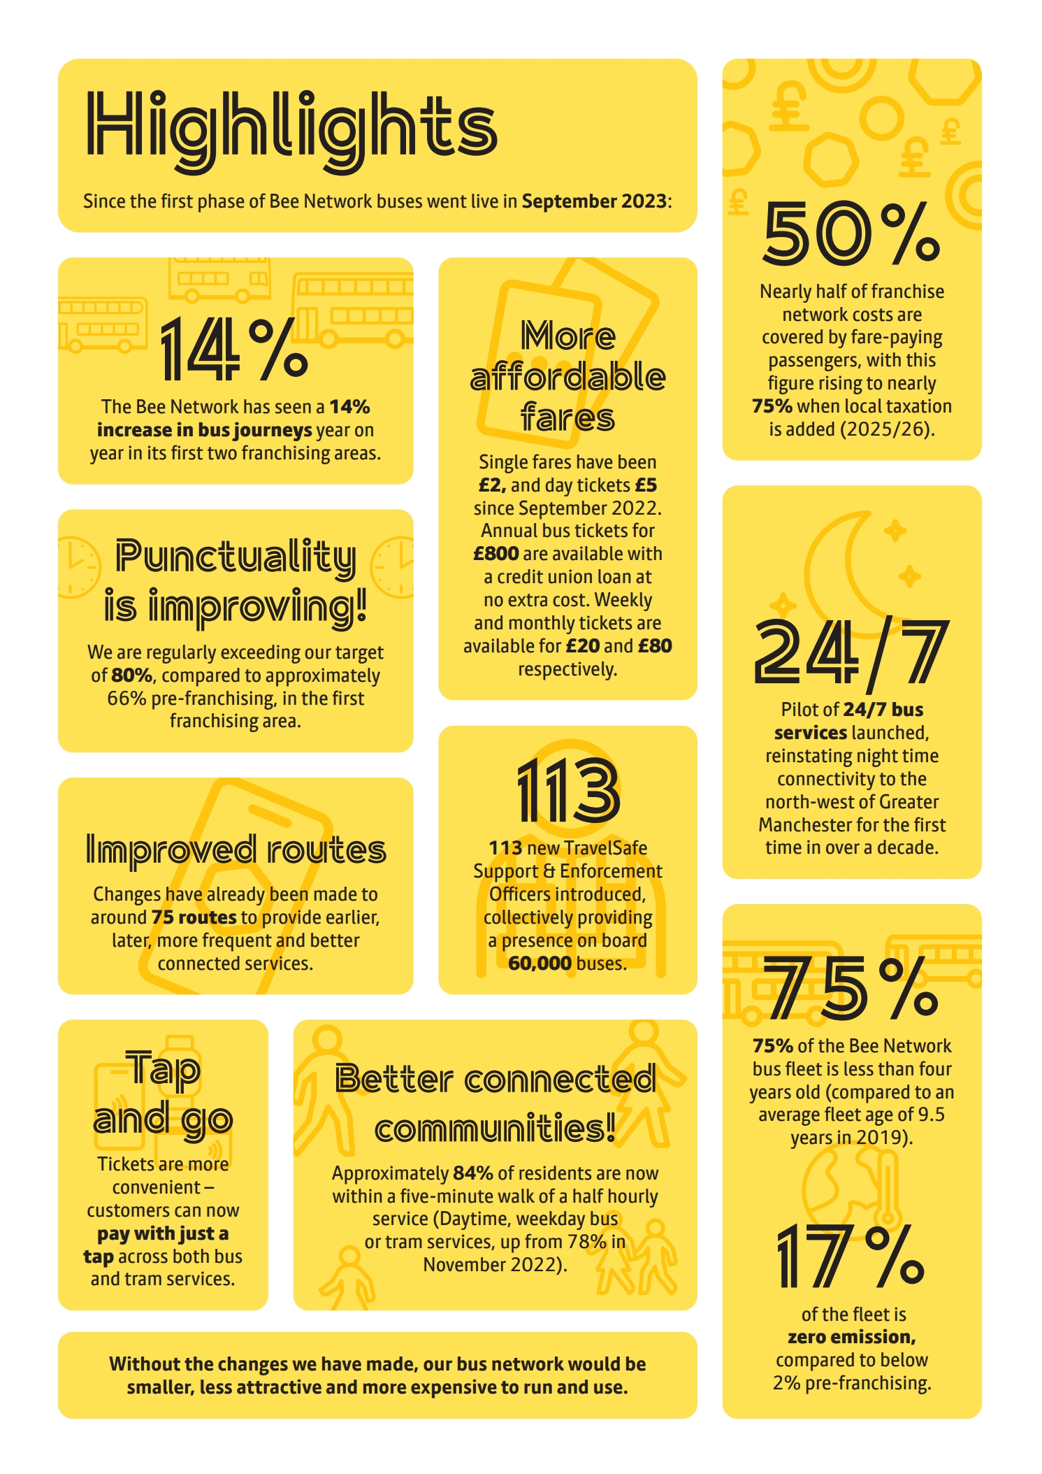

Foreword
113 TravelSafe Support & Enforcement Officers introduced, collectively providing a presence on board 60,000 buses
Through the Bee Network, Greater Manchester is delivering a fully integrated transport network, connecting people here to new opportunities, essential services and each other. As the most popular and most extensive part of our public transport system, our bus network is central to driving economic growth in our places and helping our people to live well.
In 2023, our Greater Manchester Bus Strategy set out a vision for a bus network that is the first choice for more journeys in our city region. This report sets out the encouraging progress that we are making towards that goal. Through the Bee Network, we are delivering:
- Improved reliability
- Better connectivity
- Greater integration
- More affordable fares
- A sustainable financial model for bus services
- More people choosing to travel by bus
Together, these outputs are making bus travel more attractive than ever, supporting more people to travel sustainably and helping to catalyse growth within our economy.
As pioneers of bus franchising, we know there is significant interest in what has been achieved in Greater Manchester, and we are working closely with other transport authorities across the country to share the lessons of our experience. We also recognise that, despite a strong start, we are at the beginning of our journey towards the bus network we want to build.
Over the coming months, we will develop operational excellence and growth plans that will set out how we intend to go further, working hard to make additional improvements to reliability, connecting more communities, improving the customer experience and shifting the way people travel around Greater Manchester.
Our achievements to date are significant and are testament to the hard work of all involved. The strong partnerships we have developed and deepened with Bee Network operators, trade unions and our local authorities have been key to this success.
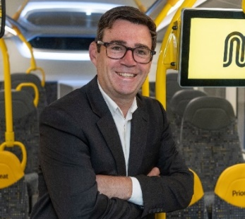
In particular, I am grateful to the thousands of drivers, engineers and other bus staff who deliver this key public service for Greater Manchester every day. The successes set out within this report reflect their dedication and commitment to their communities.
Andy Burnham
Mayor of Greater Manchester

Introduction
Greater Manchester is the first place in the UK to take back control of its bus network. After forty years of decline and deregulation, the transformation of our city region’s most used form of public transport is well underway.
As part of the Bee Network, our integrated transport system for Greater Manchester, we’re delivering better buses that support our wider ambitions as set out in the Greater Manchester Strategy, and our vision for the transport network, described within our Local Transport Plan. As the most popular form of public transport, buses have a key role to play in helping make Greater Manchester a thriving city region where everyone can live a good life.
The bus system we inherited was unable to support this goal; it was expensive, shrinking and almost entirely unintegrated. In 2022/23, the Greater Manchester bus network was almost 40% smaller than in the 1970s and bus usage was struggling to recover from decades of fragmentation and more recent impacts of the COVID-19 pandemic. A ticket for a single journey could cost up to £4.50 and, on some routes, customers could expect their bus to be late a third of the time.
It was clear that, without reform, the bus system would not be able to support our ambitions for Greater Manchester.
Since the launch of Bee Network buses in September 2023, things have changed – for the better. Stand on almost any main road in Greater Manchester and the difference is visible: newer, yellow buses – almost 1 in 5 electrified – starting to come more frequently and more reliably, carrying more people to more places.
What’s more, changes have been made to improve people’s experience of taking the bus. Fares are more affordable, more integrated and simpler than before the Bee Network; customers can buy a £2 hopper ticket with just a tap of their bank card. We’re doing more than ever to ensure people are safe on the network and – almost as importantly – feel safe when using it.
And in doing all of this, we are getting better value for public money: in a deregulated system, Greater Manchester would be paying more to retain the network it had pre franchising.
Without the changes we have made, our bus network would be smaller, less attractive and more expensive to run and use. Instead, thanks to our strong partnerships with local authorities, Bee Network operators and communities across the city region, Greater Manchester now has a network that is stable and growing, with opportunity for greater enhancement and growth in the future.
This document outlines what we set out to achieve for our bus services through the process of bus reform, what has been accomplished so far and, as we look ahead to the next phase of the Bee Network with the integration of local rail services, some of our ambitions for the future.

Scale of Change
Bus reform – and franchising specifically – has represented an enormous effort, undertaken by Transport for Greater Manchester and the Greater Manchester Combined Authority on behalf of the city region. The headlines below highlight just some of the elements involved in improving our bus services since the decision to franchise was made in March 2021.
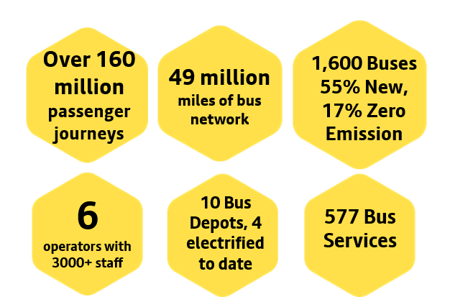
The first phase of franchising began operations in September 2023 and the whole network was fully franchised in January 2025.
Like any change of this scale, while early indications are positive, the full benefits and impacts of franchising will take several years to come to fruition; monitoring and evaluation will be undertaken over the coming years.

Initial ambitions for Bus Franchising
Buses carry more people than any other form of public transport in Greater Manchester, making up 75% of all public transport journeys here. They play a critical role in supporting people to access economic opportunities and essential services. Given the scale of the bus network, additional local control was an essential part of creating an integrated transport system for the city region, and driving our wider ambitions for our people and places.
Recognising the importance of buses, Greater Manchester’s leaders have made the case for greater local control of the bus system ever since its deregulation in 1986. Their tenacity was rewarded in 2017 with the passage of the Bus Services Act which, for the first time, allowed mayoral combined authorities outside of London to franchise local bus services.
As part of the process set out in the Act, Greater Manchester was required to undertake a ‘Franchising Assessment’, setting out the case for bus reform. This assessment highlighted a dramatic decline in bus usage even before the COVID-19 pandemic: between 2008/09 and 2017/18, annual bus usage fell from 233 to 194 million trips, a 17% decrease.
The assessment reflected on the challenges within Greater Manchester’s deregulated bus market that contributed to this decline:
- Above-inflation fare increases
- A lack of co-ordination between competing bus operators and with the Metrolink and rail networks
- Services not being provided where there was social and / or economic need
- Complex fares and ticketing which disincentivised use
- Reduced number of commercial operators and declining competition in the market
The assessment also noted a range of other external factors that supported the case for a different way of providing bus services:
- A declining number of trips per person in the city region
- An increase in car ownership and relative reduction in costs of car use
- Congestion affecting traffic speeds
- The need to improve air quality and decarbonise
- Technological change, such as the development of app-based ride-hailing platforms, which made buses less competitive
With these factors in mind, the assessment recognised that, without change, Greater Manchester’s bus system would not be able to support our significant ambitions for the city region and its people.
Through franchising, Greater Manchester finally has a mechanism to integrate transport services into a single network, helping us fulfil the long-held ambition of joining up our buses with Metrolink, the largest light rail network in the UK, local rail services and active travel.
We now have the control to specify services to support our people and places and use buses to help deliver a thriving city region where everyone can live a good life.
Although the initial case for bus franchising envisaged that the bus network we inherited would remain largely unchanged for several years after franchising, we have however been able to deliver greater improvements, sooner than envisaged, benefitting passengers now and into the future.
Our Greater Manchester Bus Strategy, published in July 2023, set out our ambitions for the network. By 2030 we want:
- To increase bus usage by 30% from 2022/23 levels to 200 million journeys a year.
- 90% of Greater Manchester residents to be within 400m of a half-hourly daytime bus or tram service.
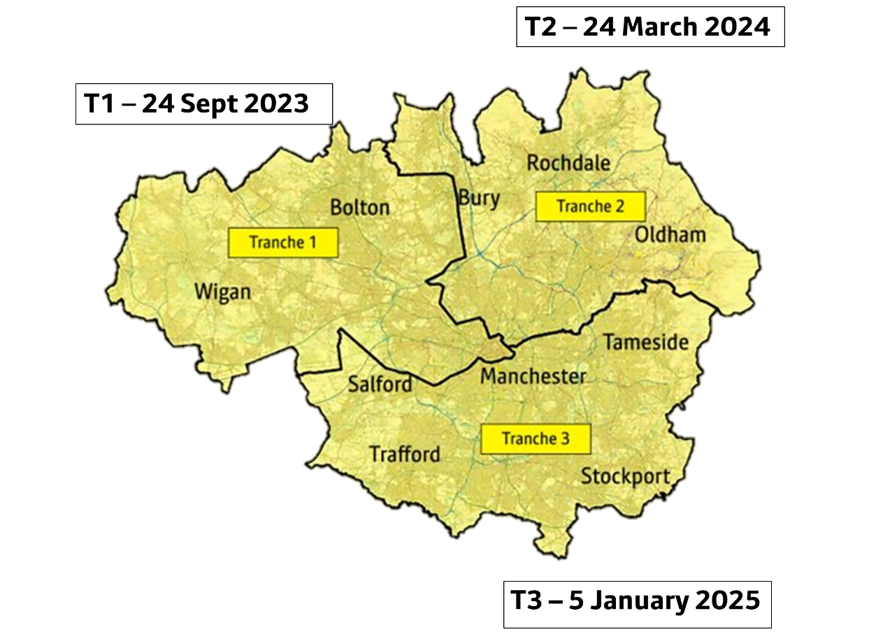
Delivered in three tranches between September 2023 and January 2025 (see map below), franchising has given us new tools to achieve these ambitions; not least the ability to improve our understanding of how customers use services and how they’ve reacted to the changes.
This delivery report sets out the reforms Greater Manchester has made to its bus network since 2021 and considers the early impacts that they have had to date. These developments are grouped around the headings below:
- Customer experience
- Service delivery
- Bus usage
- Finance

Customer Experience
Customers and their needs are at the heart of our plans for Bee Network bus services. We’re working hard to deliver the improvement in customer experience that will contribute to a 30% increase in bus usage by the end of the decade, both for new passengers and existing bus users.
Transport Focus 2024 surveys of adult bus users on Bee Network buses in Greater Manchester reveal the following purposes for bus travel on the city region’s franchised services. This gives a good idea of the sorts of economic and social activity being supported by the bus network:
- Work commute 38%
- Shopping trip 21%
- Education 14%
- Visiting friends/relatives 8%
- Leisure trip 7%
- Medical/ other appointments 5%
- Other purposes 7%
Core to delivering on our ambitions for bus users are our customer commitments, launched just prior to franchised bus services, which set out our promise to customers. Developments relating to these commitments are set out below.
- Safe - We will create a safe and secure network
- Accessible - Everyone can use us
- Affordable - We will keep the cost of travel as low as possible
- Reliable - We will deliver a reliable network*
- Sustainable - We will take the lead in creating a greener, healthier Greater Manchester*
- Accountable - We will use your feedback
*Addressed under ‘Service Delivery’ below

Safe
We are creating a safe and secure network, where customers can be confident they can complete their journey without experiencing anti-social behaviour or feeling unsafe. We know this is especially important for women and girls using our network, many of whom told us, before the Bee Network, that they do not feel safe when using public transport. We are working hard to change this.
- We’ve introduced 113 new TravelSafe Support & Enforcement Officers across our bus network, providing guidance and preventing anti-social behaviour. Since September 2023, these officers have responded to over 6,000 incidents, including harassment, drink and drug related, vaping, thefts and property damage.

- Between September 2023 and the end of April 2025 TravelSafe Support & Enforcement Officers have also delivered the following:

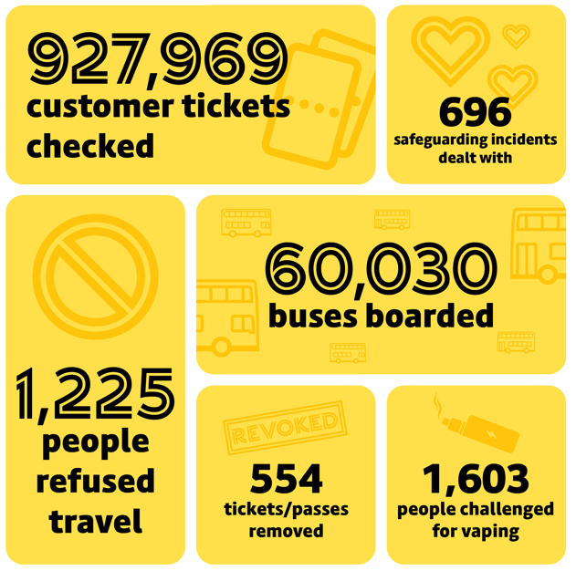

- Over 90% of Bee Network bus passengers see the presence of TravelSafe Support and Enforcement Officers as effective at stations/interchanges (92%), with 81% seeing them as effective on the bus.
- We have installed CCTV cameras on buses to provide reassurance to bus users.
- TravelSafe LiveChat was added to the Bee Network app in May 2024 to provide customers with a direct link to contact Greater Manchester Police inconspicuously. From October 2025, this will become a dedicated transport live chat.
- We’re also working closely together with the Greater Manchester Police Transport Unit, who treat the transport system as an ‘eleventh district’ of Greater Manchester, supporting greater visibility and integrated working with TravelSafe officers.
- We published our Vision Zero Strategy and Action Plan in November 2024, aiming to eliminate road death and life-changing injury by 2040, with a target to achieve a 50 per cent reduction by 2030. We’re now working with operators and trade unions to develop a Bee Network safety plan that responds to the Strategy.
- Alongside our pilot of 24/7 bus services, we have worked with Strut Safe, a UK-wide phone line that keeps customers company when walking alone, helping them to feel safe until they arrive home.

Perceptions of personal security have improved between 2023 and 2024 in our Network Principles Survey. For example, rising from 61% to 66% across Greater Manchester for ‘personal security waiting at the bus stop at night’, and from 65% to 70% for ‘personal security while travelling on the bus at night’. Improvements have also been seen in perceptions of safety ratings of Bee Network services overall when waiting and onboard in the quarterly customer surveys during 2024.
Have to be aware and Piccadilly Gardens can be a bit scary, but there is security now which make me feel safe
36 night bus passenger travelling to/from a place of work, 2024

Clean modern bus with lots of room. Love the extra space for wheelchairs and prams. Nice having random bee network person on there too who helped with the ramp and made us feel a lot safer. Loving the bee network :)
192 passenger, 8 Jan 2025, 1:15pm

Love the bee network. Staff are all lovely, on the buses, at the interchange and the travel safe officers. Stockport interchange is fantastic and the new hopper tickets are ideal. Thank you so much for all you do
325 passenger, 14 Feb 2025, 1:45pm

Accessible
We want a network accessible to everyone in Greater Manchester – that means creating a network that is physically accessible, but also easy to understand and use. We are working with local advocates and communities to improve the information at and accessibility of bus stops and buses, so that everyone in Greater Manchester can use the Bee Network. In November 2024, the Committee appointed its first ever Disability Advocate, Cllr Tracey Rawlins, who will work with us to effectively voice the needs and experiences of disabled people in relation to the public transport network and walking/ wheeling/ cycling provision.
- We have an ongoing programme of works to improve level access boarding at bus stops, with over 30 bus stops upgraded in 2023/24-2024/25 as part of improvements to local walking conditions.
- We have established a new standard for Bee Network buses, with upgrades in process to ensure that all vehicles meet these requirements. Two thirds of the fleet (68%, May 2025) now meet this standard, which includes:
  - Two spaces for wheelchair users and access ramp
  - Hearing loop
  - Audio-visual announcement system
- Alongside franchising, we launched a new Bee Network app, co-designed with TfGM’s Disability Design Reference Group, which provides real time tracking and journey planning alongside timetables and ticketing information for both buses and trams. As of April 2025 there were 445,000 monthly active users of the app (unique users), from almost 1 million downloads (972,000 as of 27 April 2025). The app means customers can have transport information for the whole of Greater Manchester in the palm of their hands, wherever they are.
- An app to support getting around key transport interchanges, known as GoodMaps, was launched on a trial basis in March 2025.
- In March 2025, we introduced ‘Tap and Go’ ticketing on our buses, making travel simpler and easier by automatically calculating the cheapest fare for customers. ‘Tap and Go’ has also enabled contactless, multi-modal, capped payments across bus and tram for the first time and would not have been possible without a franchised bus network.
- Beginning in Autumn 2024, we are providing dementia awareness training to all our frontline staff, helping them to ensure that people living with dementia have the support they need to navigate the Bee Network with ease. We have worked with the Alzheimer’s Society and local dementia campaigner Joy Watson to put training in place for frontline staff including bus drivers, TravelSafe Support and Enforcement Officers and those working in transport interchanges.
We have delivered a new, award-winning transport interchange in Stockport town centre in 2024, greatly improving passenger facilities and catalysing development in the surrounding area.
Those areas that have been franchised the longest are beginning to report the benefits of this approach. People in Bolton and Wigan who do not have access to a car have reported that their ease of travel to access key destinations has increased.
Friendly driver. Parked bus right by kerb and lowered it when he saw we had a wheelchair. Offered to do ramp too and showed us how new ticket machines work. I Like the enviro 400mmcs that have just appeared they are nice and clean and comfy the MX08 ones were getting a bit tired.
325 passenger, 6 Jan 2025, 1:30pm

Affordable
We know that bus users in Greater Manchester are more likely to be from communities with higher levels of deprivation than other forms of transport.
Before 2022, bus users in Greater Manchester were faced with a confusing array of tickets, which had consistently risen in price ahead of inflation. Since then, we have intervened, lowering the cost of bus travel by flattening fares and introducing discounted multi-modal products.
- In September 2022, Greater Manchester was the first place in the country to introduce £2 single fares, alongside £5 day tickets, reducing the effective average fare for bus users by about 20% and increasing bus usage by c. 5%. Around three quarters of those who used the new £2 and £5 bus ticket offers reported that the new fares had been helpful to their cost of living.
- At the launch of the first phase of franchising in September 2023, we introduced a new multi-modal product, lowering the cost of travel on bus and tram by up to 30%.
- With the full franchising of Greater Manchester’s bus network in January 2025 we introduced a number of new products:
  - A ‘Hopper’ fare, allowing unlimited travel on Bee Network buses within 60 minutes, supporting people who need to change buses on their journey.
  - Annual Bus tickets, allowing unlimited travel on Bee Network services for £800, available with a credit union loan at no extra cost. Customers can spread payment for this ticket, paying £15.38 per week and saving c.£240 over the course of a year. A multi-modal variant is also available through credit unions.
- At the same time, we ‘flattened’ existing fares, reducing the cost of an adult weekly ticket from £21 to £20 and a 28-day ticket from £84.50 to £80.
- ‘Tap and Go’ contactless, multi-modal ticketing across bus and tram was introduced in March 2025, finally realising our ambition for a fully integrated ticketing system. There have been over 5 million taps to date (May 2025), making up over 30% of adult fare-paying bus boarding transactions, ahead of expectations.
Satisfaction with fares overall, across all types of public transport, has jumped from 63% in 2022 to a record high of 82% in 2024. A remarkable 73% of Greater Manchester residents also perceived their fare as good value for money in 2024 - the highest level since 2016.
I had my £3 ready to buy a single to get home after a long day at work. I was surprised when the bus driver said it was £2. Read up about tickets for the BN and it's fantastic. The single hopper is a bargain, plus the weekly pass for £20. Guys this will help so many people in Manchester. Thank you.
Passenger, Longsight, 14 Jan, 7:53pm

The bus driver was very friendly, informing everyone who bought a single ticket that it can be used again within the hour (I didn’t know that).
Passenger, Piccadilly, 8 Jan, 8:35pm

Accountable
The Bee Network belongs to the people of Greater Manchester. We therefore need to be responsive to their needs and support them with a high standard of customer care if things go wrong.
- Our franchising contracts require high standards from operators and incentivises them to provide a good service.
- We publish reliability data from services on our website weekly.
- We’ve worked with Greater Manchester’s constituent authorities to create local forums and committees to shape the development of the Bee Network in their area.
- Since franchised bus services began in Greater Manchester, we have asked bus users to ‘rate their journey’ through the Bee Network app. Since its launch we have had 31,842 pieces of feedback about our bus services (to 6 May 25), which have been used to enhance services and improve our offer to customers.
- We convene the Transport Workforce Engagement Board, bringing together operators, trade unions and Transport for Greater Manchester to promote high employment standards across the Bee Network.
Since April 2024, residents’ agreement that the Bee Network is run in the interest of the people of Greater Manchester has steadily improved to 64% in March 25 (was 52% in April 24).
A belief that fares are set in the interests of the people of Greater Manchester is the most influential factor in fare payers’ sense of value for money, increasing from 56% in 2016 to 70% in 2024.

Service Delivery
Franchising has given us control of buses in Greater Manchester, allowing local leaders and residents to direct the growth and development of the network as part of one coherent system, responding to demand, our growing centres, and helping to reverse the decline in bus use. Since the first phase of bus franchising went live, we have worked to improve the way bus services operate in Greater Manchester, meeting customer needs and those of our city region.

Fleet and sustainability
We have upgraded the bus fleet in Greater Manchester, replacing old buses with new, bringing in cleaner, greener electric vehicles and improving interiors and their cleanliness.
- By April 2025, more than half (55%) of Bee Network buses are new and 75% of the fleet is less than four years old (compared to an average fleet age of 9.5 years in 2019). 17% of the fleet is zero emission, as of May 2025, relative to just below 2% in 2022.
- Early evidence suggests that changes to the fleet have contributed to improved air quality in Greater Manchester.
- We’re working with operators to upgrade all bus interiors to the standards of the Bee Network, with 68% completed to-date, as of May 2025.
- Cleanliness standards are built into the franchise contracts, requiring operators to keep buses clean and tidy.
- We have provided electric charging facilities at four depots, with more to follow in the coming years. We are also working with Go North West to trial converting existing diesel buses to electric traction.
Clean new bus. Next stop announcements working - audible good upstairs at back of bus.
135 passenger, Manchester, 5 Mar 2025 3:19pm
Driver stopped to let an elderly lady off outside her house between stops as it was snowing, which was very much appreciated by her and fellow passengers.
345 passenger, 7 Jan 2025, 12.30pm

Nice friendly driver. Electric bus - lovely and quiet, smooth and clean. 203, 9 March 2025, 10am

Reliability and network performance
Reliability and punctuality are key priorities for our customers – they need to know that their bus will arrive when it’s expected and get them where they need to go on time. We’re using the tools provided by franchising to give Greater Manchester better, more reliable buses; services in the first franchised area are now routinely exceeding our 80% punctuality target. In March 2025, on time punctuality across the whole network was 75.8% compared to 71.6% in March 2024 (when only c.20% of the network was franchised). We know there is more work to do but are proud of the improvements to punctuality that we have already seen: these figures compare to around 67% for the whole network in the 12 months pre-franchising (noting the measurement source has also changed).
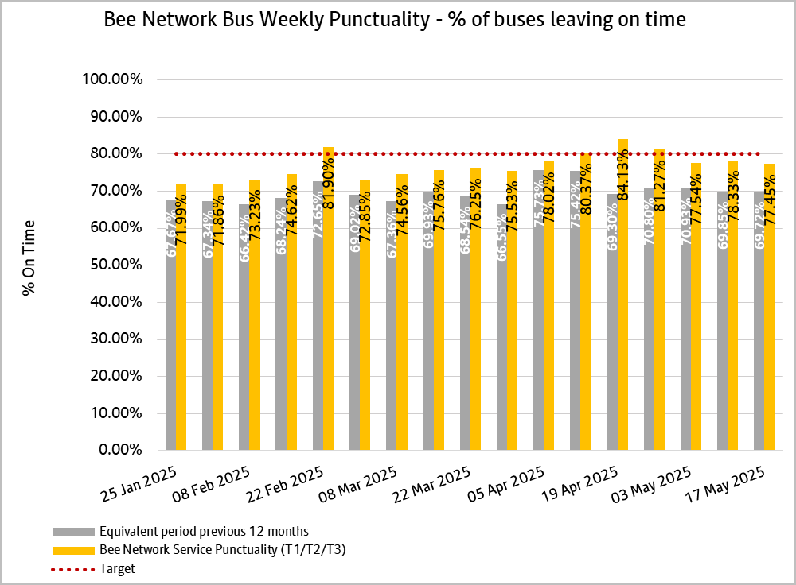

A range of initiatives to improve the performance of franchised bus services are being delivered including service improvement measures, priority for late running buses at traffic signals and tackling the impact of roadworks through closer working relationships with districts and roadwork promoters.
- The traffic signal estate continues to be used as a key tool for managing bus journeys and priority for late running buses is enabled at 229 junctions within Greater Manchester. More than one in four junctions (around half of the locations feasible) are now providing priority for public transport and funding is now earmarked for public transport priority at an additional 200 junctions.
- Working with our local authority partners, we recently completed a new ‘red route’ on the A56 corridor between Bridgewater Way and the M60 via White City Circle in Trafford, the largest of its kind so far in Greater Manchester. It means strictly no stopping at any time (except for exempt vehicles), which ensures more reliable journeys for everyone, supporting bus service performance along this key corridor.
- We’re working with local highways authorities to introduce new bus priority measures on highways, with a larger programme to follow. This includes considerations of future ‘red route’ locations.
- We’ve introduced a performance regime through franchising that incentivises Bee Network operators to ensure services run on time.
- Where reliability has been an issue, we’ve introduced more vehicles at peak times on a number of routes to ensure the timetable is maintained (20 additional buses in Wigan and Bolton with a further 20 in Oldham and North Manchester). Services in the first franchising area with additional vehicles have seen their punctuality increase by 15% since franchising.
- We have looked at our worst performing routes and started to improve them by working directly with drivers to highlight pinch points (e.g. parked cars blocking buses) and to fix them as quickly as possible.
- We’re using our newly available data to optimise routes and deliver more reliable journeys.
- We are also developing our case for a Lane Rental scheme that would incentivise utilities to reduce the duration of road works.

Network connectivity
Franchising is key to delivering our target for 90% of Greater Manchester residents to be within 400 metres of a half-hourly daytime bus or tram service.
With control of the network, we can connect more customers to our buses and increase the number of services that run on key routes. We are adapting services to their users, setting high frequency routes, extending operating hours to support late night and early morning commuters, and establishing the processes that will help us continually improve our service over time.
Thanks to our interventions, we now meet our target for 83.9% of the Greater Manchester population (up from 78% in November 2022).
- Since taking control of the network, we have upgraded or restored twelve routes to high frequency (every 12 mins or better, these are shown overleaf). There are now 41 high frequency bus routes across the city region, compared to 29 pre-franchising.
- We have introduced pilot services between Bolton, Leigh and Manchester, operating 24 hours a day, seven days a week, providing important connectivity for our nighttime economy.
- We have introduced a new bus service (615) connecting communities between Wigan and Bolton.
- Changes have already been made to around 75 routes to provide earlier, later, more frequent and better-connected services, in many cases aligning to tram and train times to join-up onward journeys.
- We have amended and altered routes and timings to suit local demand better and are now starting our first Network Reviews, working with local communities to shape the network to meet their needs.
- Early indications from a Mode Shift survey (August 2024) suggested that almost two in five of those using the bus more were also walking more (39%), likely the first and last mile to and from bus stops.
Before, I had to get taxis everyday, and it cost me a fortune. Now I just use my weekly bus pass.
36 night bus passenger travelling to/from a place of work

Much needed new service, driver very pleasant
615 passenger, 19 Nov 2024, Middlebrook, 1:46pm

The 575 bus was a double-decker (left Aspull around 3pm and I got off at Blackrod Rail Station to connect with my train) Good that the service is running the proper route now and not missing out the rail station Enough seats on board so nobody had to stand up. The bus turned up when I expected it and arrived on time at my stop.
575 passenger, 21 December 2023, Blackrod Rail Station, 3pm

The map below demonstrates how, with public transport under local control, Greater Manchester is making major progress toward a fully joined-up, high frequency integrated network. Providing higher frequency bus services on popular routes is vital to boost passenger numbers, as well as support economic growth, better link residents to job and education opportunities and reduce congestion.
In addition to the 83.9% of residents within 400 metres of a half-hourly service, more than 1.2 million people in Greater Manchester – 43.7% of the total population – live within walking or wheeling distance (400 metres) of a high frequency (every 12 minutes of better) daytime Bee Network bus or tram service shown on the map below, with plans to add additional lines in the near future.

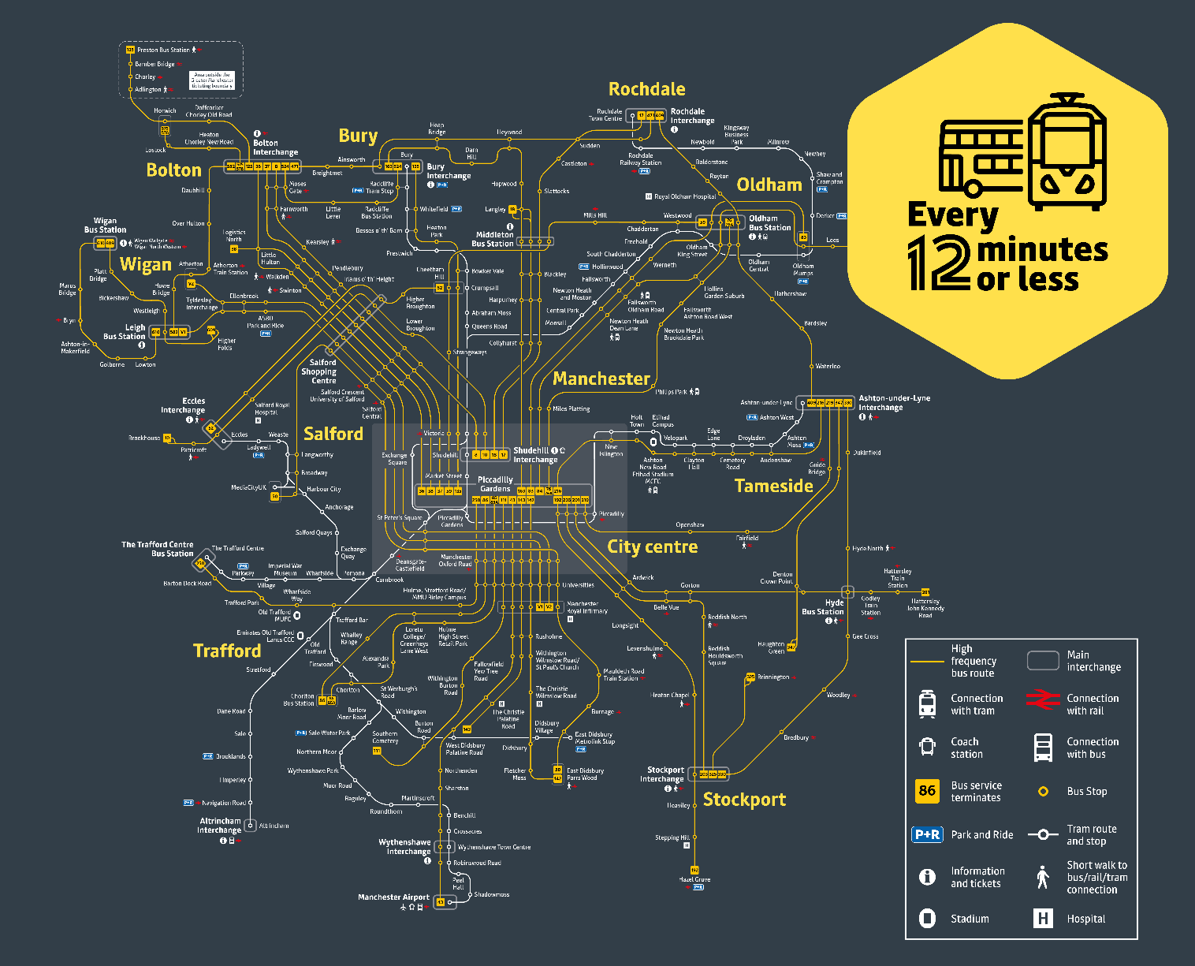
A map of high-frequency bus and tram services across Greater Manchester:

Bus usage
We have seen strong growth in bus use in Greater Manchester since services were franchised, reversing the long-term trend of declining usage. Our goal of 30% growth by the end of the decade remains ambitious, but we have already seen 14% growth in bus usage year-on-year in the first two franchising areas.
Every city is different, but Greater Manchester’s bus use is growing faster than many other metropolitan areas. National data shows that between March 2022 and 2024, bus use here grew faster than every other comparable area but West Yorkshire.
Bus use across England was supported by the recovery from the COVID-19 pandemic and £2 fares across the country; since then, we have made our own improvements to increase usage including, flattening fares and increasing service frequencies.
A comparison of metropolitan areas for 2024/25 will become available in autumn 2025.
Post-franchising, the Tranche 1 area has seen annual bus usage growth of 14% from October 2023 to end-March 2025. This is shown in the following chart.

The most popular services during March 2025 were all in Tranche 3 – the 192 c. 858,000 journeys, the 143 c. 445,000 journeys, and the 43 c. 350,000 journeys. The 192 alone made up 11% of Tranche 3 bus use, and 5% of overall network bus use in March 2025.
The most popular services in Tranche 2 were the 135 c. 299,000 journeys, the 409 c.298,000 journeys, and the 17 c.274,000 journeys. In Tranche 1 the most frequently used services were the 36 c. 256,700 journeys, the 471 c.256,300 journeys, and the 163 c.229,600 journeys (1st-31st March 2025).

Finance

Funding the transition
Delivering bus reform has been a key priority for Greater Manchester since the Bus Services Act was passed in 2017. As such, much of the funding that has supported the process has been locally assembled. It included:
- £78m of Mayoral ‘Earnback’ Funds from Greater Manchester’s Devolution Agreement – funding from central government in recognition of the increase in central government tax receipts resulting from franchising
- £33.7m of Mayoral Precept contributions
- £17.8m of Local Authority Contributions
- £5m in existing and forecast business rates pooling held by GMCA
Total = £134.5m
£134.5m
Transition Funding

Bus franchising was delivered on time, in January 2025, and in line with the £134.5m transition funding budget. In fact, implementation costs (e.g. on-bus equipment and technology etc) were £18m below budget, which in turn allowed TfGM to provide further necessary support to stabilise the deregulated market whilst it was in transition to franchising and whilst the sector was still recovering from the pandemic.

Ongoing bus network funding
Overview
With the transition to franchising now complete, we are moving to a funding model for bus services in Greater Manchester that is sustainable for the long term. On an ongoing basis, nearly 50 per cent of the franchise network’s costs are covered by fare paying passengers. Taking in local taxation, over 75 per cent of the network’s costs are covered by local, recurrent funding sources. The remaining funding predominately comes from Greater Manchester’s Integrated Settlement which under increased fiscal devolution, pools previously siloed sources of public transport funding into a single fund (e.g. Bus Services Improvement Grant, Bus Services Operators’ Grant and City Region Sustainable Transport Settlement).
Greater Manchester has chosen to keep fares low and to maintain – and in places, grow – our bus network. Whilst this means the network has required ongoing subsidy, this is fully funded and our experience so far shows that this is contributing to increased bus usage which will deliver a wider set of economic benefits (e.g. decongestion, air quality, climate etc). In time, the additional revenues generated from these journeys will increasingly contribute to the additional costs of providing a better service.
While franchising has enabled these choices, they are not inherent to this model of bus service delivery. Nonetheless, investing in our network in this way is delivering improvements for bus users – but also for the Greater Manchester economy as whole. The Confederation of Passenger Transport estimates that every £1 of government funding in buses has contributed £4.55 in benefits.
2025/26
Total Income
£390m
2025/26
Total Expenditure
£390m

Cost recovery
Even with reduced fares, including a £2 adult single, fare paying passengers are forecast to cover almost 50% of the cost of operating Greater Manchester’s bus network in 2025/26. This compares favourably to most franchised markets in Europe.
Locally funded and towards financial sustainability
Together, fare payers and residents contribute over 75% of the funding required to operate the franchised network. The Integrated Settlement funds nearly 20% of the remaining requirement This means that despite the dual challenges of COVID and inflation hitting the sector, our bus network funding model currently only requires c.5% of non-recurring funding (e.g. Reserves) and it is expected to require no non-recurrent funding over the next 3-4 years.
An investment in Greater Manchester
Even with a sustainable funding model, more Government funding is vital to keep building on the success and should be seen as an investment in economic growth, not a cost. A recent study by IPPR North indicated that every bus mile lost between 2011 and 2023 has cost the economy £6.50 in growth.
Wider benefits
Franchising has also been supported by c.£300m of central government capital funding (City Region Sustainable Transport Settlement and Zero Emission Bus Regional Areas funds), local borrowings, and operator investment in decarbonising the fleet and depots, over and above the transition funding. Decarbonising the bus fleet is vital to meeting national and city region net zero targets but also delivers key local benefits like cleaner air. These wider benefits that result from a better, more affordable and cleaner bus service promotes modal shift, reduces congestion and avoids future costs associated with carbon.

Emerging value for money case for franchising
Franchising in Greater Manchester is still in its infancy, so it is not yet possible to draw definitive value for money conclusions on the adoption of franchising versus the deregulated model. Equally, little work has been done nationally to show the true costs of bus deregulation and the ongoing requirement for local transport authorities to subsidise ‘socially necessary’ services.
One rudimentary ‘value for money’ indicator that is available is the clear difference between the profit margins of franchised operators and those of deregulated operators.
The long-run historical profitability of the deregulated bus sector has seen profit margins in the range of 7-10%. The COVID-19 pandemic has clearly affected this, but many large operators are gradually returning to those levels. Franchised operator margins in GM and in London typically see targeted margins below this level.
We estimate that increasing the Greater Manchester operator profit margin to the deregulated target operating margin would add significant contract costs.
Mitigating that cost increase would require – either:
- A reduction in the overall size of the network
- Removing the least profitable routes
- Increasing fares significantly
- Increasing the Transport Levy on Greater Manchester local authorities
Or a combination of all of the above.
In short, a deregulated market could not provide the same sized network for the current cost of franchising.

What our customers are saying
The creation of the Bee Network and delivery of bus franchising mean that we now have a direct relationship with customers, allowing us to listen to them and put them at the heart of operational decision-making. Quarterly customer surveys show us that just before the Tranche 1 transition (Aug/Sept 23), satisfaction among all public transport / active travel users with the Bee Network (all forms of transport) was 60%. In March 2025, overall satisfaction with the Bee Network (all forms of transport) among the same group had increased to 85%.

Customer agreement with the statement “the Bee Network cares about its customers” has been steadily increasing to 71% in March 2025, up from 66% in March 2024.

The net promoter score – those who would strongly recommend the Bee Network (public transport / active travel) minus those who give a low recommendation – has risen over time to +34 points in March 2025 for all public transport / active travel users; up from +24 in September 2024.

Agreement has been steadily rising that the Bee Network is something Manchester can be proud of (66% in March 2025, 50% in April 2024) and is part of Manchester’s culture (56% in March 2025, 42% in April 2024). This brand recognition is remarkable, given the short time the Bee Network has existed.

As we look to the future, our customers are keen for us to continue improving services, including: the wait for the bus, punctuality, frequency, reliability and, just as importantly, predictability via information and communication during disruption.
Friendly driver. Nice clean comfy bus. Brilliant having Changing Places Facilities at both Stockport and Ashton Interchanges :) 330 passenger, Ashton, 10 Feb 2025, 1:47pm
Nice clean new bus. On time. Not too busy. Parked really close to kerb so very easy to board using a wheelchair.
325 passenger, Interchange, 4 Feb 2025, 8:24pm
Great having the £2 Hopper tickets! Nice clean new buses that are sort of on time, but so often it doesn’t really matter. Feel safe seeing all these travel safe people on the network - glad they are here on 325 and not just the 192 all the time.
325 passenger, Brinnington, 20 Feb 2025, 11:20pm

What’s next?
The Bee Network has driven significant improvements across our bus system and demonstrated the value that franchising can deliver. We are proud of the improvements that have been made here since 2022.
Nonetheless, with the whole bus network finally under local control, there is still more we can do to ensure buses deliver for Greater Manchester. We are now preparing Operational Excellence and Growth Plans that will support continuous improvement and increased growth in bus usage on the Bee Network for years to come.
At the same time we will use the lessons we have learned from the process of bus reform as we drive forward the next phase of the Bee Network, integrating local rail services into our transport system.
By continuing to listen to our customers, we will focus on meeting our customer commitments, reviewing the Bee Network to understand where it can be improved, managing and adapting streets to prioritise buses and alleviate congestion, and helping all residents to access opportunities, essential services and each other.
Safety | - The Bus Services Bill will enable us to introduce new provisions and powers to tackle antisocial behaviours on buses  - We will continue to install infrastructure to improve safety and perceptions of safety, including enhanced CCTV on buses, better lighting at stops, improved lighting and CCTV at interchanges, crossings in close proximity to stops and more real-time arrival information  - Hundreds of new shelters will be installed in the next 2-3 years  - We continue to work towards achieving Vision Zero: zero road deaths or serious injuries on Greater Manchester roads by 2040 and are working with our operators to develop a Bee Network Safety Plan to further enhance road safety  - We will continue to deepen our partnership working with Greater Manchester Police and support their approach to the network as an ‘eleventh district’ of Greater Manchester  - Dedicated transport LiveChat will launch in October 2025, providing further reassurance for customers when using the network
Accessibility | - All buses will have audio-visual announcements from October 2026  - We’re working towards all buses having hearing induction loops and two spaces for wheelchair users  - 500 bus stops will be upgraded by 2030 to improve accessibility, including level boarding via raised kerbs and places to rest, new shelters are being procured  - We require accessibility training for bus drivers and are providing dementia awareness training to all our frontline staff  - We are about to start installing over 300 real time displays at bus stops across the network  - We are working to deliver a new transport interchange in Bury, providing a modern, integrated transport hub that joins up bus, tram and active travel as part of the Bee Network, with significantly improved passenger facilities
Affordability | - We will deliver additional multi-modal integration by bringing local rail services into the Bee Network and integrating Starling Bank Bike Hire into our ticketing product set  - Our upcoming Fares and Concessions Strategy will seek to keep fares affordable and support inclusive ticketing, while balancing the financial sustainability of the network
Reliability | - We are delivering bus priority measures (Quality Bus Transit, city centre radials, bus pinchpoints, and highways network management), as well as real time passenger information screens at bus stops to reduce customer uncertainty  - 51 Bus Pinch Points minor schemes, and audits of bus lanes, are in development for delivery by the end of 2027  - We will deliver on-street improvements on over 120km of key bus routes up to 2027
Sustainability | - We are working to deliver the ambition for 100% of the Greater Manchester bus fleet to be zero emission by 2030  - We will deliver a new Bury Interchange, an operationally carbon-neutral interchange, integrating bus, cycling and Metrolink
Accountability | - We are conducting a series of Network Reviews, which will form a transparent, rolling programme with community input  - We are running a programme of engagement and consultation activity where residents, businesses and local groups can get involved and have their say  - We conduct regular research with Greater Manchester residents and users of our bus network to measure changing perceptions

Monitoring and Evaluation
Local and national decisionmakers are closely following developments in Greater Manchester. We need to be in a position to be held accountable for our progress and to learn and share lessons for future development and delivery via evidence gathering.
Given the scale of the change and expenditure, it is right that we both monitor, and track change over time to evaluate. We will continue to evaluate both the shorter term impacts over the first 1-2 years after franchising, and longer term (3-5 years after).
Our future evaluation will cover changes made to the fares, fleet, network, services and network performance and customers’ experience of this. Longer term, the effects on bus usage, wider decongestion, social, environmental benefits, and reflections on the franchise element and net cost to Greater Manchester will be considered.

Sources: Financial year data from DfT operator returns (table bus01e)
Economic Impacts of Bus | CPT
Revealed: Bus cuts hit deprived areas the hardest | IPPR
Companywatch data

