LiveSimply Award for Schools
assembly script
For primary schools
Themes: LiveSimply, sustainability, solidarity, climate change, global neighbours, poverty
Materials Required: PowerPoint presentation, LiveSimply animations
Preparation: Read through the script and check the PowerPoint and animations link
Desired learner outcomes:
- For pupils to understand what the LiveSimply award is and how it works in schools
- For pupils to make the connection between their faith and caring for the world and our global neighbours.
- For pupils to be inspired to act to bring about positive change

Time allocation: 10-15 mins
Note: This assembly is aimed at KS2 but can be adapted for use throughout the school.
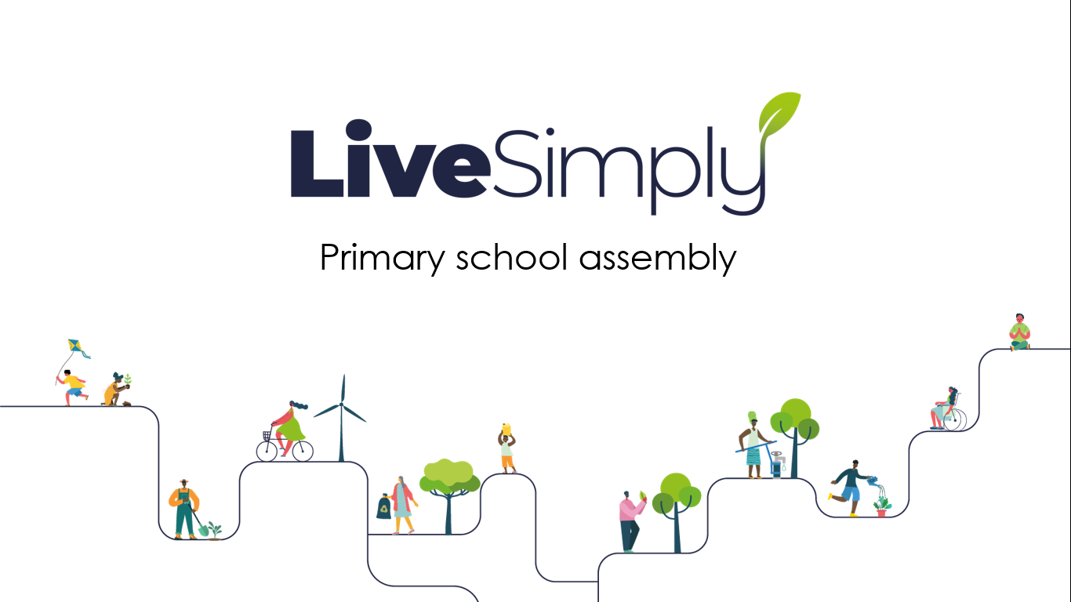 | Good morning/afternoon everyone.  Today we are going to hear about CAFOD’s LiveSimply award for schools and what it means for our school community.
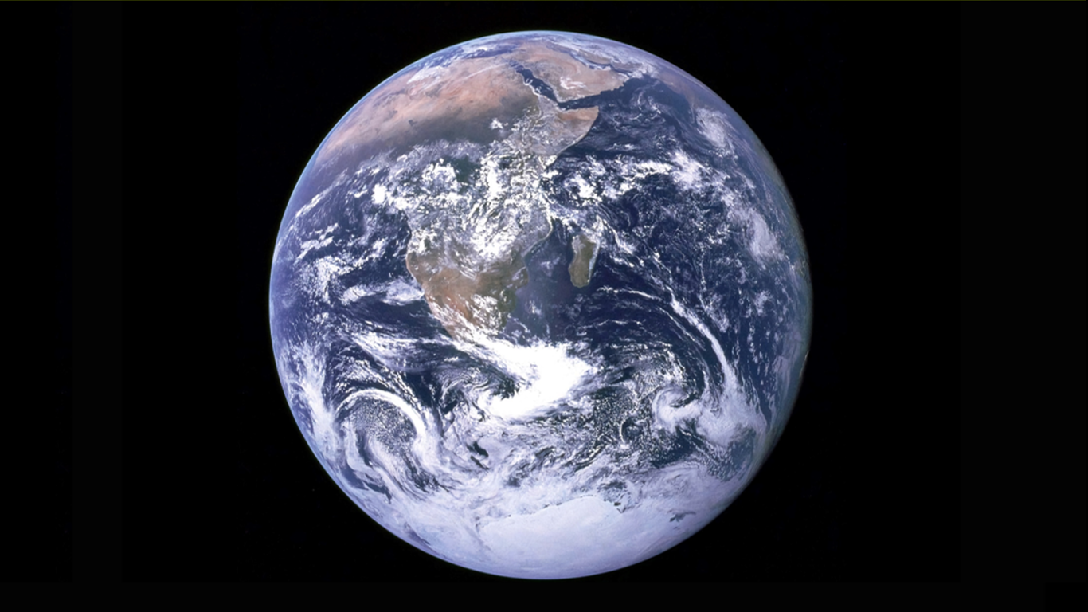 | Let’s start by having a think about the sort of world we want to live in.  What would you like to see in the future?  (Children could be asked to reflect quietly or you may choose to allow them to share answers in pairs or to the wider assembly)
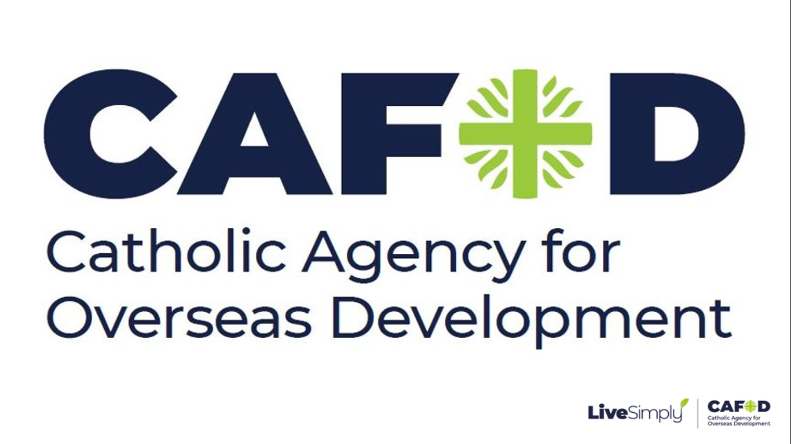 | CAFOD has a vision for the future too.  A vision of a world without poverty.  A world where people have enough food to eat and clean water to drink and a safe home to live in. A world where all children can go to school, and anyone who is sick can see a doctor.
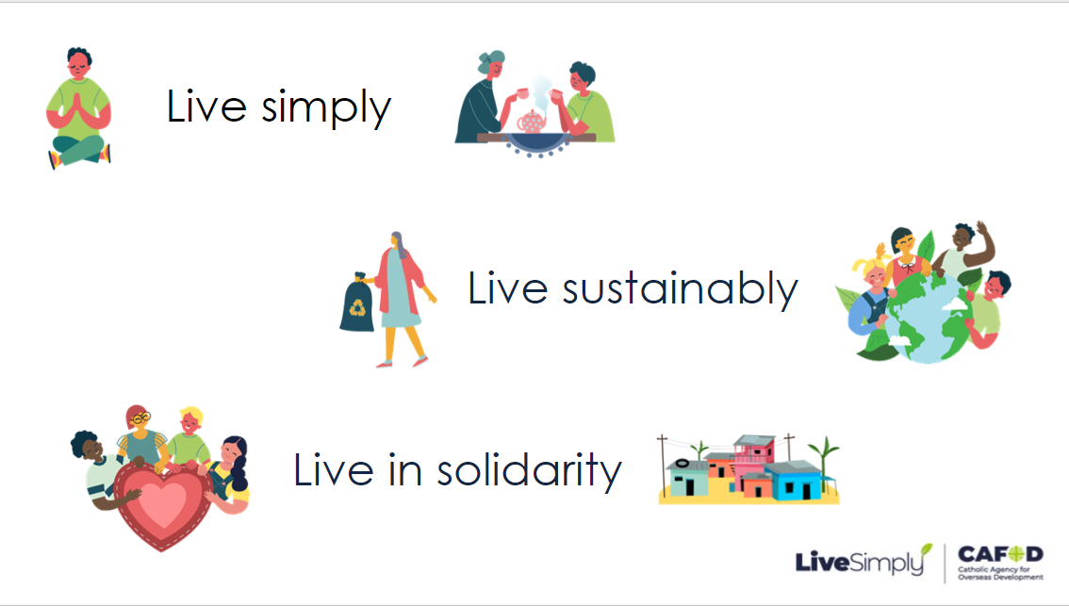 | Our school is joining CAFOD to try to create this kind of world, through the LiveSimply award  As a community we are going to try our best to:  Live simply  Live sustainably  Live in solidarity  We’re going to have a think about what that means  (If time is limited you may wish to skip the next slide and go straight to the animation)
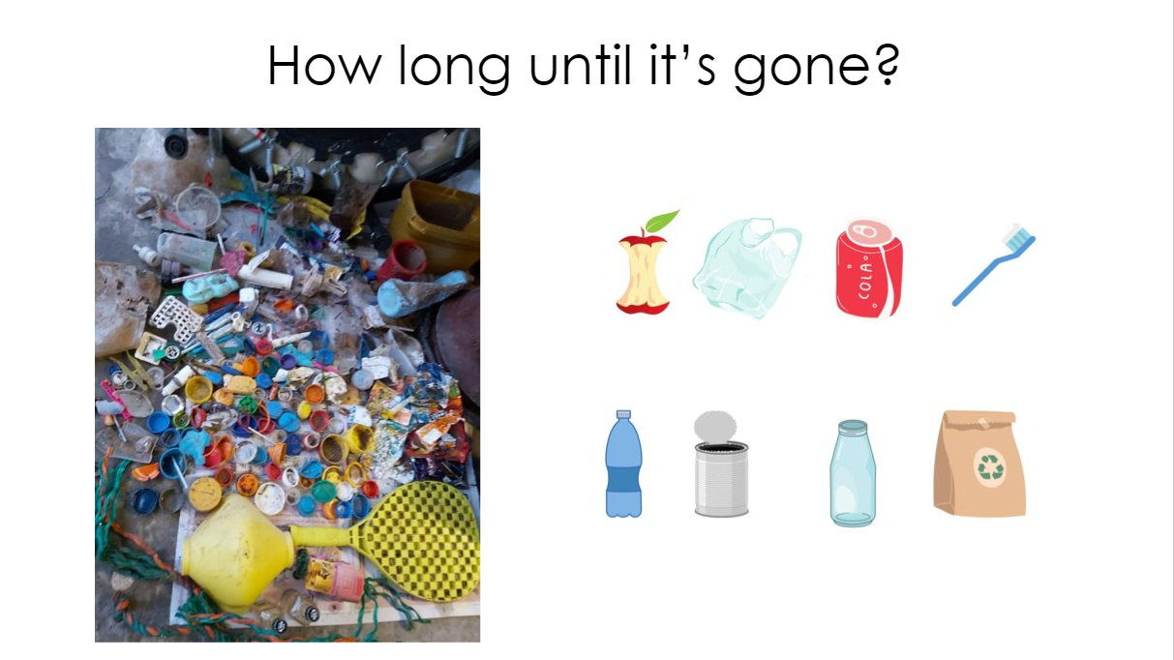 | But first we’re going to play a game called ‘How long until it’s gone?’  (The slides at the end of the presentation can be printed for this activity)  When we throw something into the rubbish, if it can’t be recycled, it’s often buried in the ground. This is called ‘landfill’.
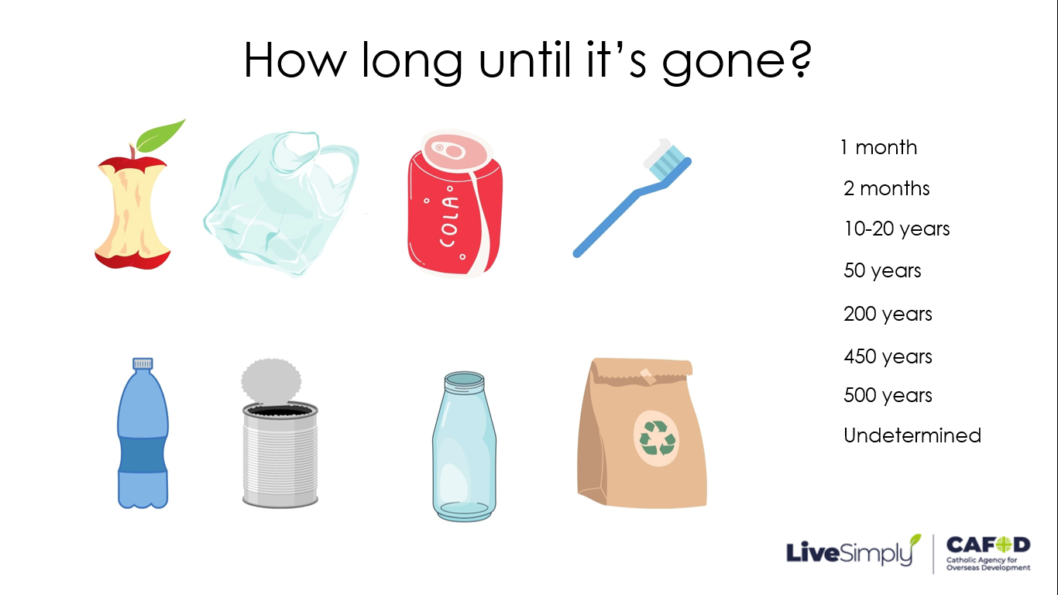 | Give 8 volunteers one of the items each and ask them to stand beside the length of time they think it take for different items of rubbish to break down and disappear.  You could stick the lengths of time up on a wall or ask other volunteers to hold them.  Once everyone had made a choice you may wish to ask if other children agree/disagree.
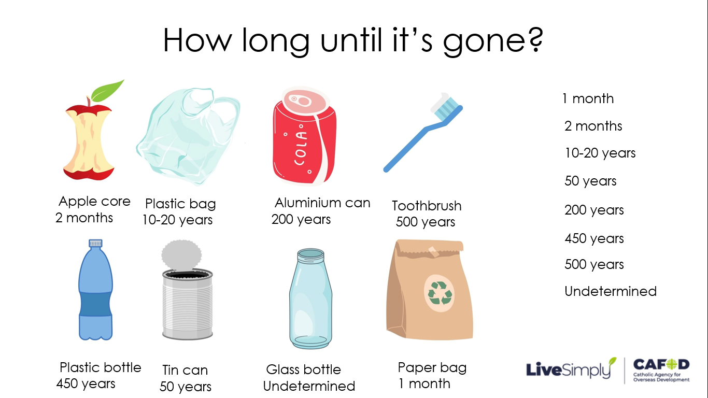 | The correct answers are:  Apple core: 2 months  Plastic bag: 10–20 years (but it breaks down into smaller microplastics)  Aluminium can: 200 years  Toothbrush: 500 years  Plastic bottle: 450 years  Tin can: 50 years  Glass bottle: unknown (possibly never)  Paper bag: 1 month  Thinking about our waste is just one aspect of Live Simply, but there’s a lot more to it than that.
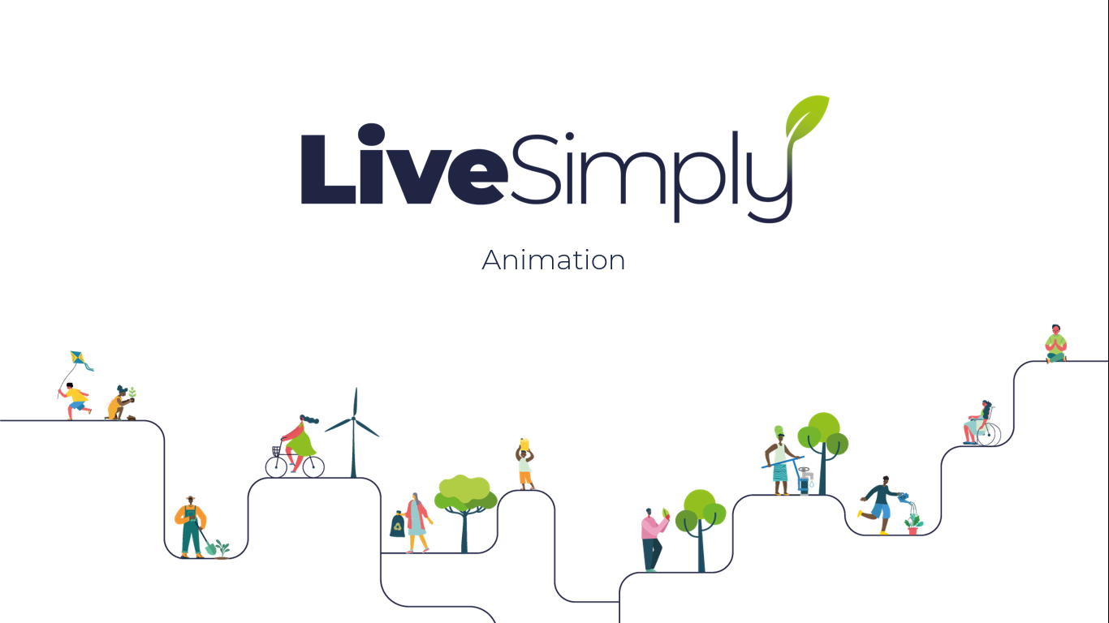 | Let’s watch a short animation that introduces us to the main ideas.
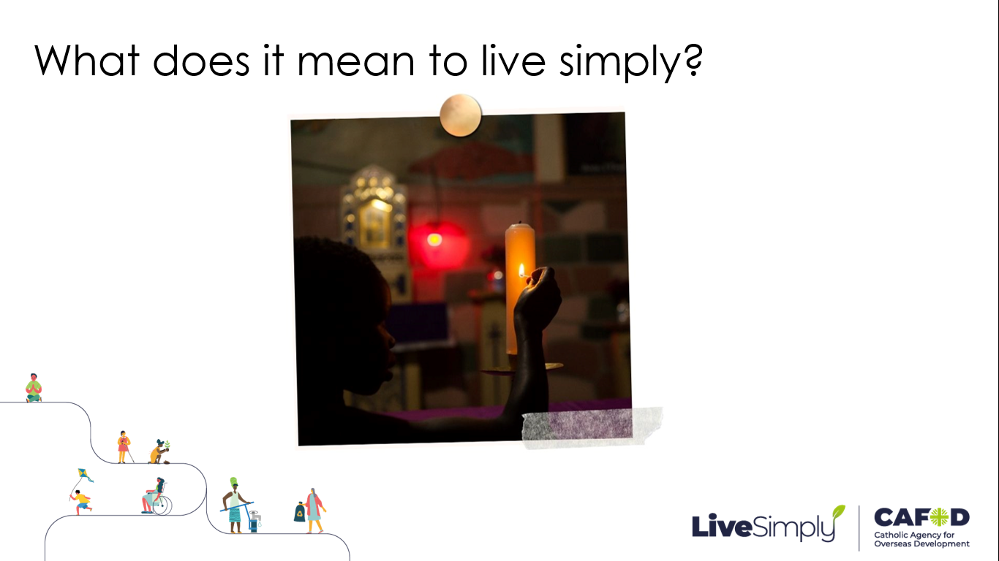 | Living Simply means living like Jesus.  Spending quiet time in nature or in prayer.  Being grateful for all we have instead of always wanting more  Spending time in nature appreciating God’s beautiful creation and  Spending quality time with other people, (putting down the electronic gadgets.)
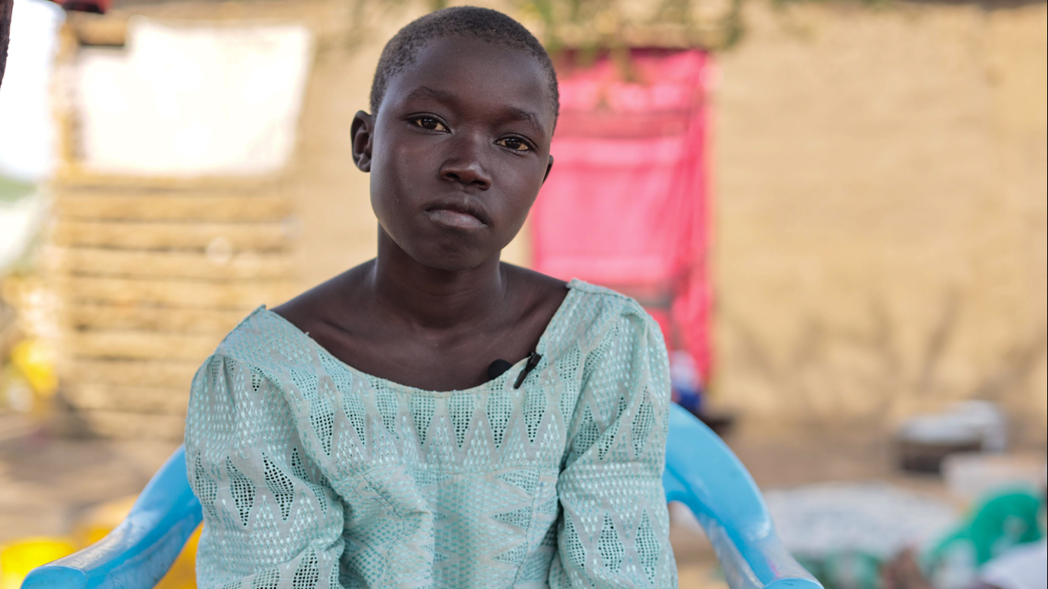 | We can be inspired by the example of young people throughout the world in living simply.  10 year old Huriya lives in South Sudan. She goes to school, where her favourite subject is maths.  Huriya finds happiness in being with her friends. She says:  "I love playing with my friends. When they call my name, it makes me feel good.”
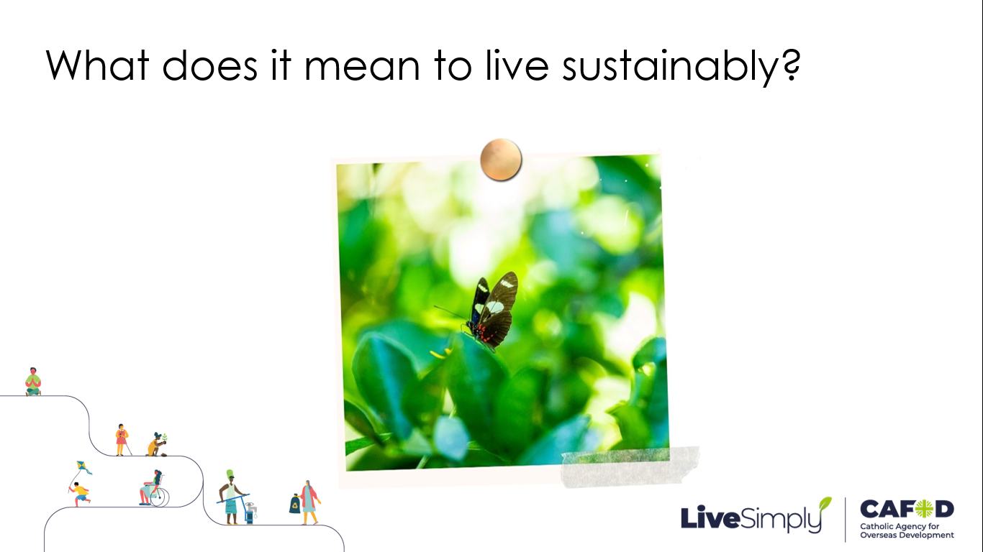 | Living sustainably means looking after our world and remembering it is for everyone
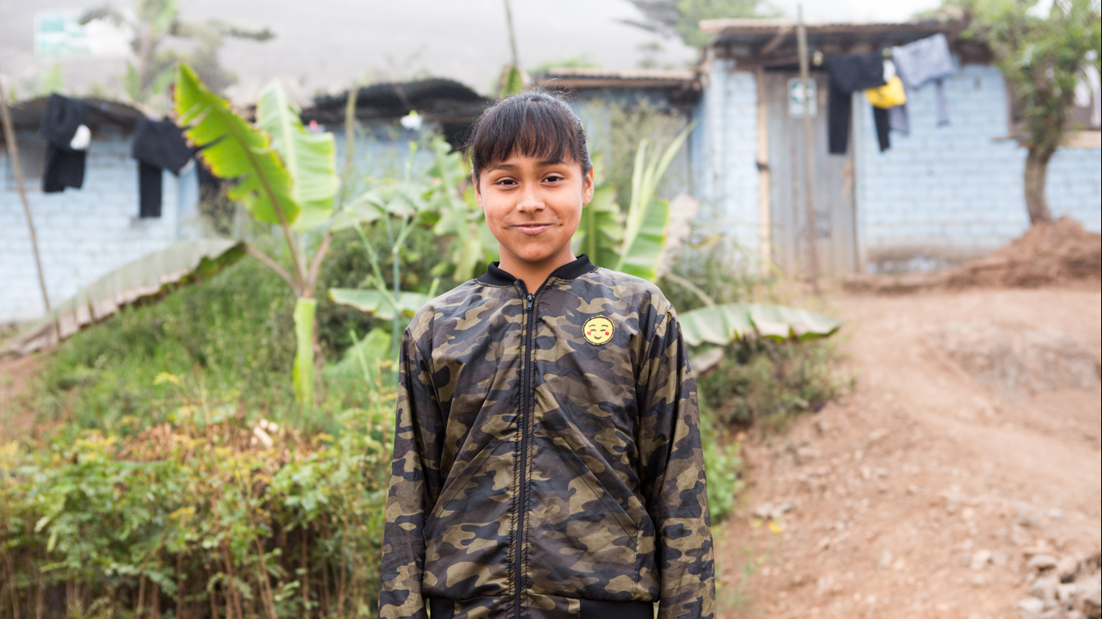 | Abigail lives in a mountainous district towards the north of Lima, in Peru, and aged 11 joined a local eco brigade.  The children in the eco brigade try to protect the nearby Lomas Mountain range, which is a crucial part of the eco-system. They have worked on a forestation project, planting small plants to help protect the land.
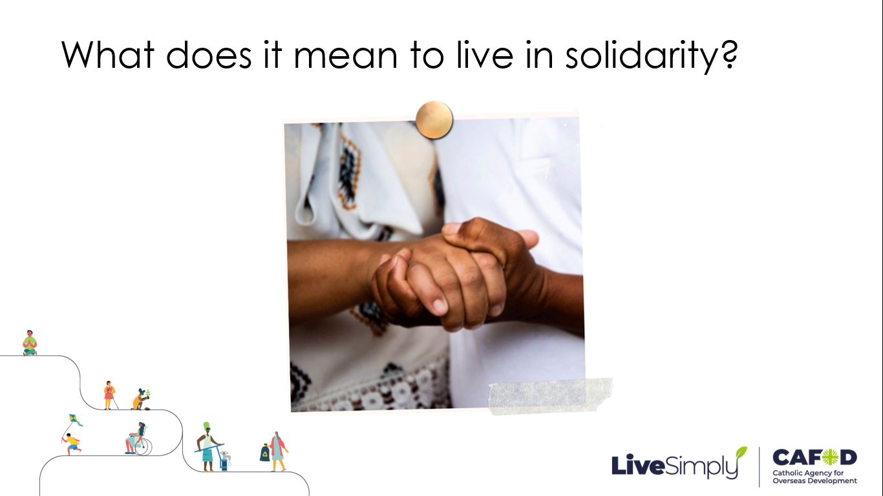 | Living in solidarity means seeing everyone in the world as part of one big family.  We need to work together to make sure that all our brothers and sisters have what they need to flourish.
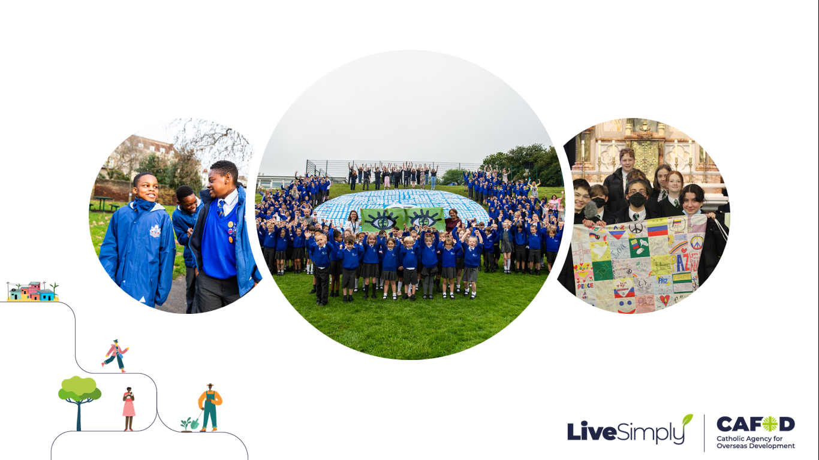 | There are lots of ways young people in the UK are living in solidarity with our global neighbours.  Many schools, families and parishes take part in the CAFOD Big Lent Walk to raise money.  58,000 children in England and Wales joined CAFOD’s Eyes of the World campaign and called on our government to keep the world’s poorest people at the heart of the climate change talks.  (Current campaigns are on our school website that you may like to take part in)  Students from Notre Dame High School in Norwich and the Explorer Scouts created a patchwork wall hanging to express their love and friendship with the young people trying to create a more peaceful future in Colombia.
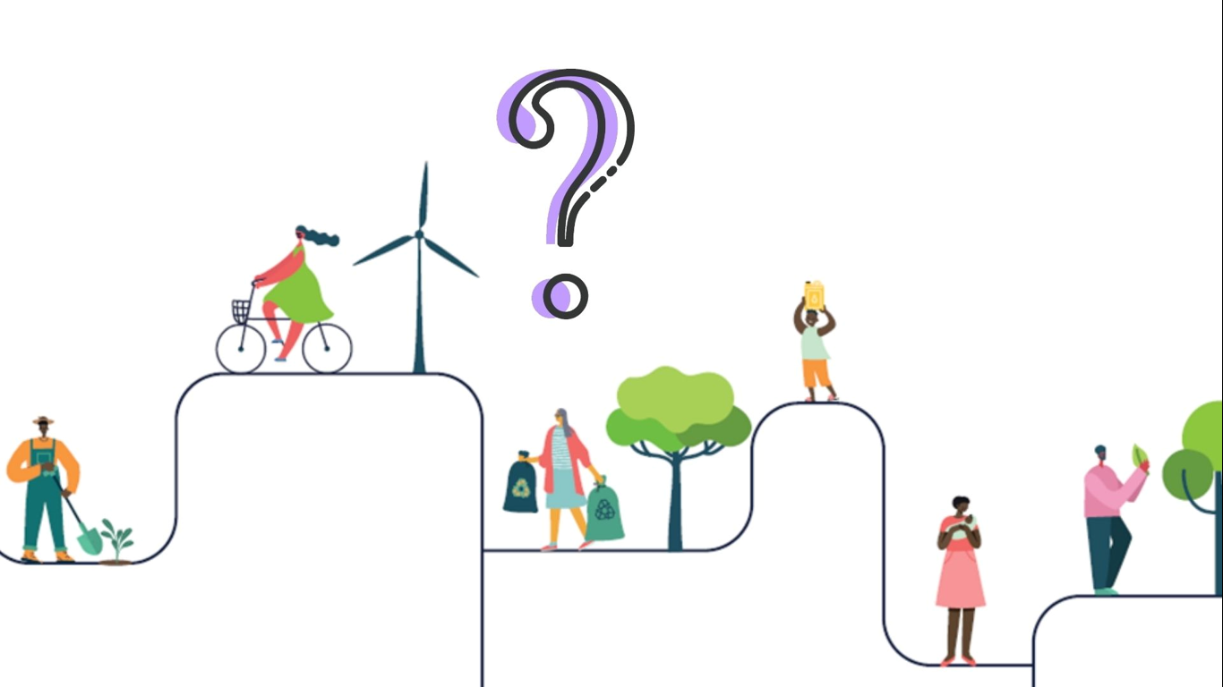 | What’s next?  (If you have already made any specific plans, you could share them here or you may like to ask the children to share their creative LiveSimply ideas)  Share what’s happening with your family and friends.  Pray for our school community as we take this project on  You may wish to watch the second Live Simply animation – Why LiveSimply? at this point (embedded into next slide)
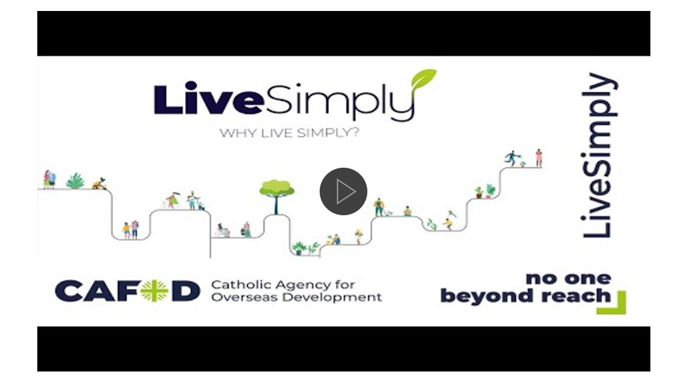 | Why LiveSimply animation 2:53mins
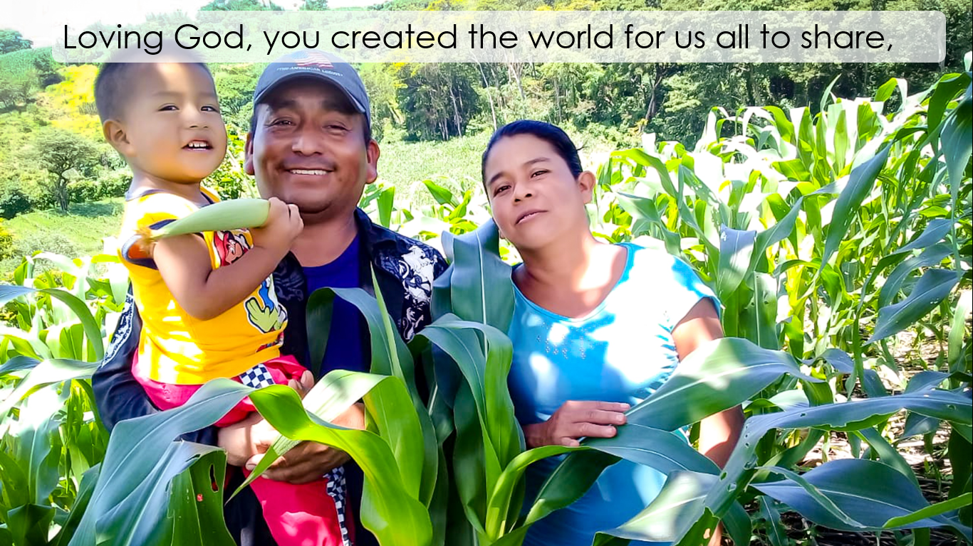 | Let’s close with the LiveSimply prayer.  Loving God, you created the world for us all to share,
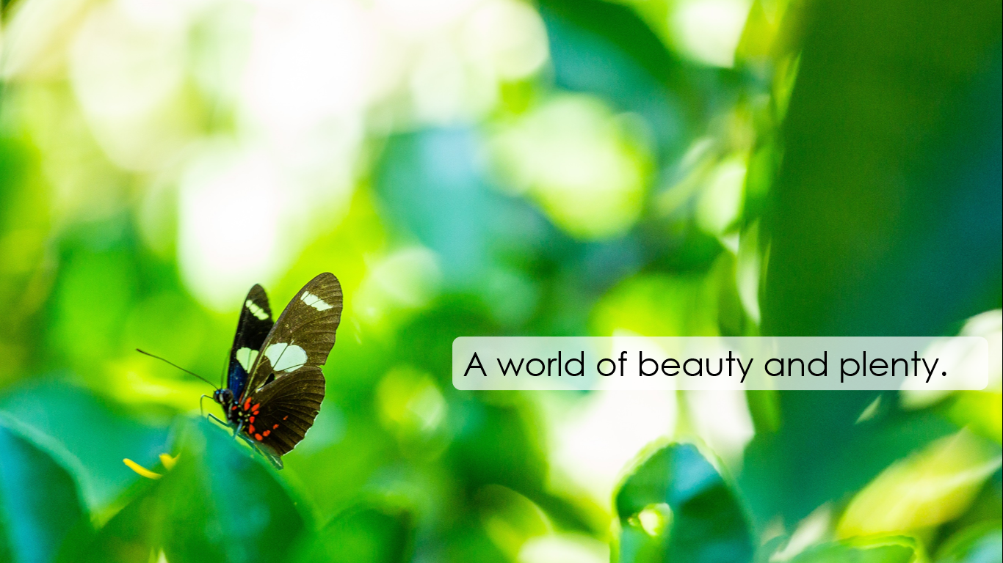 | A world of beauty and plenty.
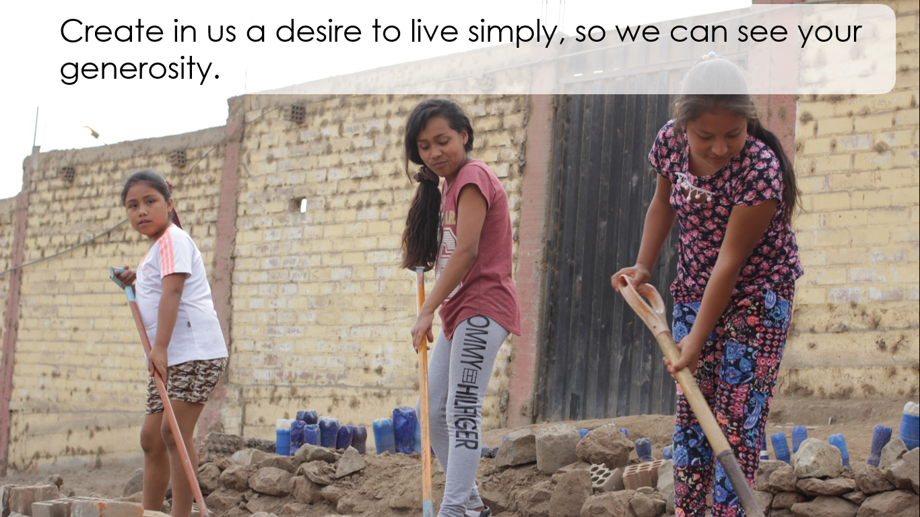 | Create in us a desire to live simply, so we can see your generosity.
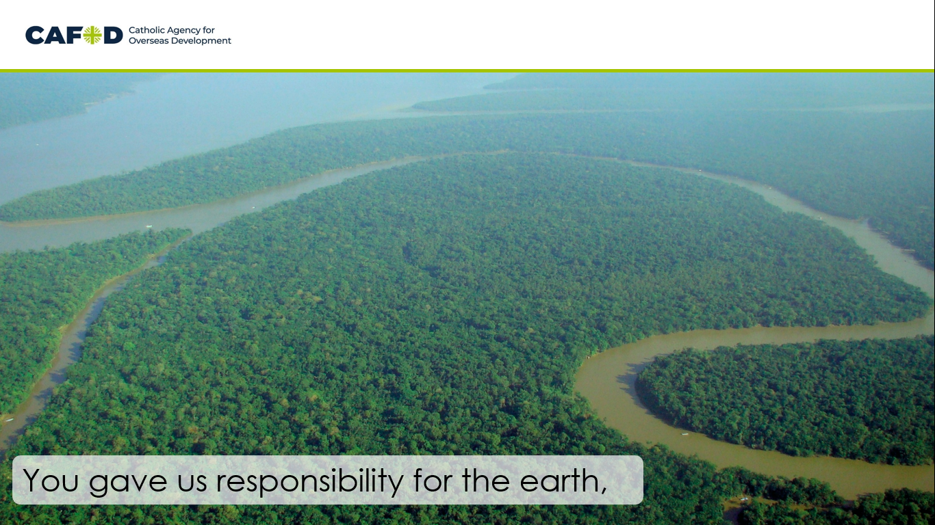 | You gave us responsibility for the earth,
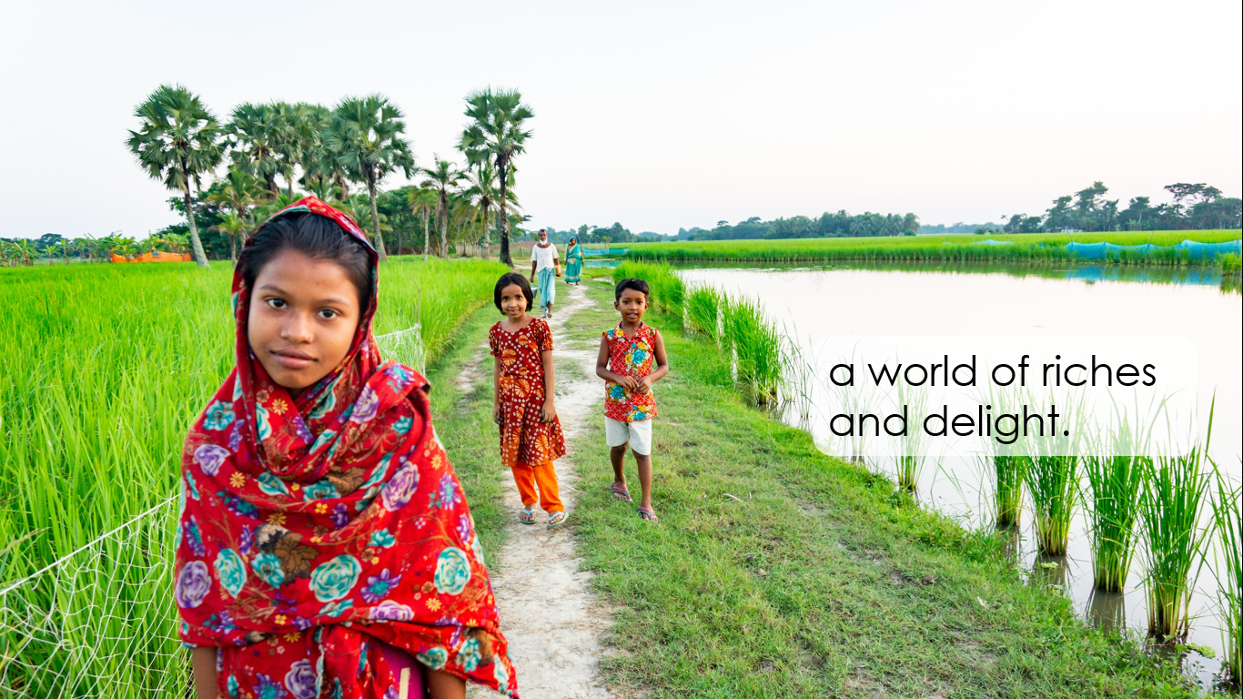 | a world of riches and delight.
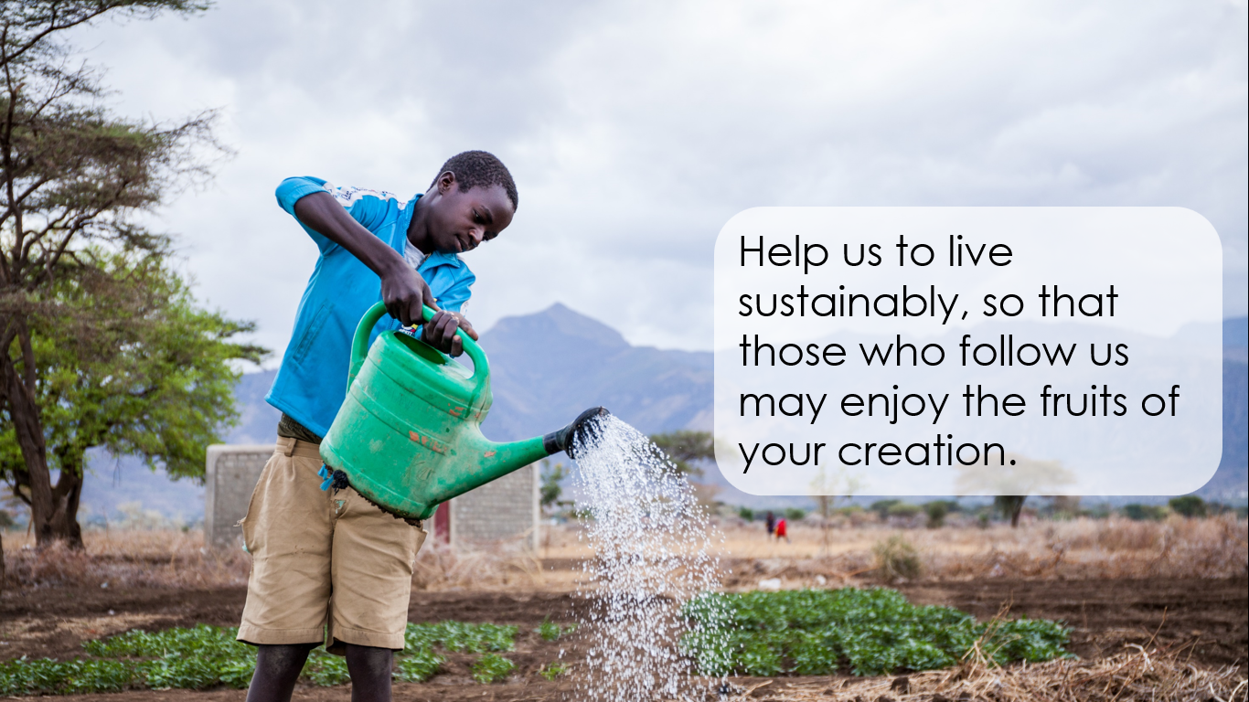 | Help us to live sustainably, so that those who follow us may enjoy the fruits of your creation.
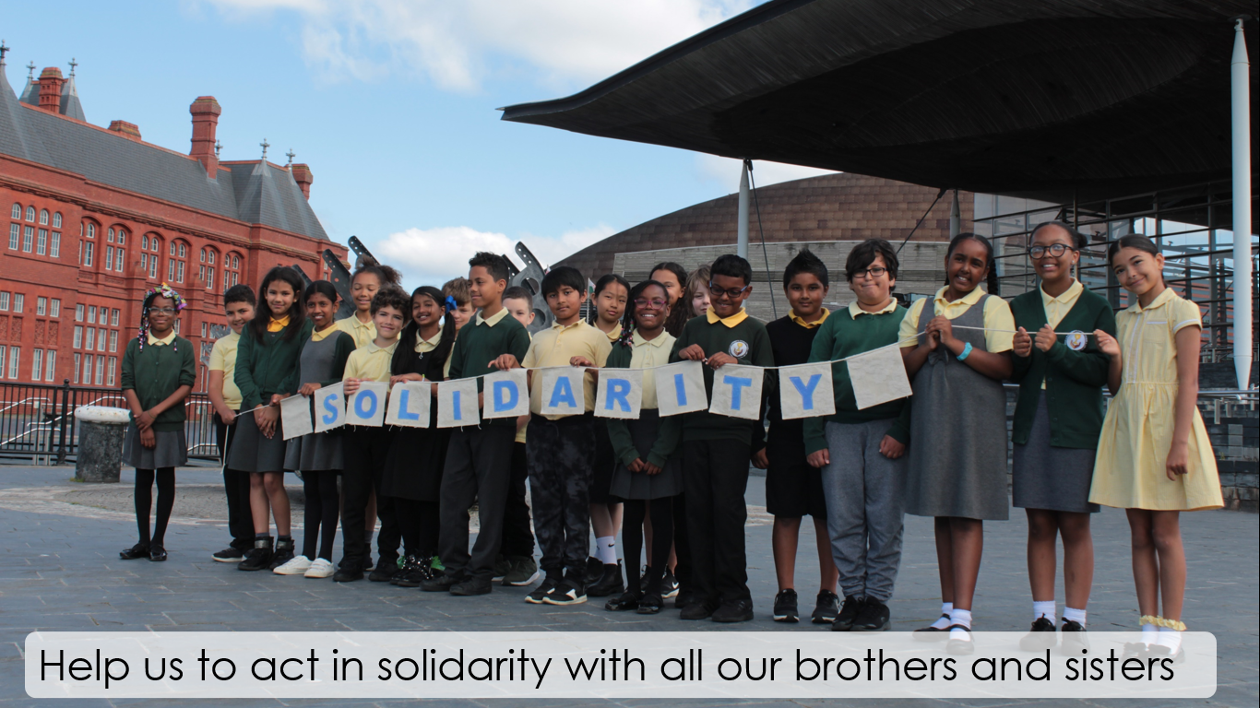 | Help us to act in solidarity with all our brothers and sisters
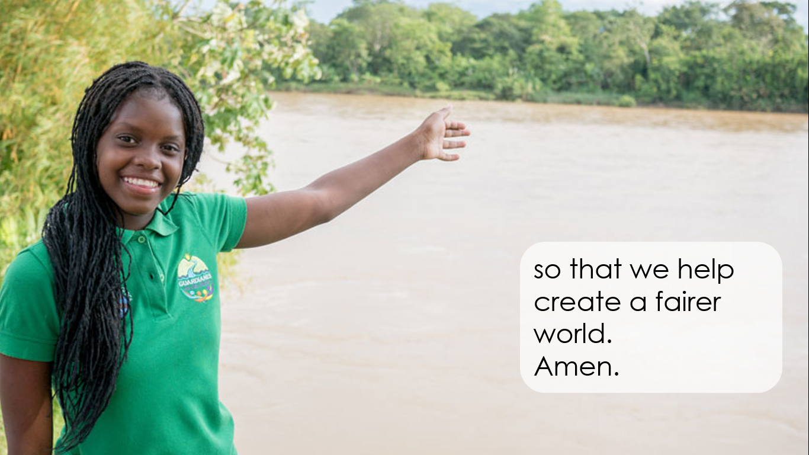 | so that we help create a fairer world.  Amen.

