Peace liturgy
Primary schools
This assembly is designed for a teacher or class to lead a liturgy on peace and can be used on or around International Day of Peace (21st September).

Theme: Peace

Materials Required: Scripts for each reader, PowerPoint, film

Desired learner outcomes: For pupils to reflect on what peace-building means and Jesus’ teaching about peace.

Time allocation: 20 minutes

Slide 1:
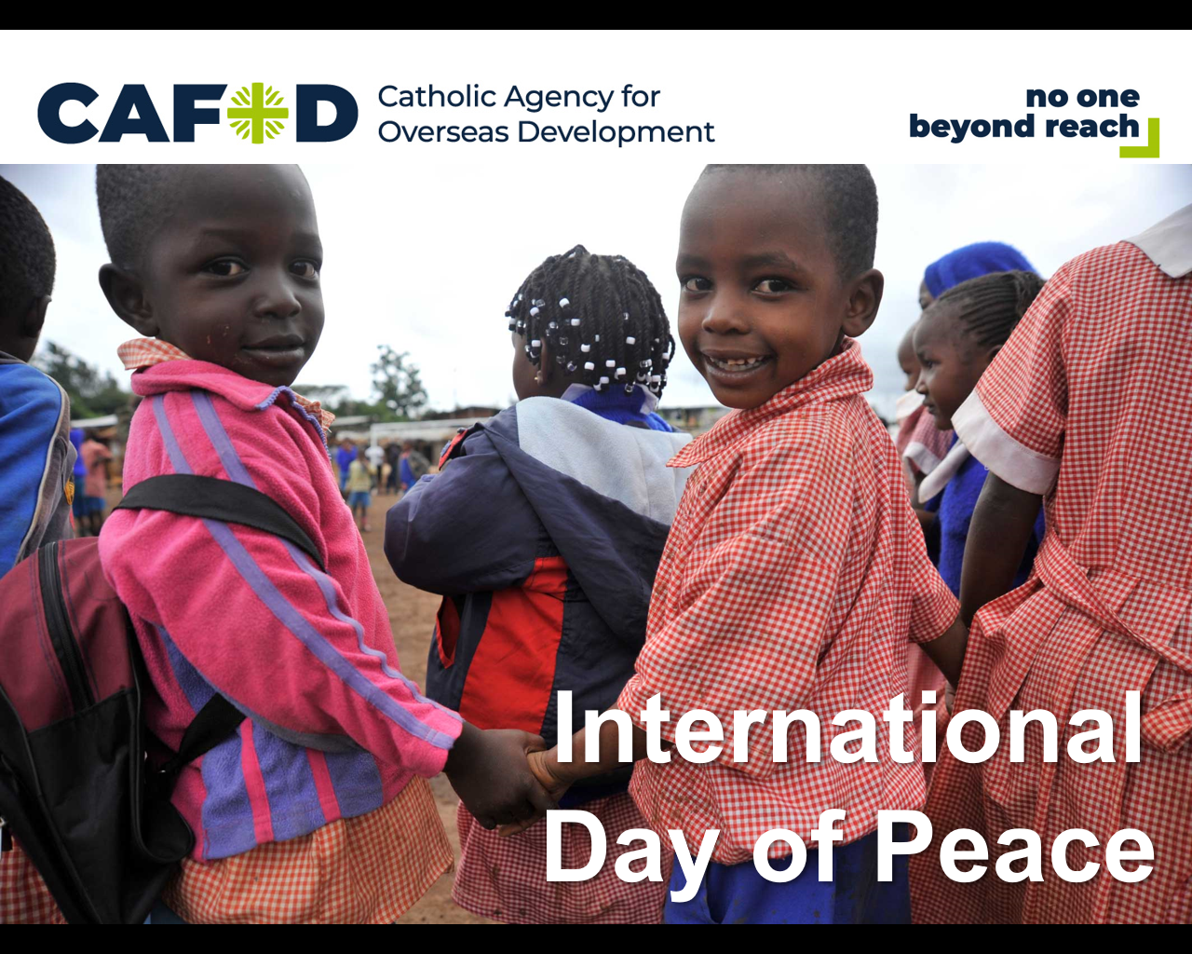Leader: We gather this morning to pray for peace in our world. We begin our day in the name of the +Father, and of the +Son, and of the +Holy Spirit. Amen

We see pictures of conflict almost everyday on the TV, the internet and in newspapers. We have all watched recent fighting in Syria and South Sudan and in many other places around the world. We remember the people who have lost their lives or been injured in conflicts, and the families that have been left without food, water, shelter or medical care. We remember families affected by violence in their communities – violence from gangs, crime and conflict, which stops children from being able to go to school or from going out to play.

Or, on International Day of Peace: Here in our school, today, with people all over the world, we are gathering together to celebrate the International World day of Peace. In order to do this, we gather around the person who brings together all the nations of the world, as one family – Jesus, the Light of the world. Jesus said to his disciples, “Peace I leave with you, my peace I give you. A peace the world cannot give, this is my gift to you.”

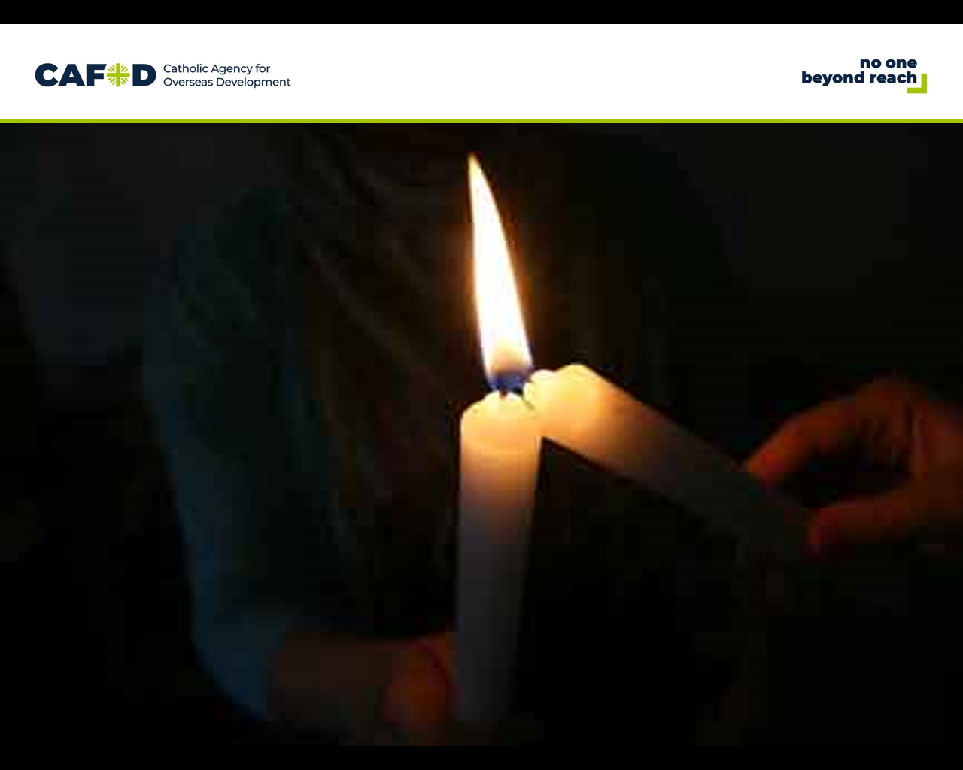Slide 2:
Reader 1:
We gather here together [on International Day of Peace] to pray for peace around the world. We remember all of the people who have died recently in conflicts around the world.

Suggested hymn:
Christ be our light (Laudate 883)
(Pairs of children could come to the front during each verse of the hymn, holding candles)

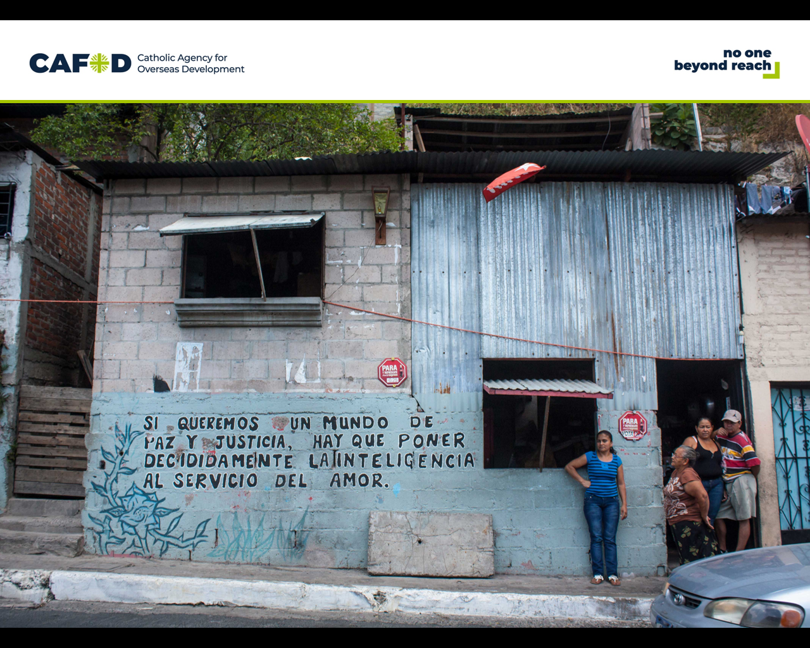Slide 3:

Reader 2: As we watch this film let’s remember all those who are affected by conflict.

We remember in particular people in El Salvador, who suffered a long civil war, and continue to face challenges of gangs and violence.

[Play ‘Building peace’ film]

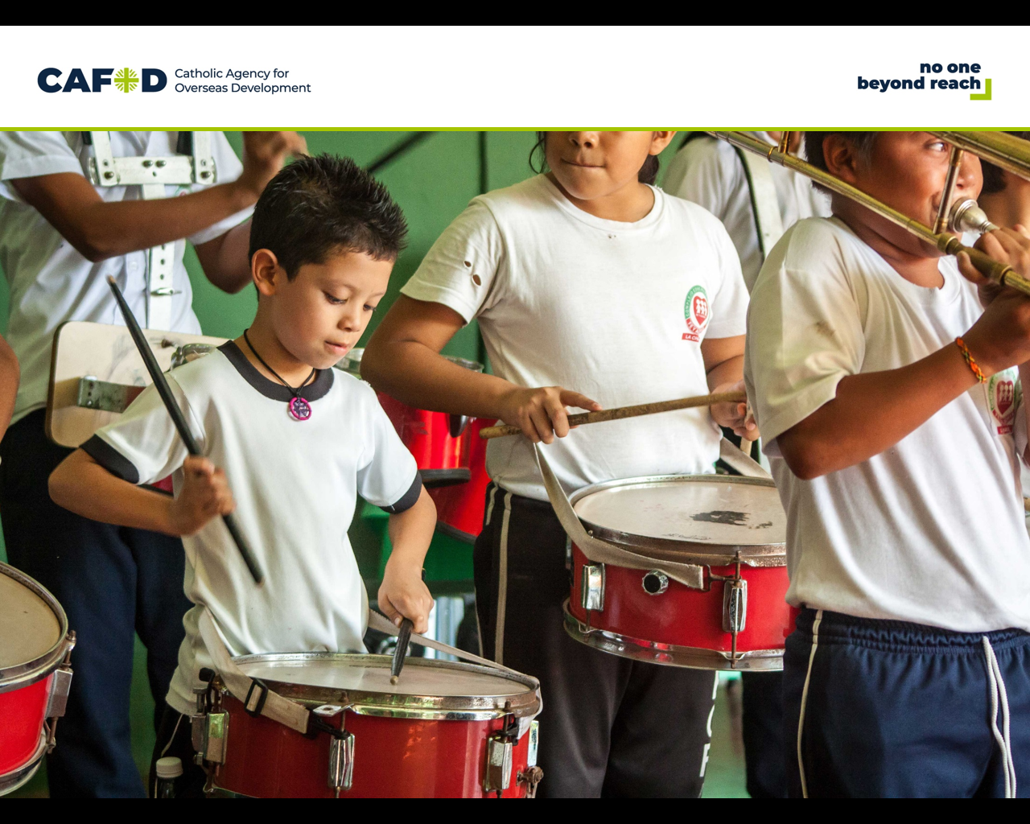Slide 4:
Reader 3: This is eight-year old Diego. Diego lives on the outskirts of San Salvador, the capital of El Salvador. There are lots of gangs in the area. CAFOD partners have been working with Diego’s community to find more peaceful ways of living together.

As part of this peace-building project, Diego’s school runs different sport, music and dance activities for children to join. These activities help children like Diego to develop their talents. Diego learns to play the drum in a peace band.

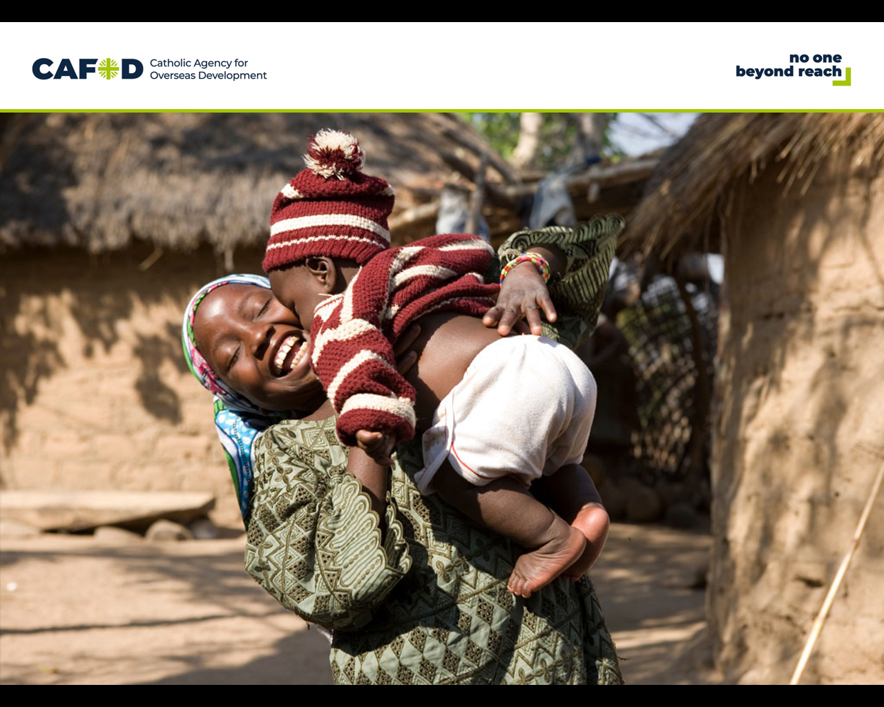Slide 5:
Reader 4: All people, everywhere in the world, deserve to have peace in their lives. As followers of Jesus, the Prince of Peace, we are called to be peacemakers, at home, in school, wherever we are. There is a famous prayer, written by St Teresa of Avila, which reminds us that Jesus uses us to spread his gospel of peace, in the way we live our everyday lives. Let us listen to the prayer.

Reader 5:
Christ has no body now on earth but yours, no feet but yours. Yours are the eyes - through which his love looks out to the world. Yours are the feet - with which he goes about doing good. Yours are the hands - with which he blesses people now.

Leader: In this quiet moment we pause to ask ourselves these questions:

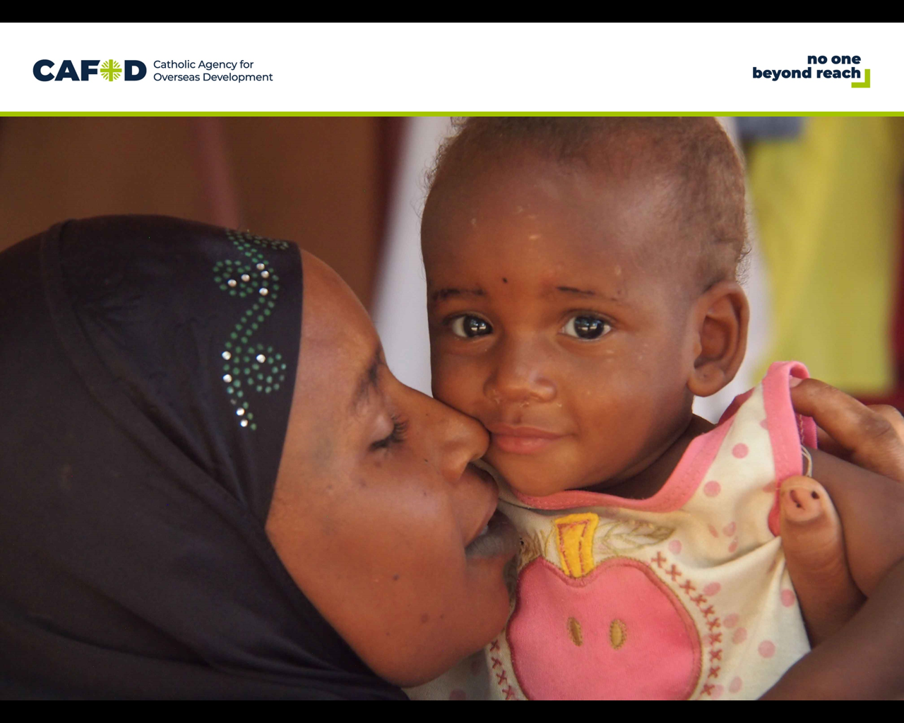Slide 6:

How can my eyes, the way I look at people, bring peace and love?

(Pause before taking suggestions from children)

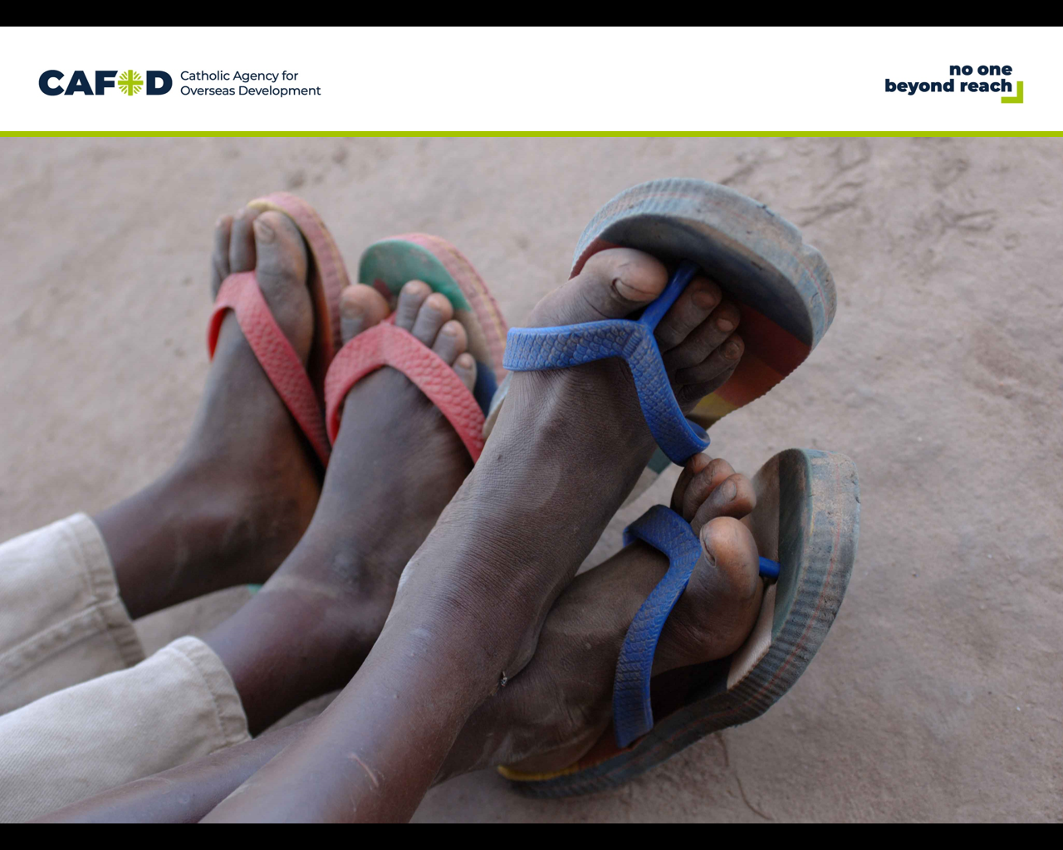Slide 7:

How can I use my feet to do good and bring happiness and peace?

(Pause before taking suggestions from children)

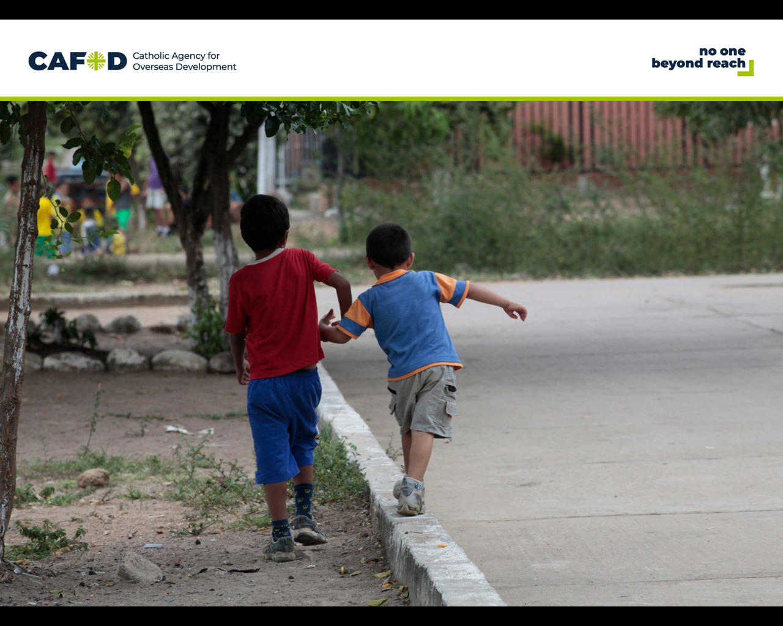
Slide 8:

How can I use my hands to bless and help and bring peace to those around me?

(Pause before taking suggestions from children)

Reader 6: (re-read the prayer)
Christ has no body now on earth but yours, no feet but yours. Yours are the eyes - through which his love looks out to the world. Yours are the feet - with which he goes about doing good. Yours are the hands - with which he blesses people now.

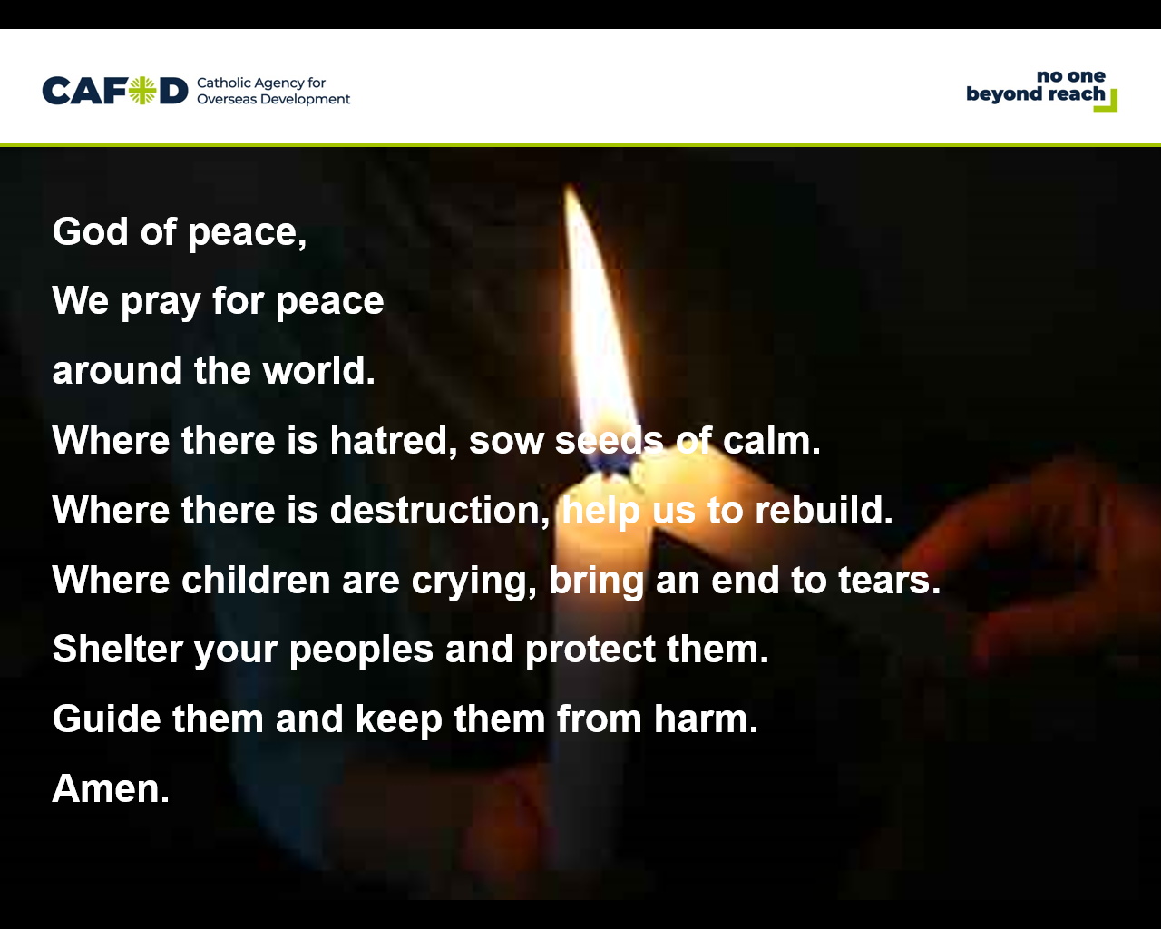Slide 9:
Leader: Let us now pray for our sisters and brothers all over the world who are affected by violence and conflict.

God of peace,
We pray for peace around the world.
Where there is hatred, sow seeds of calm.
Where there is destruction, help us to rebuild.
Where children are crying, bring an end to tears.
Shelter your peoples and protect them.
Guide them and keep them from harm.
Amen.

Leader: In the name of the +Father, and of the +Son, and of the +Holy Spirit. Amen

Leader: We finish our celebration with a hymn
Suggested hymns:
Awake from your slumber (Laudate 824)
All over the world (Laudate 984)
Peace is flowing (Laudate 902)
Shalom (Laudate 925)
How lovely on the mountains (Laudate 768)

Take action
At the end of the liturgy, find out more about Diego, who features in our award winning El Salvador Geography pack available at cafod.org.uk/geography

