Step up to the plate animation script
KS1
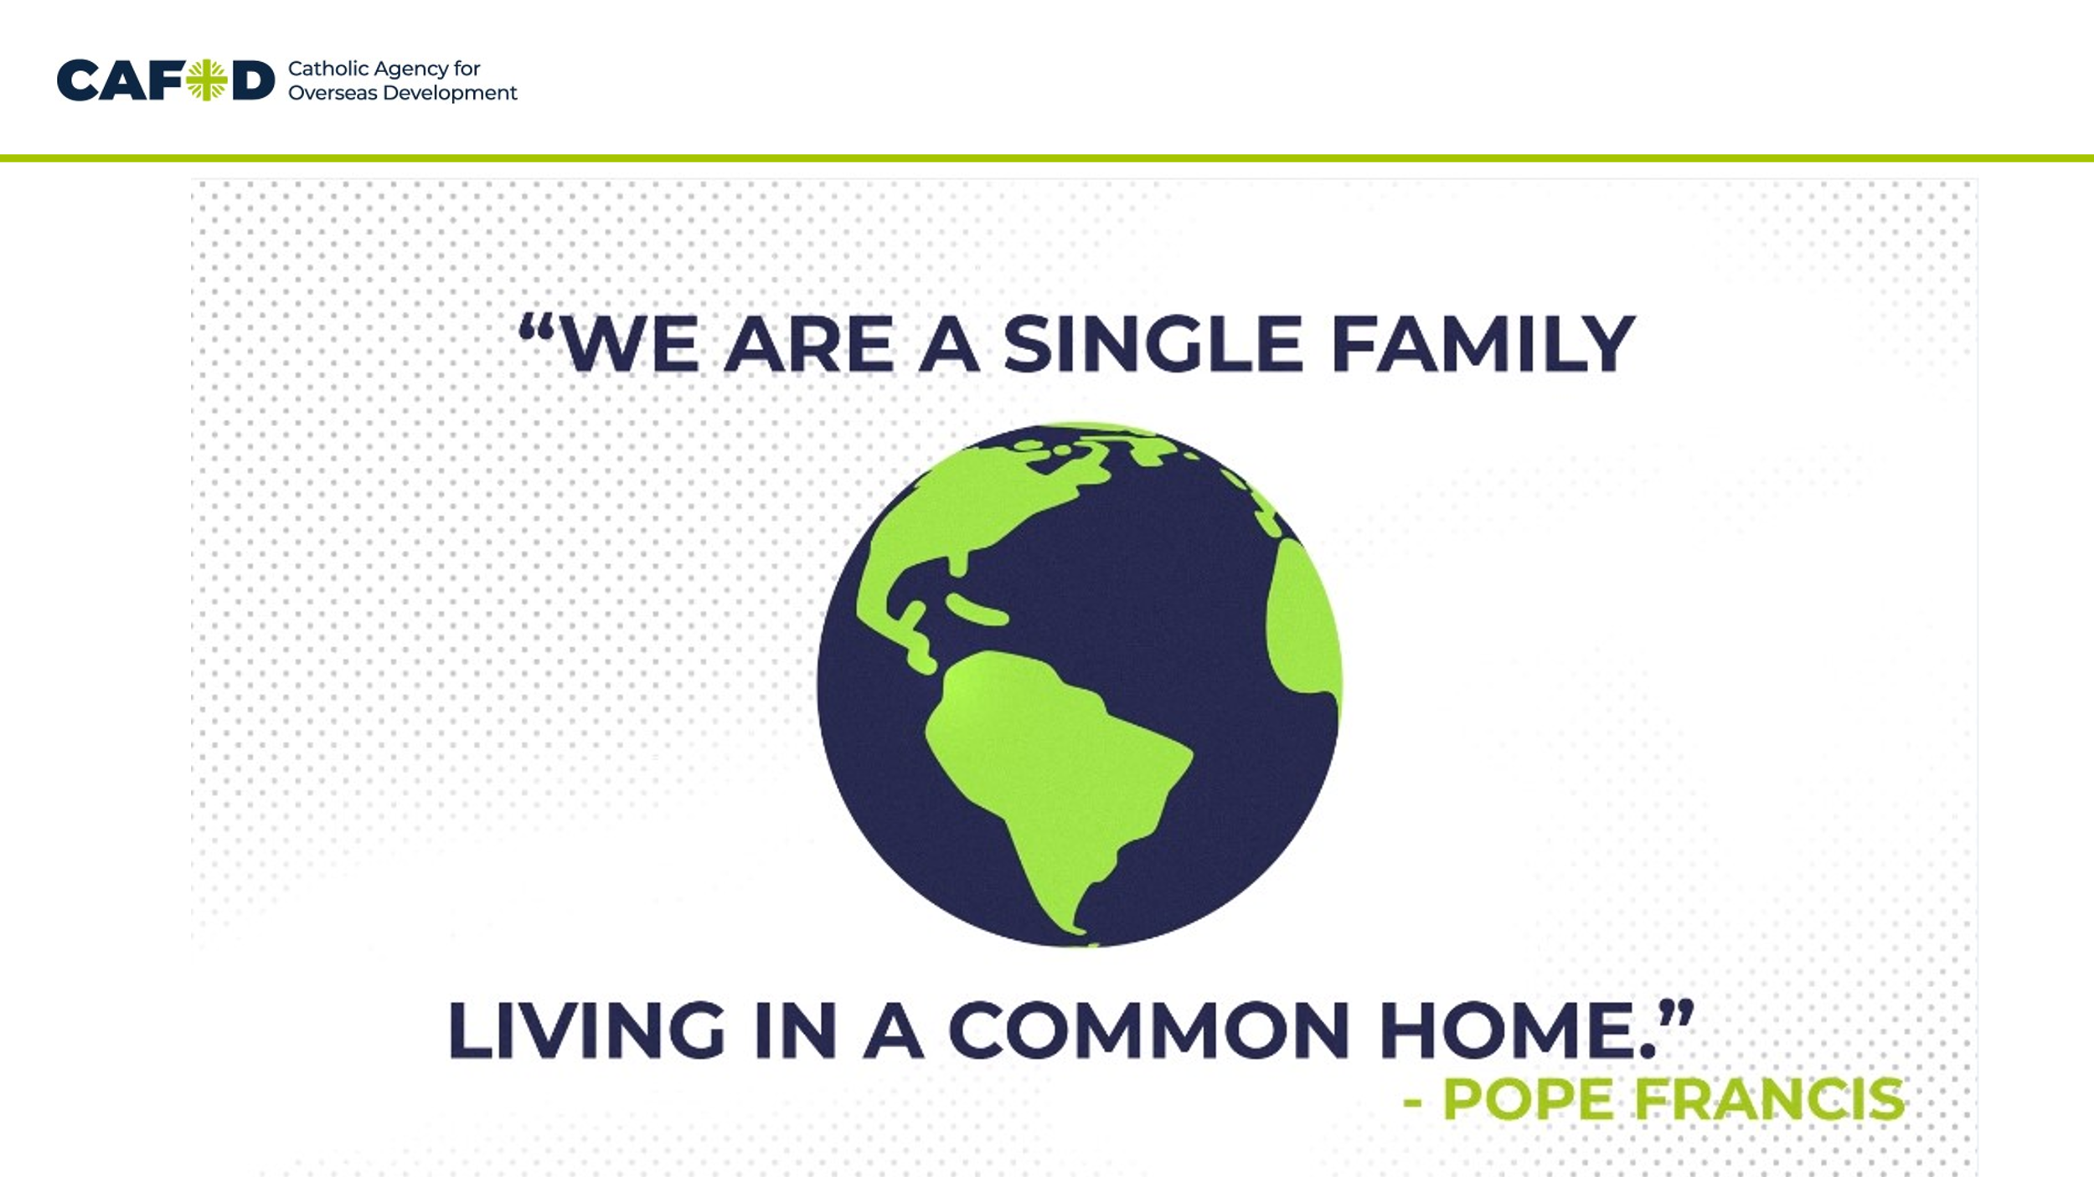 | Pope Francis said we are “A single family living in a common home”.  We are all one big family around the word, and we all share the earth as our home.
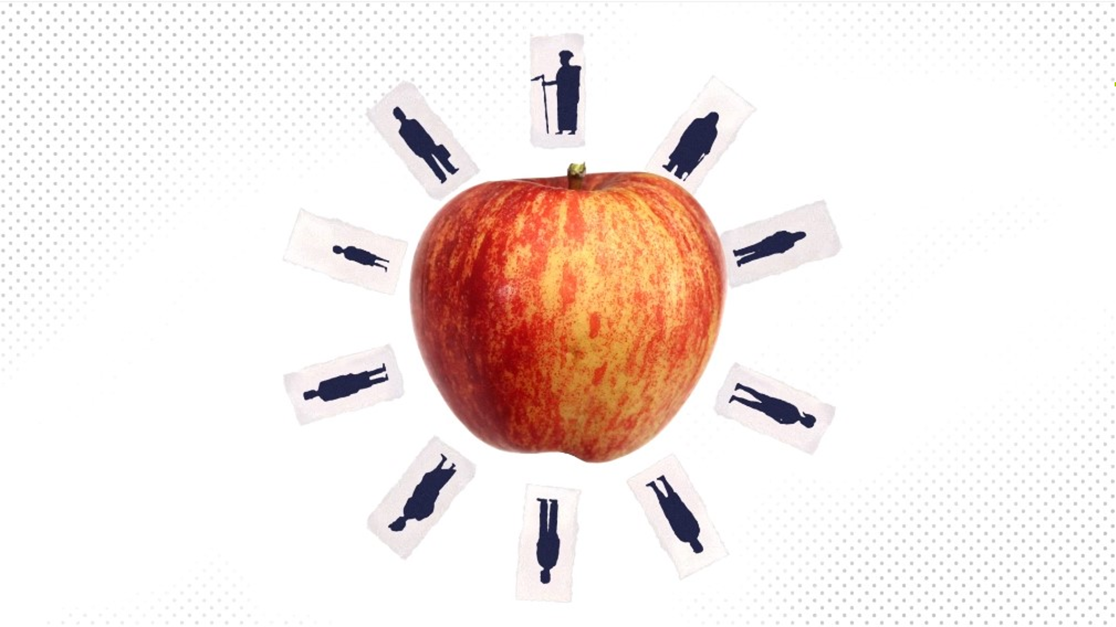 | We all need food to eat, and our world has more than enough food to feed everyone.
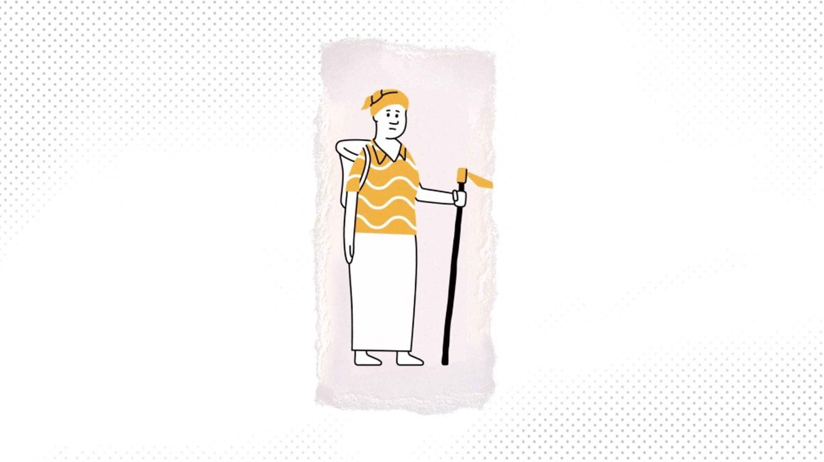 | But one in every ten people around the world is going hungry.
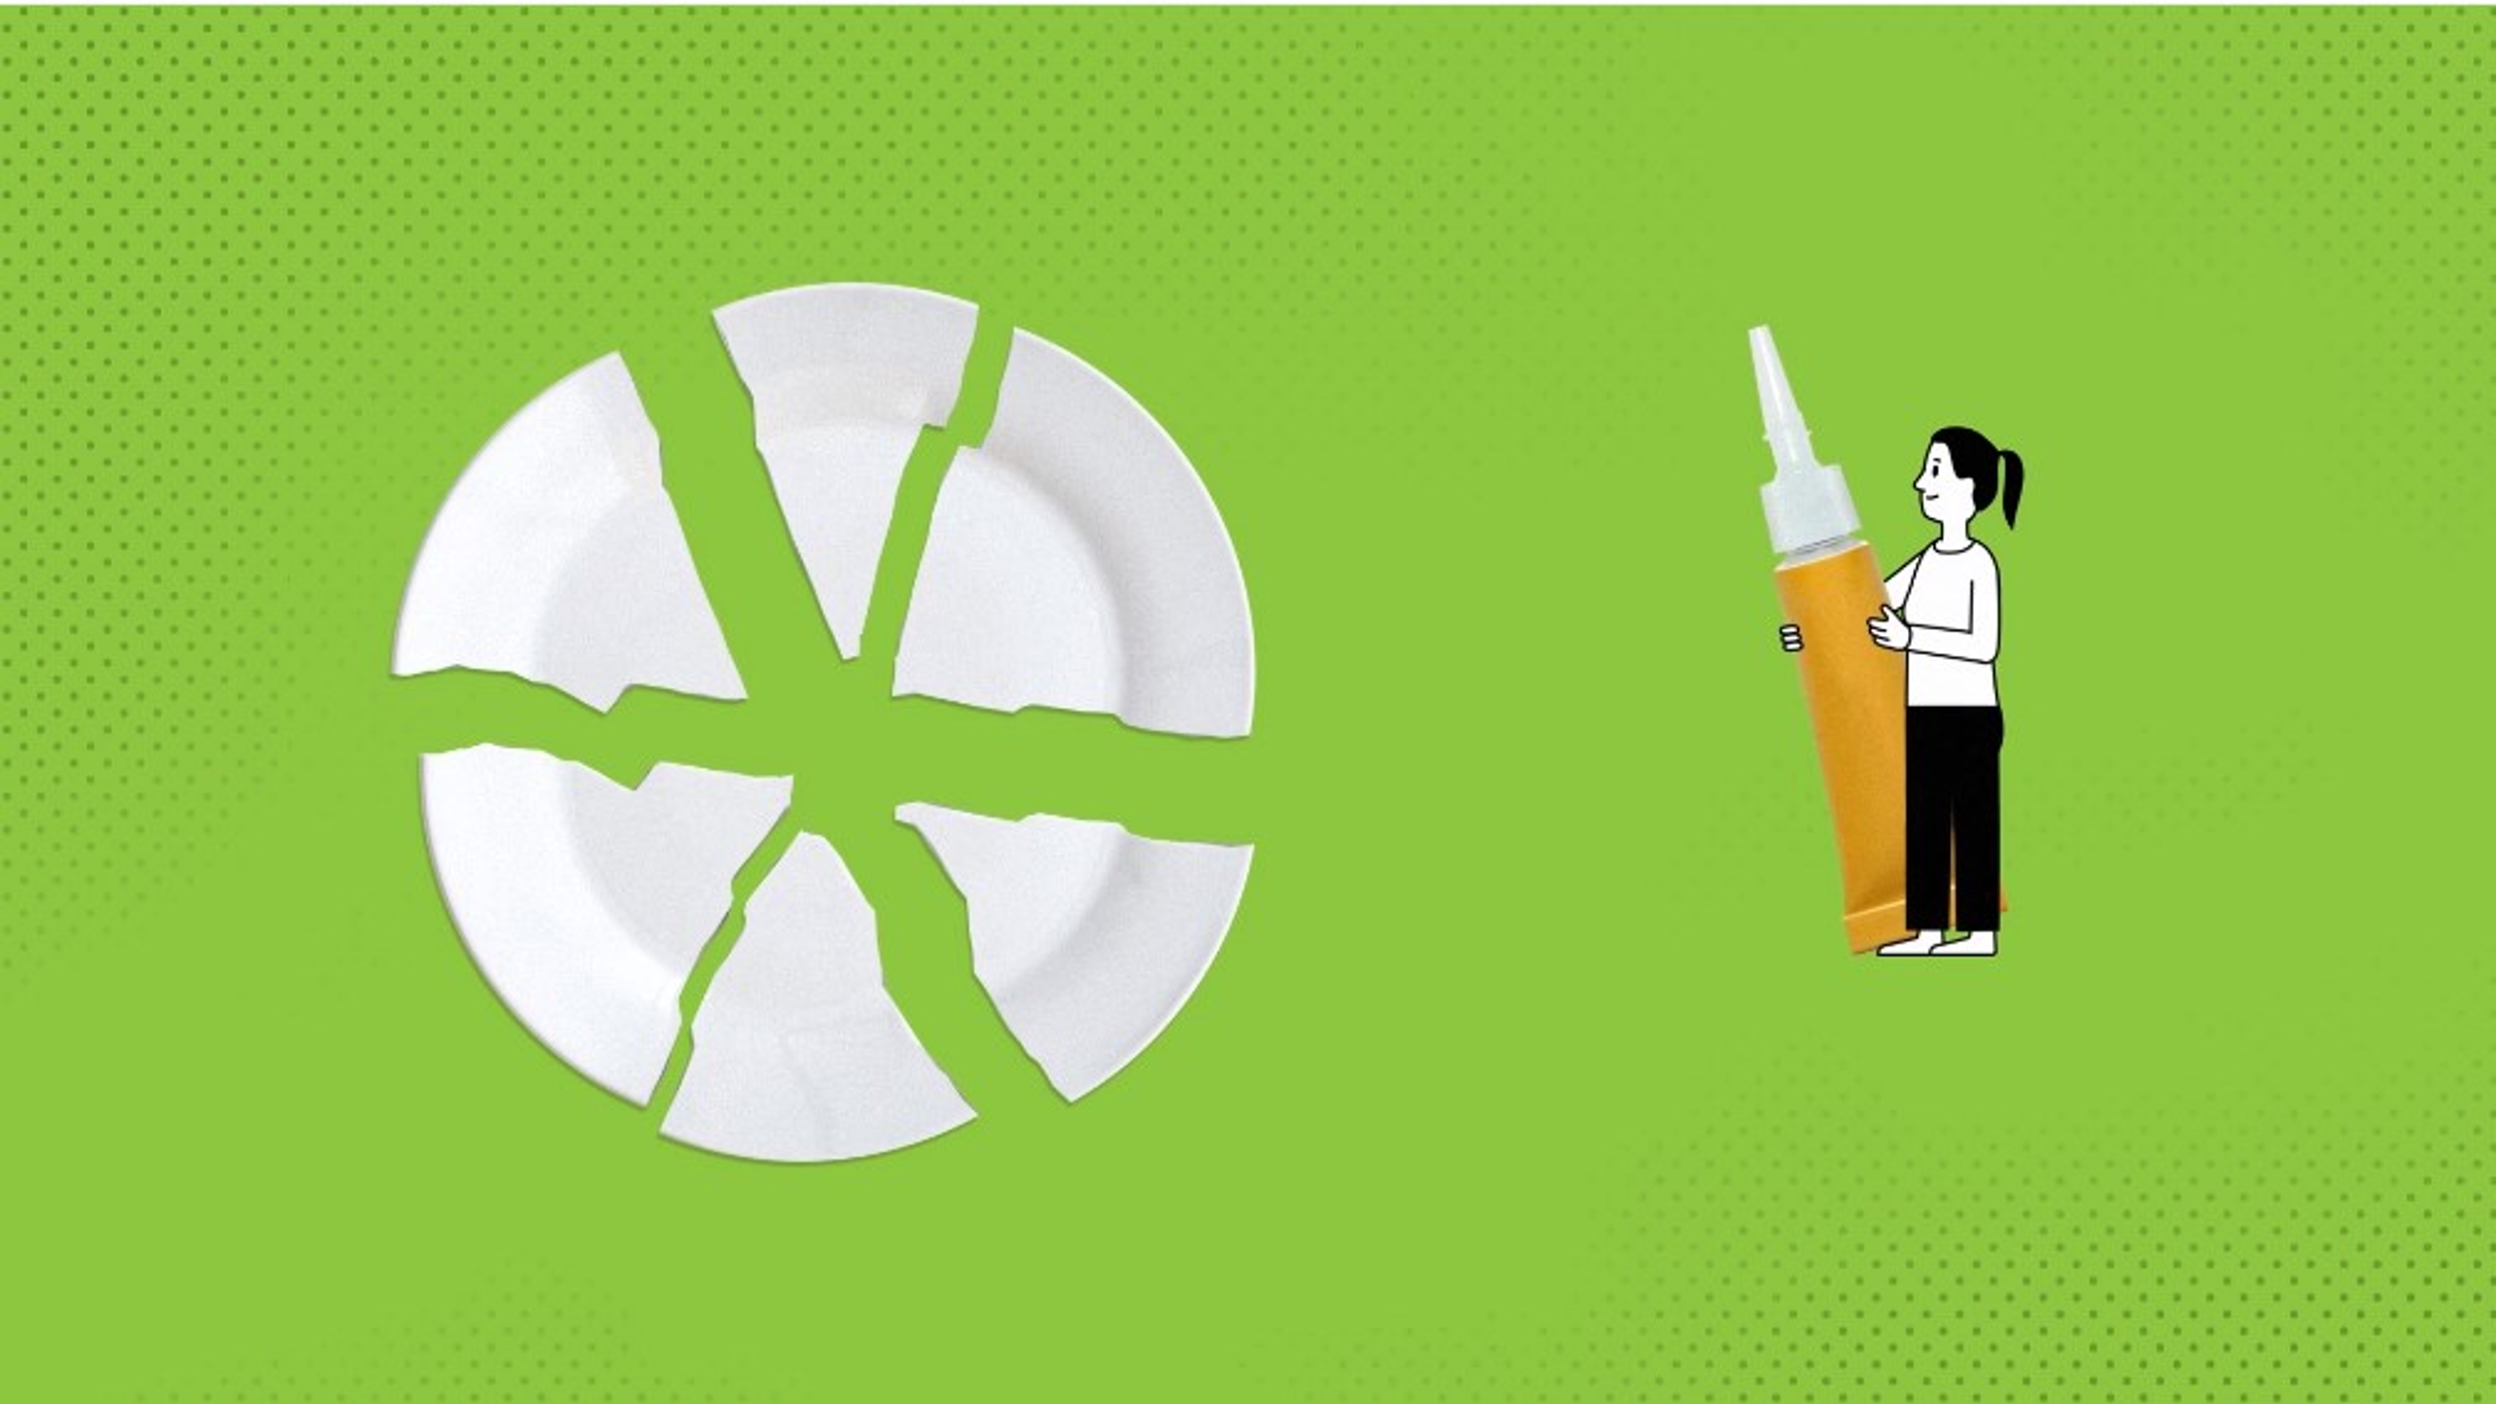 | The way we grow and share food is called our global food system.  And it’s broken. It doesn’t work for everyone.  This is not fair, and this year we can all Step up to the plate and do something about it!
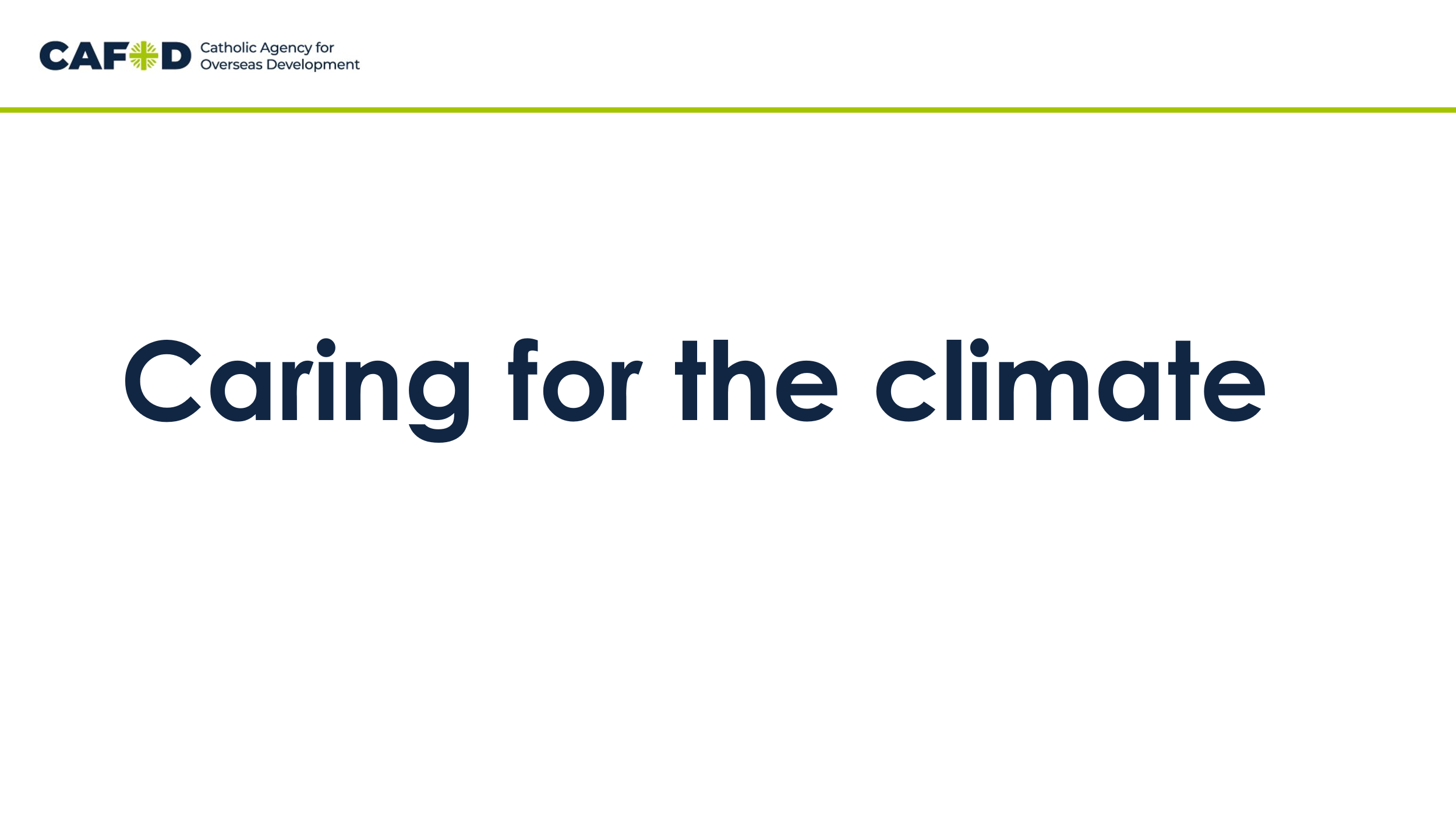 | Let’s find out more.  First, let’s think about how we need to care for the climate when we grow and share food.
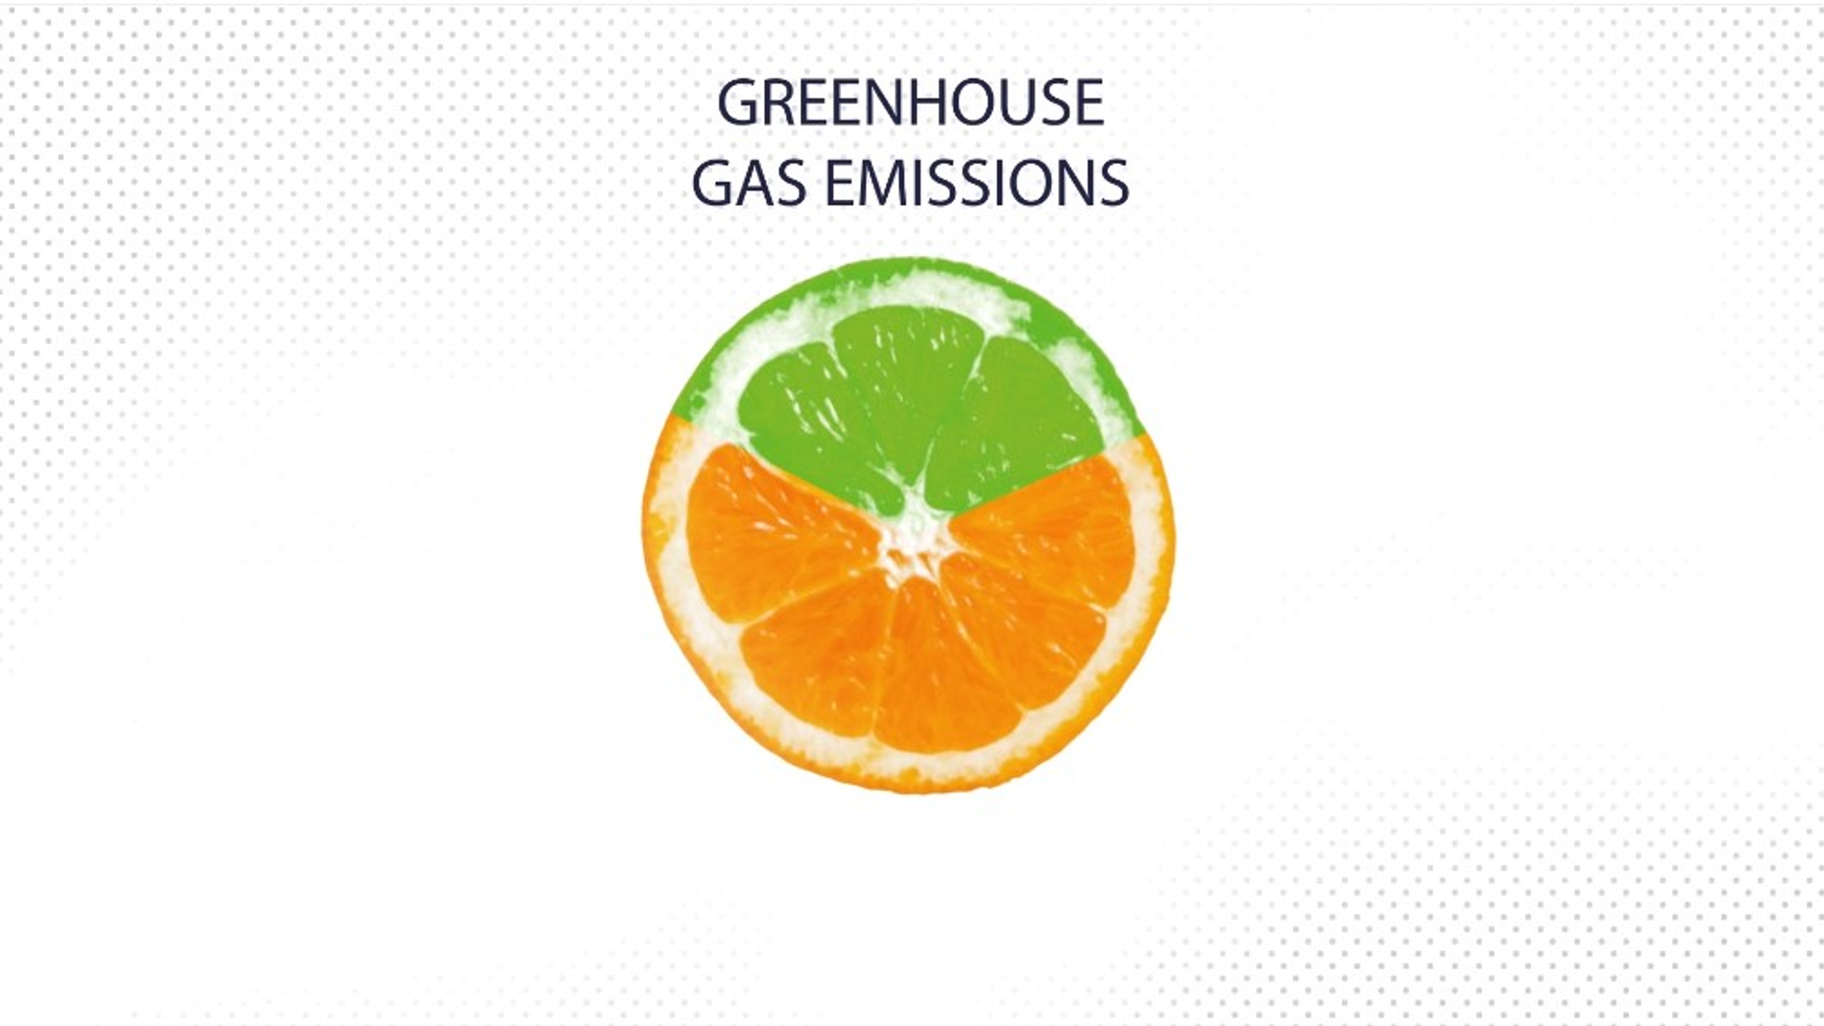 | The way we grow food creates a lot of greenhouse gas which is bad for the climate.
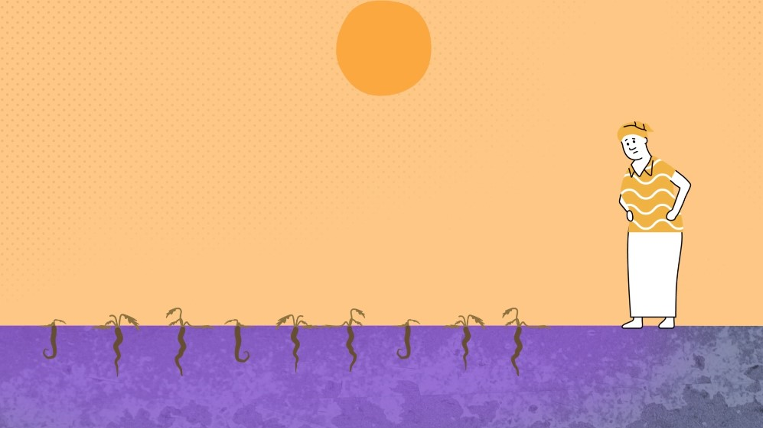 | It speeds up climate change and makes it harder and harder for people trying to grow their food.
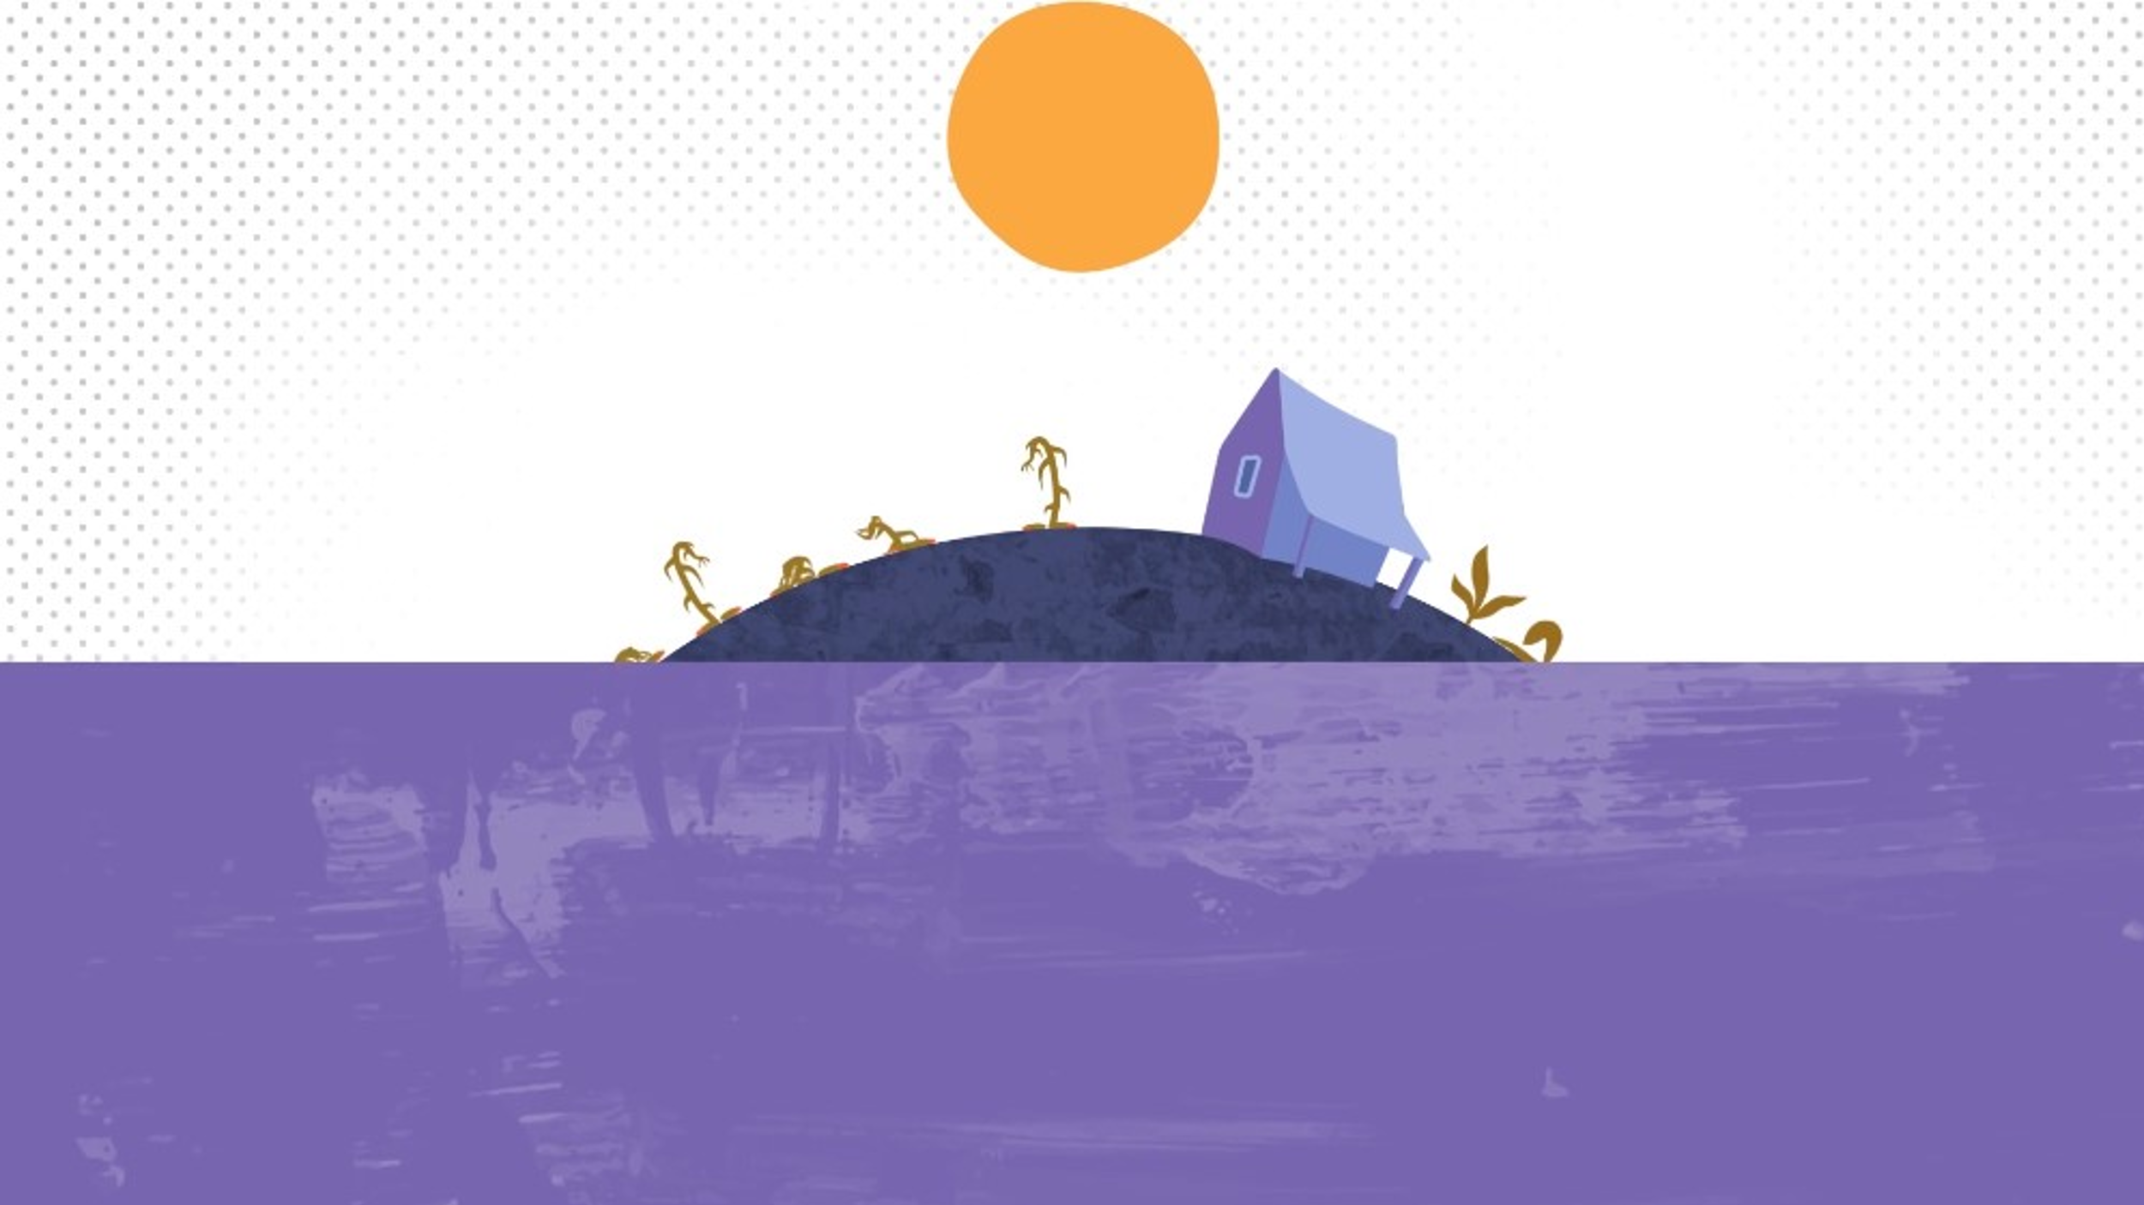 | Storms, droughts and floods are more extreme, destroying crops and making it impossible for things to grow.  Sea levels are rising making the land salty so some plants can’t grow properly.
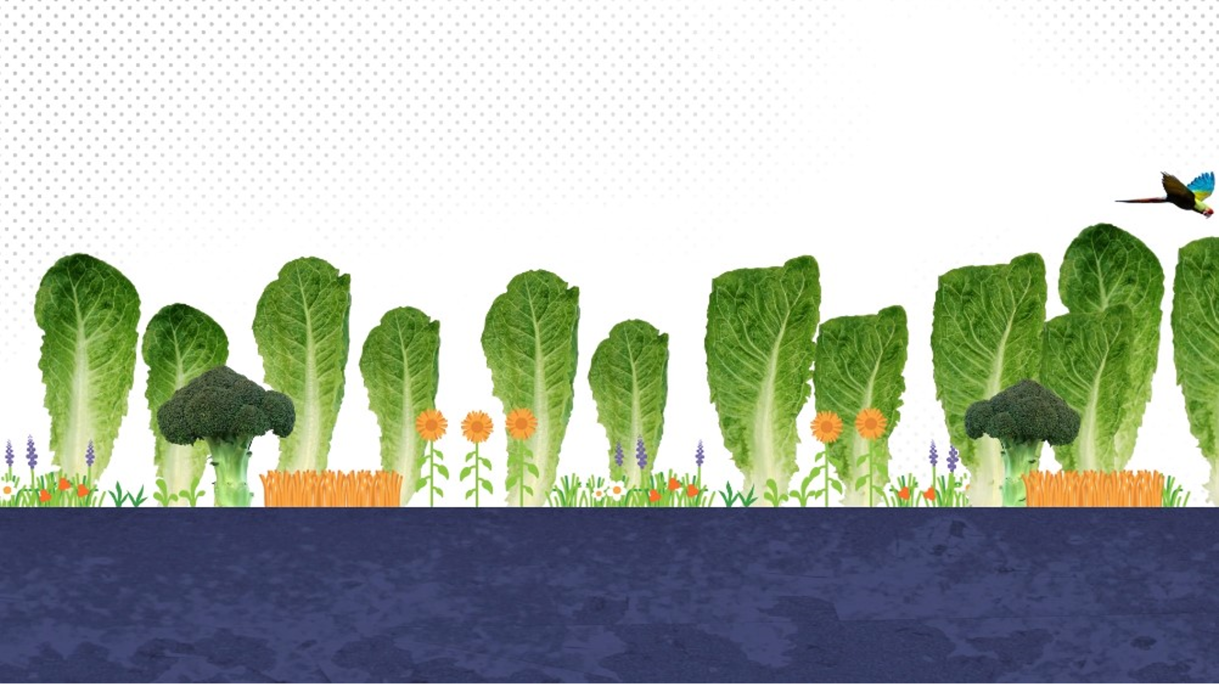 | This climate crisis is made even worse when big companies cut down the rainforest.  This is bad because the rainforest gives us air to breathe, rain for crops and is a home for animals.
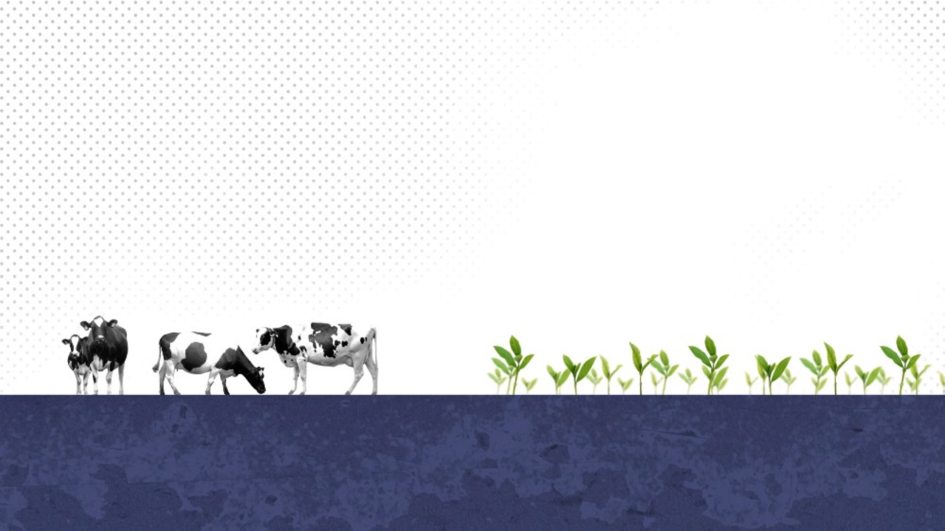 | Big companies are cutting it down because they want the land for cows and to grow crops like soya.
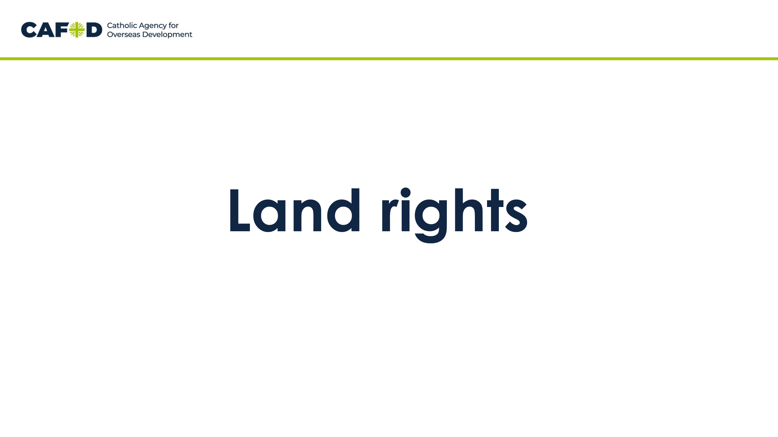 | Now let’s think about the land where we grow and share food.
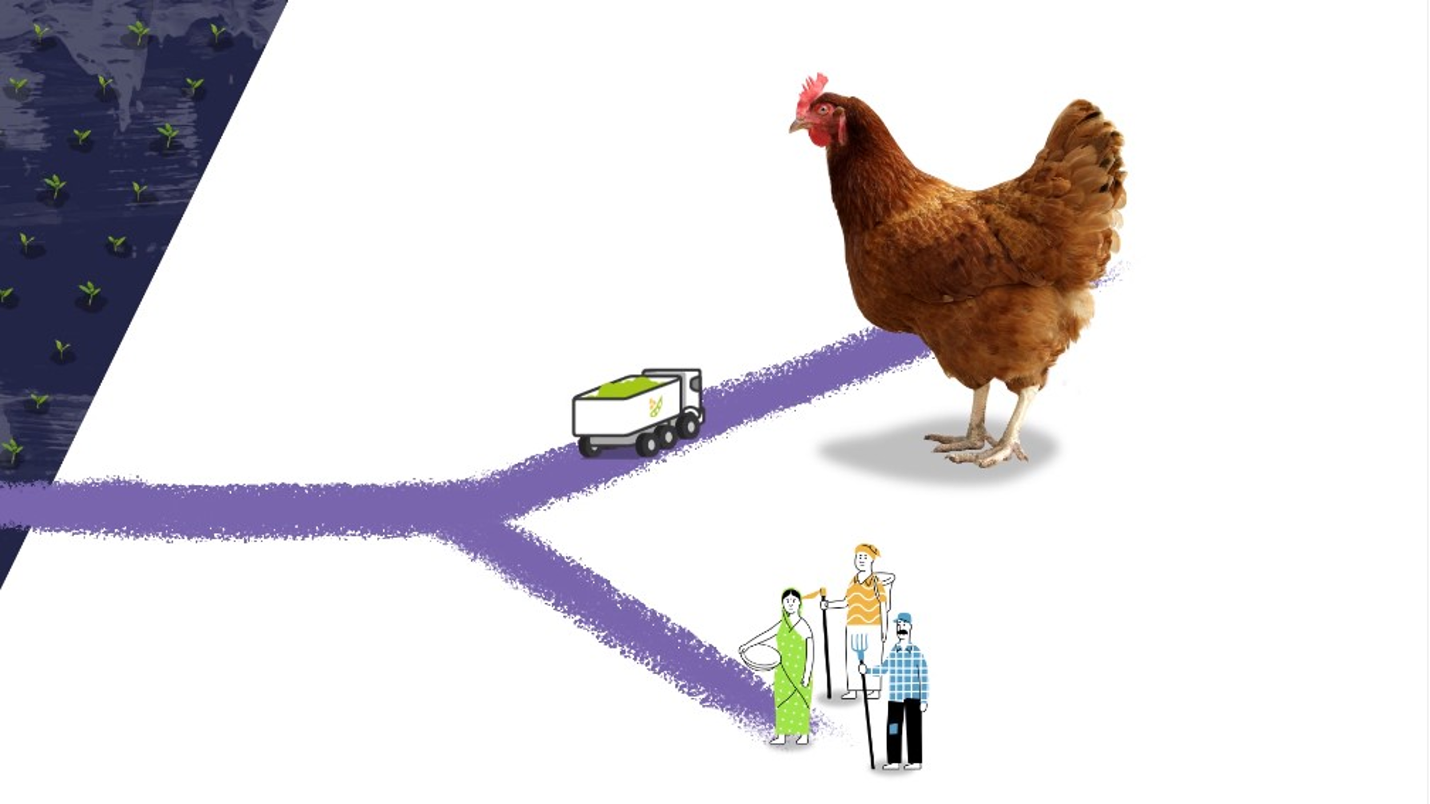 | Most soya beans that are grown are sold to feed chickens, not people.
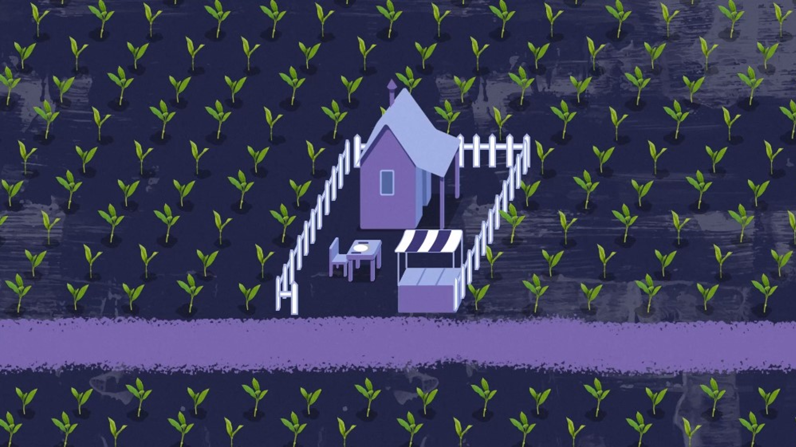 | And land is often taken away from small farms. The farmers can no longer grow food to eat or sell.
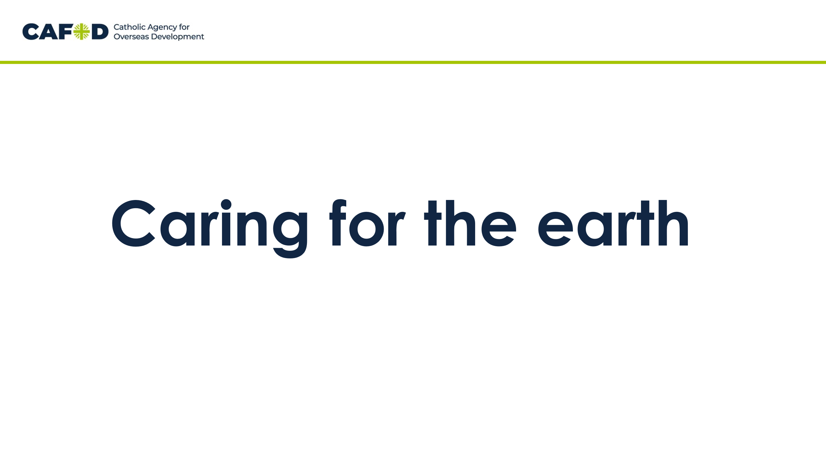 | Now let’s think about how we need to care for the earth when we grow and share food.
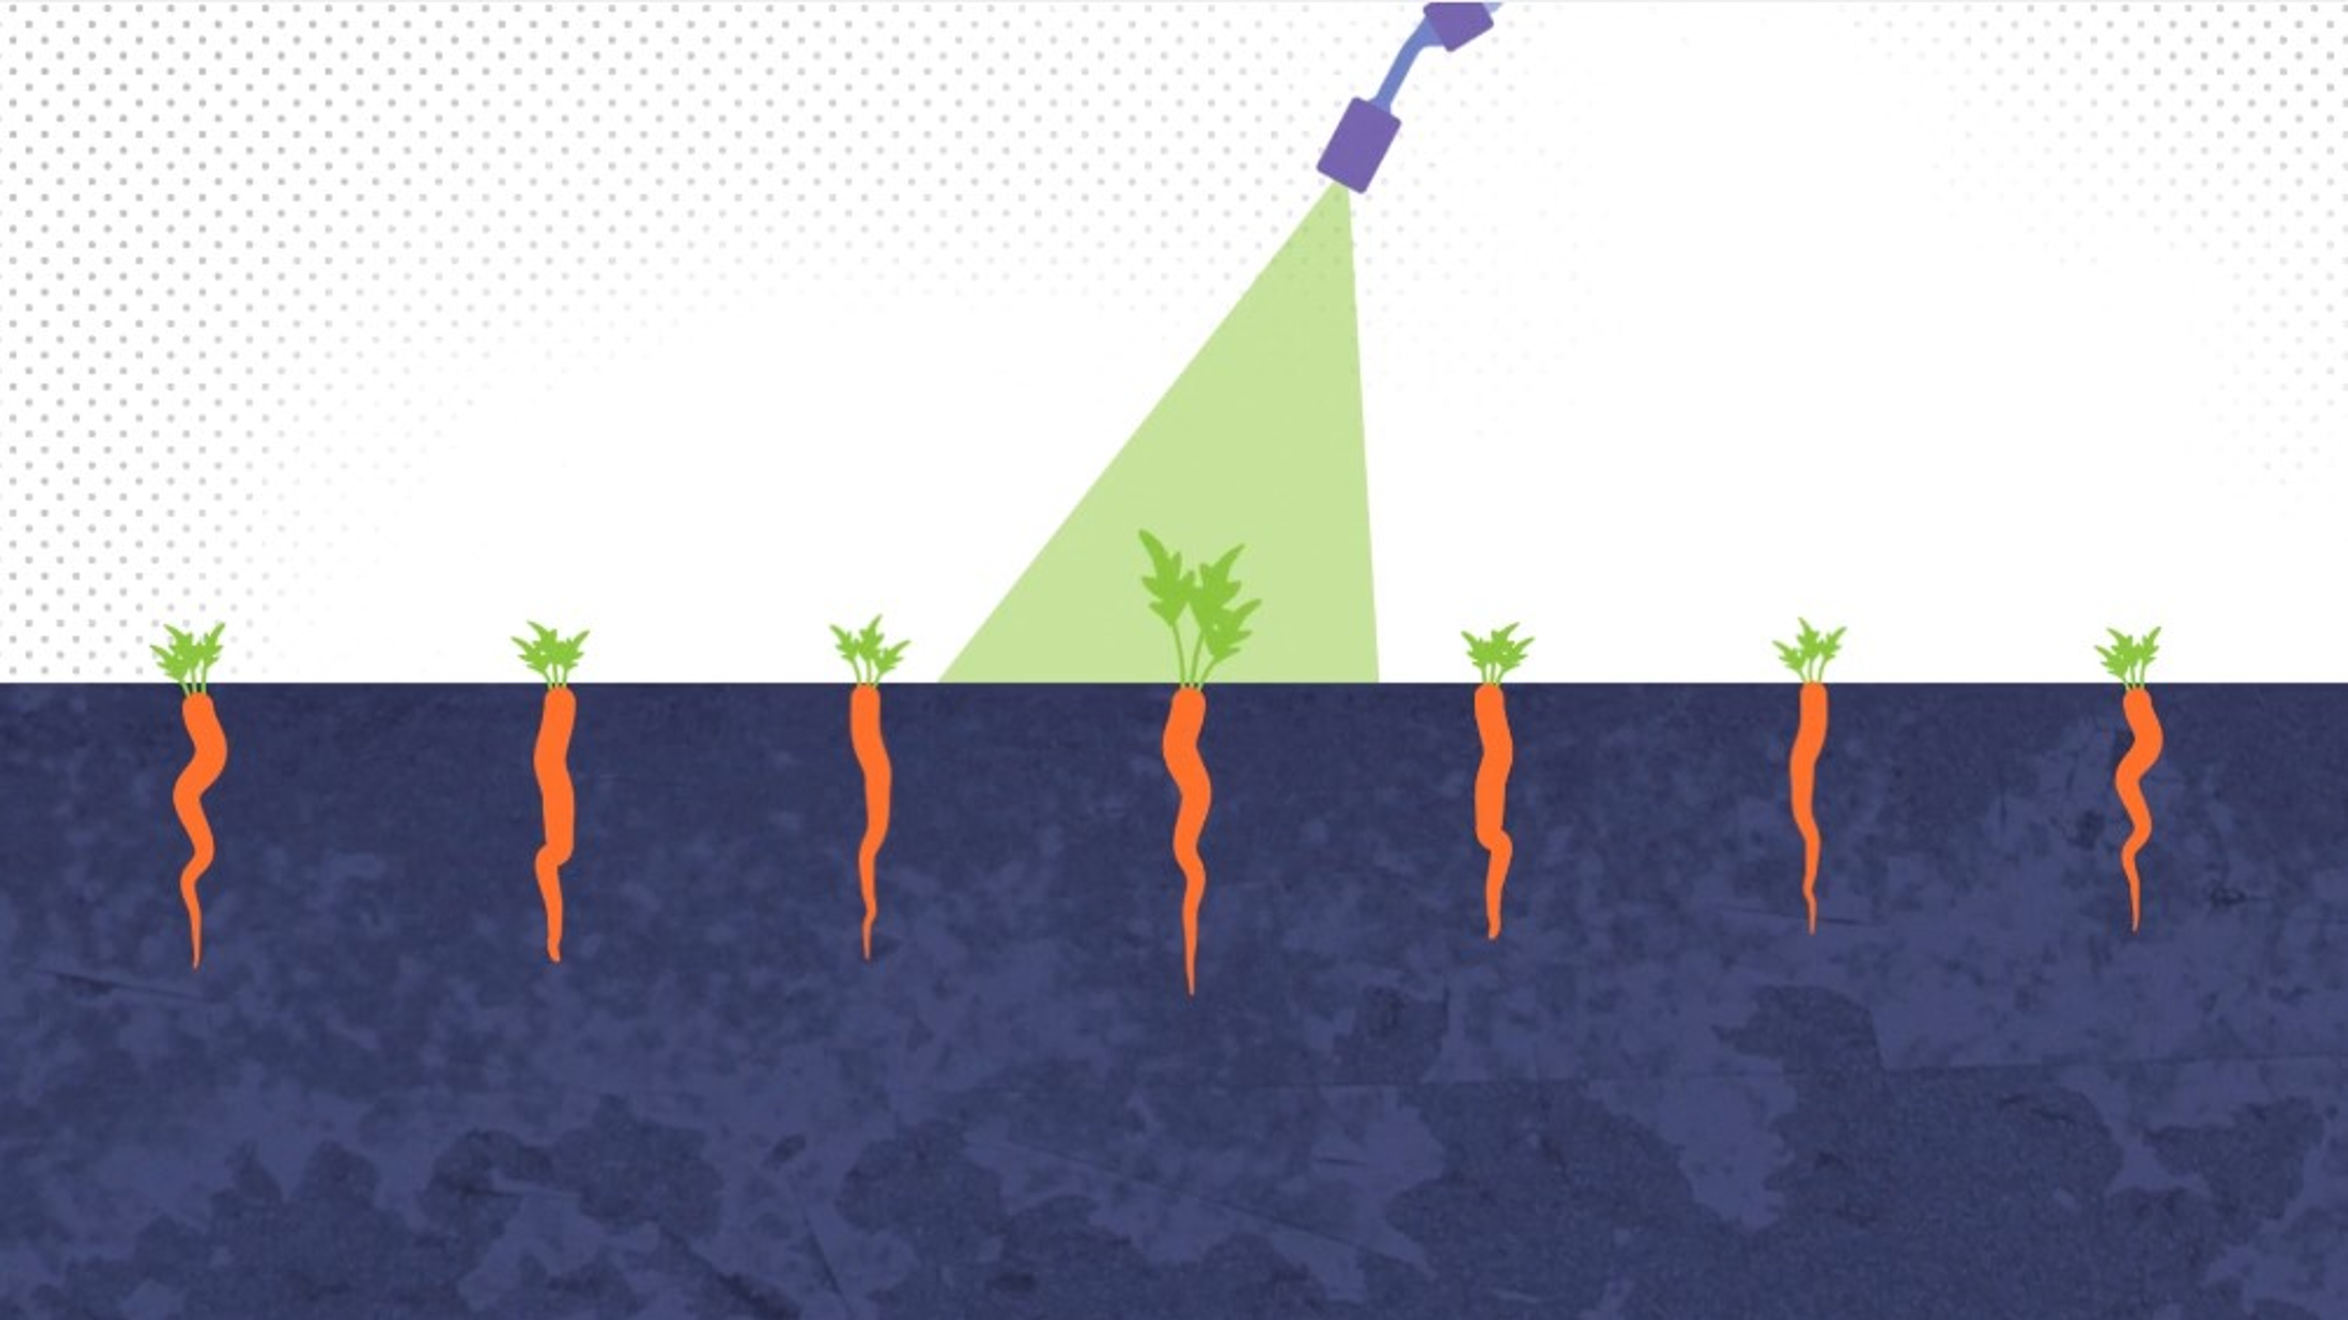 | Some chemicals can make crops grow faster and give bigger harvests.
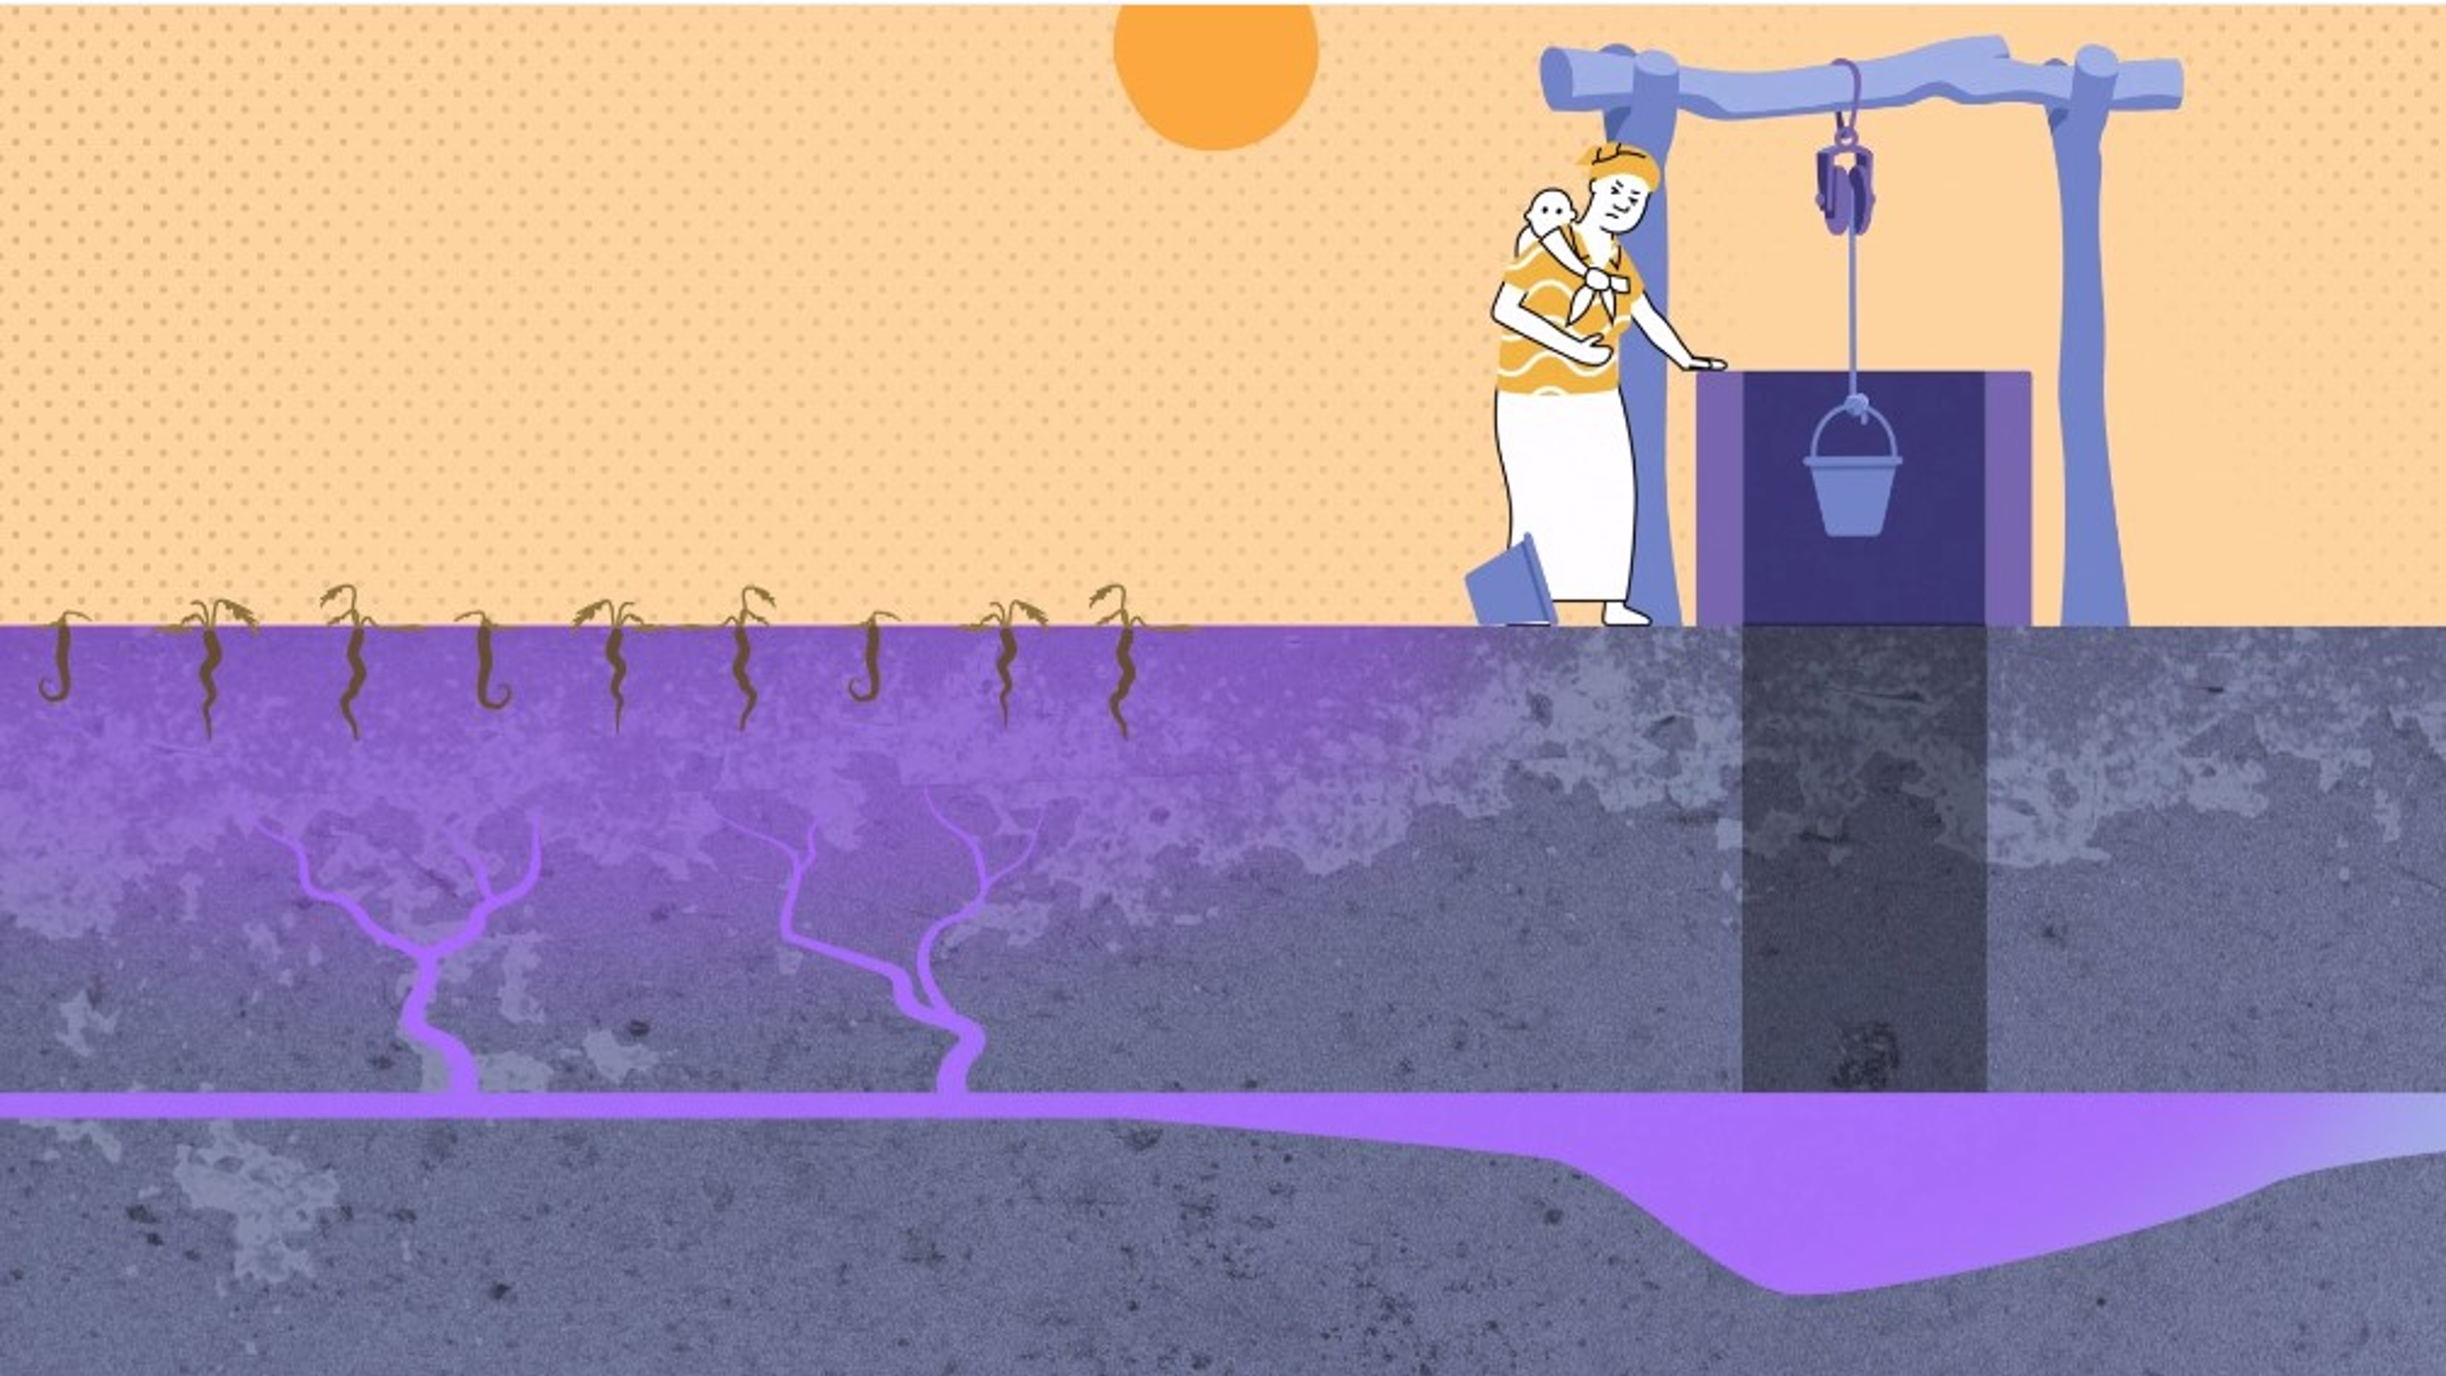 | But as well as speeding up climate change, the chemicals in them are bad for the soil and harm people.
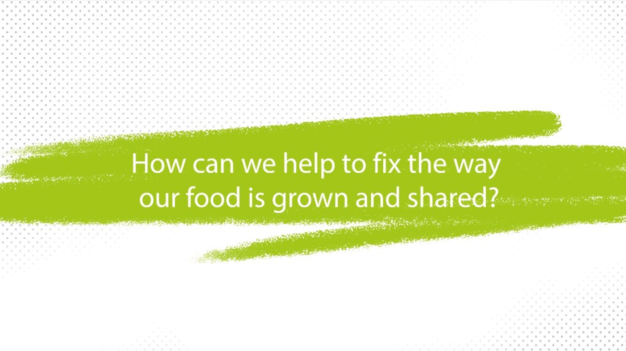 | So how can we help to fix the way our food is grown and shared?
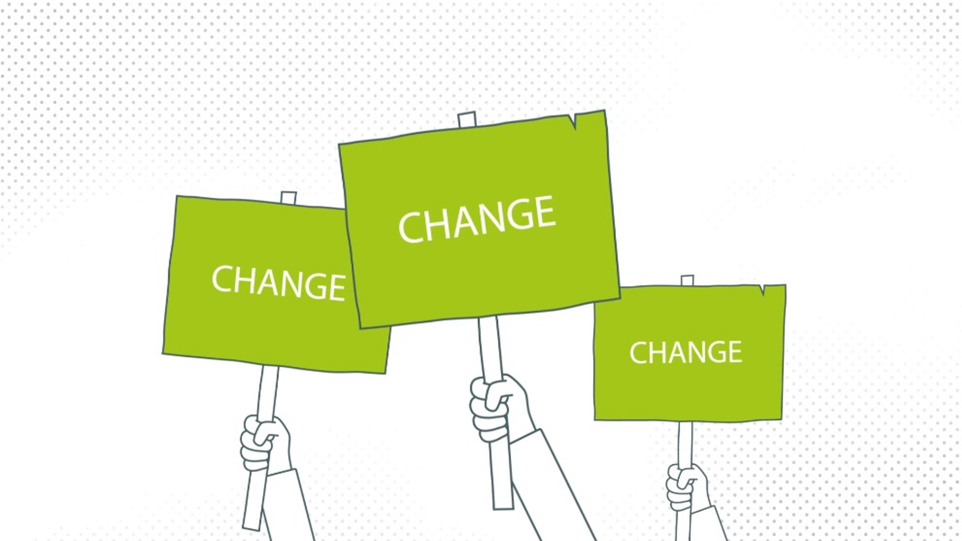 | We need to speak up so that world leaders can hear us.
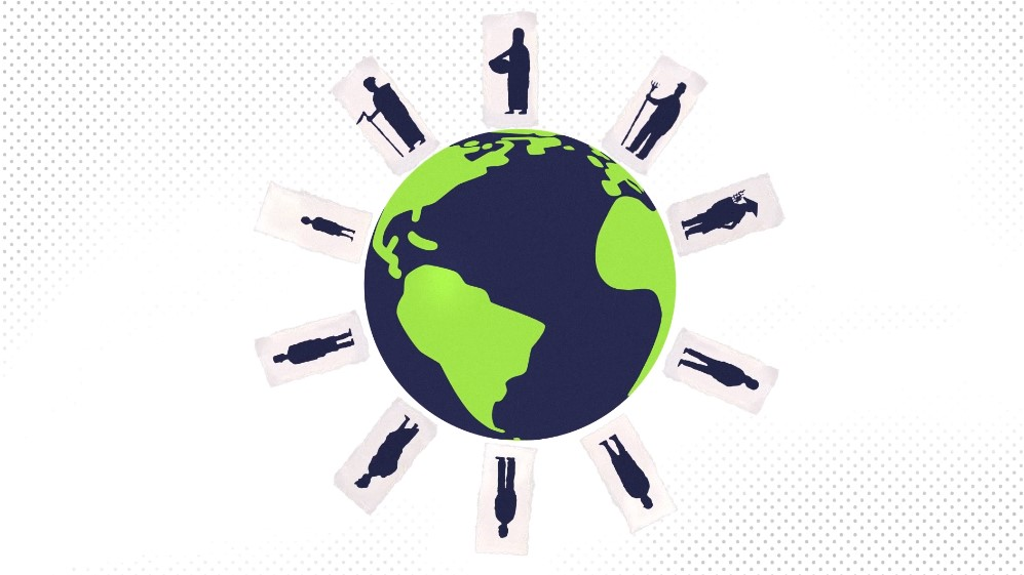 | We need the government to help people around the world who are growing their own food, rather than helping the big companies.
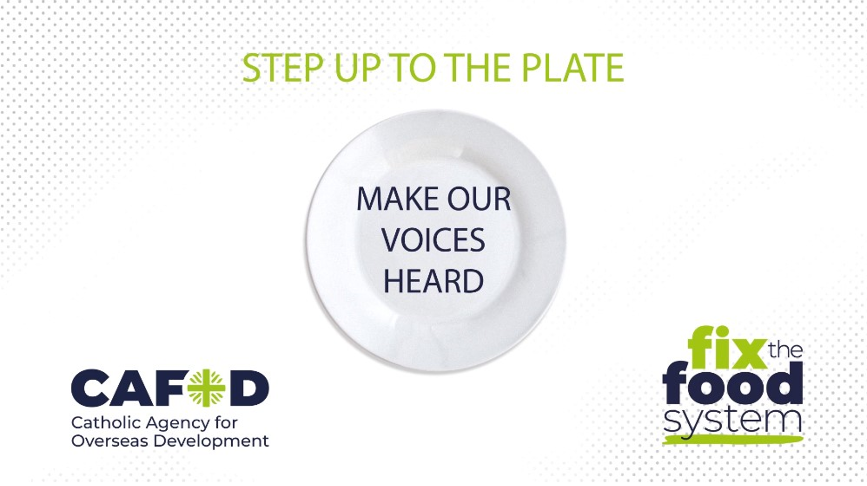 | So, let’s all Step up to the plate, make our voices heard and make a real difference to our global family!

