The next Installment
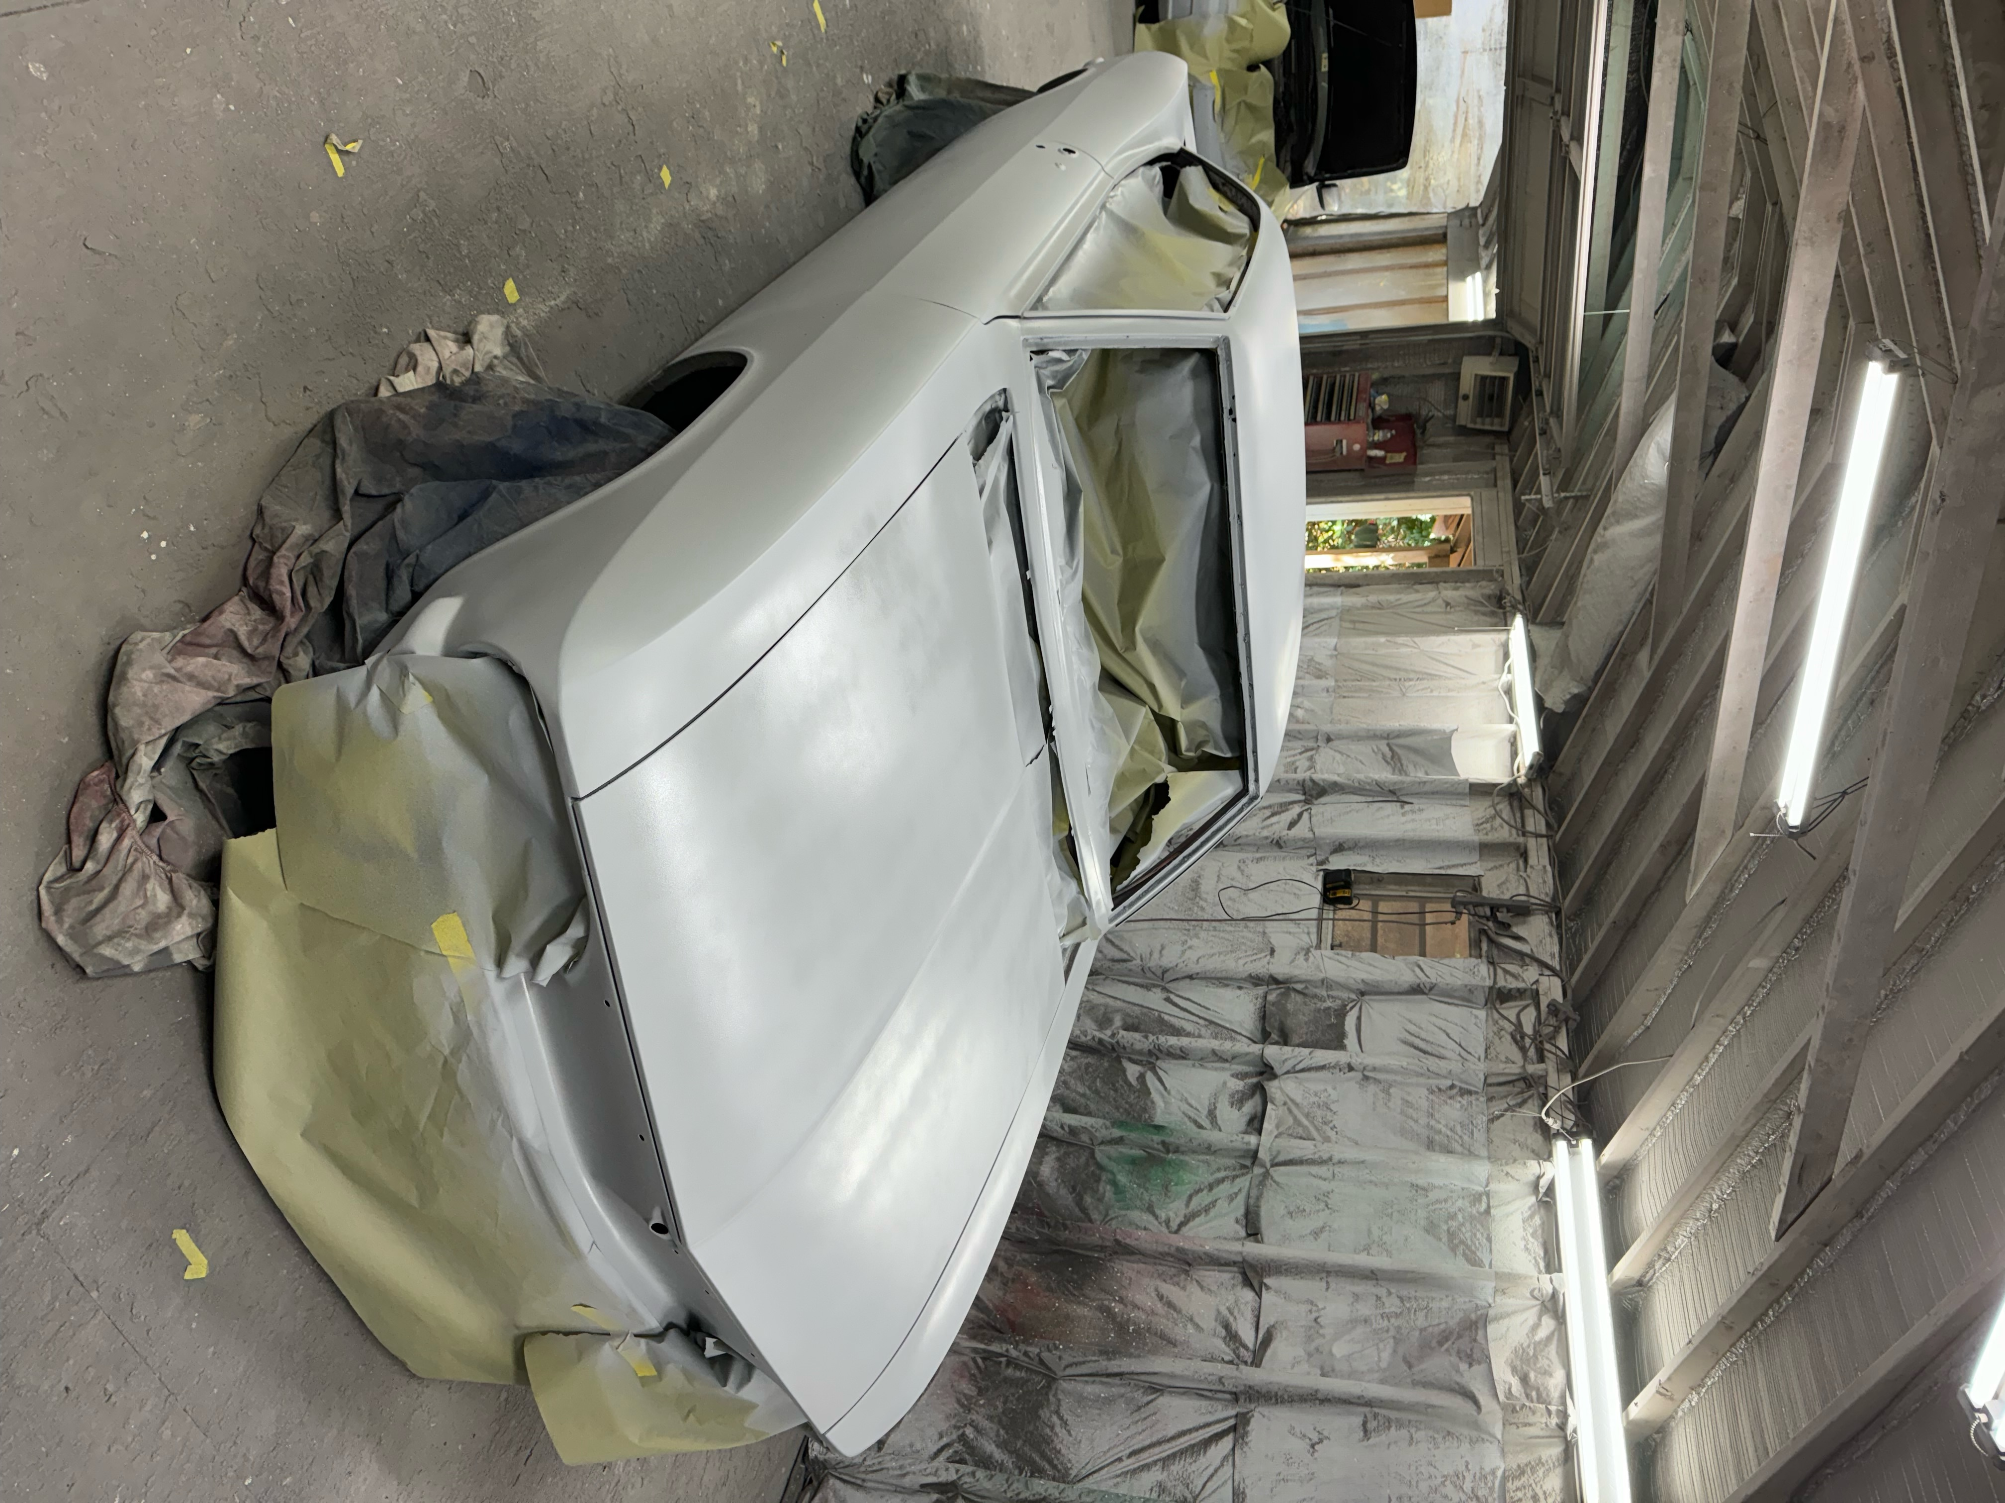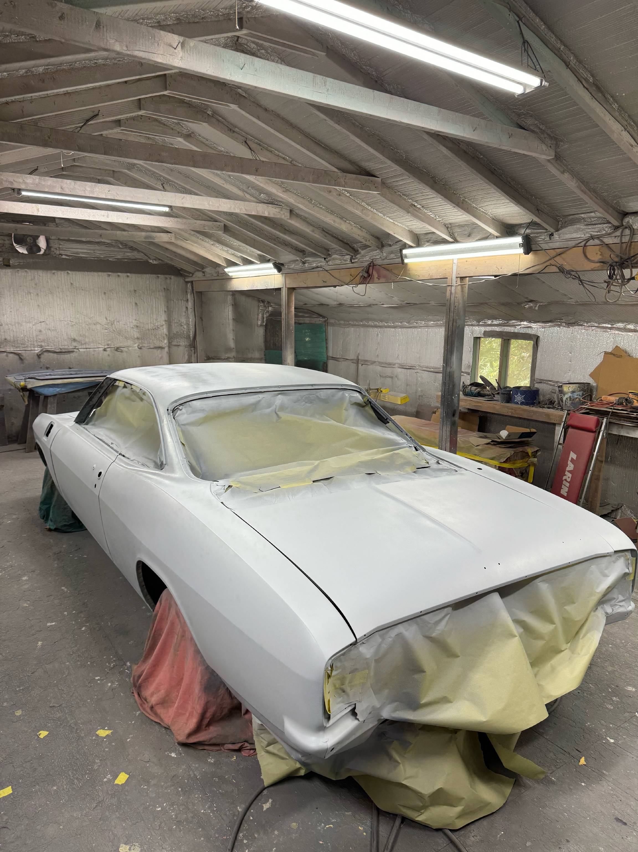 When I last posted information the Corsa was headed off to the paint shop for a respray in Aztec Bronze with the interior painted in the Medium Bronze to match. During the work at the body shop the metal piece across the base of the windshield was replaced (beyond my skill set) and a large hole in the quarter panel under the battery was repaired professionally. Some pictures of the car in primer are below.
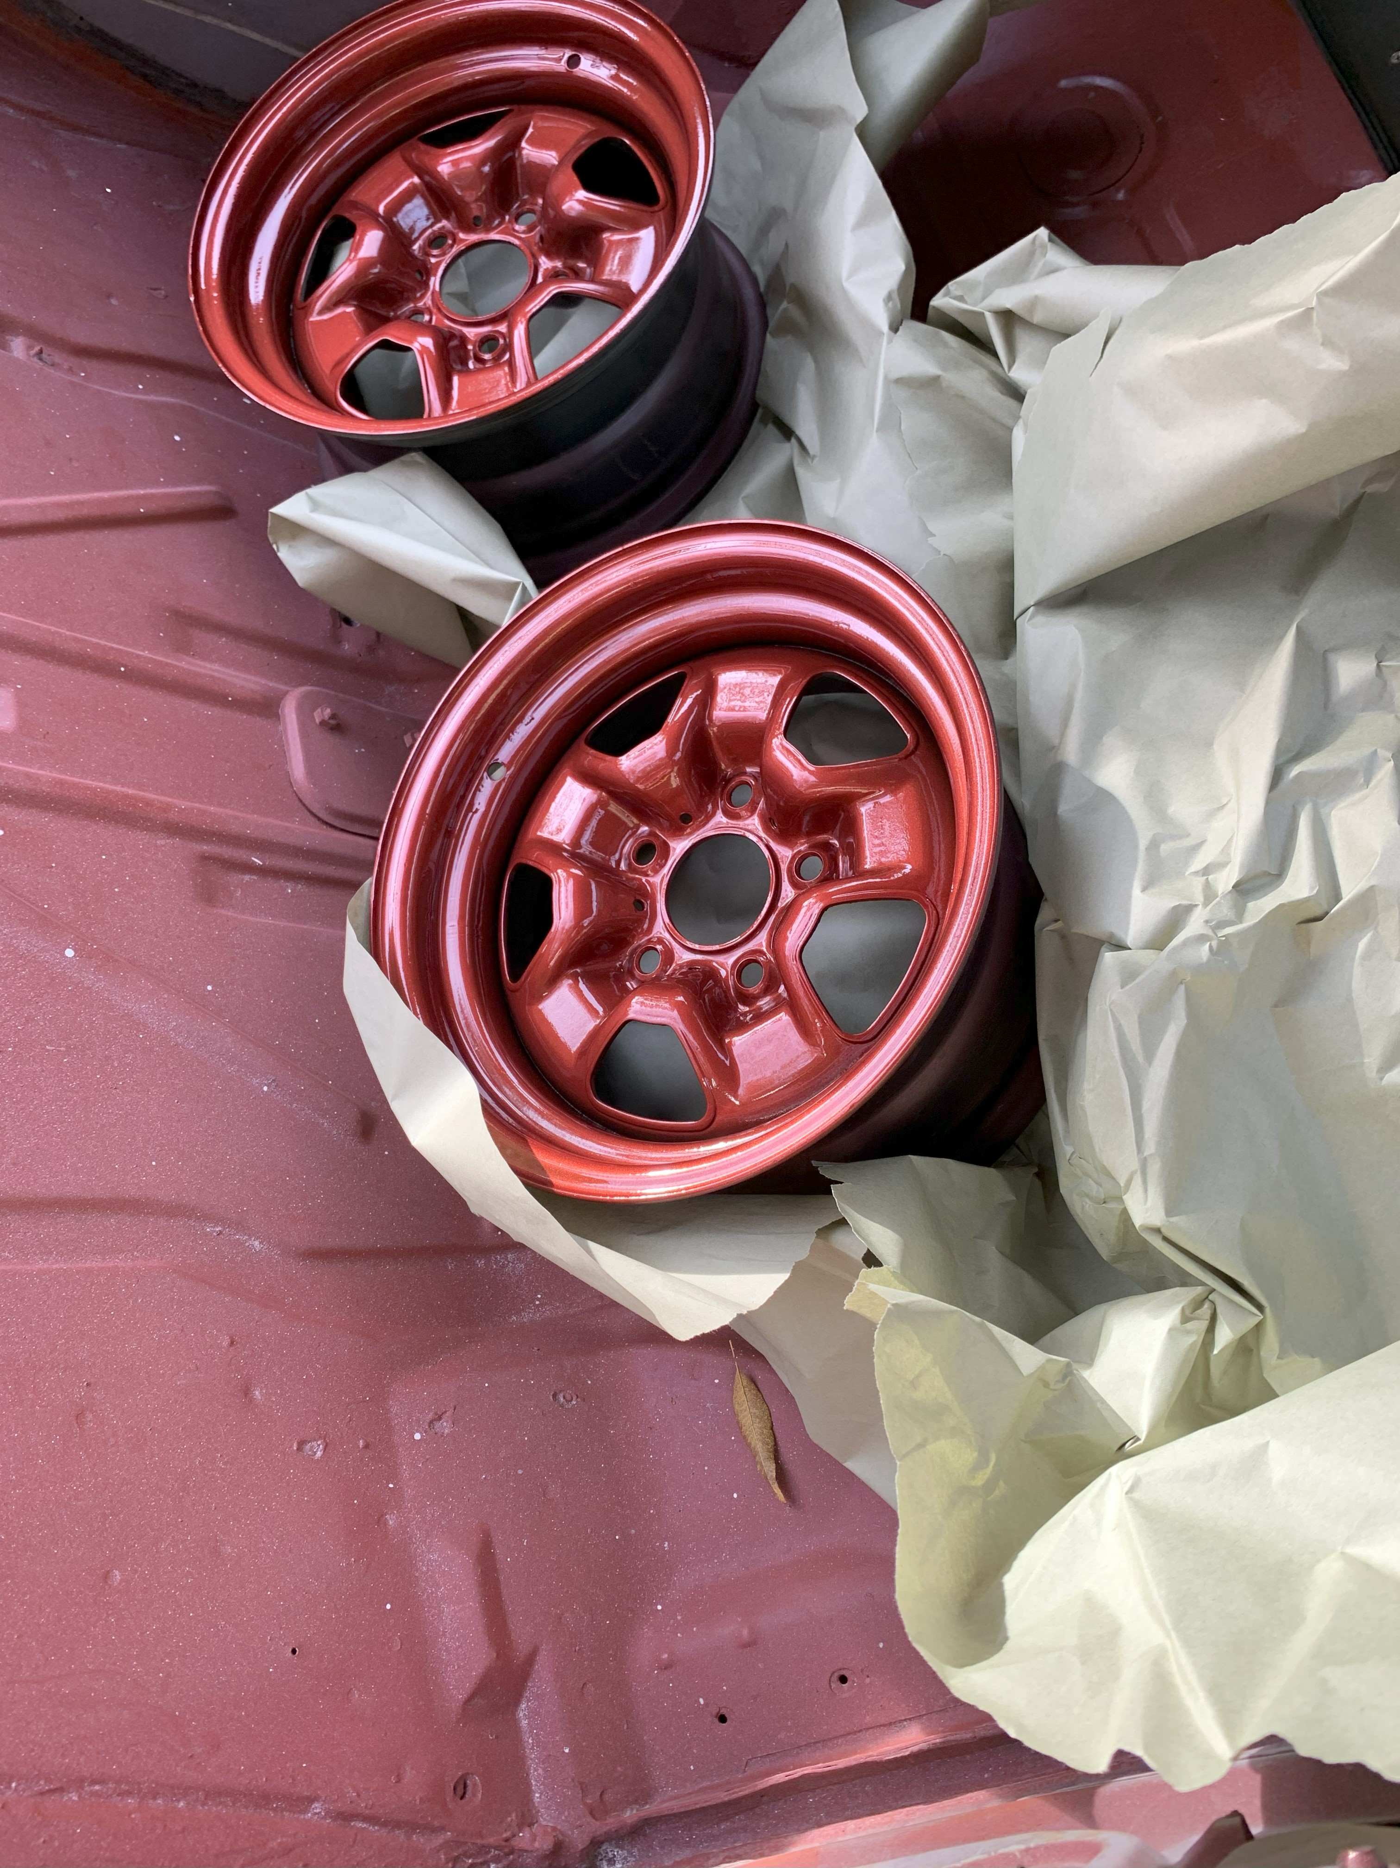While the car was there, I found a set of 14x7 Oldsmobile Rally Wheels and dropped them off to be painted to match the car when it was sprayed.

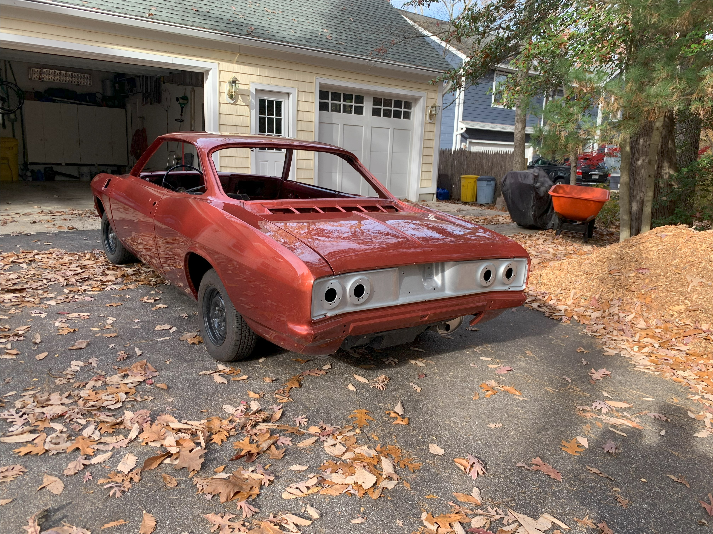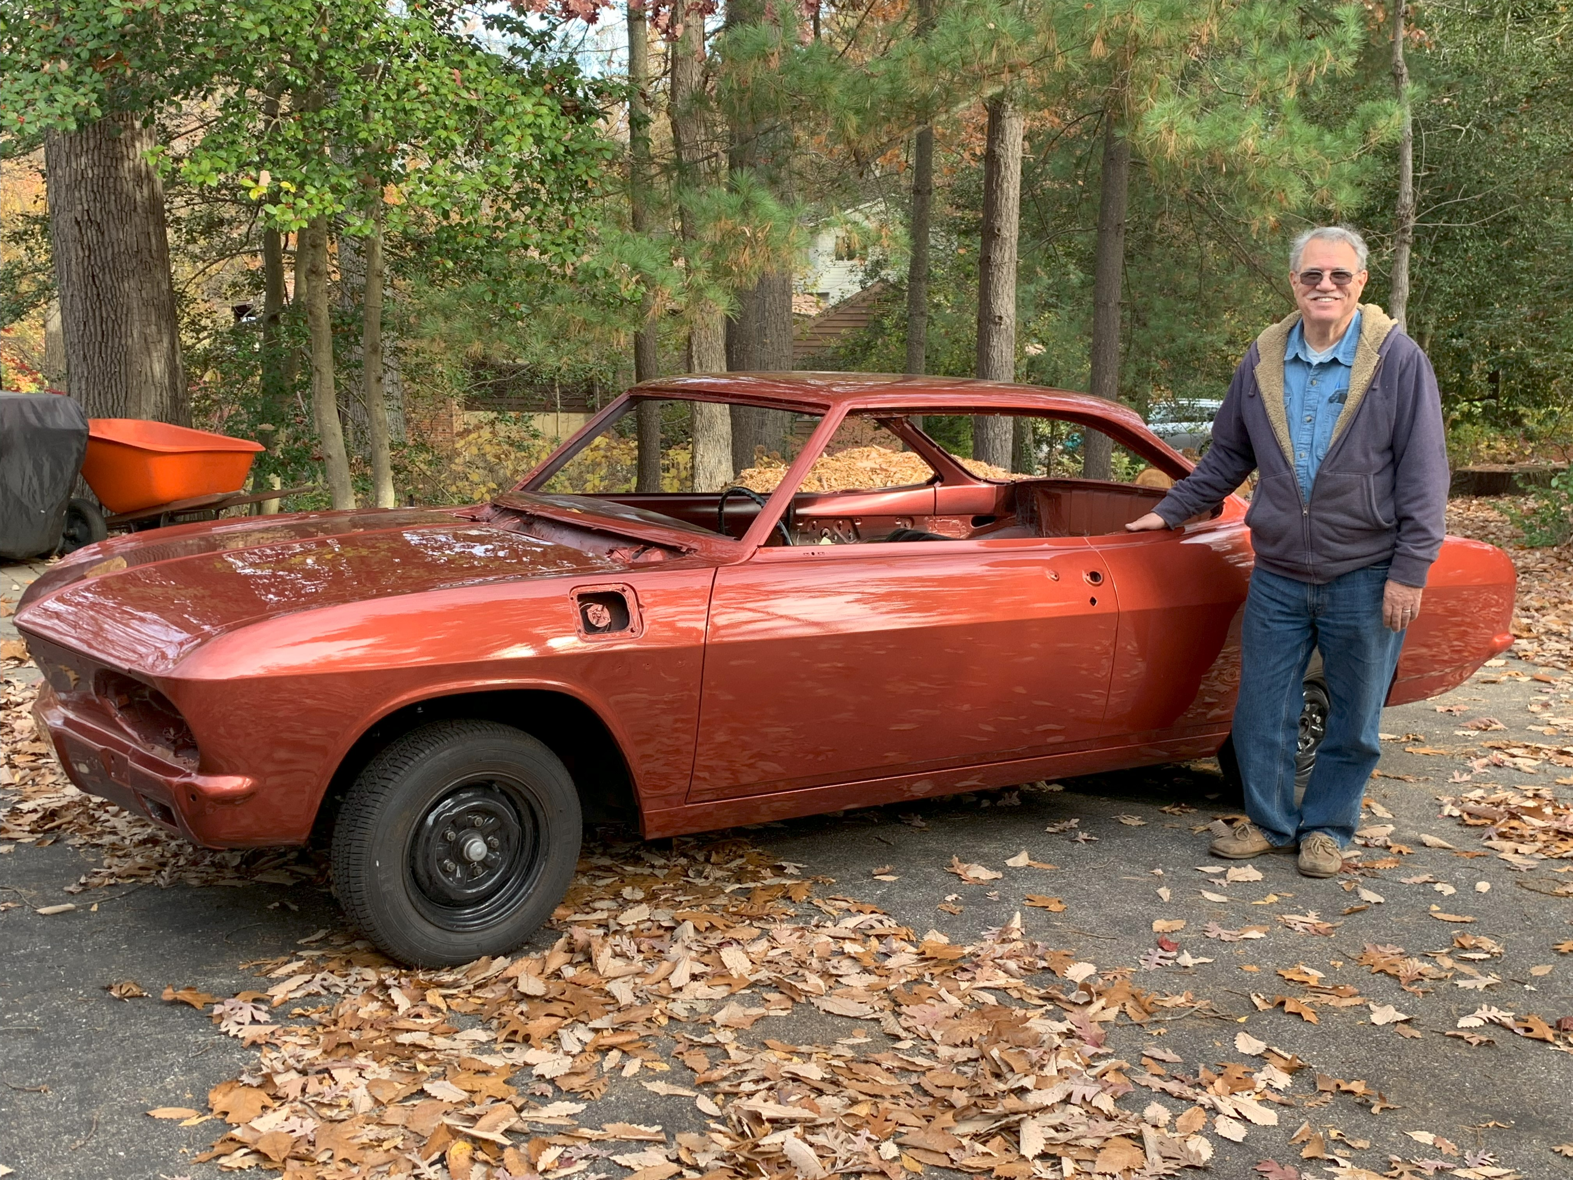Just back from the paint shop and ready for the re-assembly process - Lots to do!

Through the miracle of time and many man-hours working on the car….The outside is almost done and it is time to order parts from Clark’s to do the inside. Headliner, door cards, seat covers, carpet….a long list but my goal is a stock car, with the exception of wheels and tires. 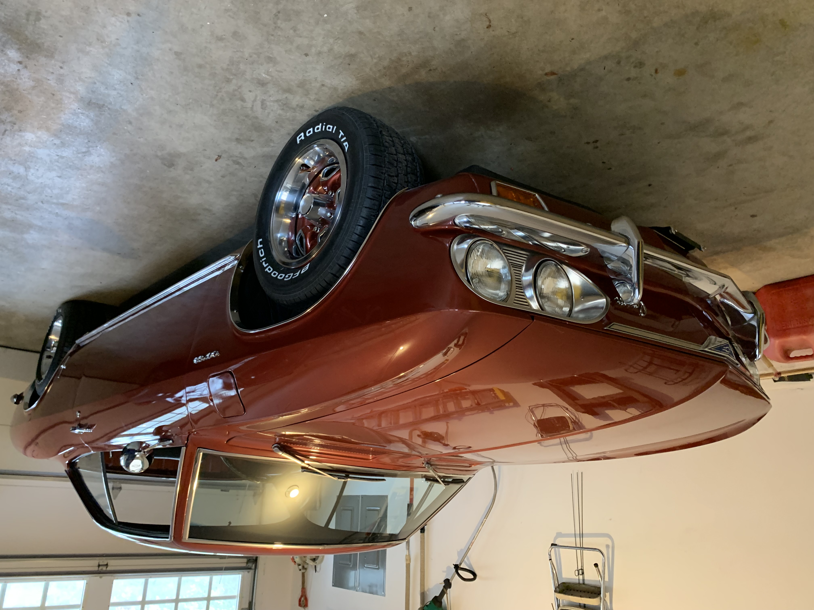New 225/60-14 tires look sharp on the wheels and match the Outside Diameter of the original stock tires.

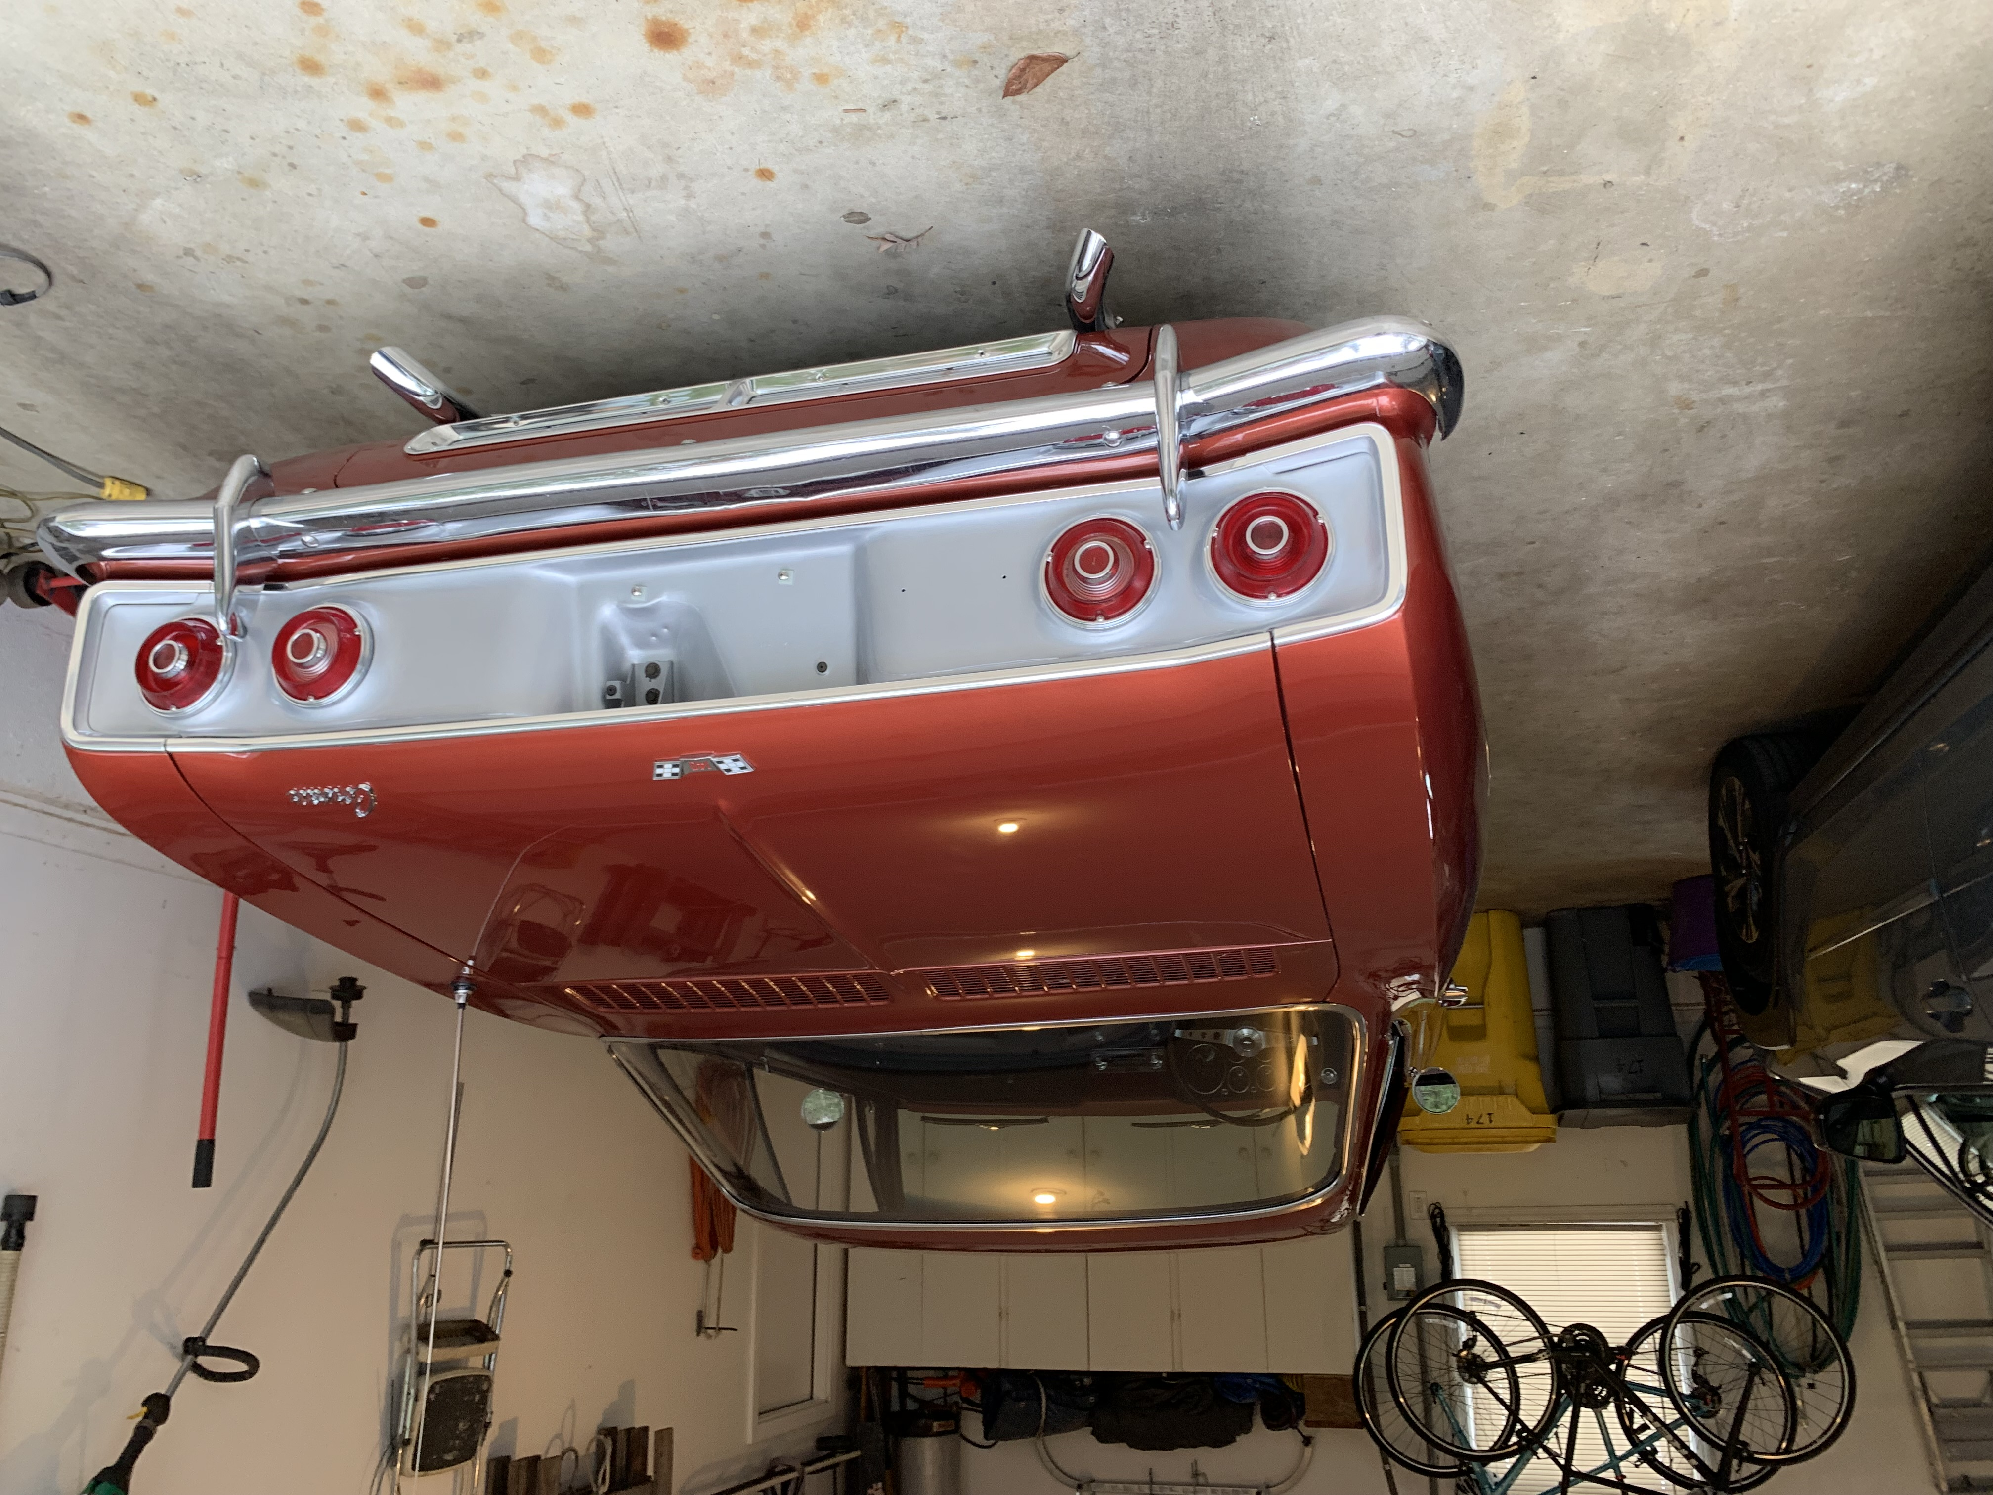
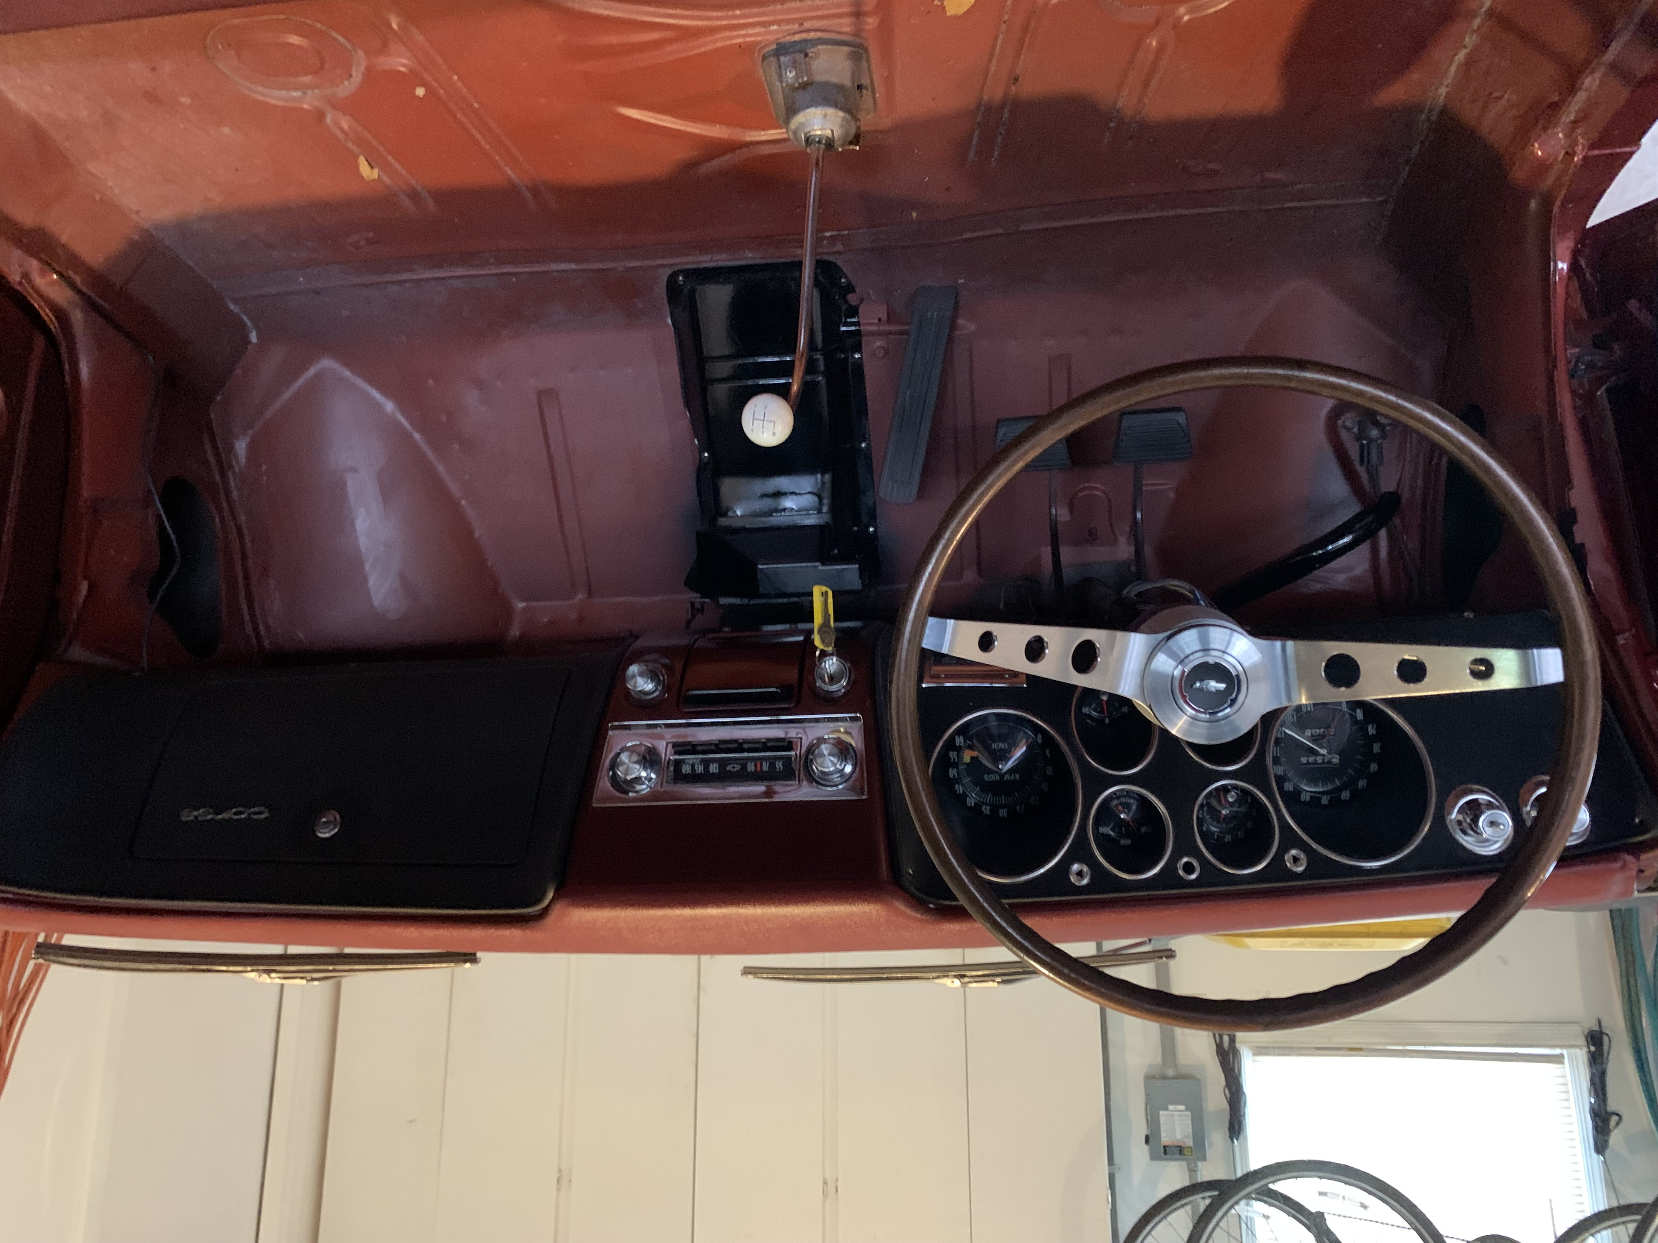The steering wheel is from Ron Fedorczak and is a nice addition to the interior. I have a stock black one is someone needs one. As you can see on the interior photo the radio is back in, with a new speaker designed by Jim Simpson and published a couple months back. One of my good friends is an RF Engineer and he worked on the radio to get it working. It works but there are not many AM stations around anymore. Someone needs to make a blue tooth adapter for the antenna lead so that music from a phone can be piped into the car.

That’s all for now. Time to get on the phone with Clark’s to order some interior trim.

