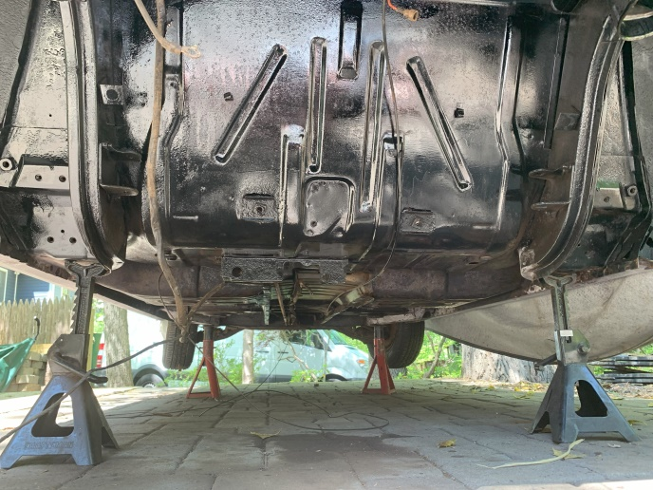
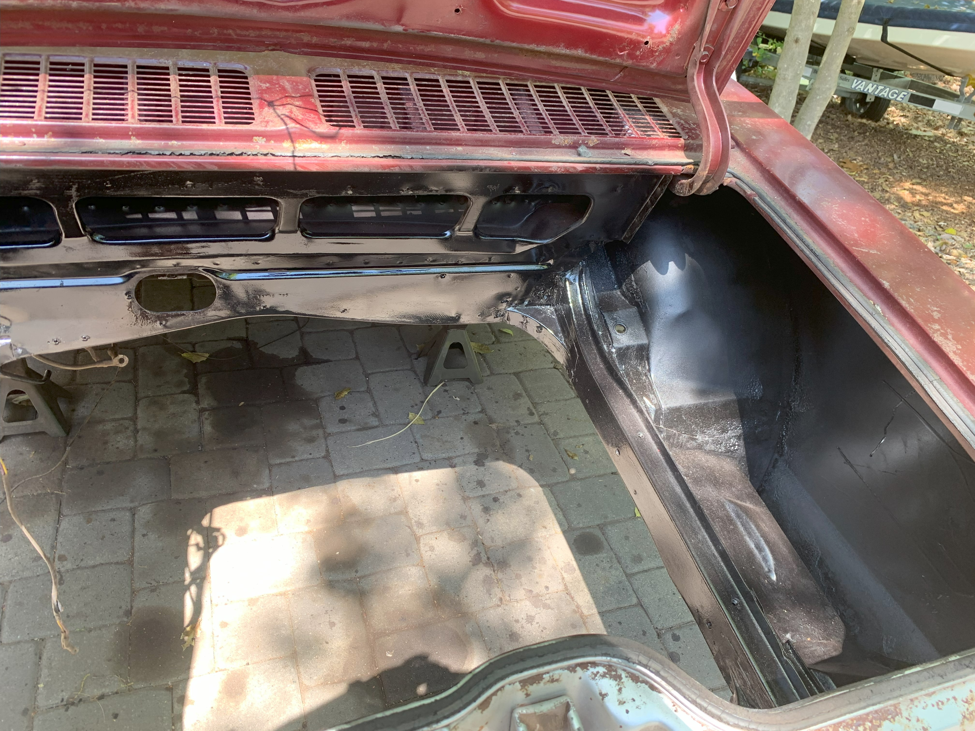Some quick update information on the 66 Corsa rebuilding. The car body is starting to get work done on it. The engine compartment has been cleaned of loose rust, treated with rust converter and then resprayed with either Rustoleum black paint or undercoating. The area under the car up to the front firewall has also been cleaned of rust and treated with the rust converter…painting yet to be done.
The tunnel covers , front and rear, have also been pulled down in preparation for replacement of the clutch cable, fuel and brake lines. The interior was in great shape and did not need much cleaning, however the rear cover was rusted and pretty rough. I thought about ordering one from Clarks but decided to give my hands a shot at making one. While there is a shoulder on the original, I dealt with the difference in height by filling with some black rubber material. Kind of a test for me to see how it works. I can always order one from Clarks if I decide this does not work. New rear seals to be installed on the tunnel when it goes back together.
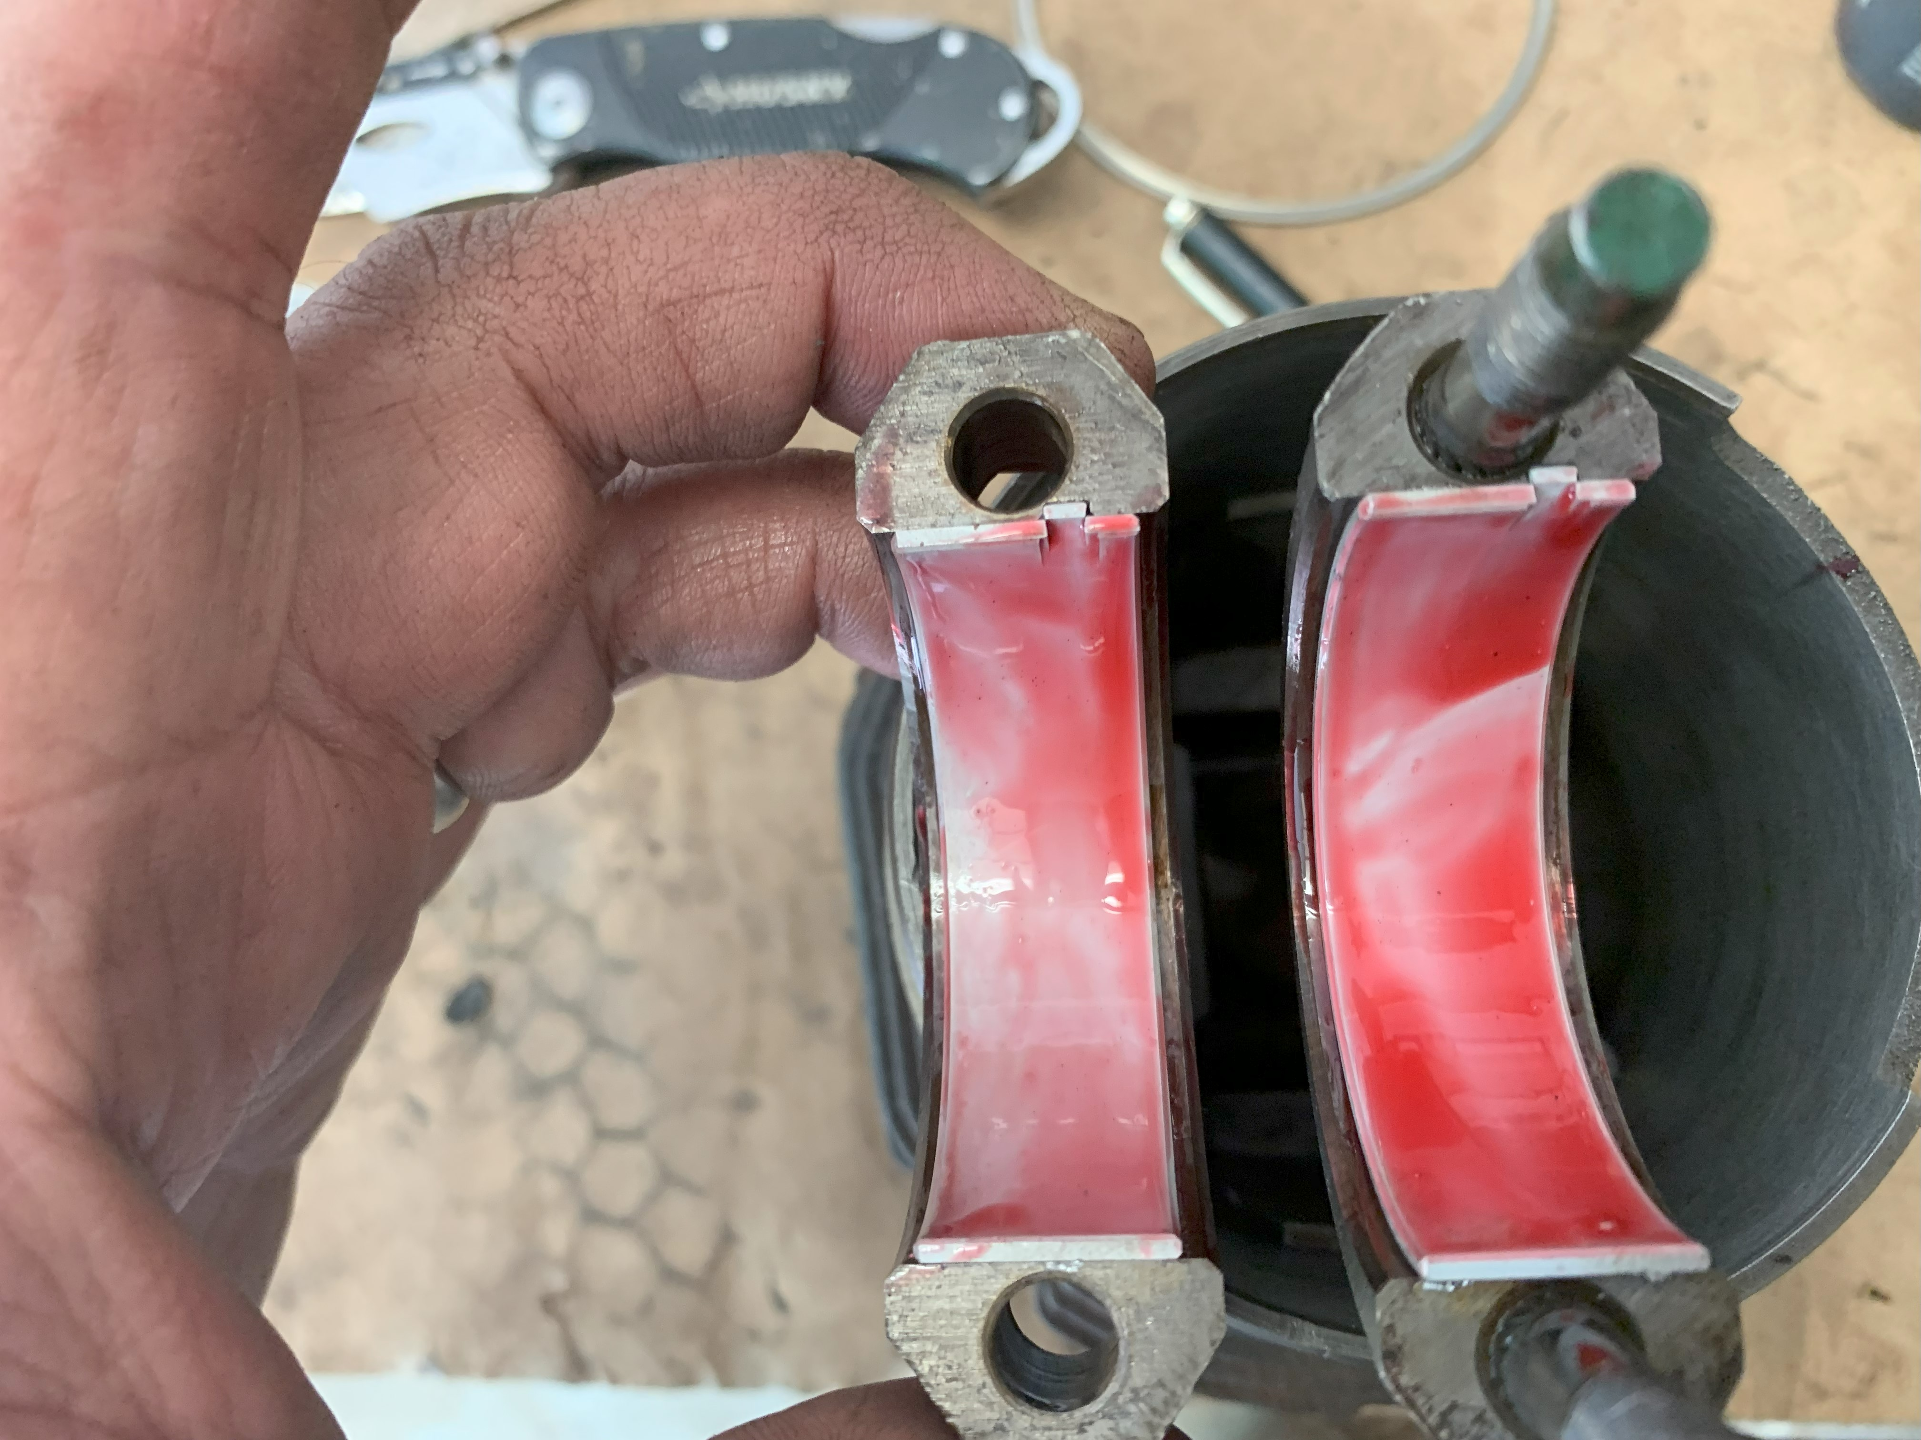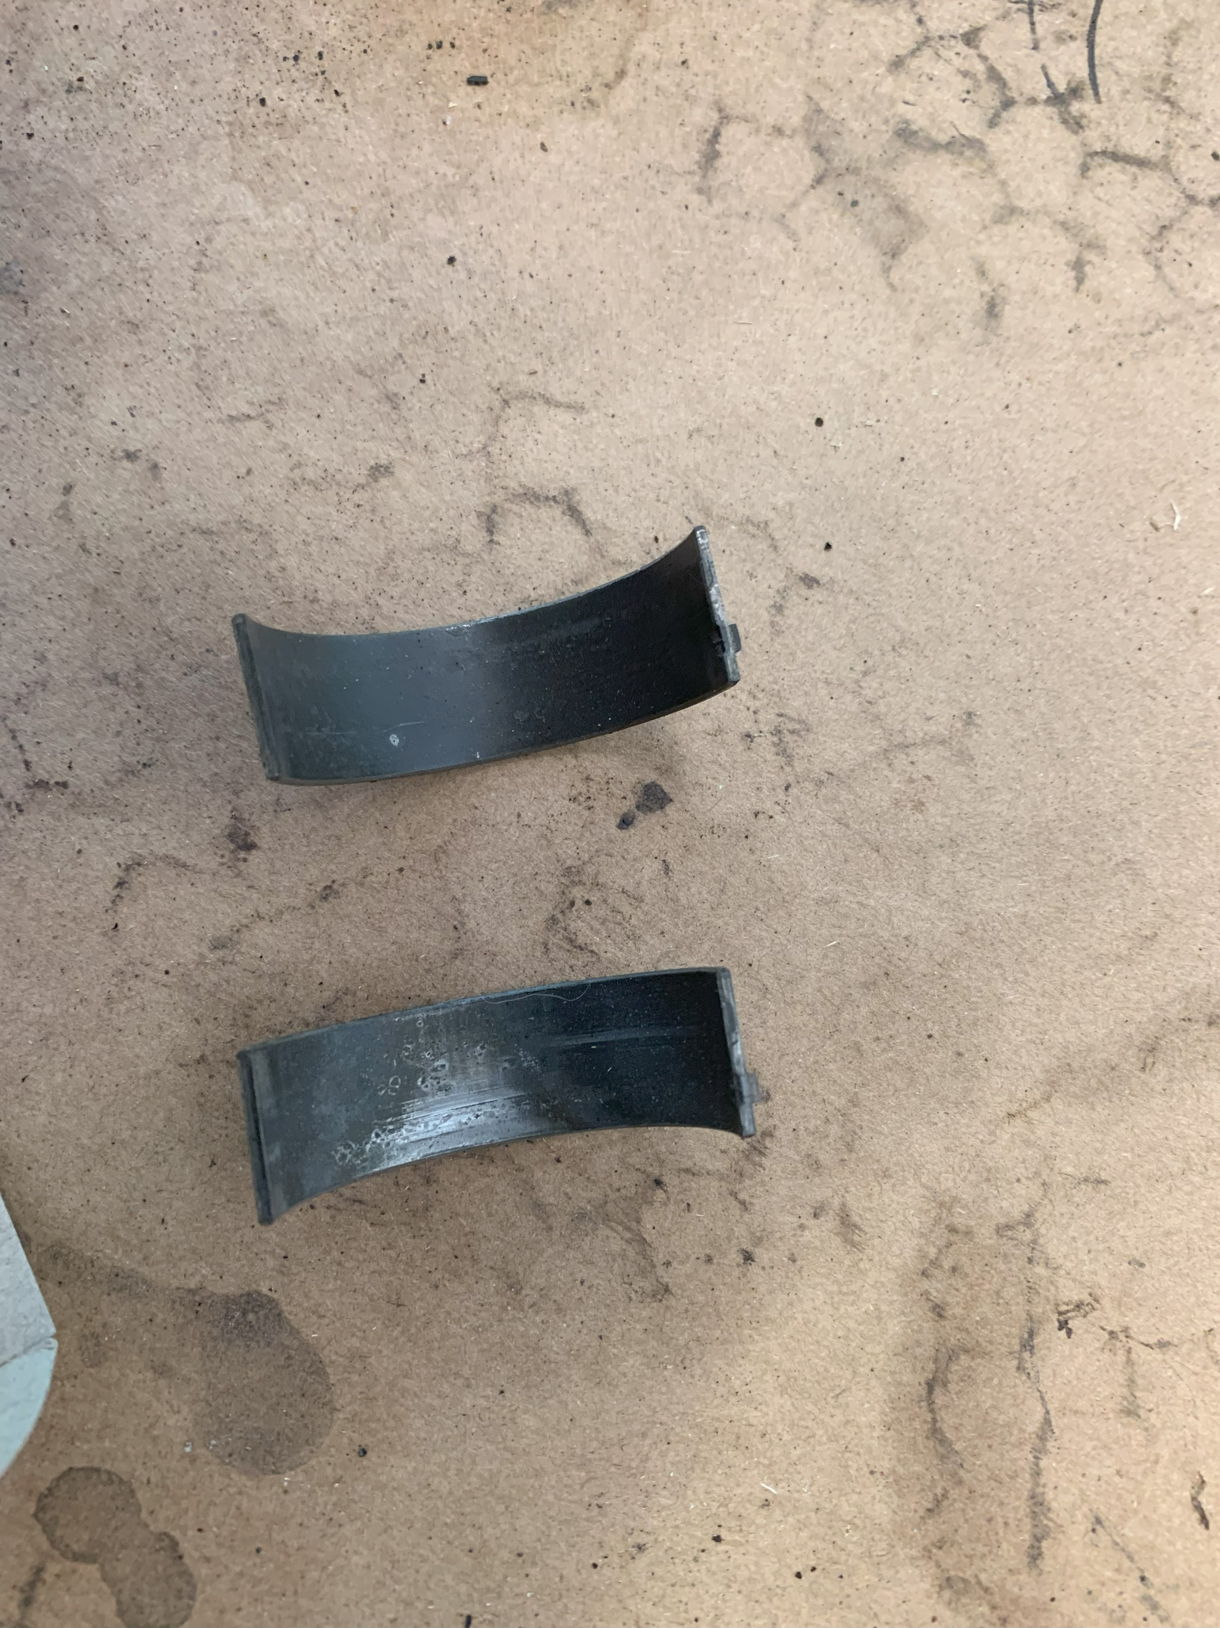Engine work is continuing. New rings and rod bearing were obtained and installed. The old bearings, pictured below were just old and rough since the car was sitting for 50 years. The new bearings, on the right, have been installed in a connecting rod and have assembly lube applied.

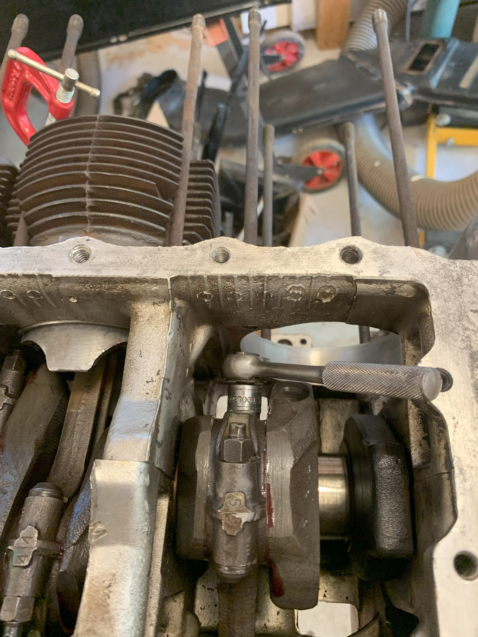I assembled the rings onto each piston and used a ring compressor to assemble the piston to the cylinder, making sure the ring gaps were right and the ring ends were spaced out and not aligned when installed. In the picture below you can see two things: Each piston rod was stamped with a location (1 to 6) and that I used a small ¼” dive ratchet to snug the bolts before torqueing the nuts. I have seen many videos where the cylinders were painted to make them look nice but I chose not to – paint inhibits heat transfer and….the cylinders are never seen once the engine is assembled.
During assemble of the cylinders/pistons I made sure to rotate the engine, using the harmonic damper bolt, two revolutions each time a cylinder was added to make sure there was no binding. You can see the small red clamp I used on each cylinder to hold the barrel in place once the cylinder was installed.
Do not forget to install the cylinder to block gasket when putting it together….I almost forgot twice but caught myself before it was too late.
Final assemble, after the cylinders were all installed include the oil pan, to fan bearing, fan and pulley and oil fill area.
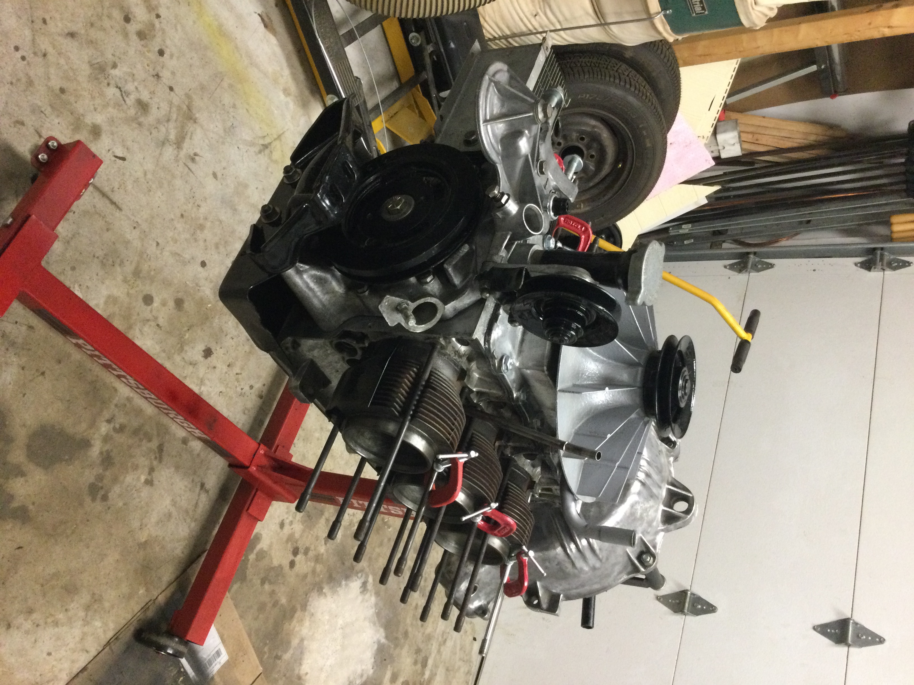
Still waiting on the heads, flywheel and pressure plate, maybe mid May. In the mean time, I’m going to try my hand at making and welding in some patch panels and getting the interior floor area clean and painted.
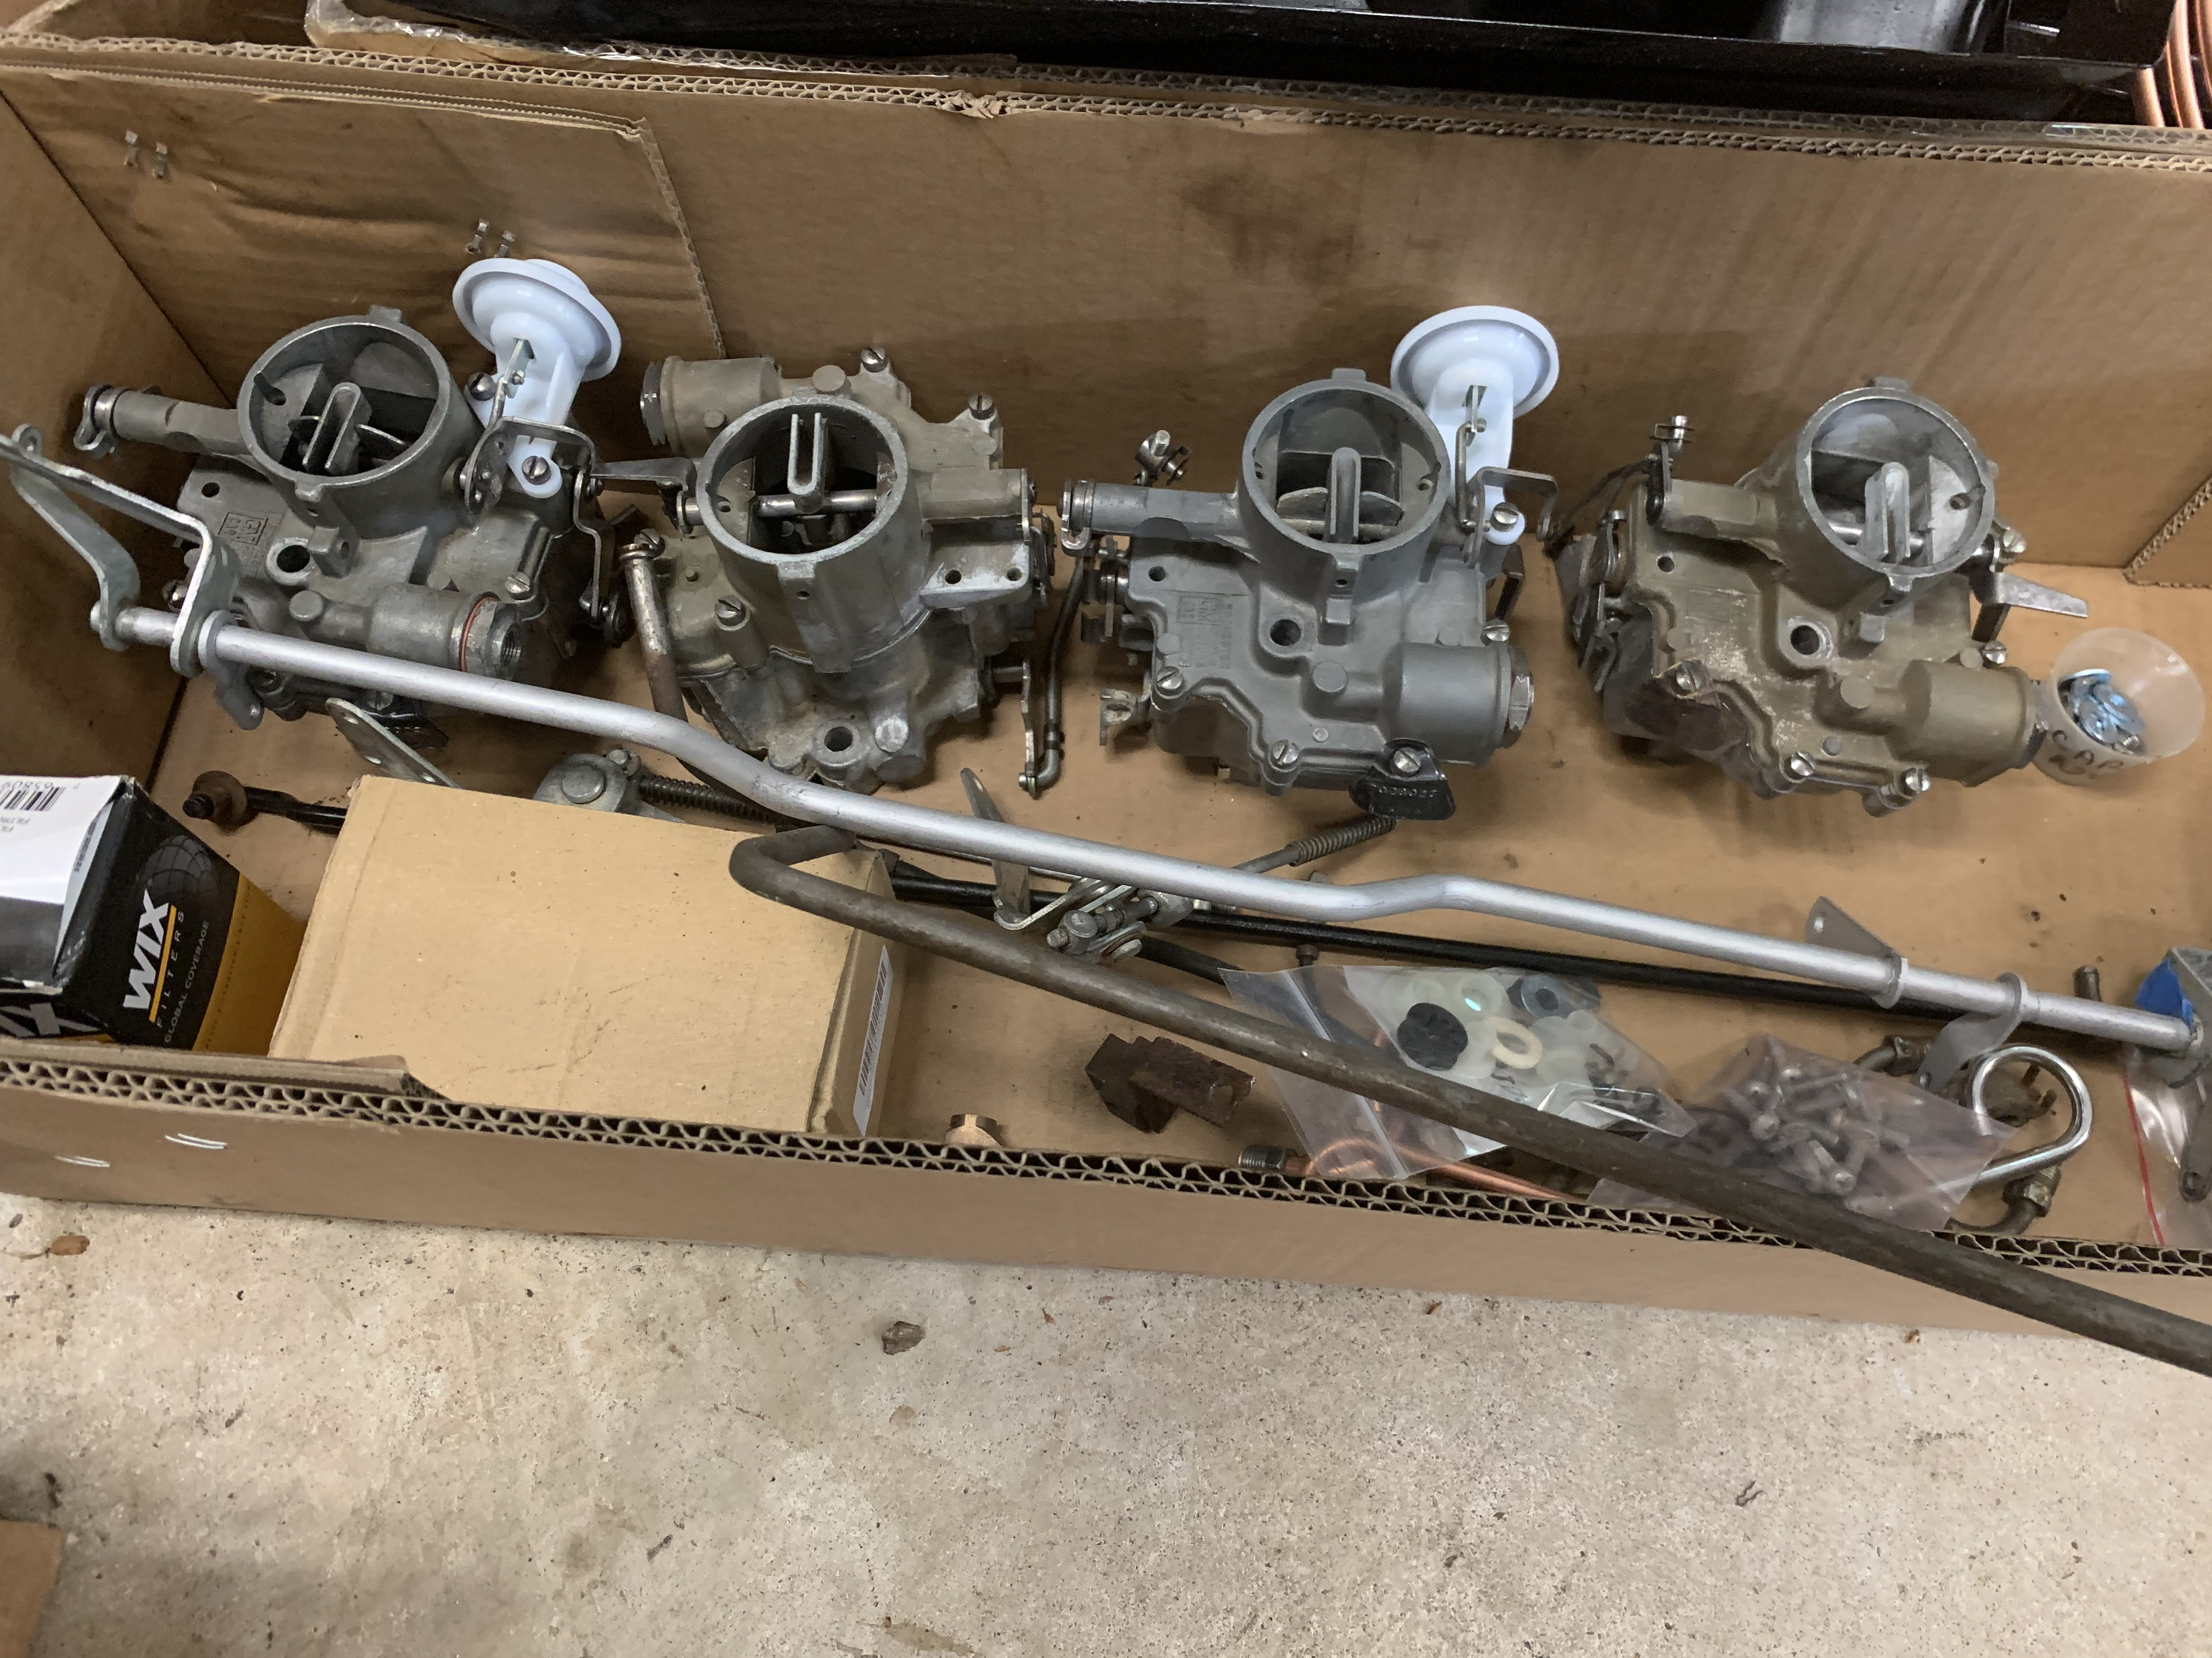Carbs have been rebuilt (Thanks to Mike Coale for having an extra carb top as one of mine was broken). I decided on an electric fuel pump and now have tubing and fittings to make new engine compartment fuel lines. The fuel lines will wait until after the carbs and linkage are reinstalled to make sure I do not create a conflict.

