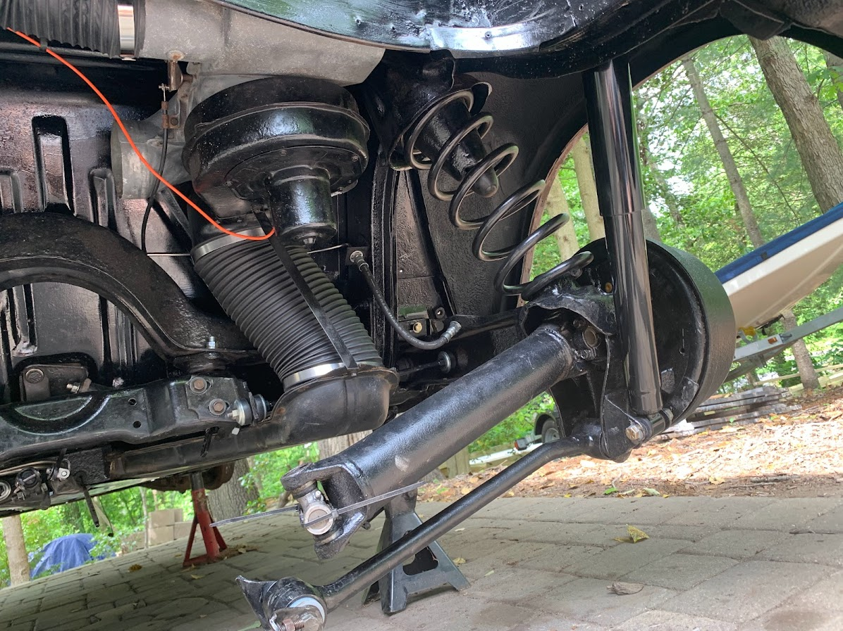The saga of the rebuild continues…..Lots of work going on while I continue to wait for the heads/flywheel/pressure plate from Corvair Ranch One of these days all will be done and ready for the engine/transaxle final assembly and installation. Since the engine was frozen when I bought the car…I am anxious to hear it run and see the wheels go round and round. . It is nice being retired and having the time to work on all the items. Nothing too hard because the car was a 1966 and pretty simple compared to today’s vehicles.
So, for the work accomplished this month…. First up in reinstall the heater blower and 2 pieces of the duct work. You can also see in the picture that I have reinstalled the cross member and rear suspension. New rear springs, u-joints, brakes, EB Cable, brake hoses, brake lines and many more new parts.
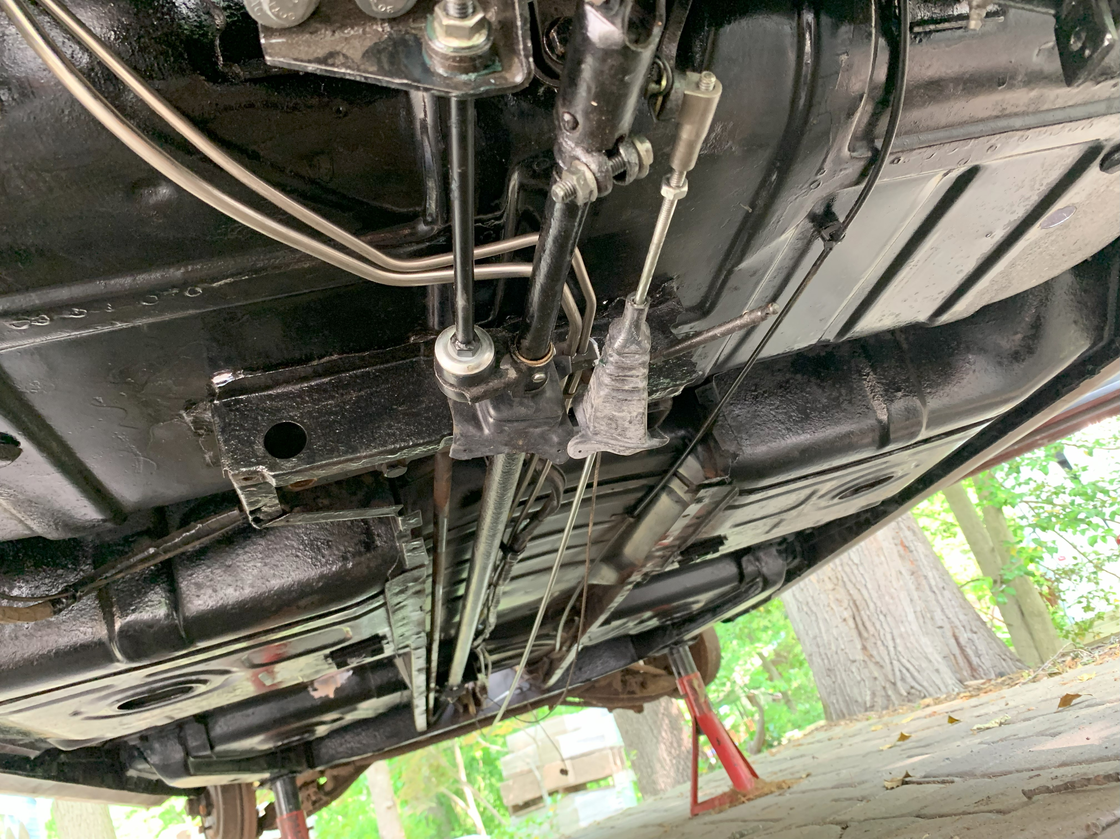I wanted to bring all the underneath parts up to ‘newish’ condition. You can also see in the picture below that I have been putting the floor trunk items back in and ultimately closing up the bottom panel. New brake and fuel lines; new clutch cable, new shift tube stabilizer. While I have the boot that goes between the shift shaft and the trunk, I learned that I missed the rubber expansion boot for the outboard end of shift shaft. You can see the new bushing in the picture at left but I cut the tube short at the mounting bracket due to corrosion which was not suitable for mounting the Clark’s bushing. I will have to figure out how to extend the tube so that outboard boot has someplace to mount. Something for next month.

In the 2 pictures below you can see the inside of the car and the condition of the floor, which was very good with only one rust spot just below the steering wheel. Still learning to MIG weld but the patch I 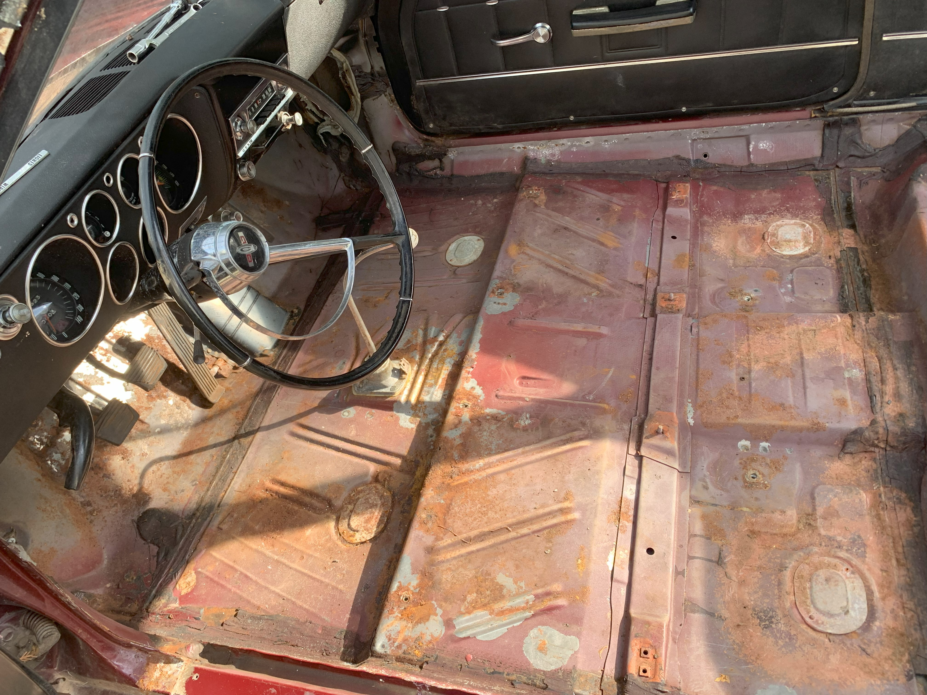made seemed to come out pretty well. Grinding and paint make me the welder I ain’t….
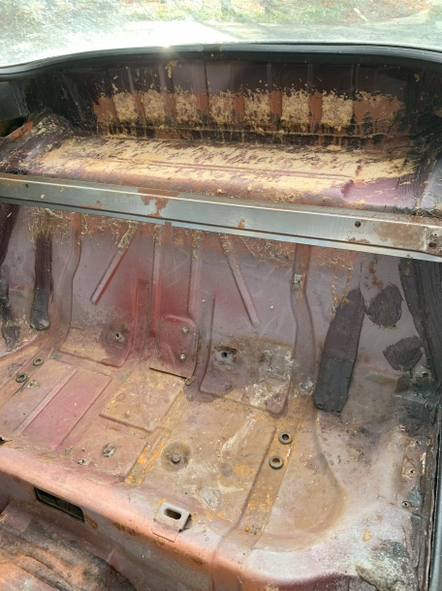
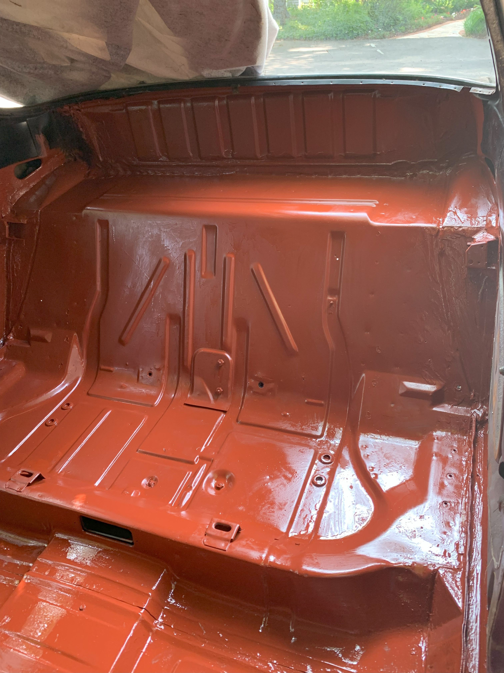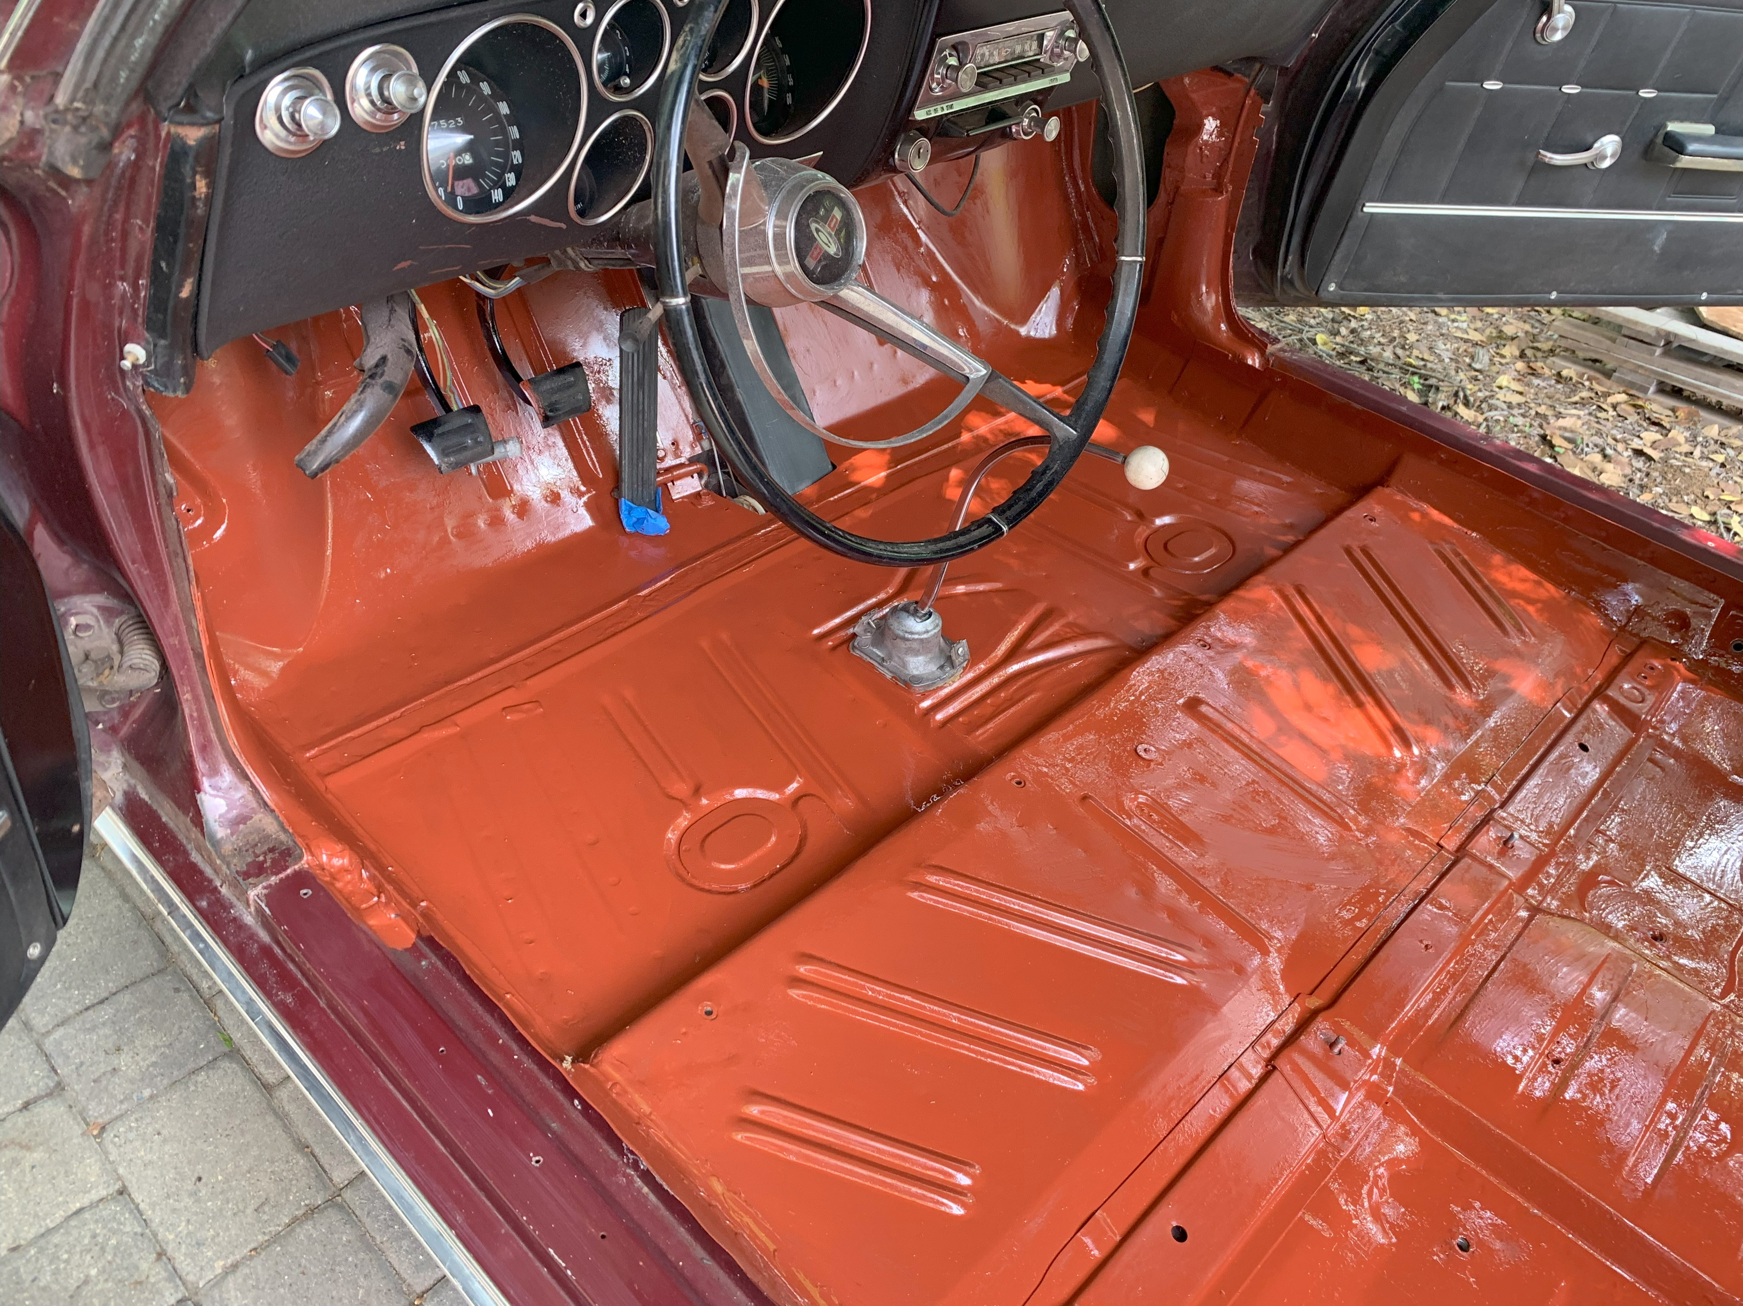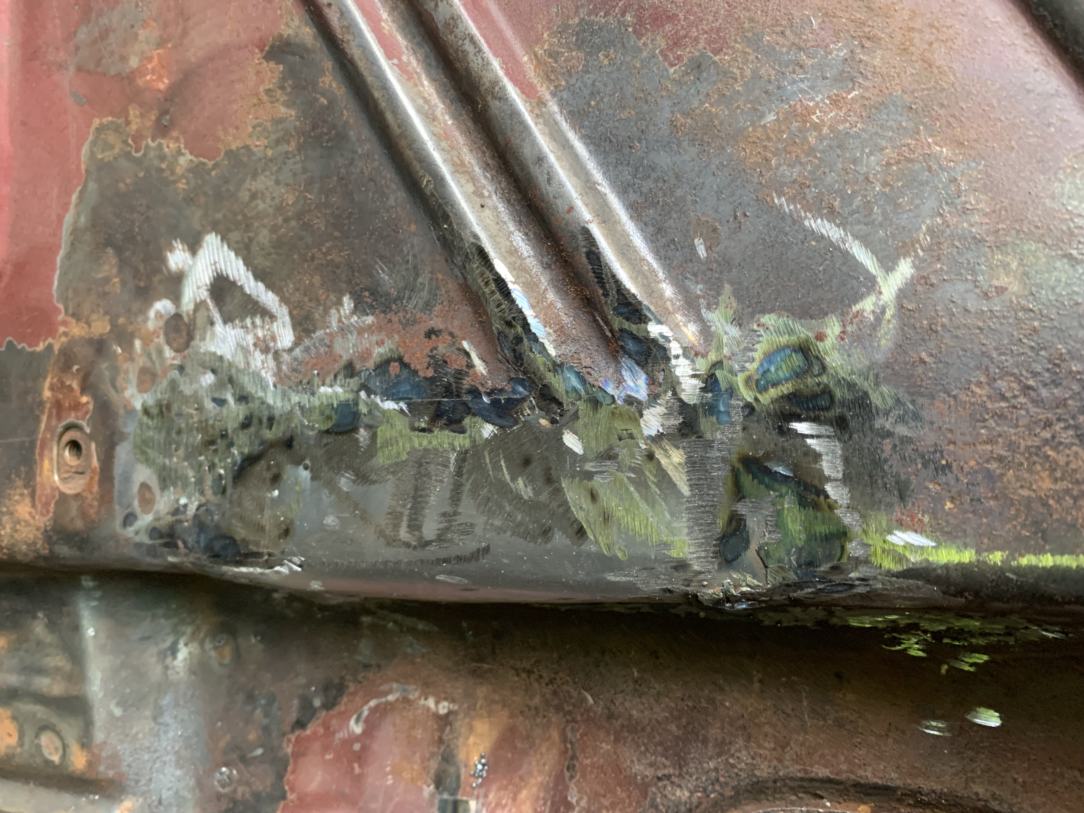After the repair was made the floor and was primed with a good Zinc Chromate Primer. There is story that goes with the primer. My father-in-law was a PHD chemist for DuPont and while cleaning out his basement I came across a 1950 can of DuPont Submarine Primer (Zinc Chromate). He now will be riding along in the car with me in the future. The finished views of the interior are below. I’m very pleased with the results.

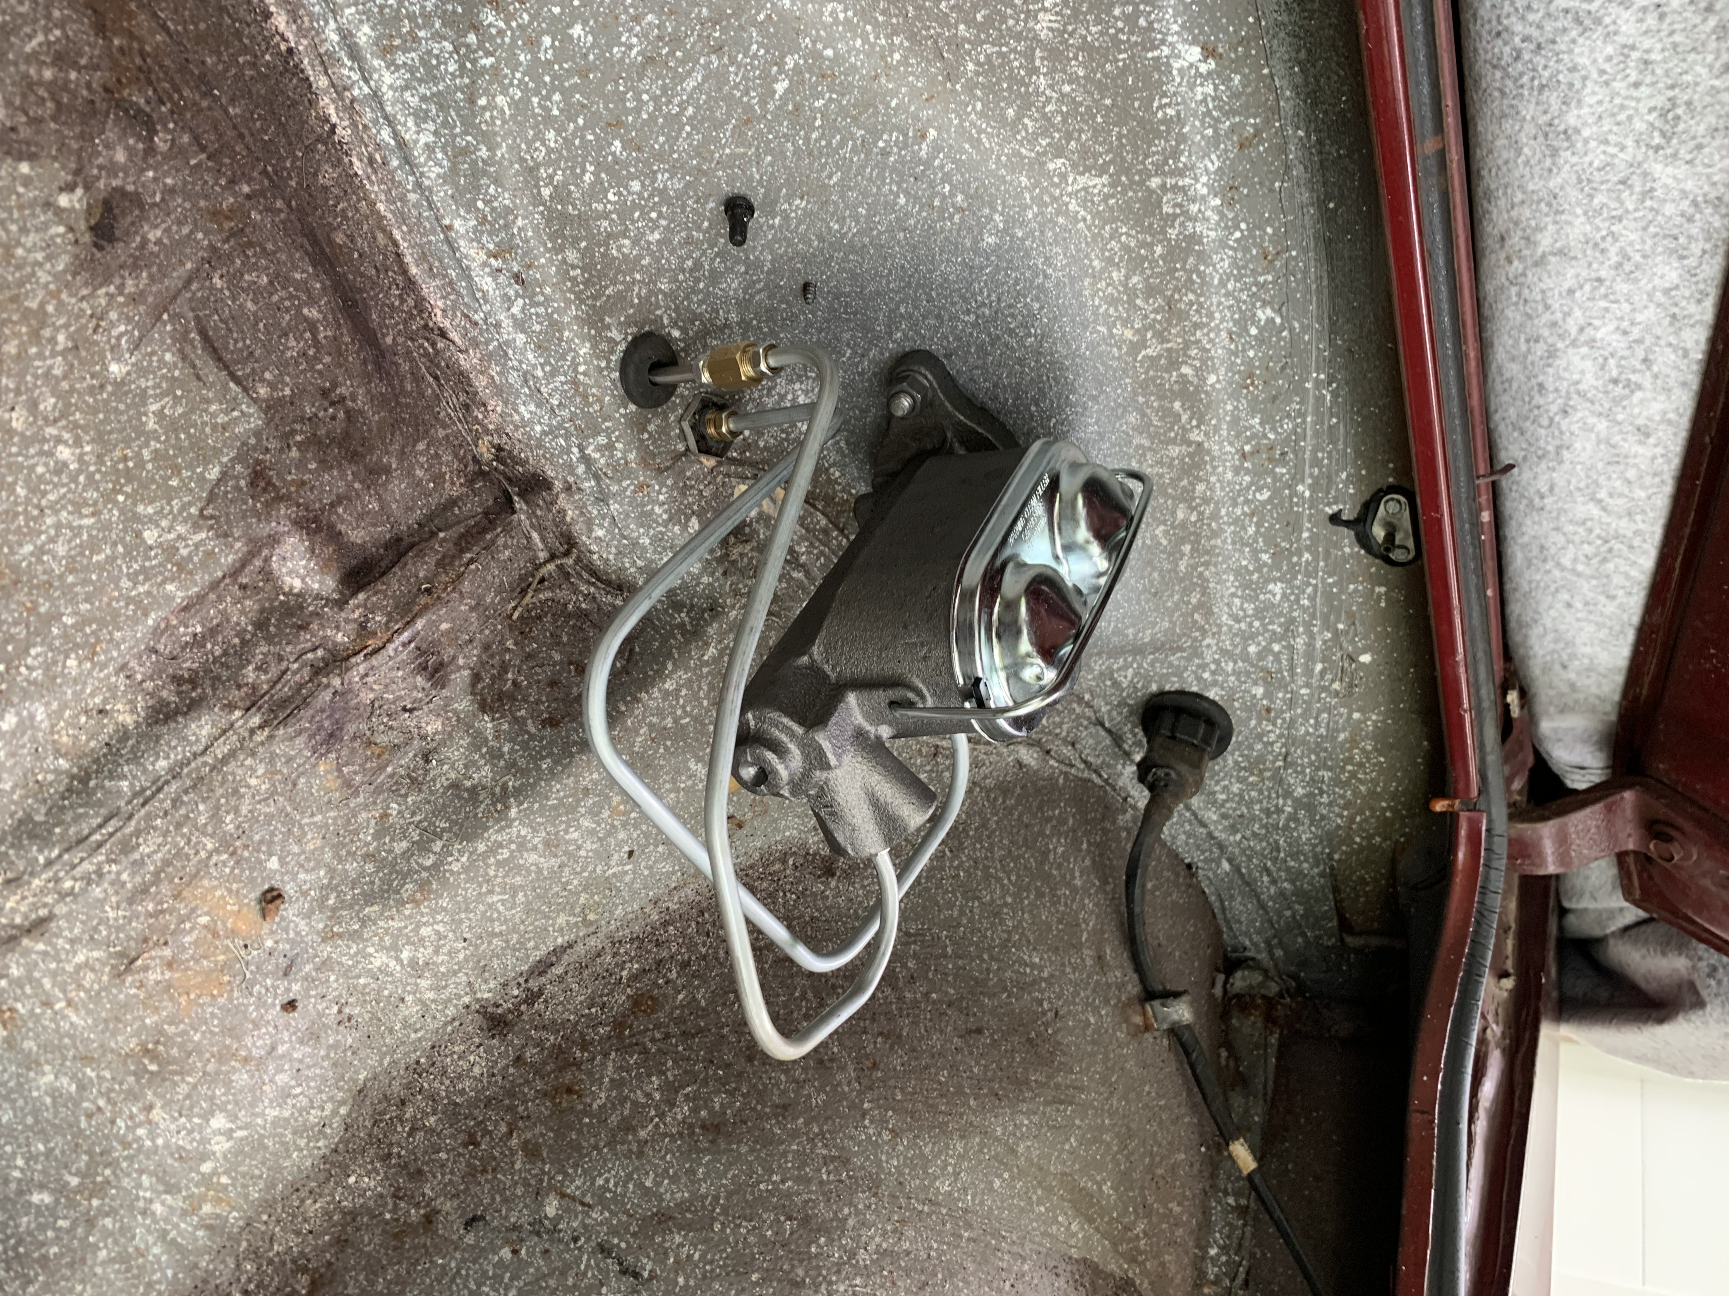Last up on the accomplishments for this month is the installation of the new dual master cylinder in the trunk. I needed to tweak the brake lines provided by Clark’s but it was not too tough of a job. The car is getting new brake lines throughout.
Next month will be pulling the front suspension and reworking that with new shocks, brakes, wheel cylinders, spring set, wheel bearings, seals (the list goes on and on)……not to mention new gas tank and all the parts that go with that evolution. Two minor rust spots to fix in the front trunk and one at a back corner. Finally, cleaning the undersides and all parts and repainting/rust proofing to match the back of the car.
Longer out will be the removal of both the front and back windows to repair the metal around them. I’m not a great welder and these have me concerned. I’m happy for any advice and knowhow from anyone who has done this in the past. Not something I want to do wrong.

